COURSE CODE/TITLE: | CPE212 Automating Server Management |  | SECTION: | CPE31S2
DATE PERFORMED: | 07/23/2026 |  | DATE SUBMITTED: | 07/23/2026
NAME: | Aicon H. Keliste |  | INSTRUCTOR: | Engr, Jimlord Quejado

ACTIVITY NO. 3.1 | Install SSH server on CentOS or RHEL 8
1. PROCEDURE OUTPUT
Task 1:
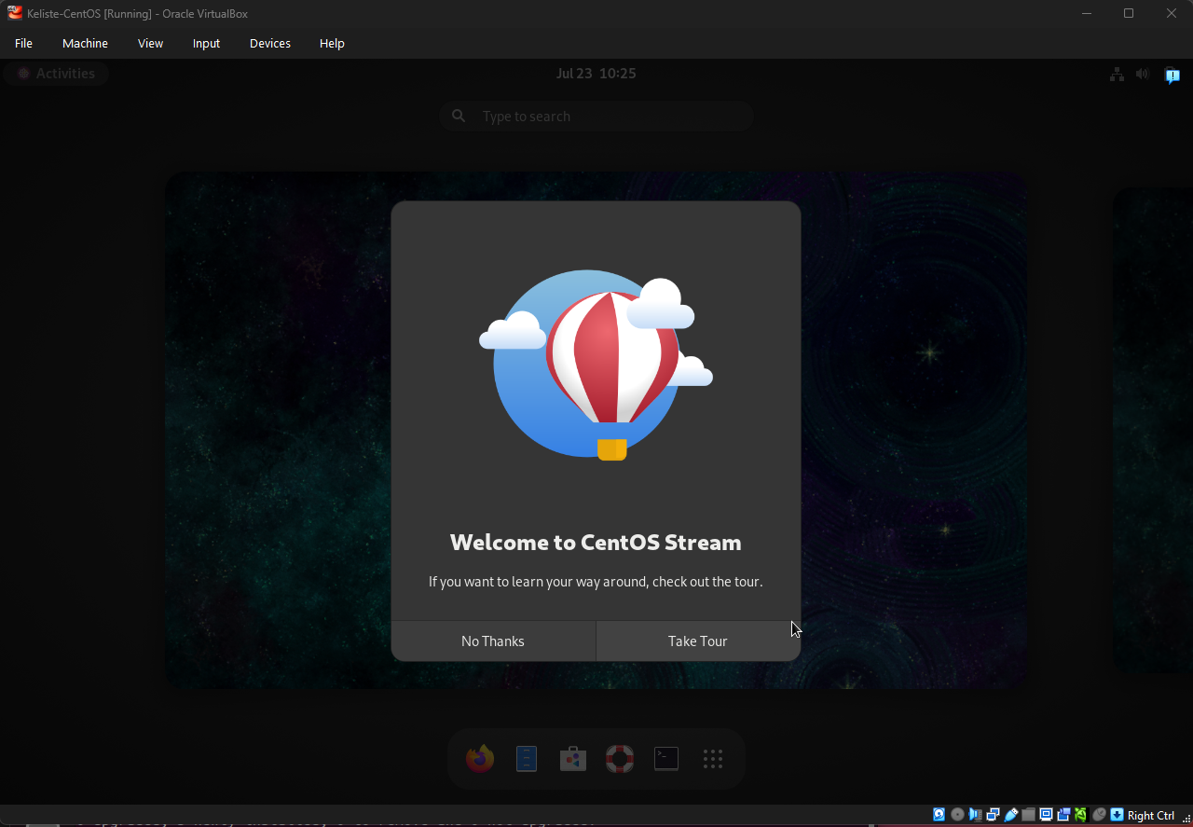

Task 2:
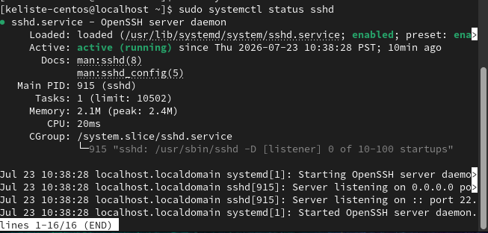
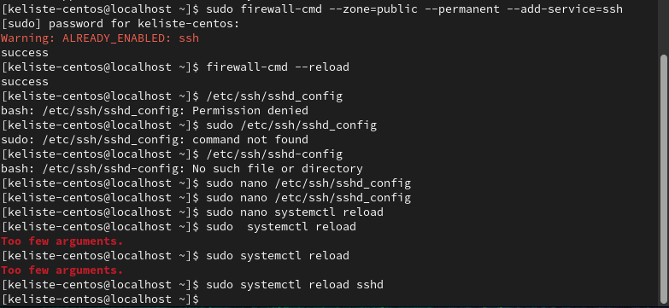
Task 3:
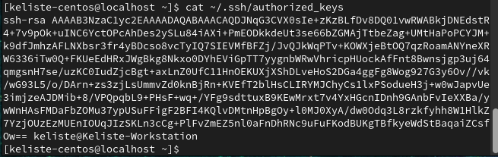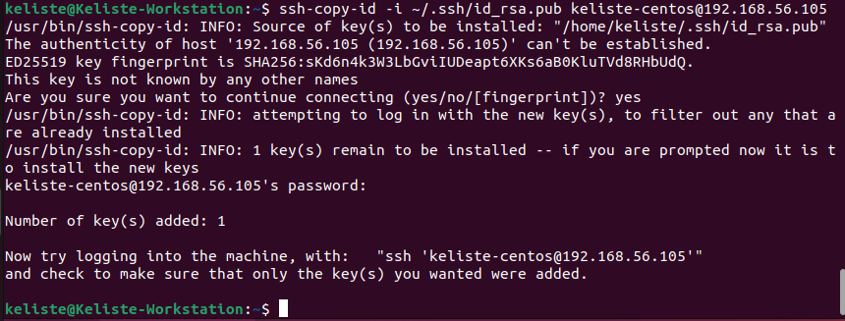

Task 4:
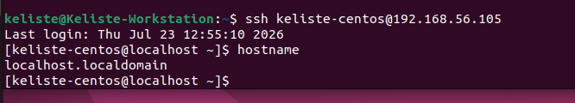
2. ANSWERS TO SUPPLEMENTAL ACTIVITY
1. What do you think we should look for in choosing the best distribution between
Debian and Red Hat Linux distributions?
- When choosing between Debian and Red Hat Linux distributions, you should consider the purpose of using the distribution. We should also consider the level of support and stability needed, the package management system, and the compatibility of the software we plan to run.
2. What are the main diffence between Debian and Red Hat Linux distributions?
- The difference between Debian and Red Hat Linux distributions is that Debian uses the APT package manager, which is also commonly used for Ubuntu. Meanwhile, Red Hat Linux uses the DNF and YUM package managers, which are also commonly used for CentOS and Fedora. Debian-based distributions are commonly used for desktops or personal computers, while Red Hat Linux distributions are more commonly used for enterprise servers and data centers.

3. ARTIFICIAL INTELLIGENCE (AI) USE DISCLOSURE STATEMENT
I hereby declare that artificial intelligence (AI) tools were used, if applicable, in the preparation of this academic work. The following indicates the nature and extent of AI assistance:

Tools Used: | Claude AI
Examples: ChatGPT, Microsoft Copilot, Grammarly, QuillBot, etc.

Purpose of Use: | Grammar Correction
Examples: grammar correction, idea generation, formatting, summarization, code assistance, explanation of concepts, etc.

Extent of Use: | For grammar checking and correction
Explain how AI was used and confirm that it did not replace original thinking, analysis, authorship, or completion of the required work.

By submitting this activity, I affirm that my use of AI complies with T.I.P.’s AI usage policy and does not exceed the permitted limits for similarity, automated content generation, or academic assistance.

I understand that any false, incomplete, or misleading disclosure may be subject to investigation in accordance with due process and may result in sanctions for violation of existing T.I.P. policies.

Lab activities, templates, and related instructional materials shall not be reuploaded, reproduced, distributed, or shared with external organizations or third parties without the prior express written permission of the Technological Institute of the Philippines.

