COURSE CODE/TITLE: | CPE212 Automating Server Management |  | SECTION: | CPE31S2
DATE PERFORMED: | 9/01/2026 |  | DATE SUBMITTED: | 9/02/2026
NAME: | Aicon H. Keliste |  | INSTRUCTOR: | Engr. Jimlord Quejado

ACTIVITY NO. 6.1 | Targeting Specific Nodes
1. PROCEDURE OUTPUT
Task 1:
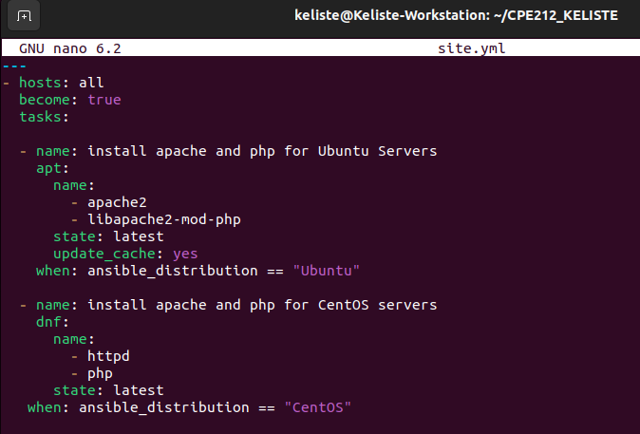
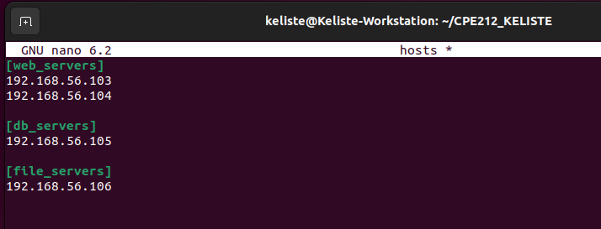
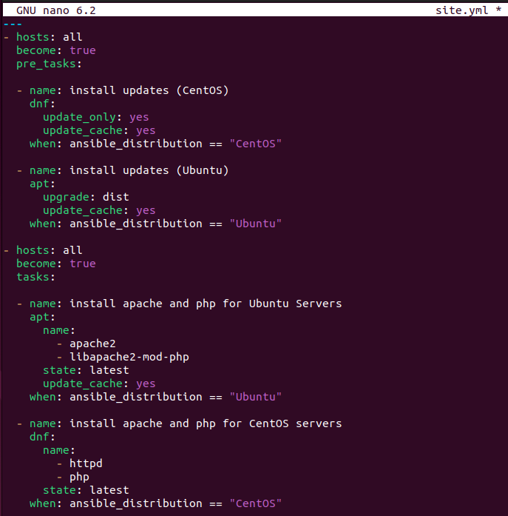
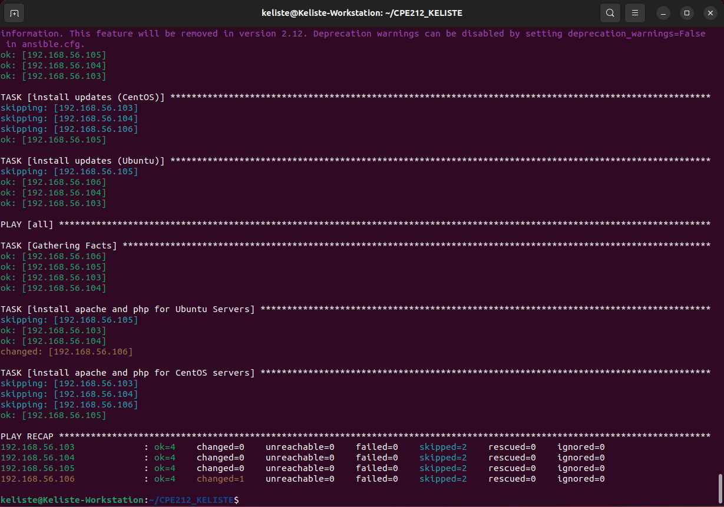
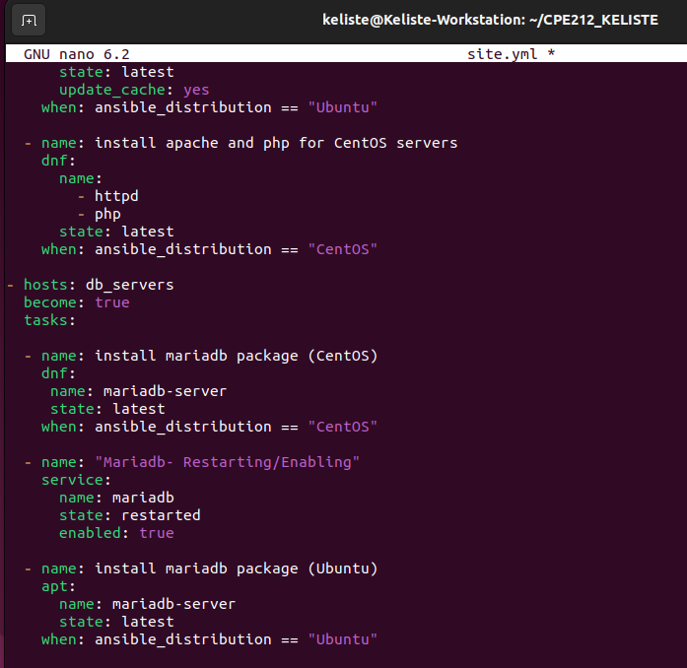
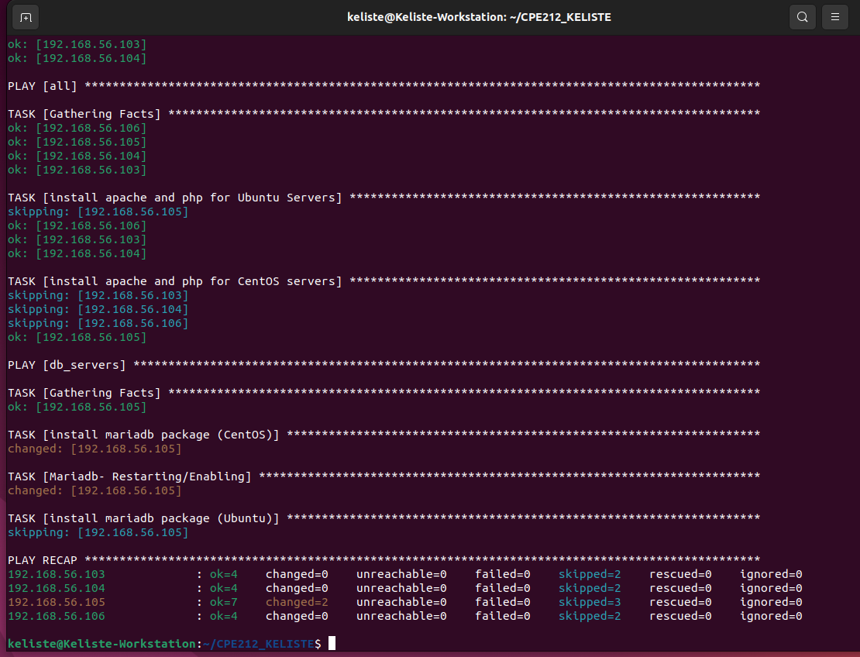
Centos - Systemctl status mariadb
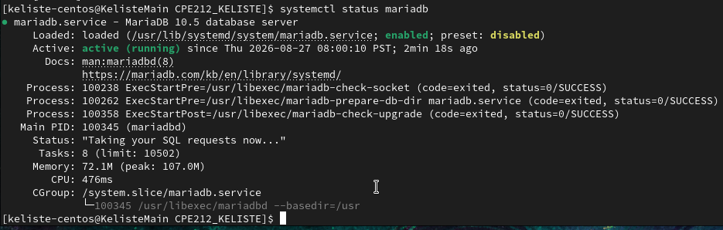
Describe: The mariadb service is loaded and enabled from the package unit file, and shows active (running).
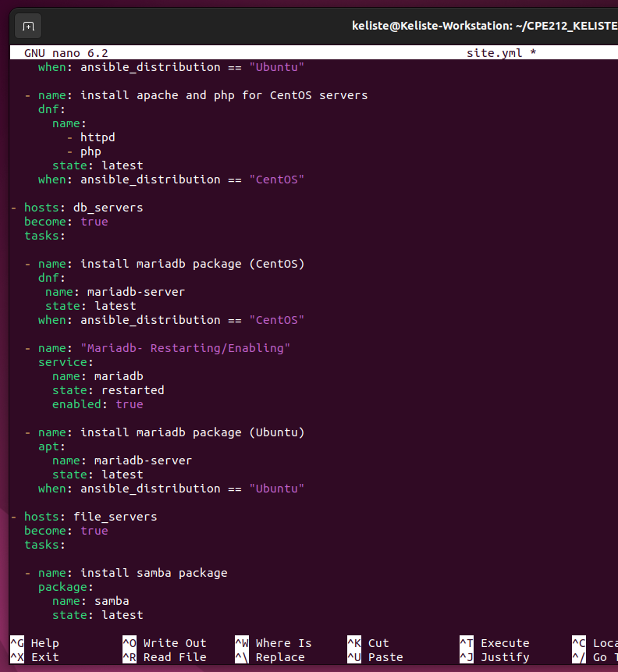
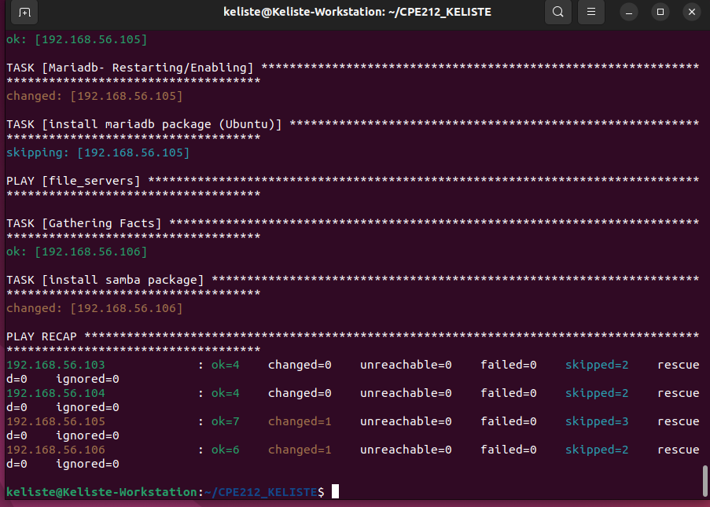

Task 2:
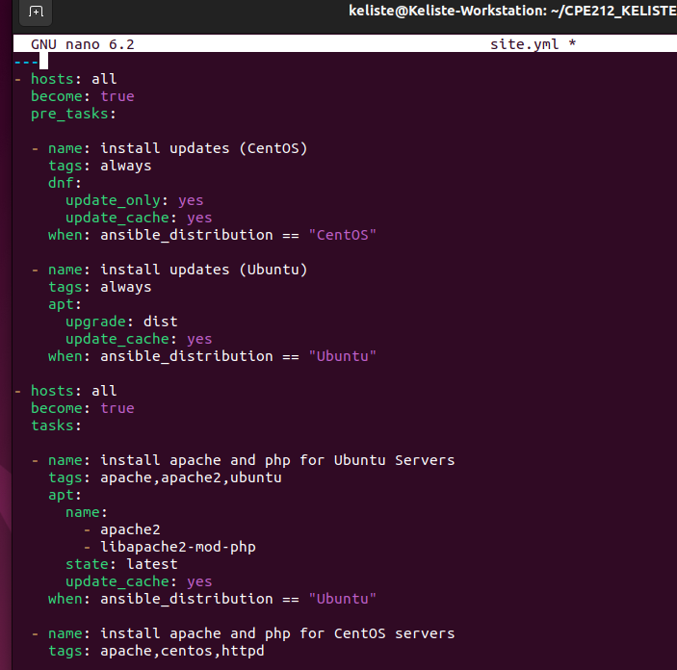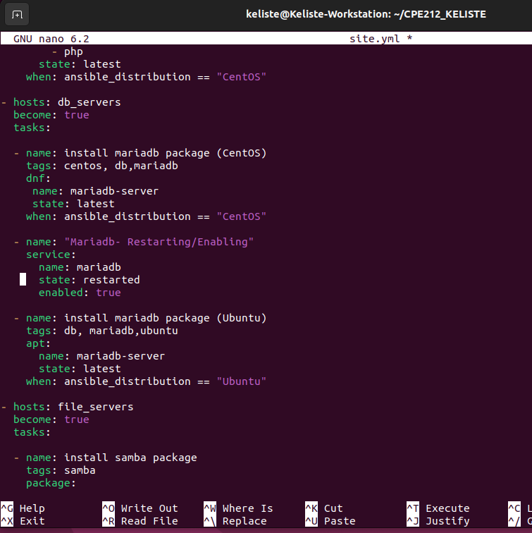
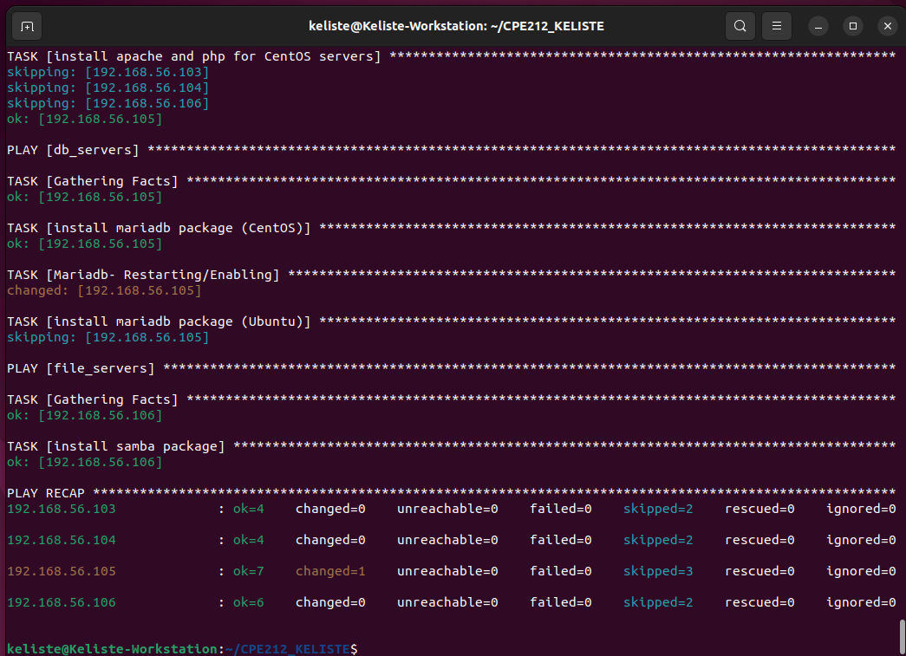
Describe:
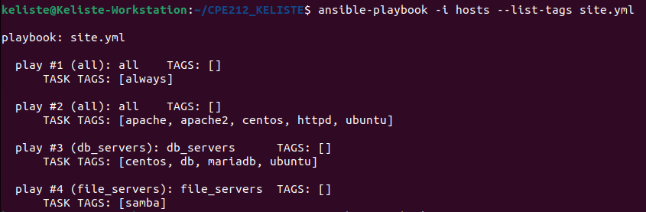
ansible-playbook --list-tags site.yml
Describe: This just lists every tag defined in the playbook without actually running any tasks
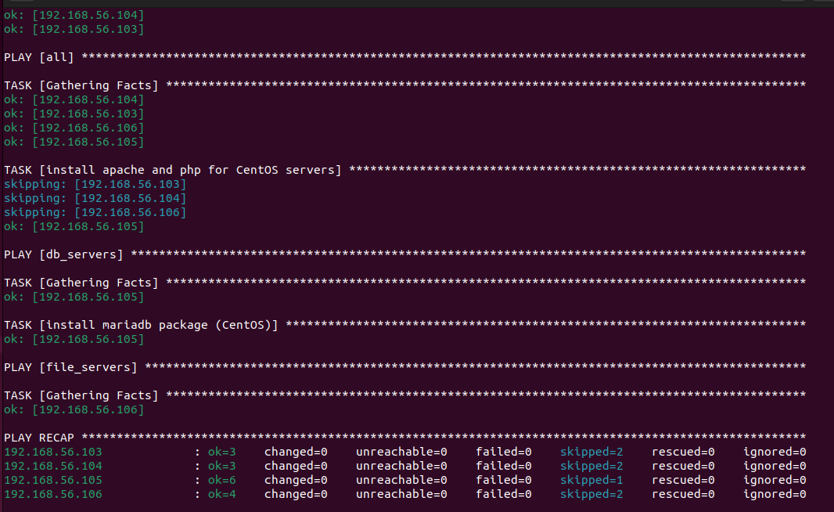
ansible-playbook --tags centos --ask-become-pass site.yml
Describe: This runs only the tasks tagged centos.
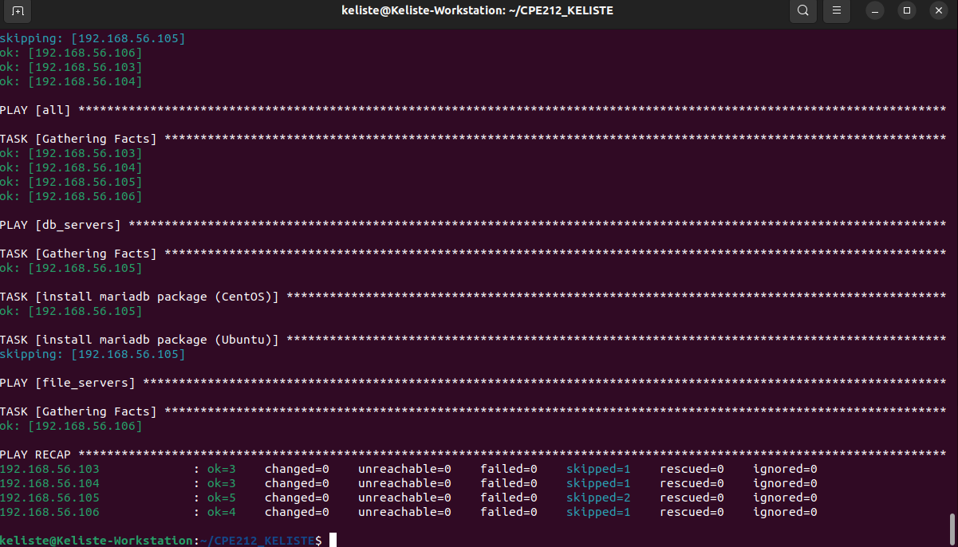
ansible-playbook --tags db --ask-become-pass site.yml
Describe: This runs only the database-related tasks, skipping the web and file server tasks entirely.
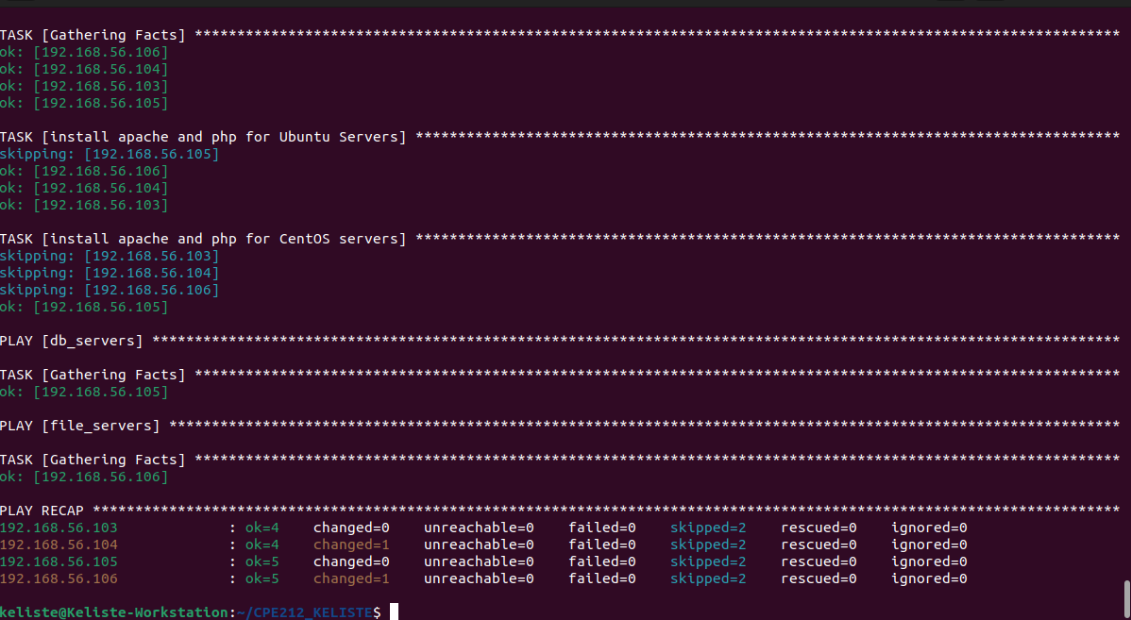
ansible-playbook --tags apache --ask-become-pass site.yml
Describe: This runs only the apache/php installation tasks across web_servers, skipping the db and samba tasks.
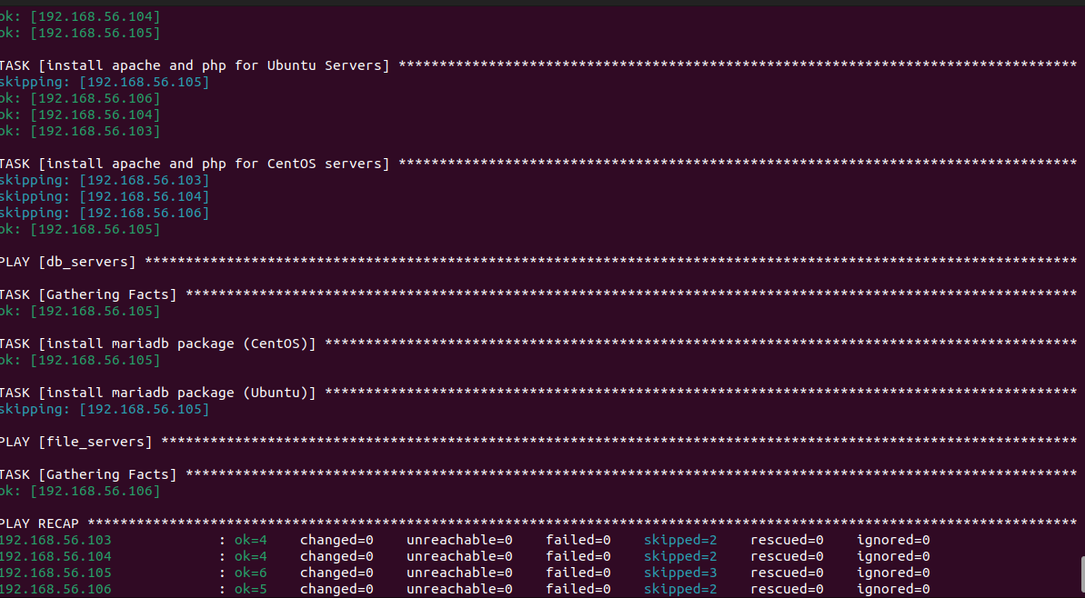
ansible-playbook --tags “apache,db” --ask-become-pass site.yml
Describe: This combines two tags in one run, so both the apache tasks and the db tasks execute together while file_servers tasks are skipped.

Task 3:
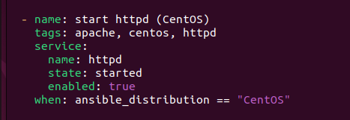
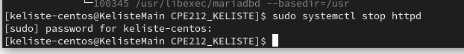
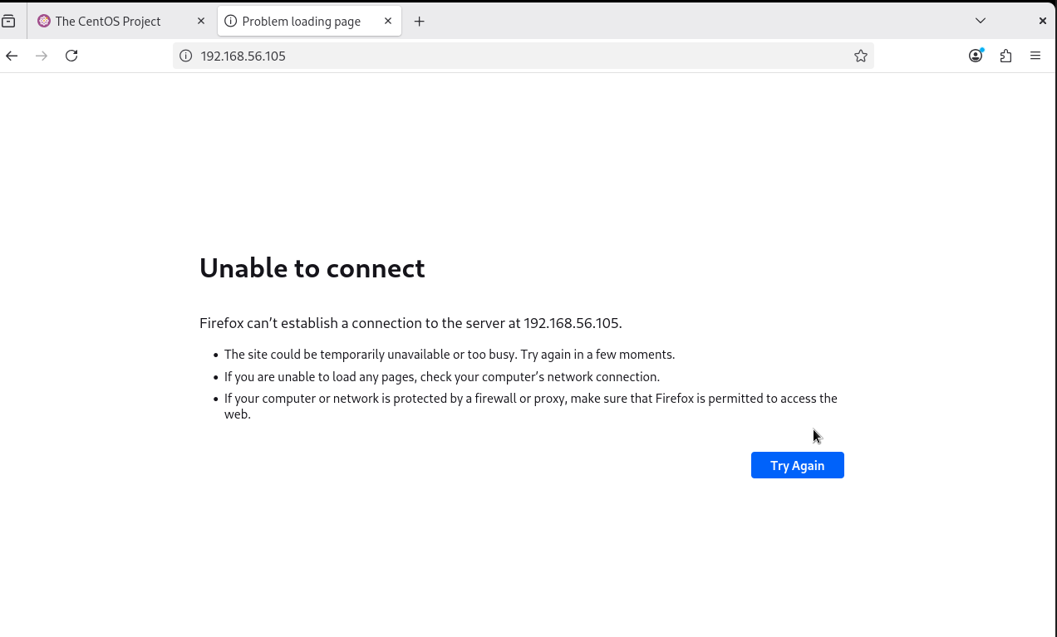
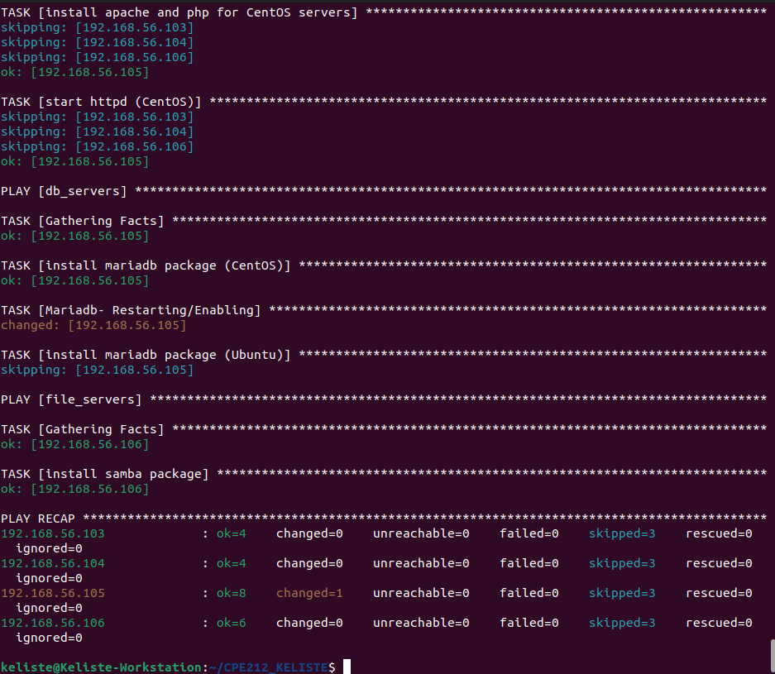
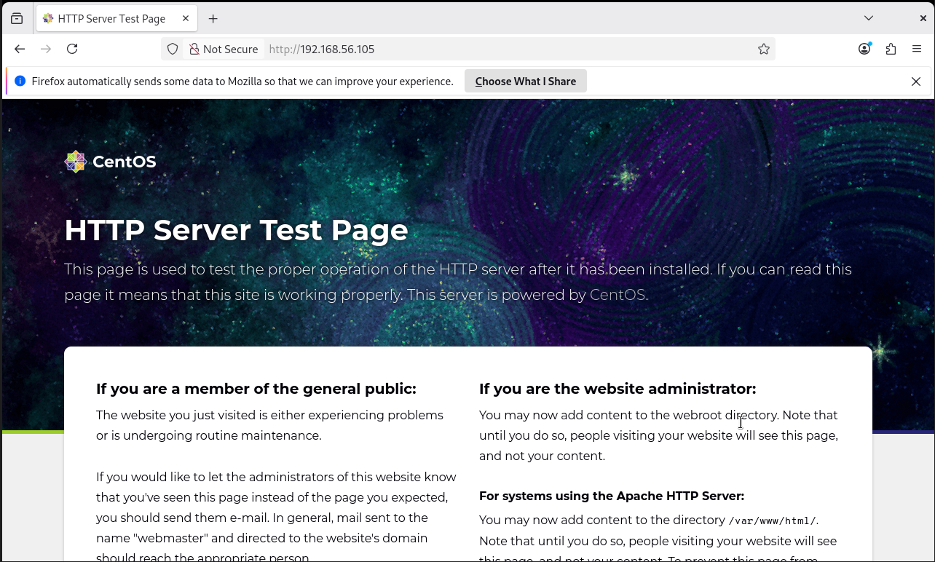
2. ANSWERS TO SUPPLEMENTAL ACTIVITY
1. Creating a Role for Web Servers
2. Creating a Role for Web Servers
3. Creating a Role for Database Servers
4. Combining Multiple Roles in a Playbook
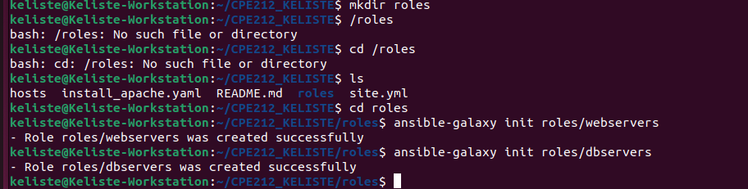
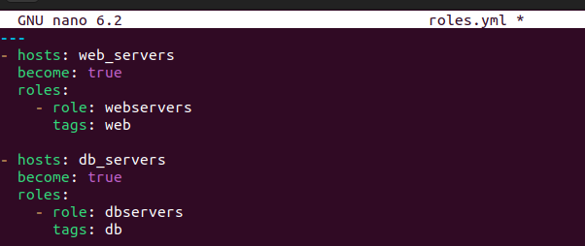
Reflection:
1. What is the importance of putting our remote servers into groups?
- Grouping remote servers matters because it lets me target exactly the machines a task applies to instead of running every play against every host.
2. What is the importance of tags in playbooks?
- Tags let me run only the parts of a playbook I actually need at that moment, instead of re-executing the whole file every time.
3. Why do think some services need to be managed automatically in playbooks?
- Some services don't start automatically after installation because the package manager only installs the software itself and it doesn't assume I want it running immediately.
3. ARTIFICIAL INTELLIGENCE (AI) USE DISCLOSURE STATEMENT
I hereby declare that artificial intelligence (AI) tools were used, if applicable, in the preparation of this academic work. The following indicates the nature and extent of AI assistance:

Tools Used:
Examples: ChatGPT, Microsoft Copilot, Grammarly, QuillBot, etc.

Purpose of Use:
Examples: grammar correction, idea generation, formatting, summarization, code assistance, explanation of concepts, etc.

Extent of Use:
Explain how AI was used and confirm that it did not replace original thinking, analysis, authorship, or completion of the required work.

By submitting this activity, I affirm that my use of AI complies with T.I.P.’s AI usage policy and does not exceed the permitted limits for similarity, automated content generation, or academic assistance.

I understand that any false, incomplete, or misleading disclosure may be subject to investigation in accordance with due process and may result in sanctions for violation of existing T.I.P. policies.

Lab activities, templates, and related instructional materials shall not be reuploaded, reproduced, distributed, or shared with external organizations or third parties without the prior express written permission of the Technological Institute of the Philippines.

