COURSE CODE/TITLE: | CPE212 Automating Server Management |  | SECTION: | CPE31S2
DATE PERFORMED: | 9/17/2026 |  | DATE SUBMITTED: | 9//2026
NAME: | Aicon H. Keliste |  | INSTRUCTOR: | Engr. Jimlord Quejado

ACTIVITY NO. 8.1 | Install, Configure, and Manage Availability Monitoring tools
1. PROCEDURE OUTPUT
1. Create a playbook that installs Nagios in both Ubuntu and CentOS. Apply the concept of creating
Roles.
2. Describe how you did step 1. (Provide screenshots and explanations in your report. Make your report detailed such that it will look like a manual.)
3. Show an output of the installed Nagios for both Ubuntu and CentOS.
4. Make sure to create a new repository in GitHub for this activity.

Site.yml
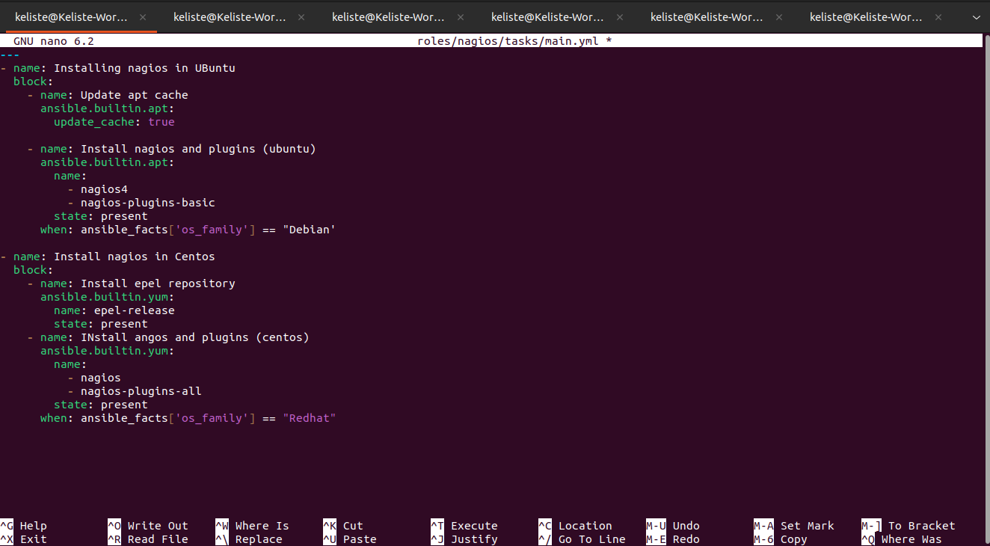
Failed
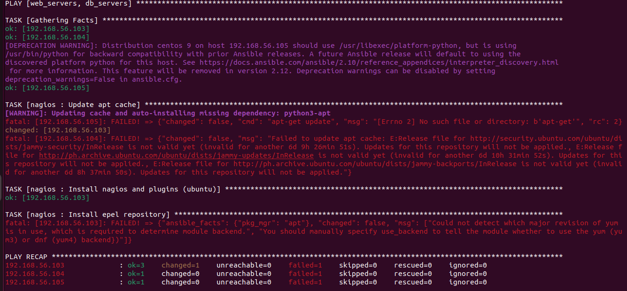
Failed on the CentOS
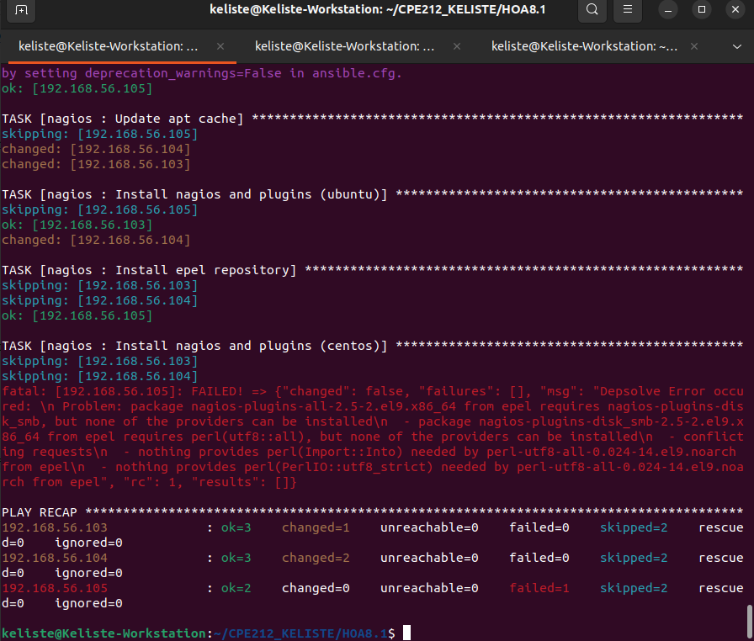

Add to site.yml
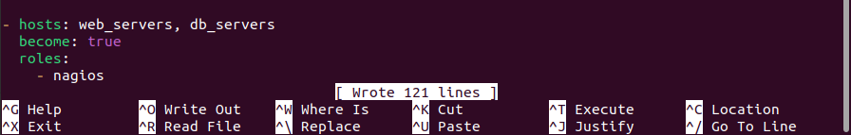
Failed on Centos
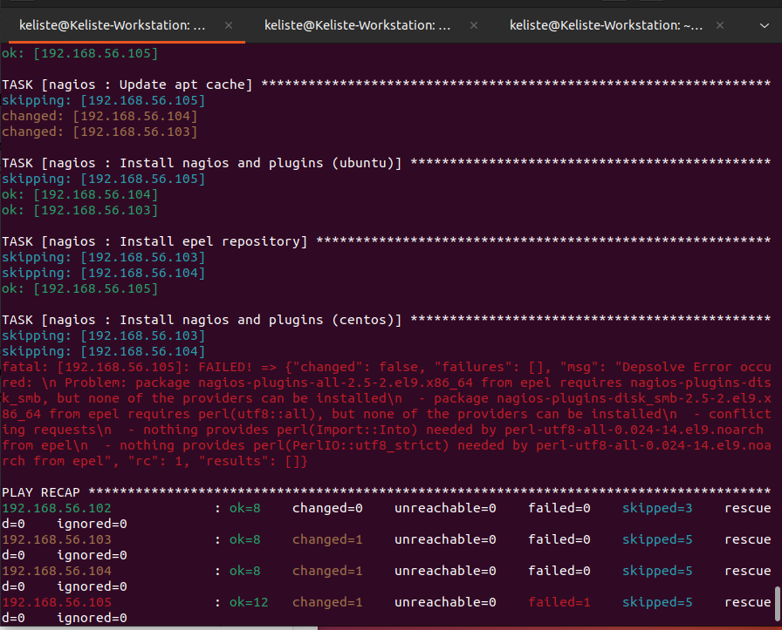

Add on the site.yml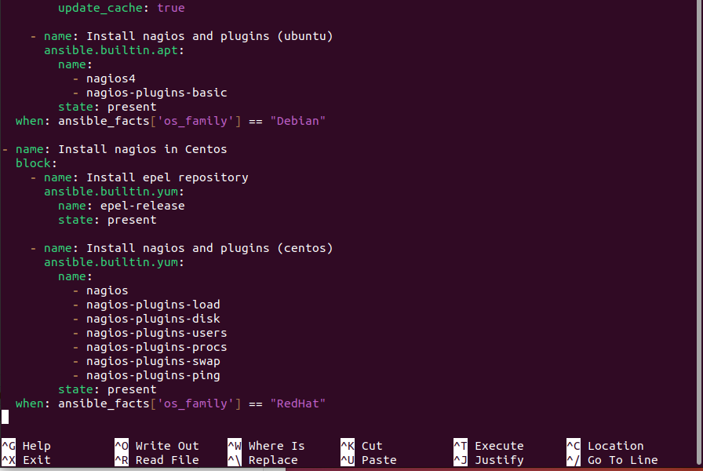
Fixed
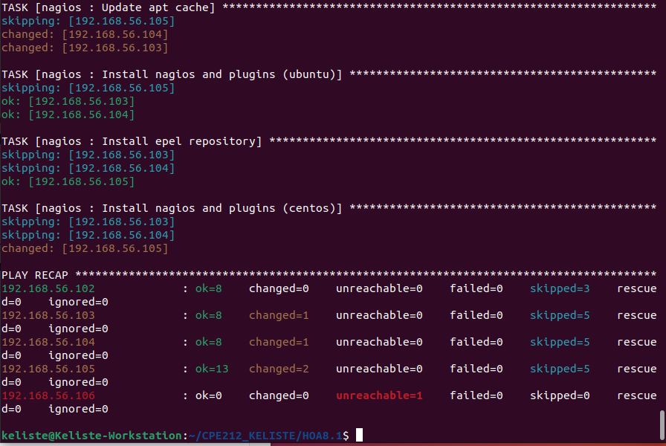
VErifty Nagios in Ubuntu
Server 1
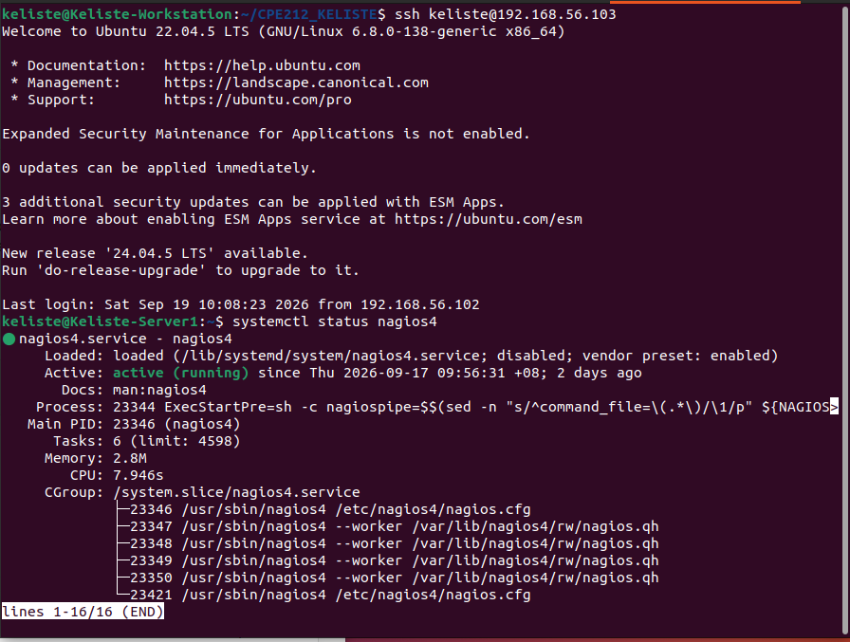

‘

Server 2
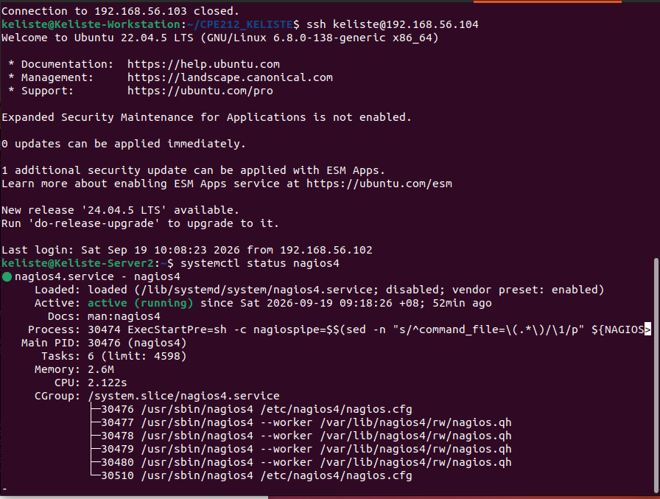

Verify Nagios in Centos
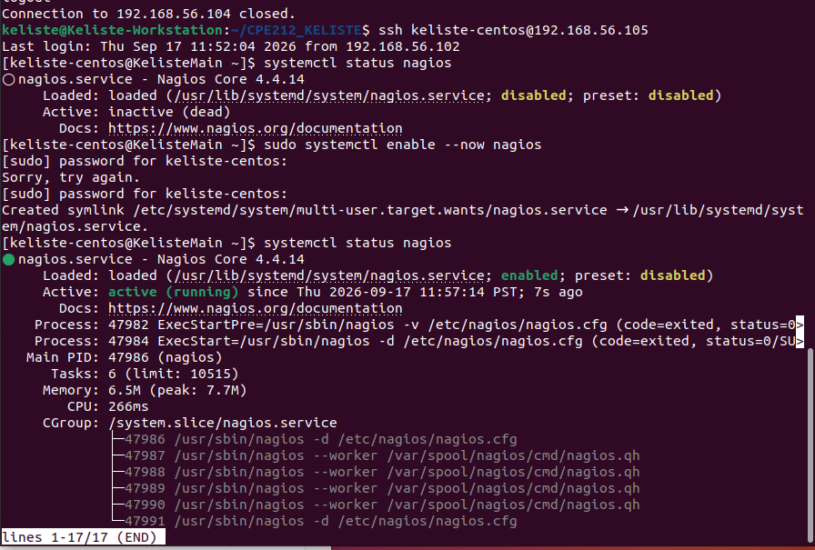

Github Repository
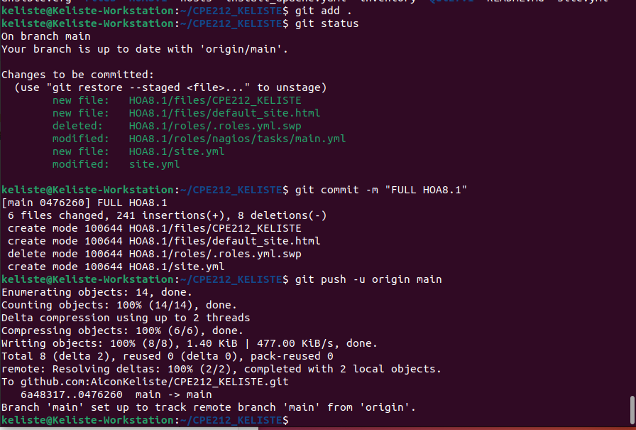
2. ANSWERS TO SUPPLEMENTAL ACTIVITY
Answer the following:
1. What are the benefits of having an availability monitoring tool?
- An availability monitoring tool like Nagios checks whether servers and services are up and alerts admins the moment something goes down, instead of waiting for users to notice. This helps avoid downtime-related losses and lets issues get fixed before they cause bigger problems.

Conclusions/Learnings:
- Through this activity, I learned how to use Ansible roles to install and configure Nagios differently depending on the OS, using “when” conditions to separate the Ubuntu and CentOS tasks. I also ran into real errors along the way, like missing role directories, missing files, and dependency conflicts on CentOS, which taught me how to actually read and troubleshoot Ansible output instead of just running playbooks
3. ARTIFICIAL INTELLIGENCE (AI) USE DISCLOSURE STATEMENT
I hereby declare that artificial intelligence (AI) tools were used, if applicable, in the preparation of this academic work. The following indicates the nature and extent of AI assistance:

Tools Used:
Examples: ChatGPT, Microsoft Copilot, Grammarly, QuillBot, etc.

Purpose of Use:
Examples: grammar correction, idea generation, formatting, summarization, code assistance, explanation of concepts, etc.

Extent of Use:
Explain how AI was used and confirm that it did not replace original thinking, analysis, authorship, or completion of the required work.

By submitting this activity, I affirm that my use of AI complies with T.I.P.’s AI usage policy and does not exceed the permitted limits for similarity, automated content generation, or academic assistance.

I understand that any false, incomplete, or misleading disclosure may be subject to investigation in accordance with due process and may result in sanctions for violation of existing T.I.P. policies.

Lab activities, templates, and related instructional materials shall not be reuploaded, reproduced, distributed, or shared with external organizations or third parties without the prior express written permission of the Technological Institute of the Philippines.

