COURSE CODE/TITLE: CPE212 Automating Server Management |  |  | SECTION: CPE31S2
DATE PERFORMED: 07/09/2026 |  |  | DATE SUBMITTED: 07/09/2026
NAME: Aicon H. Keliste |  |  | INSTRUCTOR: Engr. Jimlord Quejado

ACTIVITY NO. 1.1 | Creating Virtual Machines
1. PROCEDURE OUTPUT
TASK 1:
Server 1
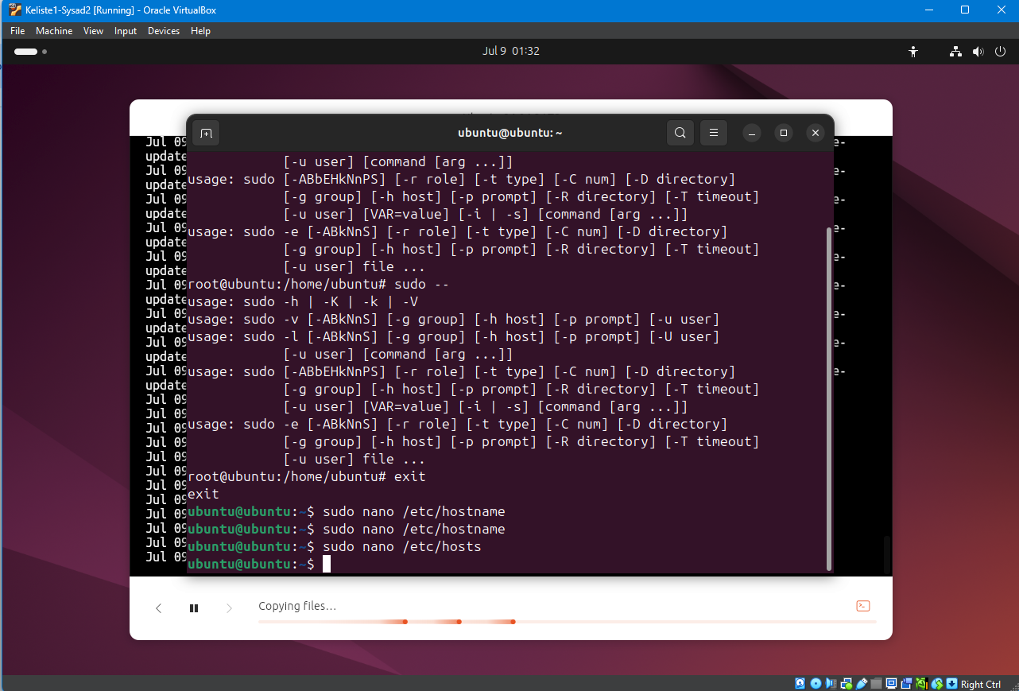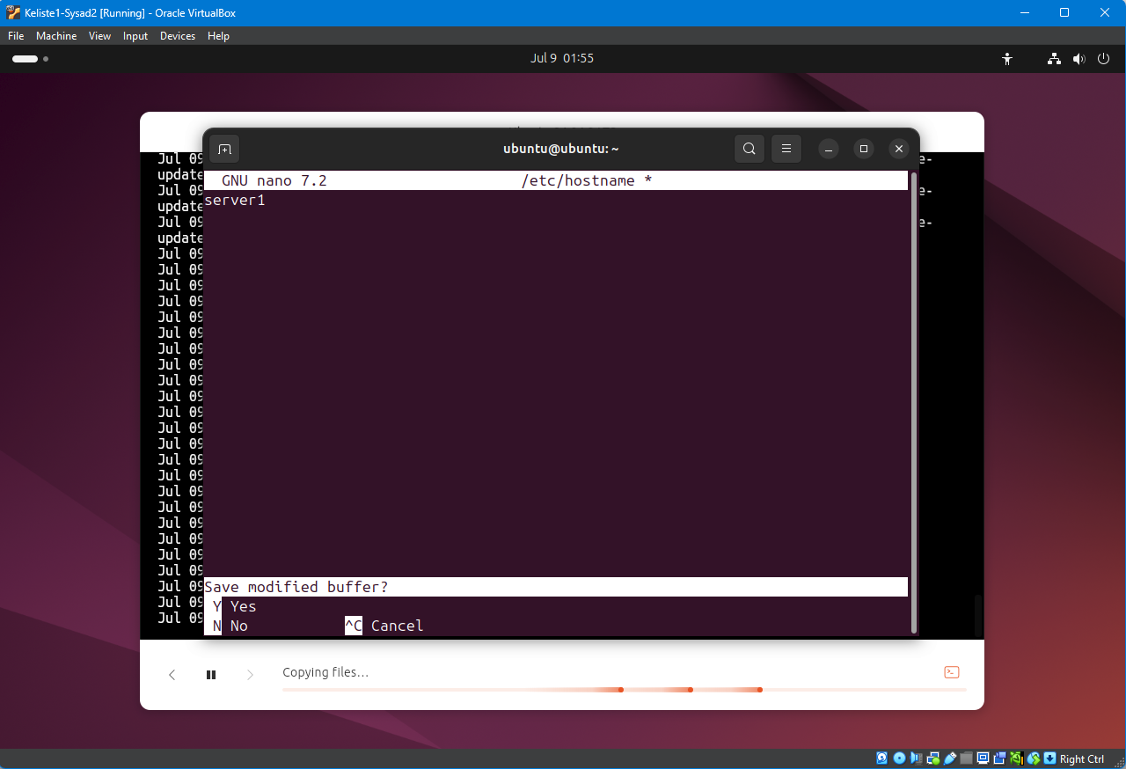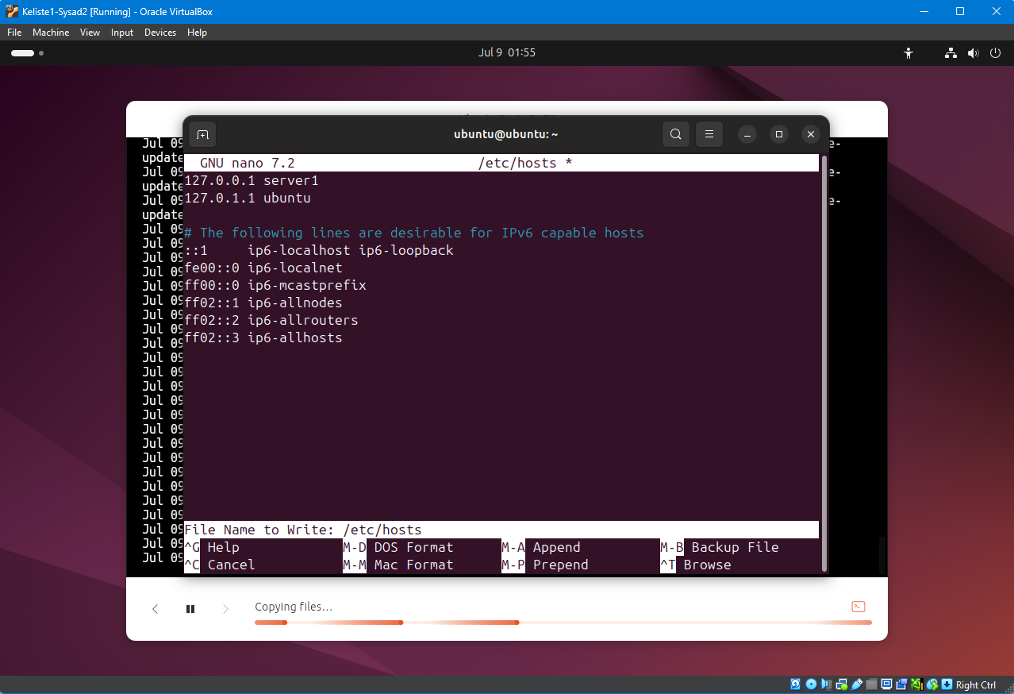

Server 2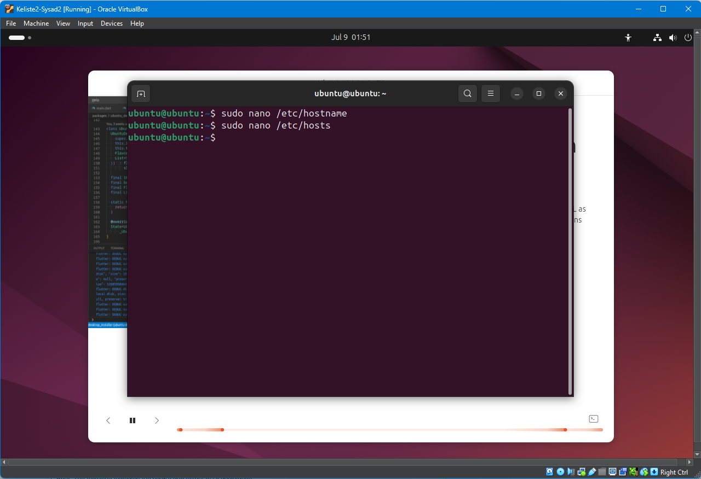
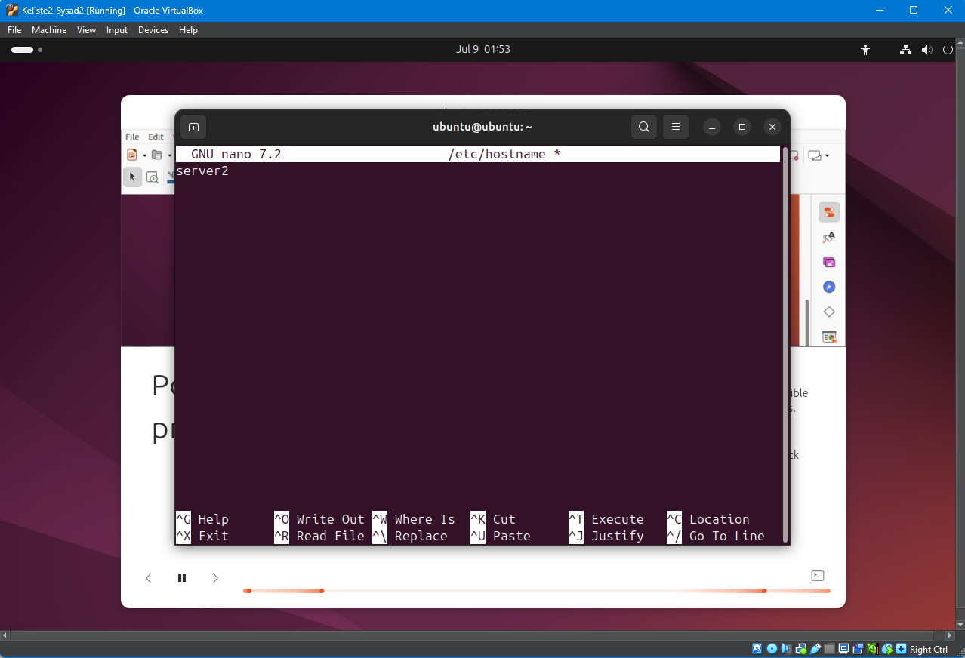
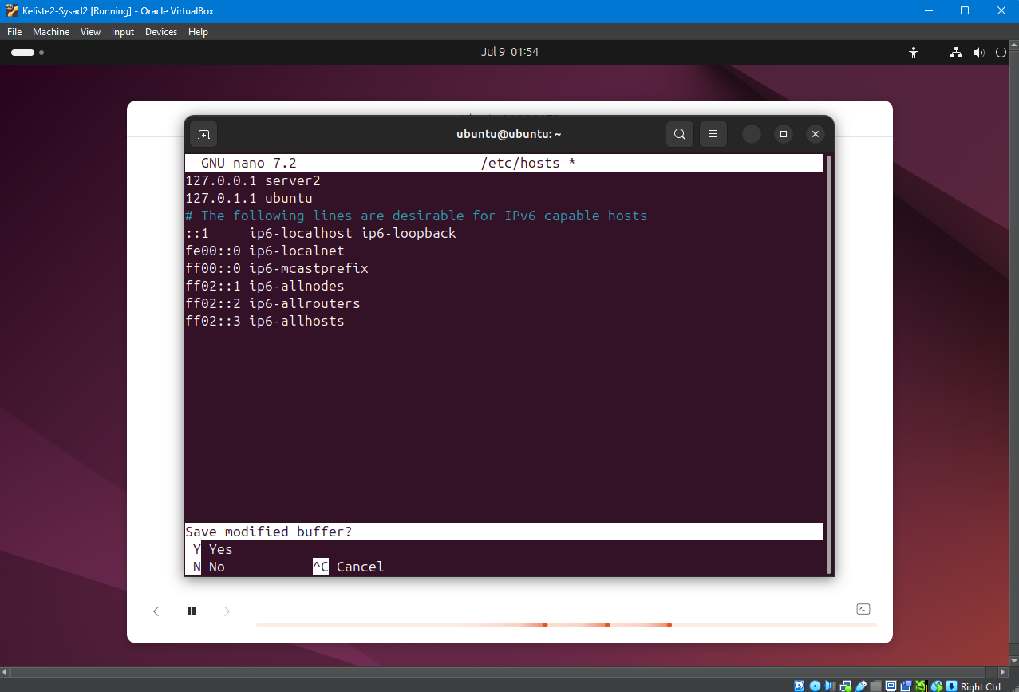

Workstation
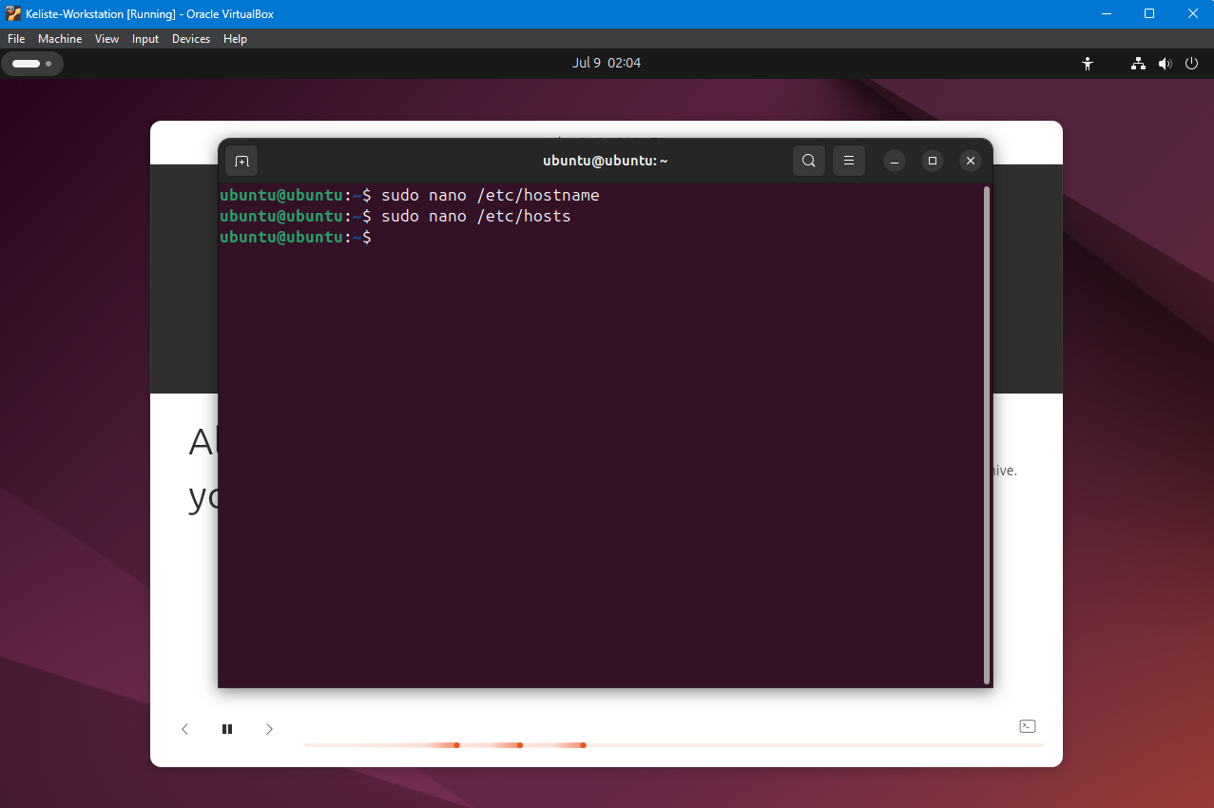
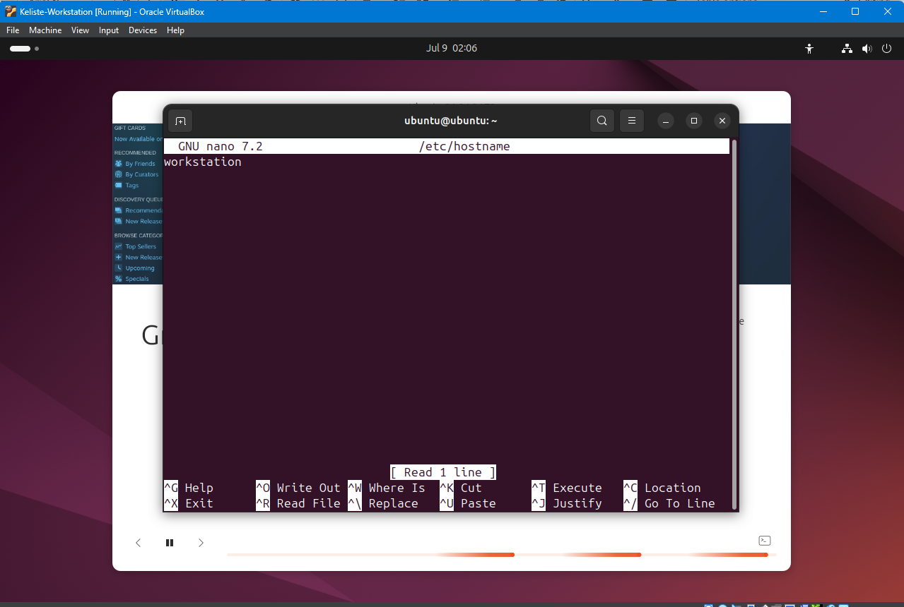
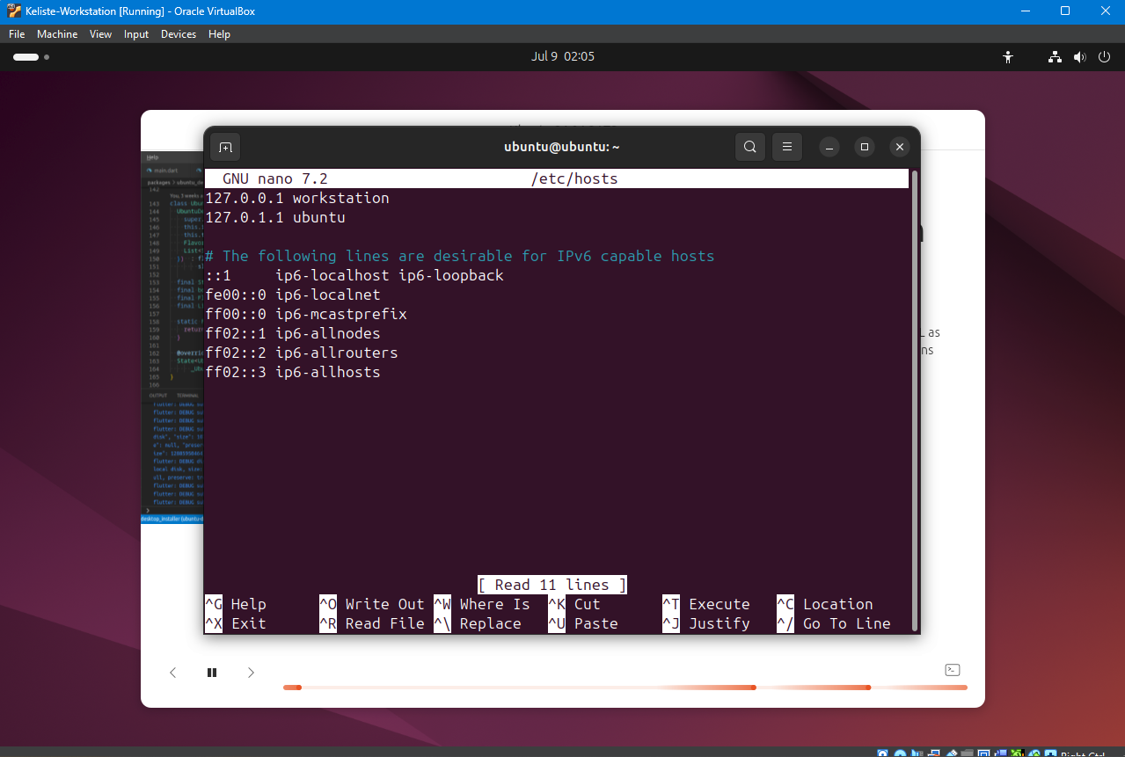

TASK 2:
Server 1
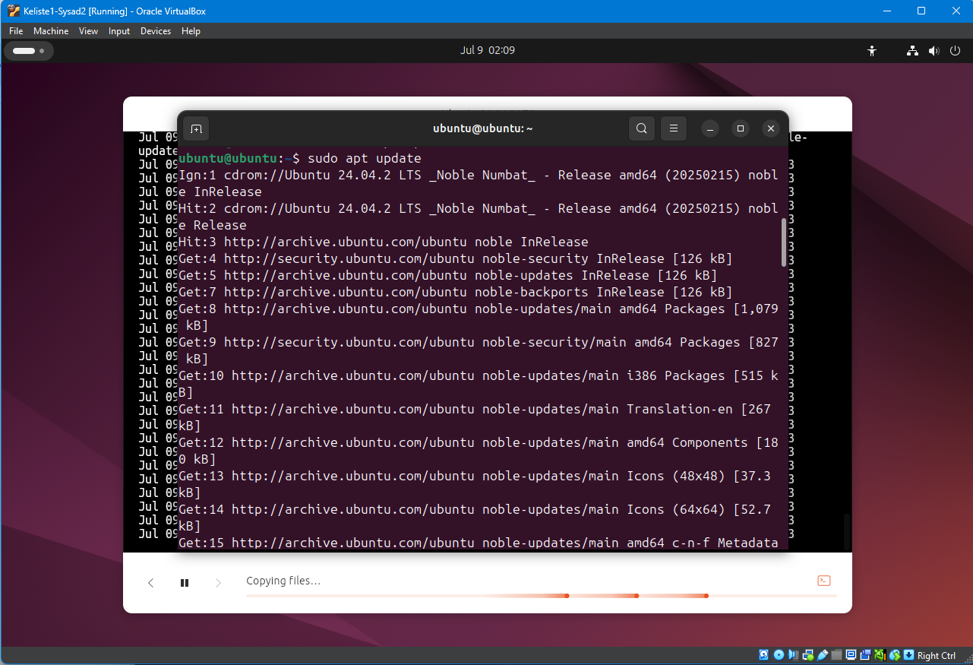
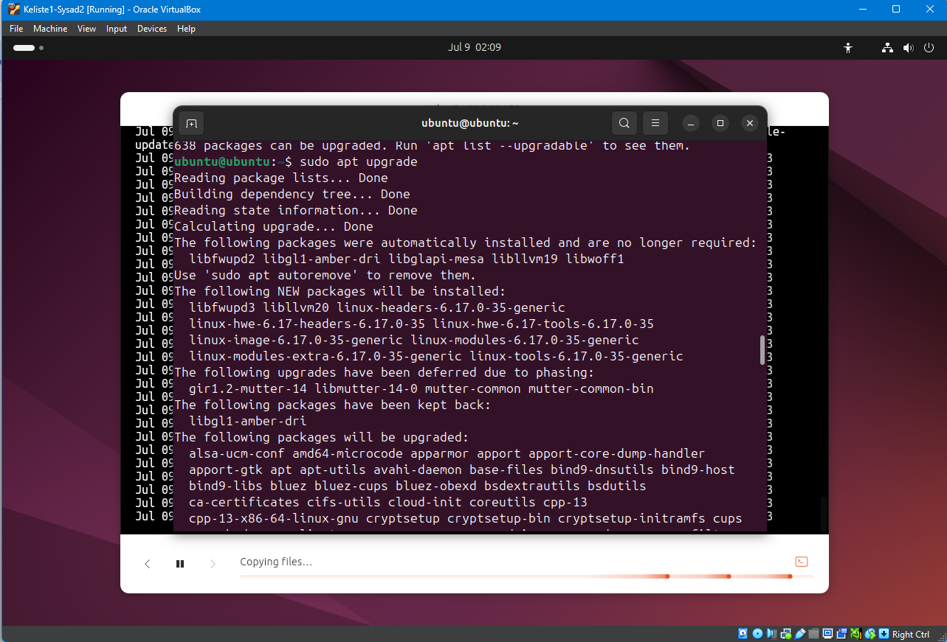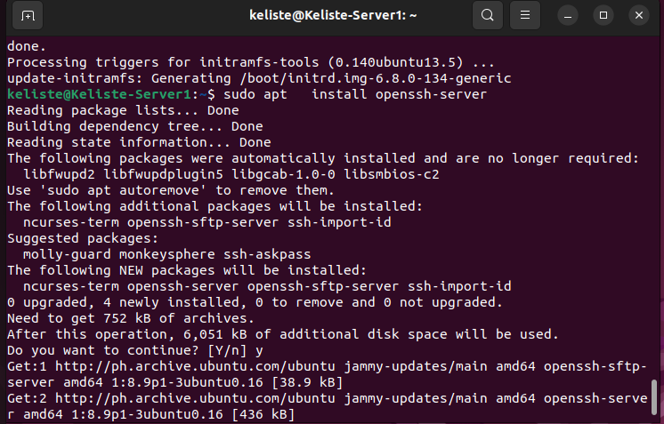

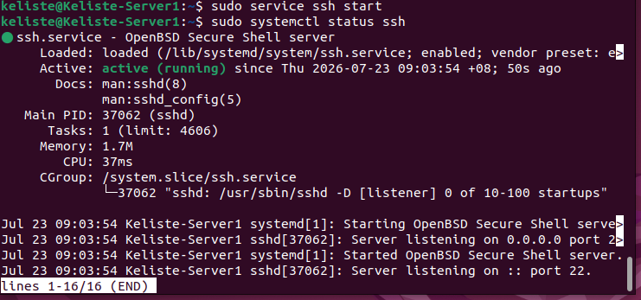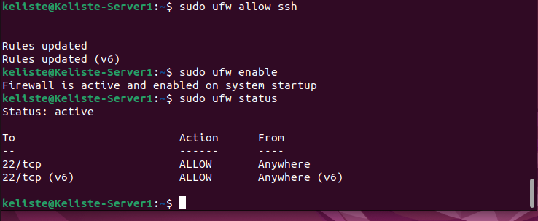

Server 2
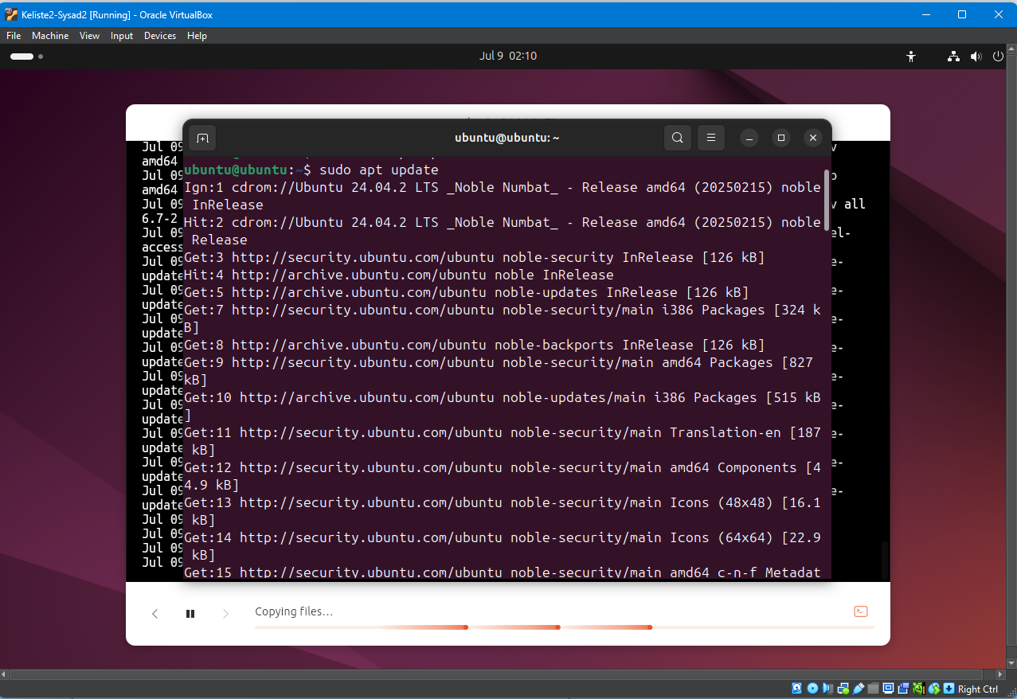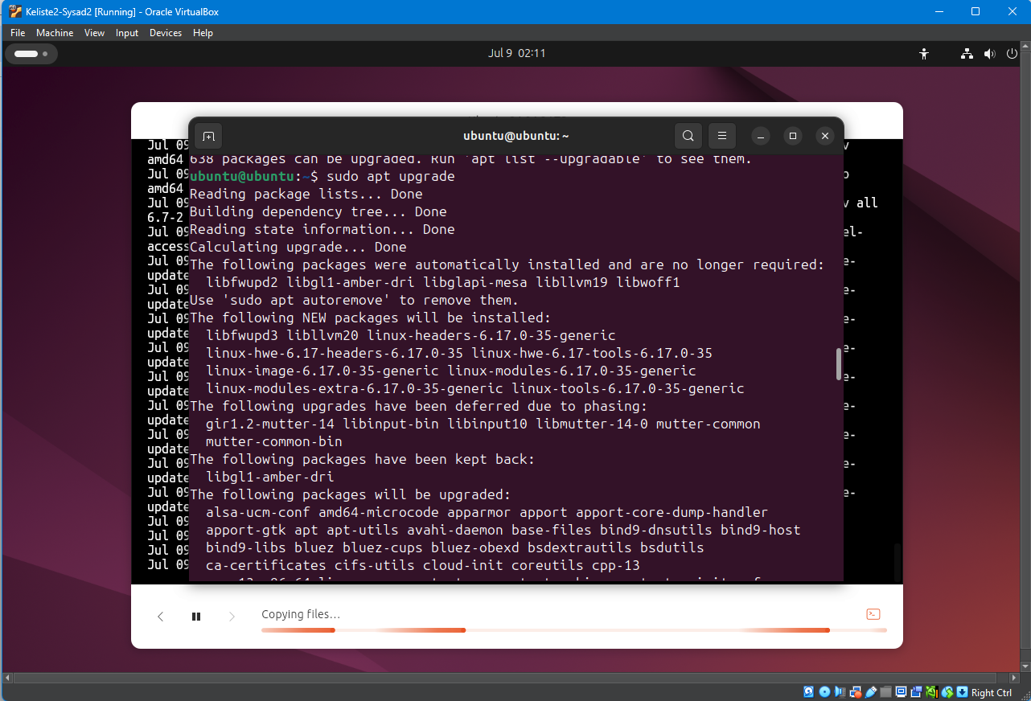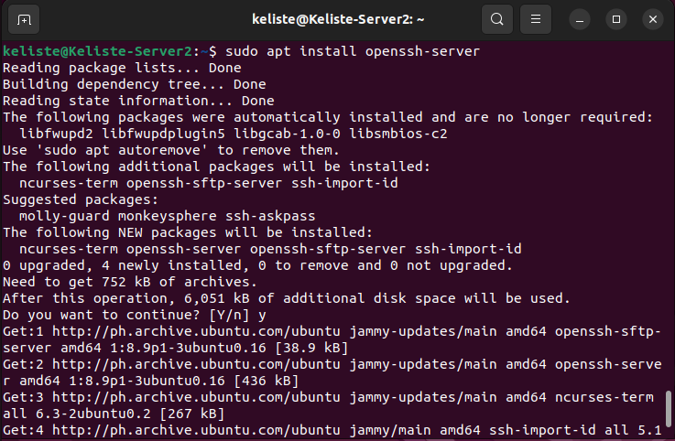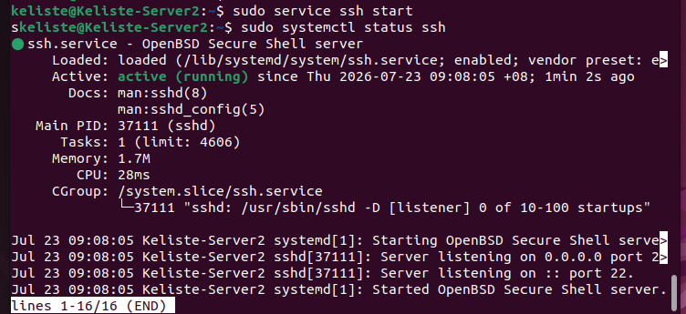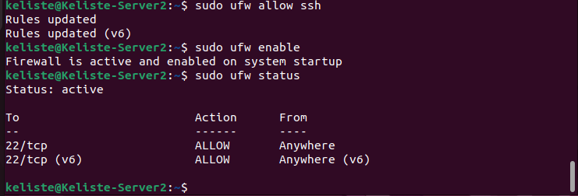

Workstation
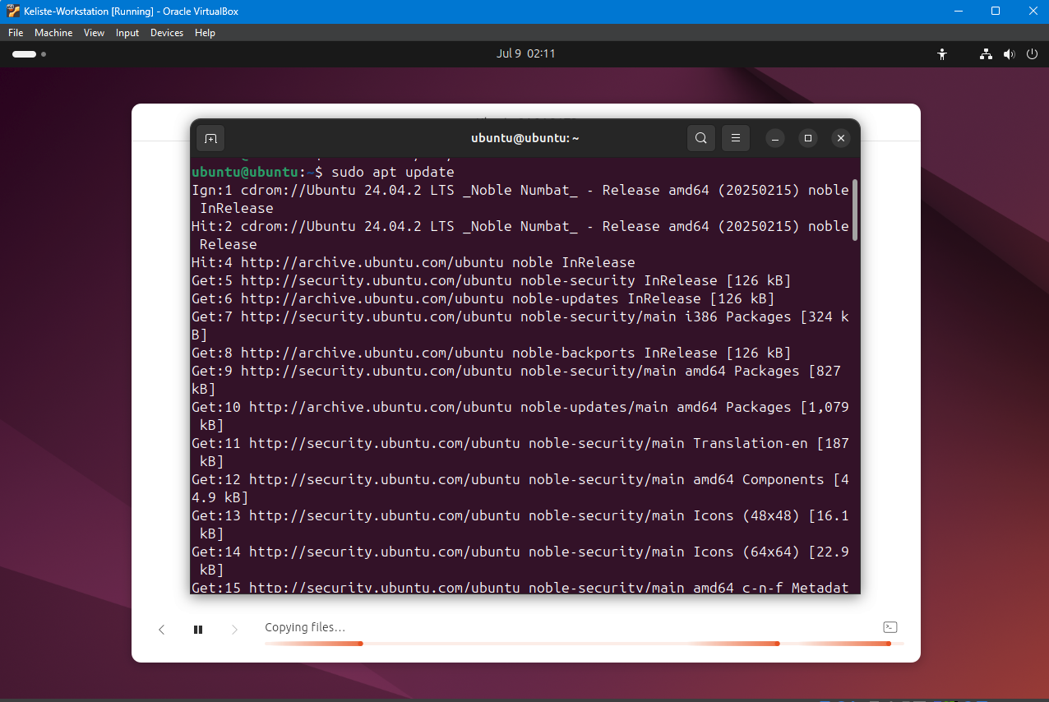
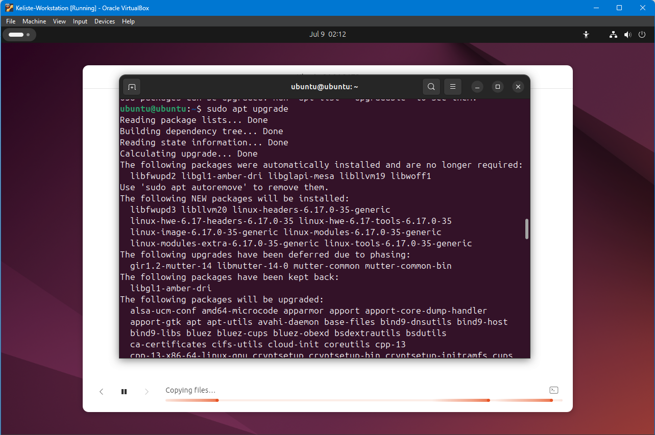
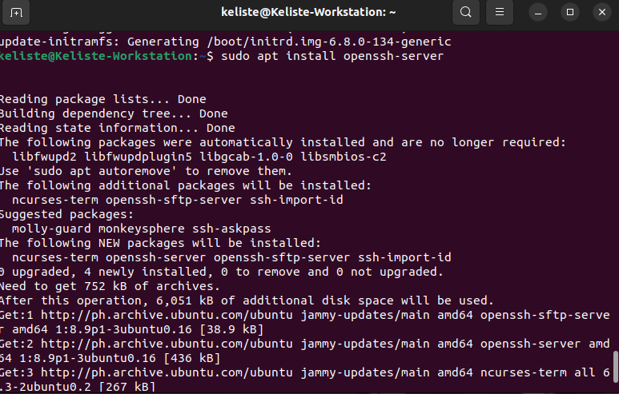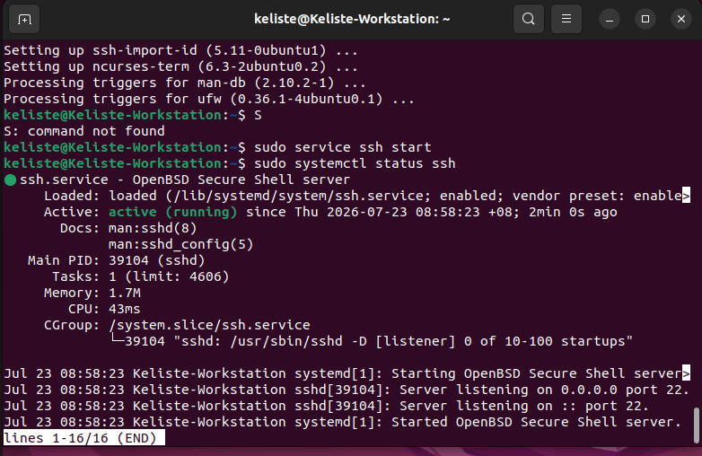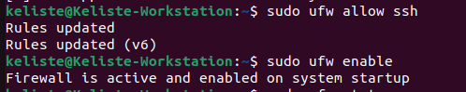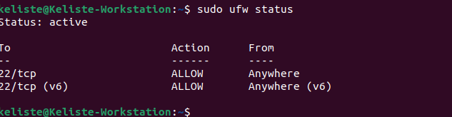

Task 3:
1.1 Server 1 IP address: 192.168.56.103
1.2 Server 2 IP address: 192.168.56.104
1.3 Workstation IP address: 192.168.56.102

Server 1
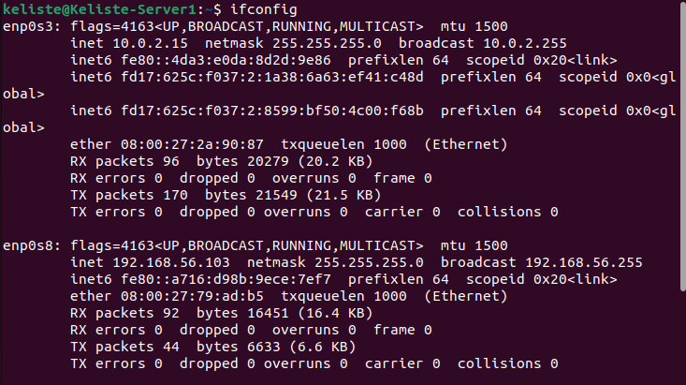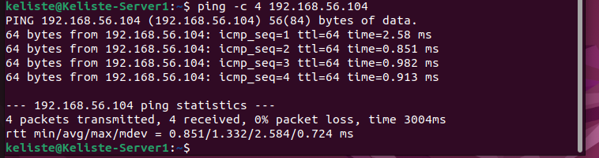

Server 2
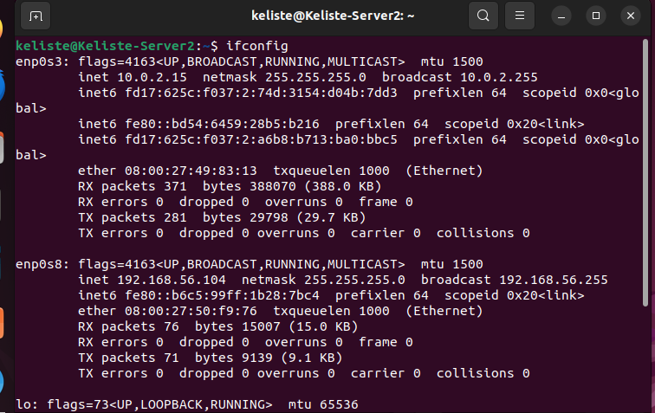

Workstation
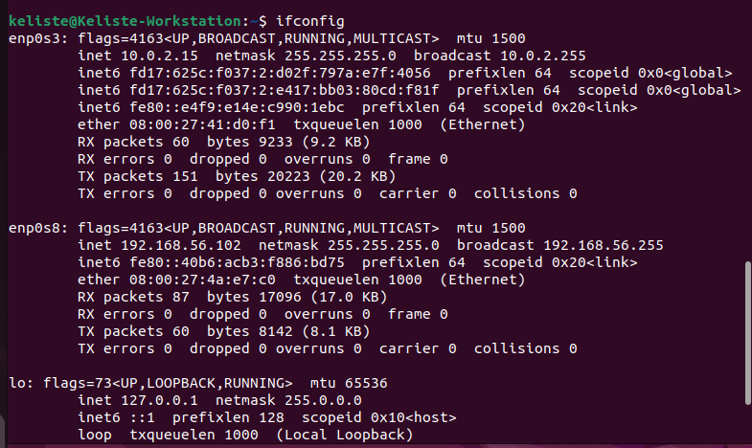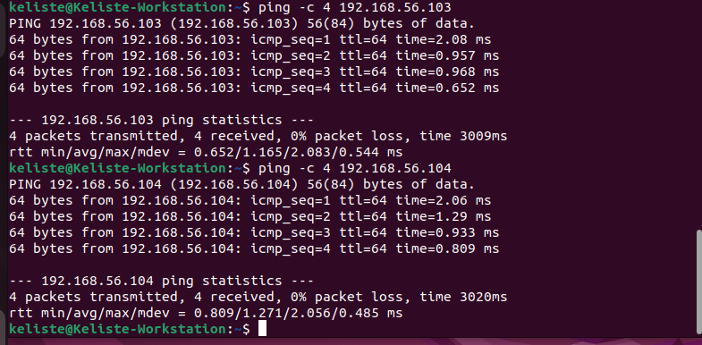

Task 4:
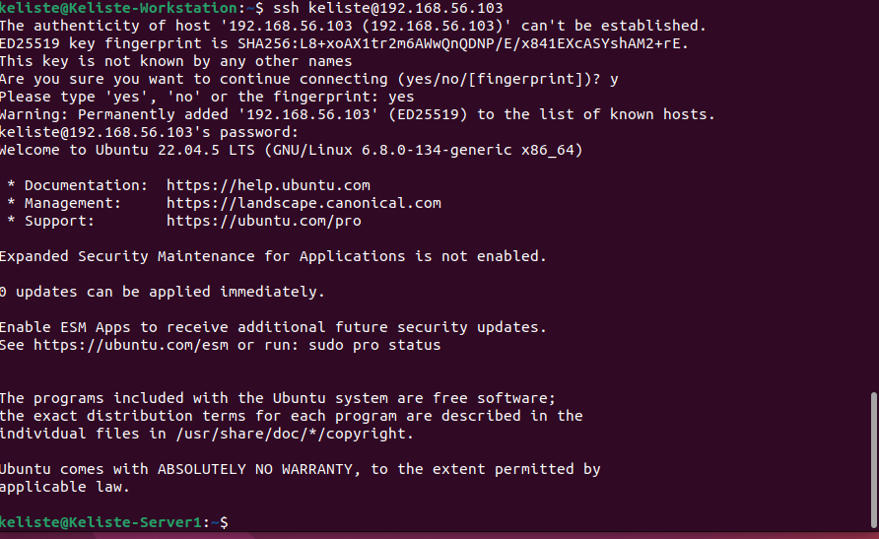
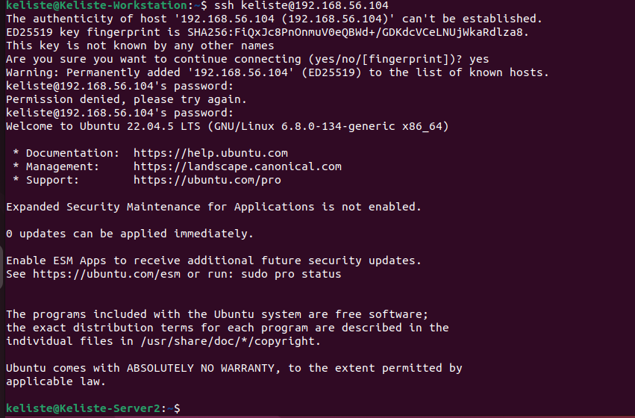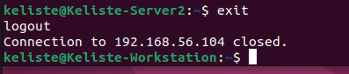
2. ANSWERS TO SUPPLEMENTAL ACTIVITY
1. How are we able to use the hostname instead of IP address in SSH commands?
- In ssh it can resolve hostname because it will mapped the IP address in the lookup source, so the system translates the name to the IP before connecting.
2. How secured is SSH?
- SSH is secured because it uses a cryptographic algorithm for encryption. Protecting data like passwords and commands from being intercepted or read in transit.
3. ARTIFICIAL INTELLIGENCE (AI) USE DISCLOSURE STATEMENT
I hereby declare that artificial intelligence (AI) tools were used, if applicable, in the preparation of this academic work. The following indicates the nature and extent of AI assistance:

Tools Used: | Claude AI
Examples: ChatGPT, Microsoft Copilot, Grammarly, QuillBot, etc.

Purpose of Use: | Grammar Correction, Idea Generation
Examples: grammar correction, idea generation, formatting, summarization, code assistance, explanation of concepts, etc.

Extent of Use: | Checking for some ideas and grammar correction
Explain how AI was used and confirm that it did not replace original thinking, analysis, authorship, or completion of the required work.

By submitting this activity, I affirm that my use of AI complies with T.I.P.’s AI usage policy and does not exceed the permitted limits for similarity, automated content generation, or academic assistance.

I understand that any false, incomplete, or misleading disclosure may be subject to investigation in accordance with due process and may result in sanctions for violation of existing T.I.P. policies.

Lab activities, templates, and related instructional materials shall not be reuploaded, reproduced, distributed, or shared with external organizations or third parties without the prior express written permission of the Technological Institute of the Philippines.

