**Pulse width Calculations**

To generate a PWM at **20ms**, Calculation for ***TPM2->MOD*** is shown below. This is for the Module.

$$0xFFFF=65536$$

$$if 65535=(400m OR 0.4s)$$

$$x=(20ms OR 0.02s)$$

$$x=\frac{65535×0.02}{0.4}=3276.75 ≈3277=0xCCD$$

For the channel, calculation for ***TPM2->CONTROLS[0].CnV*** for **1ms** is shown below

$$0xFFFF=65536$$

$$if 65535=(400m OR 0.4s)$$

$$x=(1ms OR 0.001s)$$

$$x=\frac{65535×0.001}{0.4}=163.8375 ≈164=0xA4$$

For the channel, calculation for ***TPM2->CONTROLS[0].CnV*** for **1.5ms** is shown below

$$0xFFFF=65536$$

$$if 65535=(400m OR 0.4s)$$

$$x=(1.5ms OR 0.0015s)$$

$$x=\frac{65535×0.0015}{0.4}=245.75625 ≈246=0xF6$$

For the channel, calculation for ***TPM2->CONTROLS[0].CnV*** for **2ms** is shown below

$$0xFFFF=65536$$

$$if 65535=(400m OR 0.4s)$$

$$x=(2ms OR 0.002s)$$

$$x=\frac{65535×0.002}{0.4}=327.675≈328=0x148$$

**OUTPUTS MEASURED WITH SCOPE**

**For pulse width of 1ms:**

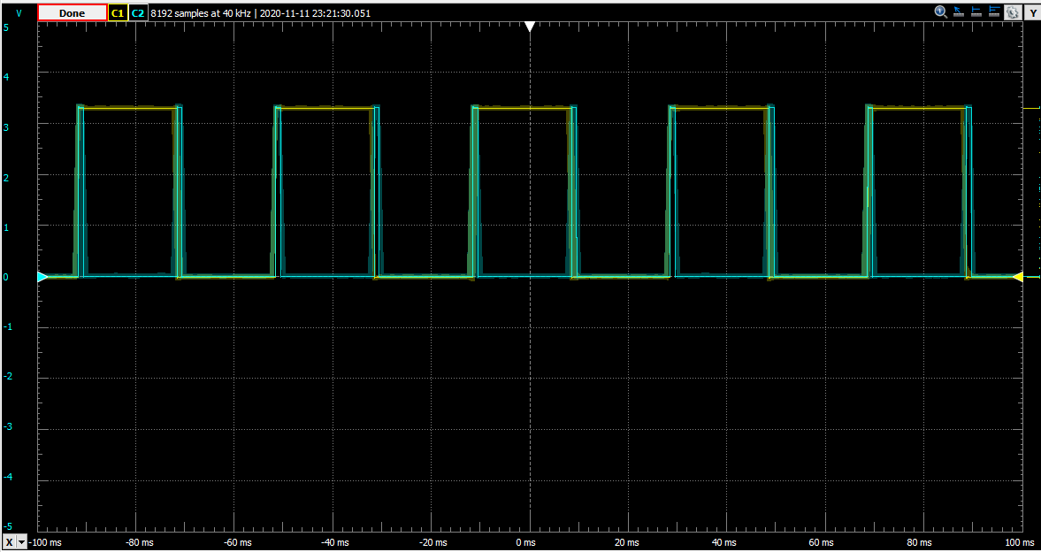

***Output for PWM at 20ms with pulse width of 1ms***

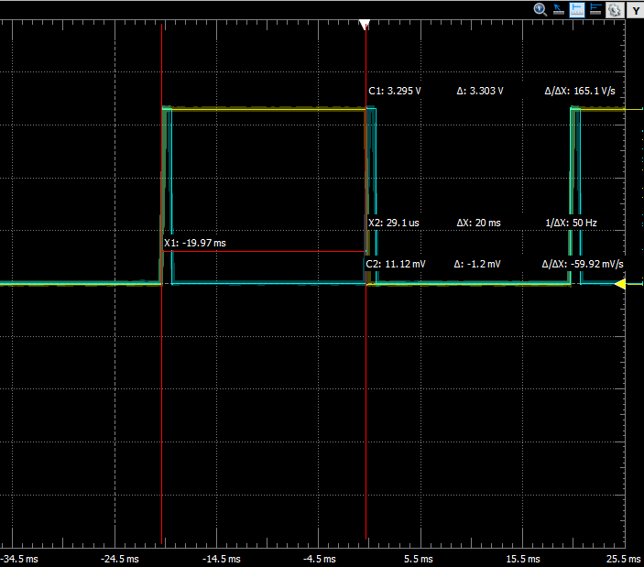

***Proof that PWM is at 20ms***

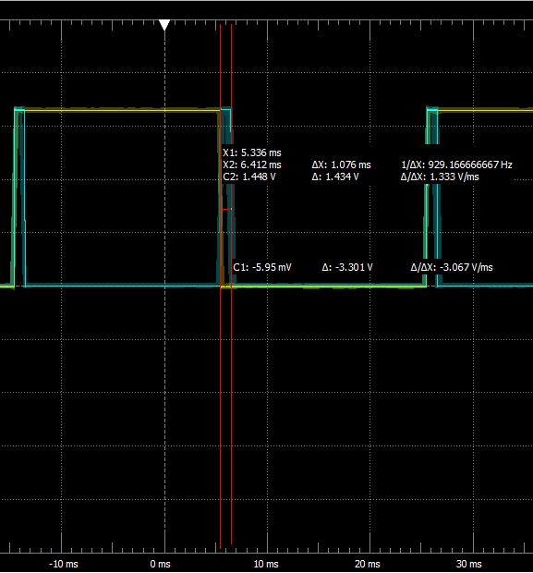

***Proof that Pulse width is 1ms (Δx = 1.076ms)***

**For pulse width of 1.5ms:**

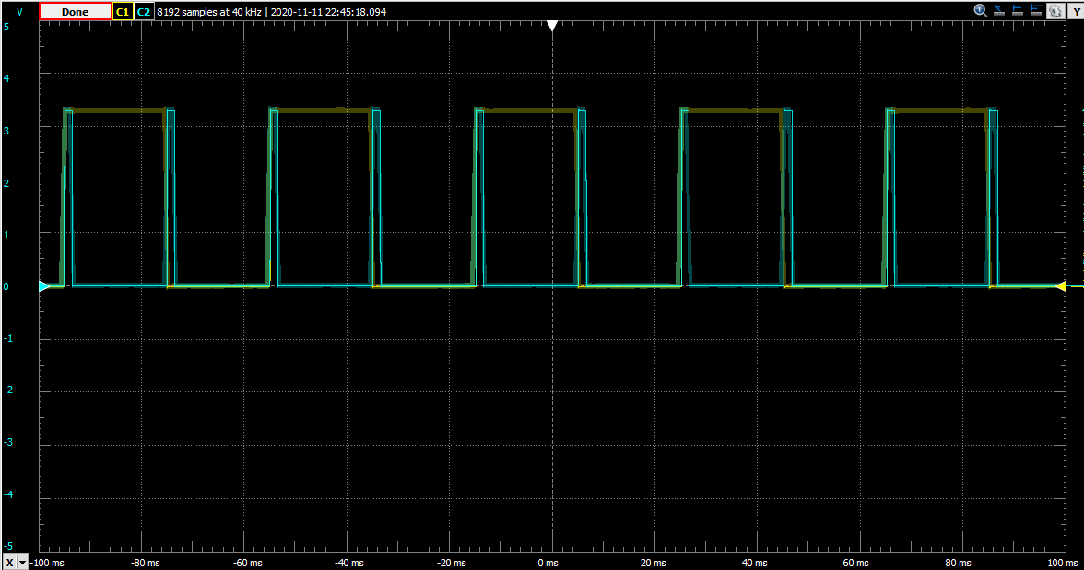

***Output for PWM at 20ms with pulse width of 1.5ms***

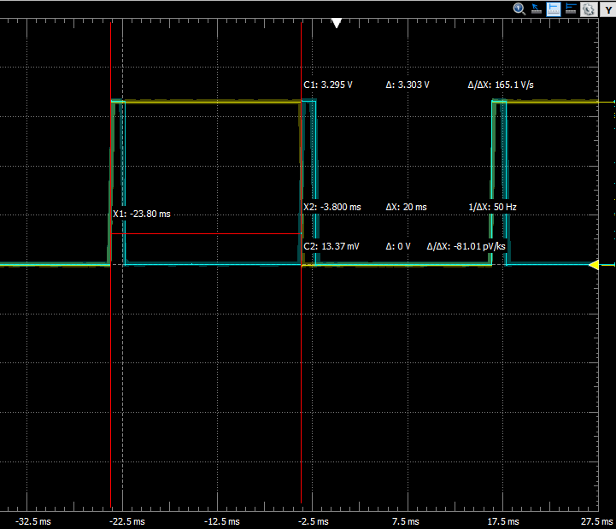

***Proof that PWM is at 20ms***

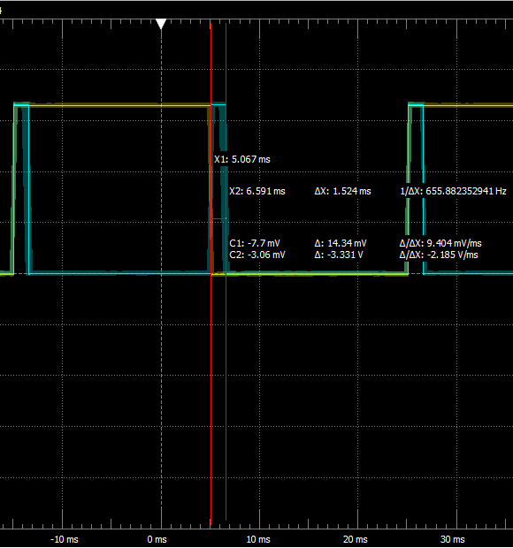

***Proof that Pulse width is 1.5ms (Δx = 1.524ms)***

**For pulse width of 2ms:**

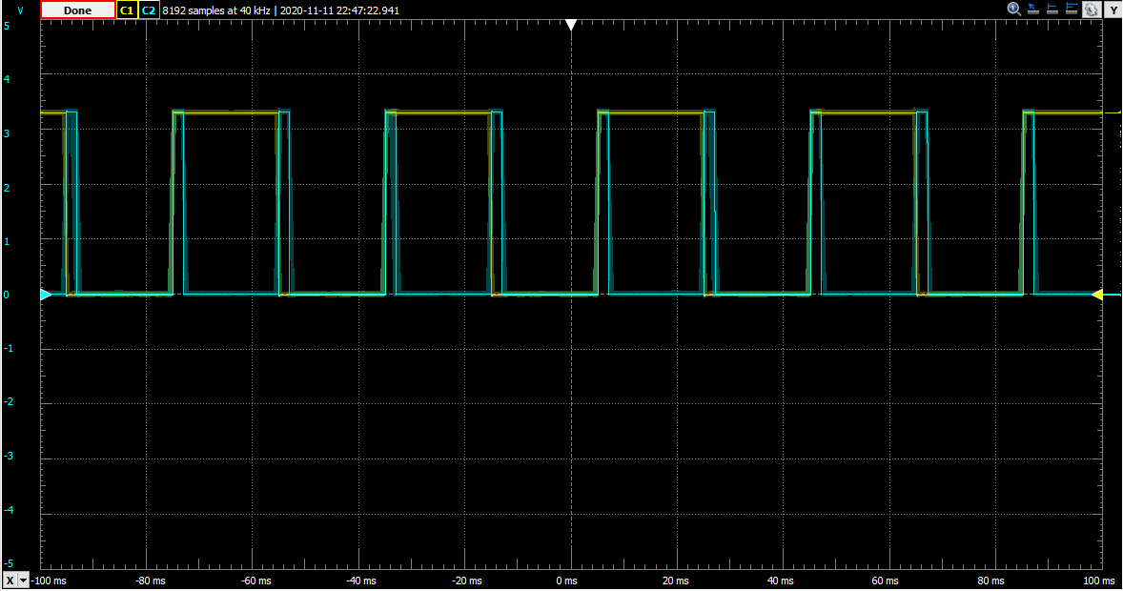

***Output for PWM at 20ms with pulse width of 2ms***

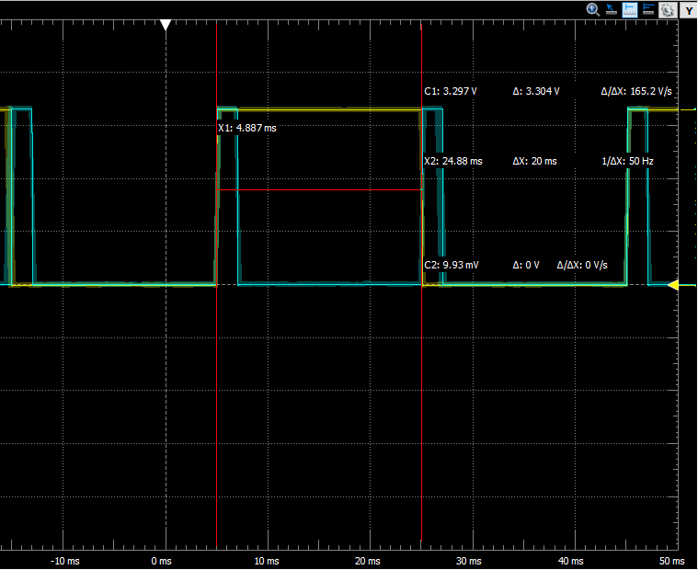

***Proof that PWM is at 20ms***

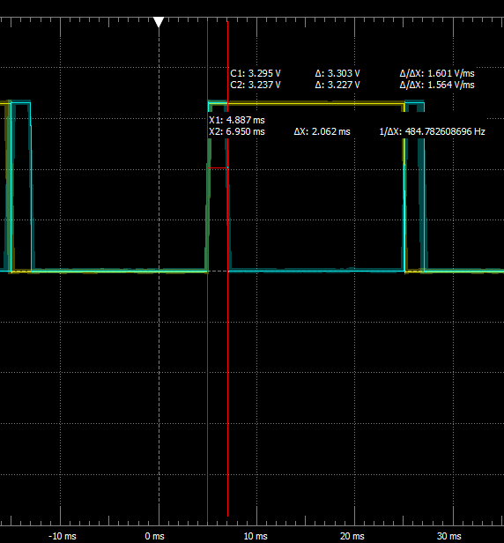

***Proof that Pulse width is 2ms (Δx = 2.062ms)***