- Escape, Chik Pan Wong & Anderson, 02, Spring 2026
- at least one image (screenshot) showing a typical scene from your game being played
- instructions for compiling and running your game, including the network server
- how to play your game, including what things happen and how the scoring works
  - The player is trapped on a planet and explore the environment, find a key, and the spaceship to escape.
- control:
    - keyboard:
      - W/S – move forward/backward
      - A/D – move left/right
      - E – take
      - Space – jump
      - F – push
      - R – on/off flashlight
      - Z – camera zoom in
      - X – camera zoom out
      - C – camera left
      - V – camera right
      - B – camera down
      - G – camera up
      - O – enable rendering terrian
      - P – disable rendering terrian
    - PlayStation gamepad:
      - RX -- Azimuth Action
      - RY -- Elevation Action
      - Z -- Radius Action
      - B0 – Take
      - B1 – jump
      - B2 – Push
      - B3 – on/off flashlight
- 6. a description of the lighting used in your game, including any lights that turn on/off
  - spotlight on/off – player’s flashlight
  - Red positional light – key’s light
  - Green positional light – player’s light
  - spotlight – spaceship light
- 7. a brief summary of any changes (or none) that you made to the network protocol
- 8. a list of changes and additions that you made to TAGE
  - CameraOrbit3D
  - GameObject – yaw
- 9. a statement indicating the (1) genre, (2) theme, (3) dimensionality, and (4) activities utilized in your game (see week 1 notes -- chapter 00 -- for examples)
  - genre – adventure
  - theme – sci-fi planet escape
  - dimensionality – 3D
  - Activity
    - Exploration – Player moves around the planet to find the key and spaceship.
    - Collection – Player collects the key needed to activate the spaceship.
    - Enemy avoidance – Player should avoid enemies that chase and attack.
    - Goal – Player wins by reaching the spaceship with the key and escaping.
- 10. an explanation of where (in the game, not the code) each project requirement is visible
- 11. a list of the requirements that you weren’t able to get working
- 12. any technique you used in your game that goes beyond the requirements
- contributions:
  - Chik:
    - Skybox and Terrain
    - Hierarchical SceneGraph
    - Light
    - HUD
    - Animation
    - NPC
    - enemy model
  - Anderson
    - Network
    - Physics
    - Light
    - HUD
    - NPC
    - player model
- 14. a list of assets that you created yourself (models, textures, heightmap, etc.), and items obtained that were distributed in CSc-155 or CSc-165
    - animation
      - attack.rka
      - enemy.rkm
      - enemy.rk
      - idle.rka
      - walk.rka
    - model
      - enemy.obj
      - player.obj
    - textures
      - enemyUV.jpg
- 15. Source and evidence of permission for any item (models, textures, etc.) not listed in #14
Soruce:
  - skybox (galaxy): https://tools.wwwtyro.net/space-3d/index.html#animationSpeed=1&fov=80&nebulae=true&pointStars=true&resolution=1024&seed=15iw8a3c0j6o&stars=true&sun=true
license: https://github.com/wwwtyro/space-3d?tab=Unlicense-1-ov-file#readme
  - spaceship: https://sketchfab.com/3d-models/spaceship-colaid1-50k-34acc30c89364a668ab1025686a686bc
license: https://creativecommons.org/licenses/by/4.0/
  - heightmap: https://commons.wikimedia.org/wiki/File:Heightmap.png
license: same website
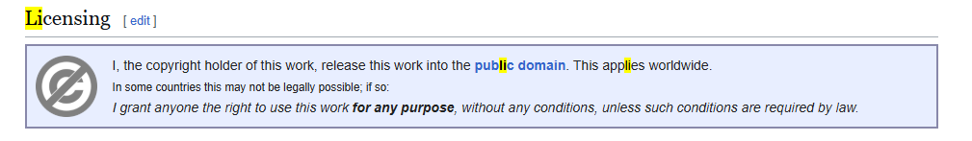
  - heightmap texture (floor.jpg): https://polyhaven.com/a/rock_face
license: CC0 https://polyhaven.com/license
  - Foot step Sound: https://opengameart.org/content/foot-walking-step-sounds-on-stone-water-snow-wood-and-dirt
license: https://www.gnu.org/licenses/gpl-3.0.html
  - Beep Sound: https://opengameart.org/content/3-ping-pong-sounds-8-bit-style
license: https://creativecommons.org/publicdomain/zero/1.0/
  - key: https://sketchfab.com/3d-models/crystal-key-473d184560c74490aeffefff8cfff23c
license type: CC-BY-4.0 (http://creativecommons.org/licenses/by/4.0/)
- 16. which RVR-5029 lab machines (at least two – it’s networked!) on which your program was tested and is known to work correctly on

