

Distributed os

hw2



November 20, 2020

**done by : Aida Bustami**

**supervise to :Dr. Samer Arandi**

**Summary:**

**I have implemented the front end tier in the same computer (192.168.1.50) in port 8000 and in secure https .**

**I ran the catalog server in**

**VirtualBox inside a virtual machine instance (ubuntu) running on static ip address which is 192.168.1.215 and I run the order server in**

**VirtualBox inside a virtual machine instance (ubuntu) running on static ip address which is**

**192.168.50.251 .**

**I implemented each microservice using Restful flask – python and I used the SQLite database .**

**I also installed GitHub client for desktop use in**

**(my host machine and the other two virtual machine)**

**\*I implementer the internal communication between virtual machine and my host by setting the network setting on both of the virtual machine to be bridged Network settings .**

**And I also used postman as the client app that will send the requests to the front end server which will then redirects the https request that has been send to it to http request related to a specific end point whether in order or catalog server.**

**I implemented 5 operations that can be accessed from the user point of view (I mean request goes to front end) but I also implemented internal operation that normal users can not do to update many information or query things in both orders server or catalog server.**

**I implemented HTTPs only on the front end microservice using self assigned certification and edit postman settings to accept it.**

**You can run my code by running front end in host , order server in vm1 , catalog server on vm2 and send requests to front end using postman .**

**running vm2 on port 192.168.1.251:5000**

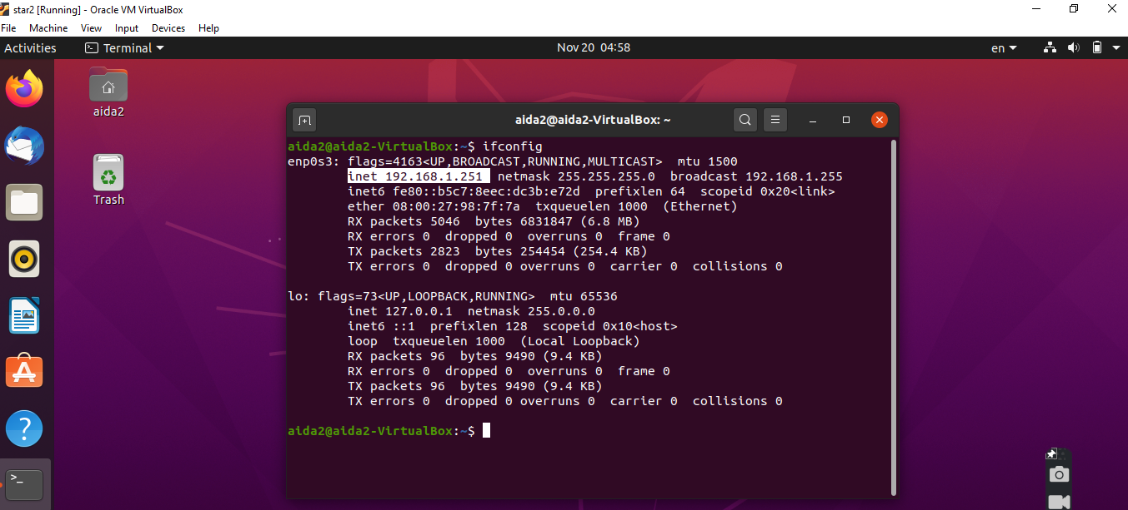

**running vm1 on port 192.186.1.215: 6000**

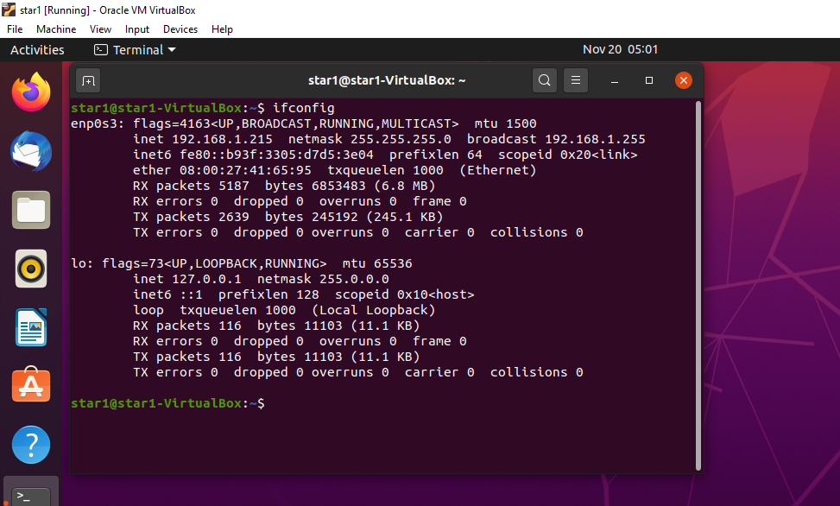

running front end server on port 192.168.50.1 : 8000

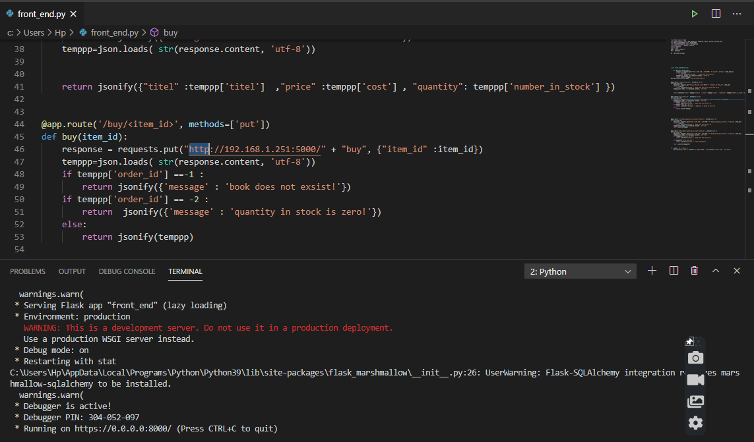

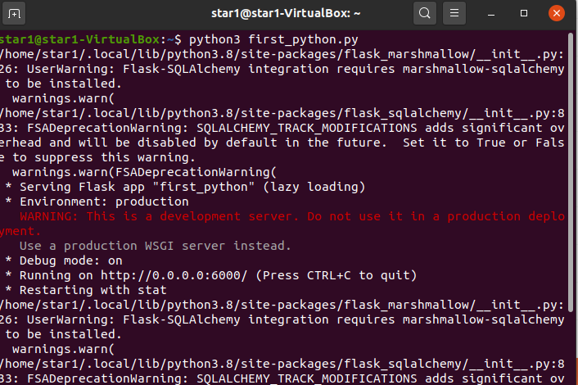

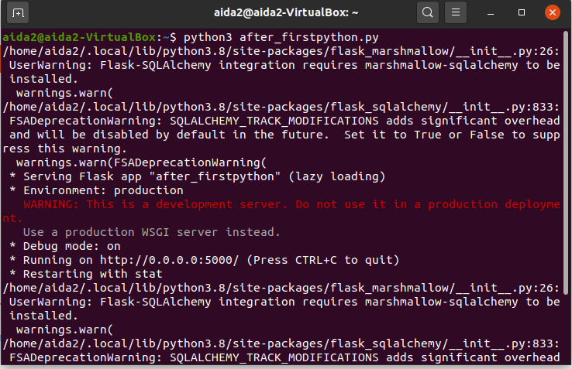

**Here is sum of the result from executing the operations that the front end server can handle .**

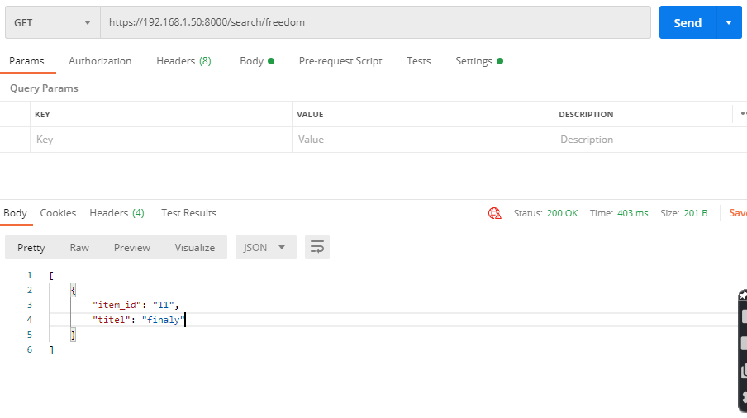

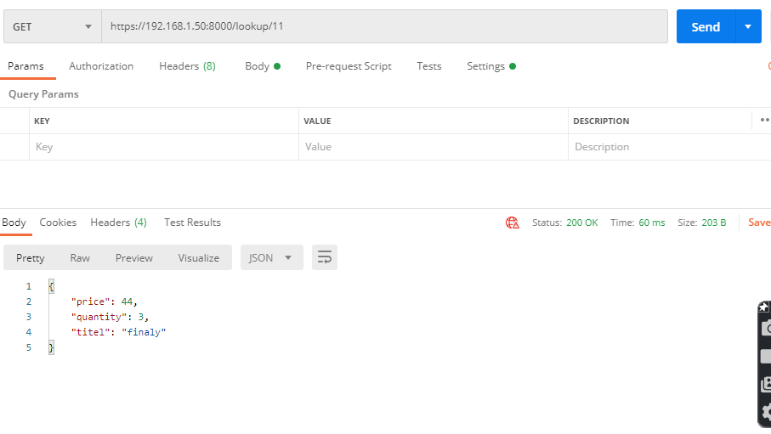

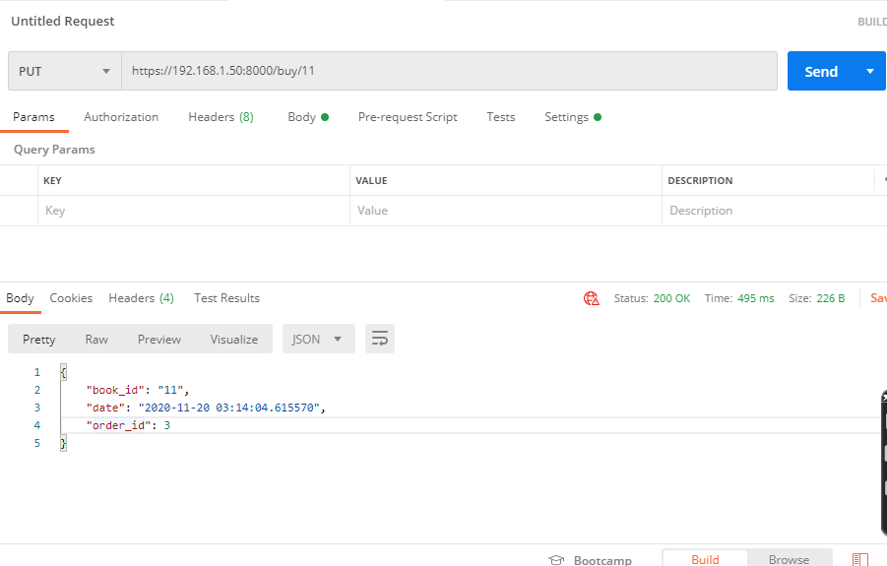

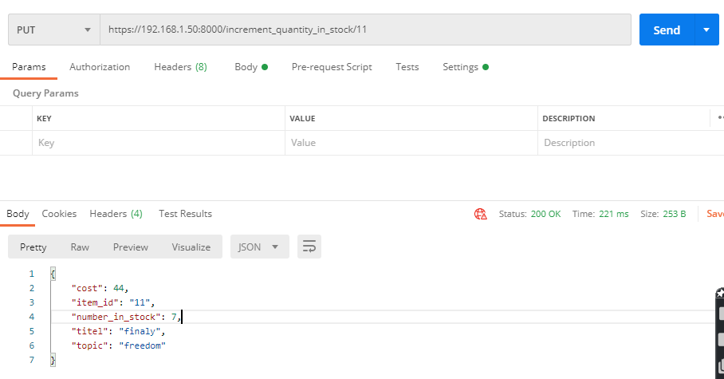

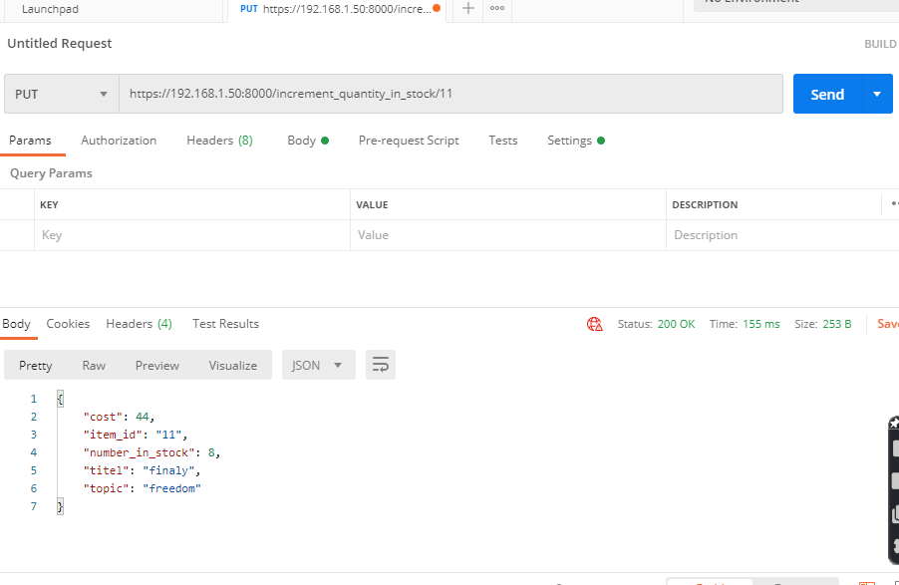

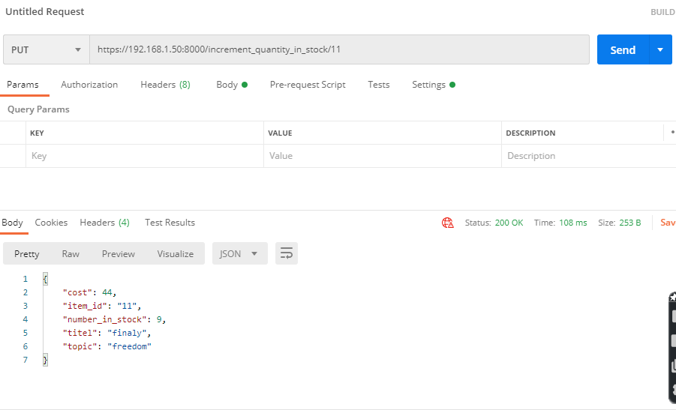

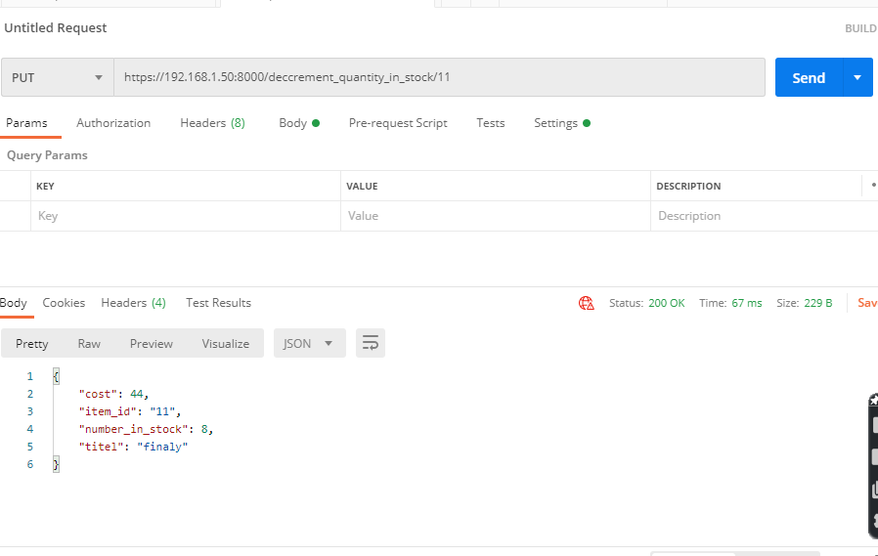

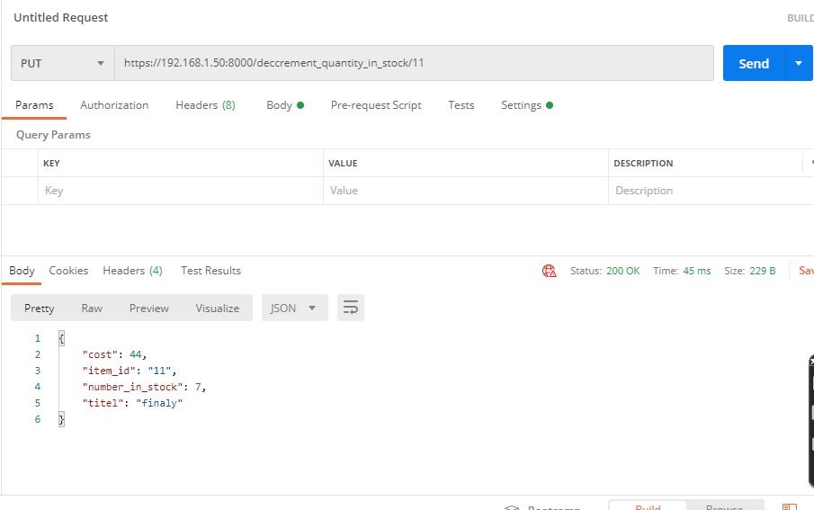

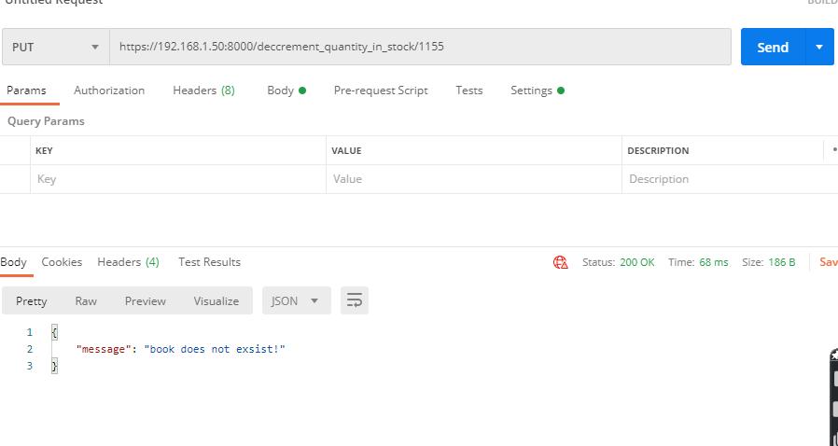

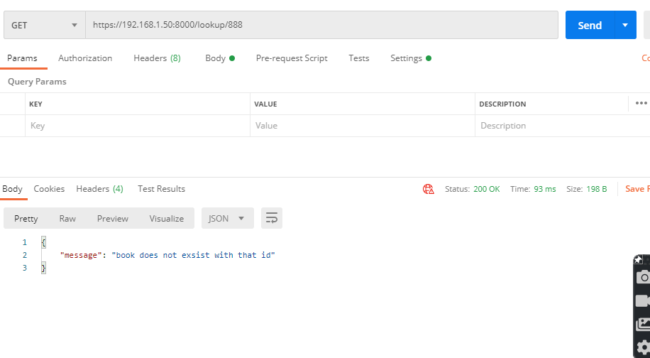

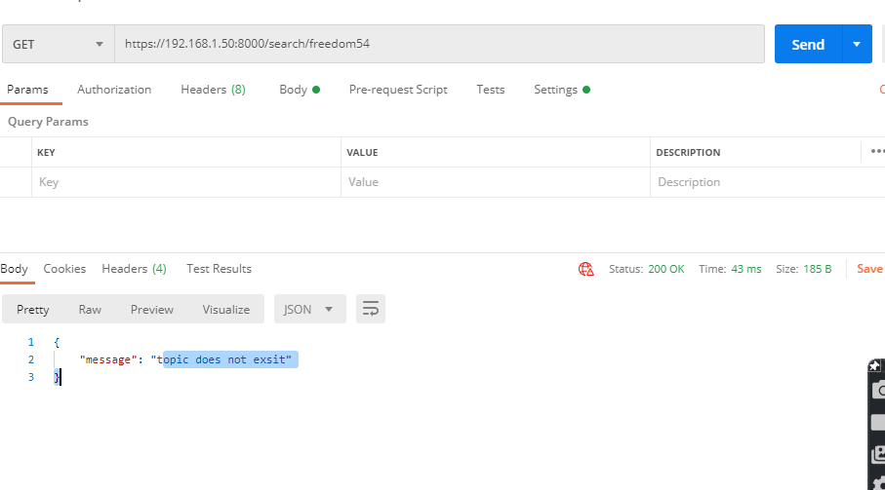

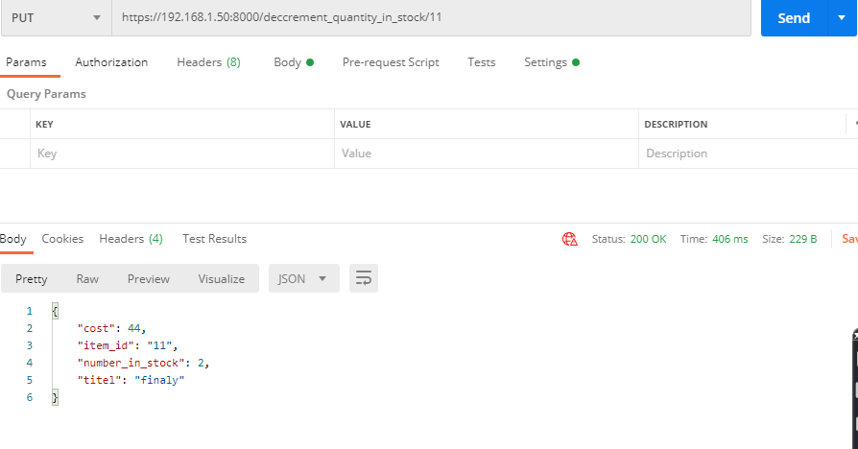

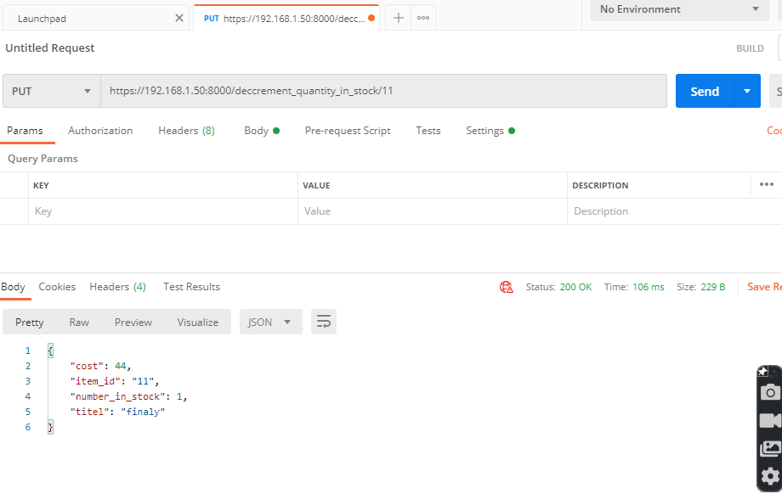

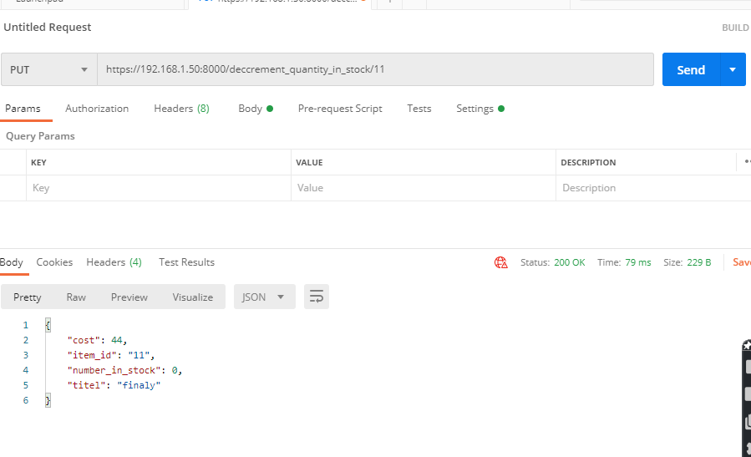

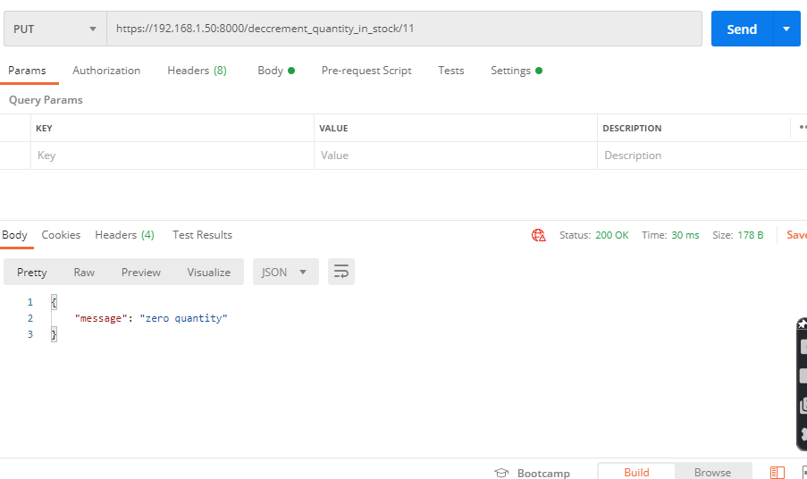

all functionality of front end has been viewed . next the is some of the test cases on functionality catalog server provides (normal users can reach from front end server).

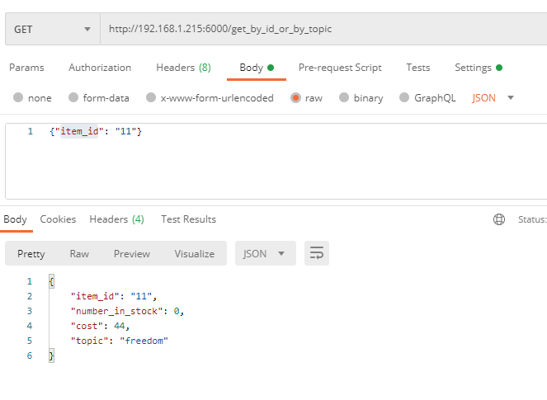

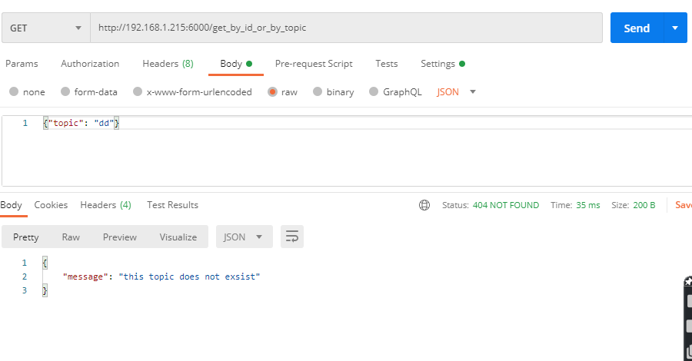

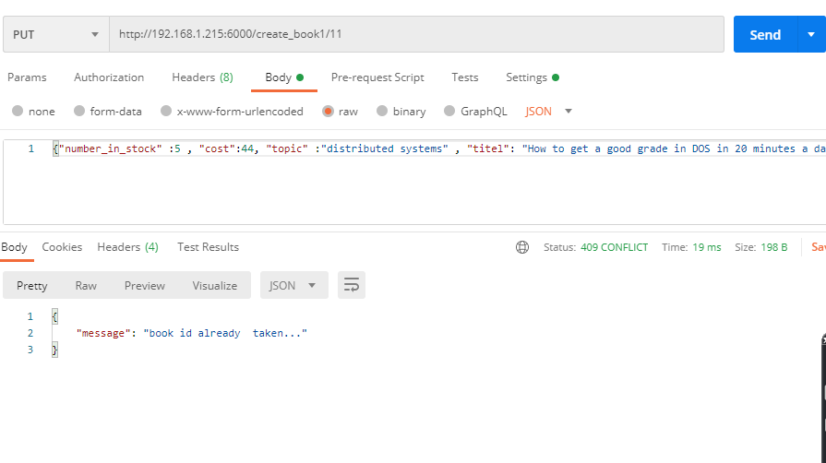

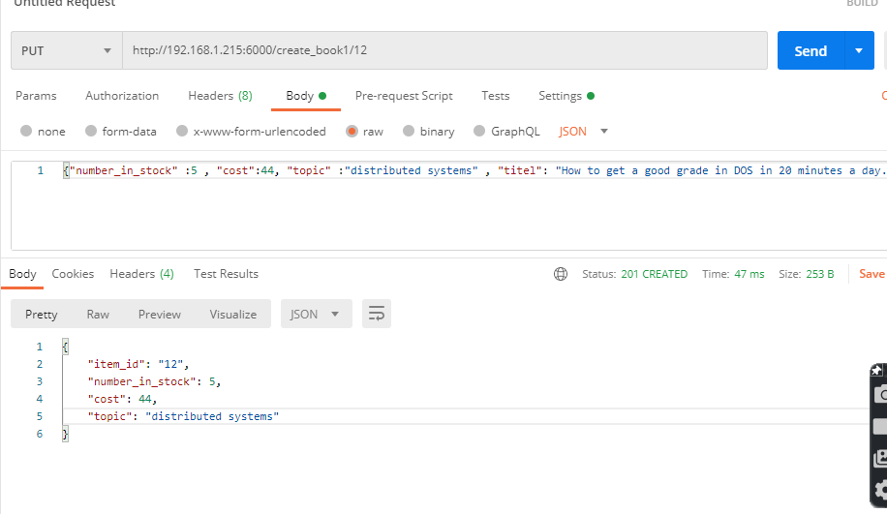

many others are there working but I think this is enogh for demonstarion .