
Async Rust

What’s Async?
Async is short for asynchronous. Asynchronous code lets us run multiple tasks concurrently on the same OS thread.
Asynchronous programming is best fitted for IO-bound tasks where the tasks would be spending a lot of time waiting, such as for a response from a server. It allows us to run multiple of those IO-bound computations simultaneously at the same time on a single thread.
Async is becoming increasingly important as more computers take advantage of their multiple processors.
Asynchronous Programming in Rust
Rust allows us to write fast, safe software whether we're building a web server, a database, or an operating system. Rust's asynchronous programming tools will get the most out of a computer hardware. Writing async code in Rust maybe a bit different, here’s how :
- Rust's built-in tool for writing async functions is async/.await
- In Rust we use async fn to create an asynchronous function
- async fn returns a Future
- Future must be run on an executor so that a task may be done
- block_on blocks current thread until the future has completely run
- .await can be used instead of block_on inside async fn, it doesn’t block the whole thread but waits for the Future to complete
Writing Async Code
We create three async fn here : learn_song, sing_song, and dance :
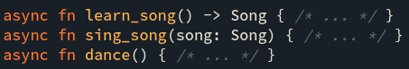

If we block_on each learn_song, sing_song, and dance individually :
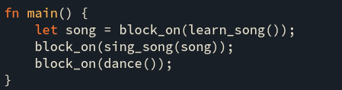

This is not the most effective way as we are only doing one thing at a time. It’s important to learn the song before singing it but we can dance simultaneously as learning and singing. So we can create two concurrently running async functions :
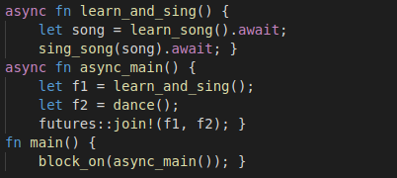

We use .await here rather than block_on to wait asynchronously and prevent blocking the whole thread so we can dance at the same time while learning and singing.
join! is used to wait for multiple futures concurrently.
Simple Async Application
Let’s create a very simple application that will fetch some data and print it on the console.
- Create a new app by running the following command in terminal :
- Add dependencies to Cargo.toml file for the external crates we’ll be importing.
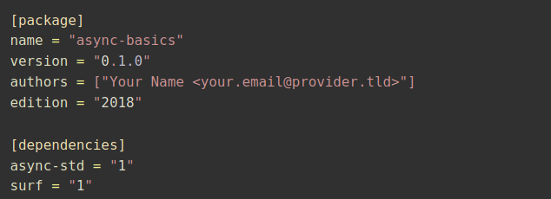
- Fetching data is the final step. Modify the main.rs file to look like the following :
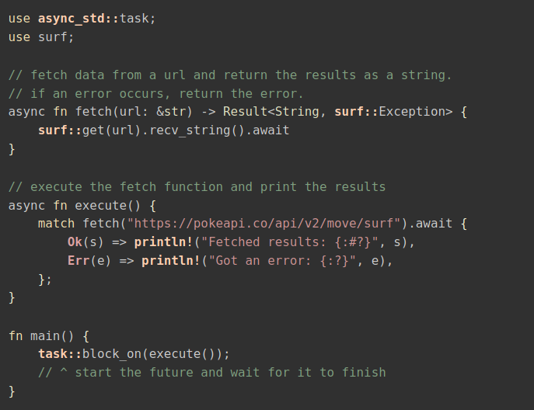
- use async_std::task and surf is to import the crates that we have declared in the Cargo.toml file.
- fetch along with the surf::get function will return the payload as a String or an Exception in case of an error.
- async fn execute() will print the output after it matches on the result, otherwise it will print the error.
Conclusion
The Rust asynchronous ecosystem is still undergoing rapid development. The Future trait inside lib std and the async/await language feature has been newly stabilized. To sum up, Rust is in midst of having some of the most performant and ergonomic support for async programming around.

