Table of Contents

|  |  |
| --- | --- |
| Section Title | Page Number(s) |
| Creating Custom Enemies | Page 2-3 |
| Adding Movies | Page 4 |
| Change Starting Character | Page 5 |
| Template | Last Page |

Creating Custom Enemies

When making a game, you will always need an enemy. RPG Maker will provide you with some predesigned ones, but what if you want your own. We will walk through the steps to create your own custom enemy.

Now in RPG Maker, navigate to the **“enemies”** tab in the database. Click in the *Image:* transparent box to select an image.

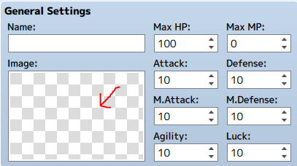

For the custom enemy to work, you will need your image of the enemy. You will need to make sure that the image file is a *.png* file, as other files might not work.

Once you have the file you will have to put it in the */*game*/img/enemies* folder.

**\*See Image Below\***

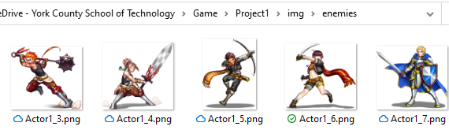

A pop-up should appear, and you can scroll down the left-hand side until you find the name of the file.

So, if you named the file **troll.png** then you should look for **troll** in the list of names.

Once you find the name click on it and your picture should appear in the right side of the box. In there you can click the ok button, and it should appear in the *Image:* box.

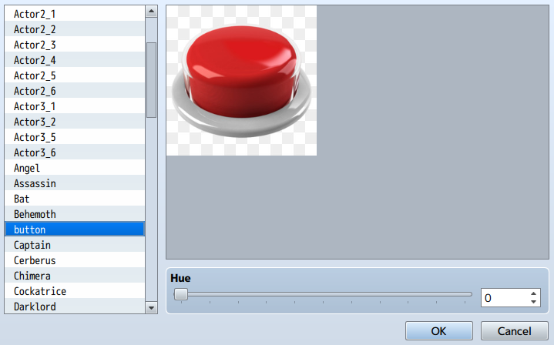

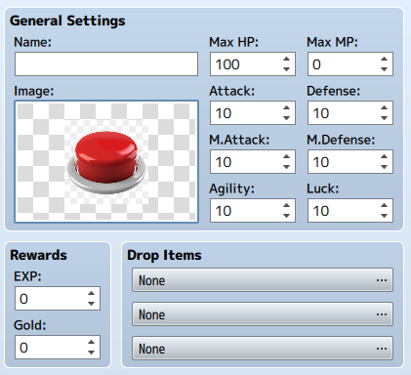

Now that we have our enemy’s image picked, we can give it a name, and stats.

In the **General Settings** you can change its basic stats. In the **Rewards** you can choose how much gold and exp you will get from killing it. In the **Drop Items** you can choose if it drops any items, and the probability it drops.

**\*See Picture on Left\***

Skills:

In the **Action Patterns** you can pick what attacks the enemy could use. You can add as many as you want. When adding a skill. You will need to pick which one and the rating. The rating is a number with the higher the number the more often it will be used. (Higher chance it is used). In there you can also pick certain conditions in which the skill will be used. For example, you can have a skill be used only when it is turn 5. **\*See Pictures Below\***

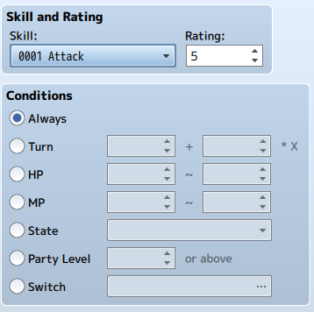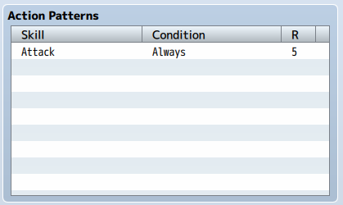

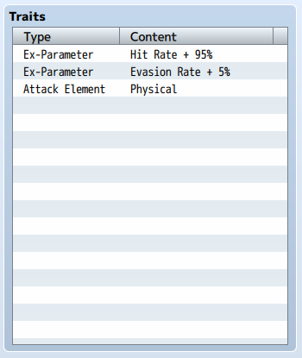

Traits:

**Traits** are used to give the enemy different things. You could give them a weapon, or armor. Ex: You could make your enemy have a high Critical Evasion parameter, which would make them better and dodging critical attacks. (AKA: Lowering the players chance of crits on that enemy)

**\*See Picture on Left\***

Adding Movies

Sometimes you will have a cutscene to give the player information, or to progress the story. In RPG Maker you can add a movie, or video file that can play. We will be adding an event that plays a video clip in our game.

Once you have that, you have to put both of the files in the */*game*/movies* folder. Also, make sure that both files are called the same name.

**\*See Picture Below\***

Before we put it in the game, we need to get our video files. For it to work with RPG Maker we need a *.mp4* and an *.webm* of the same file. To get both kinds of files, you can use and online converter.



Now that the files are in the right folder, we have to it up in RPG Maker.

To play movies in RPG Maker you have to use an event. Go into **Page 2** of the **Event Commands** click on **Play Movie.**

**\*See Image Below\***

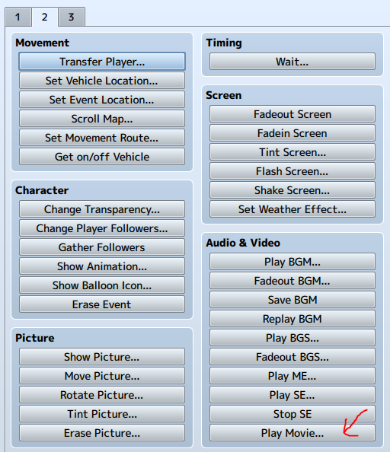

When clicked a list of movies should pop up. The names should be the name of file. Once clicked on click *“ok”* and save the event. Now when you run the event the movie should play.

You can use this for an intro cutscene, or if your character has an item you can play an unlocked video.

Since you use them in events you can use them in IF Statements, or loops. The possibilities are endless.

Change Starting Character

In RPG Maker one of the important things is your main character. They are the character the player controls, they are in almost every part of the story in the game. Making a character that the player can get along with or understands will make your game better. In this we will walk through how to change the starting party and what each section in the menu does.

First, we have to make a custom character. To do this we have to use the character generator in RPG Maker.

The character generator is to the left of the play button. Clicking on it will bring up a screen where you can make different types of characters (Male, Female, and Kid)



Once you are done with making your character click on the **Face Image**, **Walk Character**, **Damage Character**, and **Battler** tabs and export them. It will put it in the right area, and all you have to do is name them.

**\*See Image to Right\***

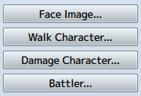

Now that you have your character we can add them to the starting party.

In the **Database** go to the **Actors** tab. In here we can make new characters.

In the Images section you can go find your custom character and add their image there.

General Settings:

In the **General Settings** section you can give your character a name and a nickname. Also, you can give them a class that can be made in the **Classes** Tab. You can also give them a **Starting Level** and a **Max Level** that they will reach. You can also give them a profile that could be their story or some info about them. It will appear in the character’s **Status Section**.

**\*See Image Below\***

Initial Equipment:

In this section is where you can put the character’s starting equipment. This would include all of the **Equipment Types** made in the **Types Tab**. This could be none, so that they might not have a weapon to start with, but will get one later in the game, or they might be a knight and have armor.

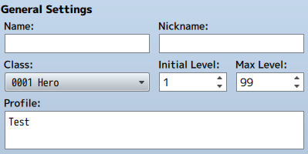

Template

Def / Intro

Steps

Steps