Table of Contents

Importing Images: Page 2

2

3

4

5

Template

[Grab your reader’s attention with a great quote from the document or use this space to emphasize a key point. To place this text box anywhere on the page, just drag it.]

s

s

s

Changing The Font

Changing the font in RPG maker MV is one of the first very advanced tasks we’ll have you do. This involves accessing folders you haven’t touched before and using a website with different fonts. Fonts are how text is displayed and is a big part of the dialog you use everyday in RPG maker MV. You will be using a font of your choice instead of us giving you one, so get creative.

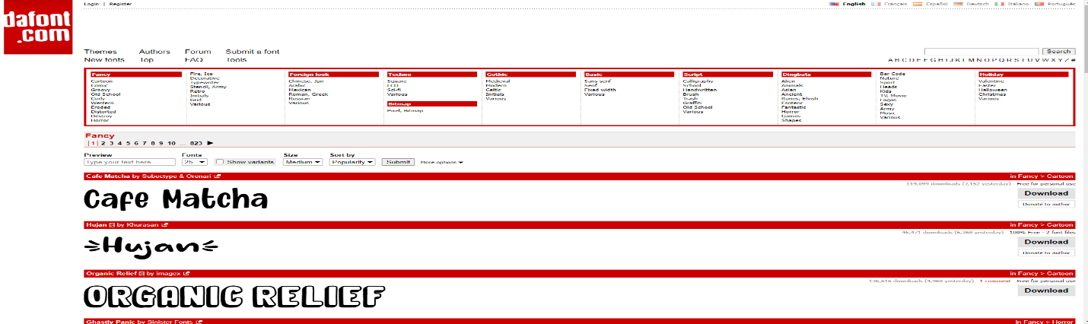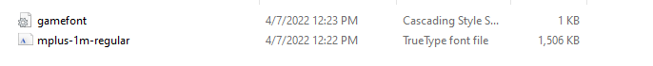

The “Fonts” the game uses for dialog.

3. Start up your game and mess with the font through text events and dialog.

2. Insert your file into the folder, and make sure the file type is correct. (TrueType font file)

1. Access the font folder and inspect it. (fonts folder)

Importing Characters

Importing custom characters is much like importing images as we will go over later. This involves using your game folder and custom image files. This will allow you to use custom sprites and let you experiment with how you want you desired character to look. This is automatically done for you when you create a character in RPG maker MV. Sprites can be found all over the internet and can be accessed from the Database.

This is the “*Characters*” the game uses for actors and actor animations.

2. Find a correlating **character** you would like to use. (Has to be a sprite sheet).

1. Find the image folder within your game folder and find the correct folder from there. (**Actors** is how they act in battle)

3. Convert the sprite sheet and insert into the folder. Access the **character** from the database and confirm it is there.

The “*faces*” the game uses for dialog.

Importing Images into your RPG maker MV can be used for many different things. These things can range to be used as doors, characters, or even enemies. We will be teaching you how to import these images for use. This is an easy challenge and only takes a moment or two to do. In this example we will be using the faces folder as it requires the least effort.

2. Find a file for use. This can be anything if the file is converted to a PNG.

1. Find the correct folder within your game files, this will require accessing the *images* folder within your *game* folder.

3. Insert the file into your folder, it can now be accessed within the game, and can be used as faces for any entity or **character** in your world.

Importing Images