Documentation Packet Week Ending [Sep 10th]

|  |  |
| --- | --- |
| Department:_______ | Student:___________________________ |

# Goals:

* Successfully fork, clone, edit, commit, push, and pull request the DocPac git repository on GitHub
* Begin compiling notebook and portfolio

# Included Documentation

# Required Documentation

* 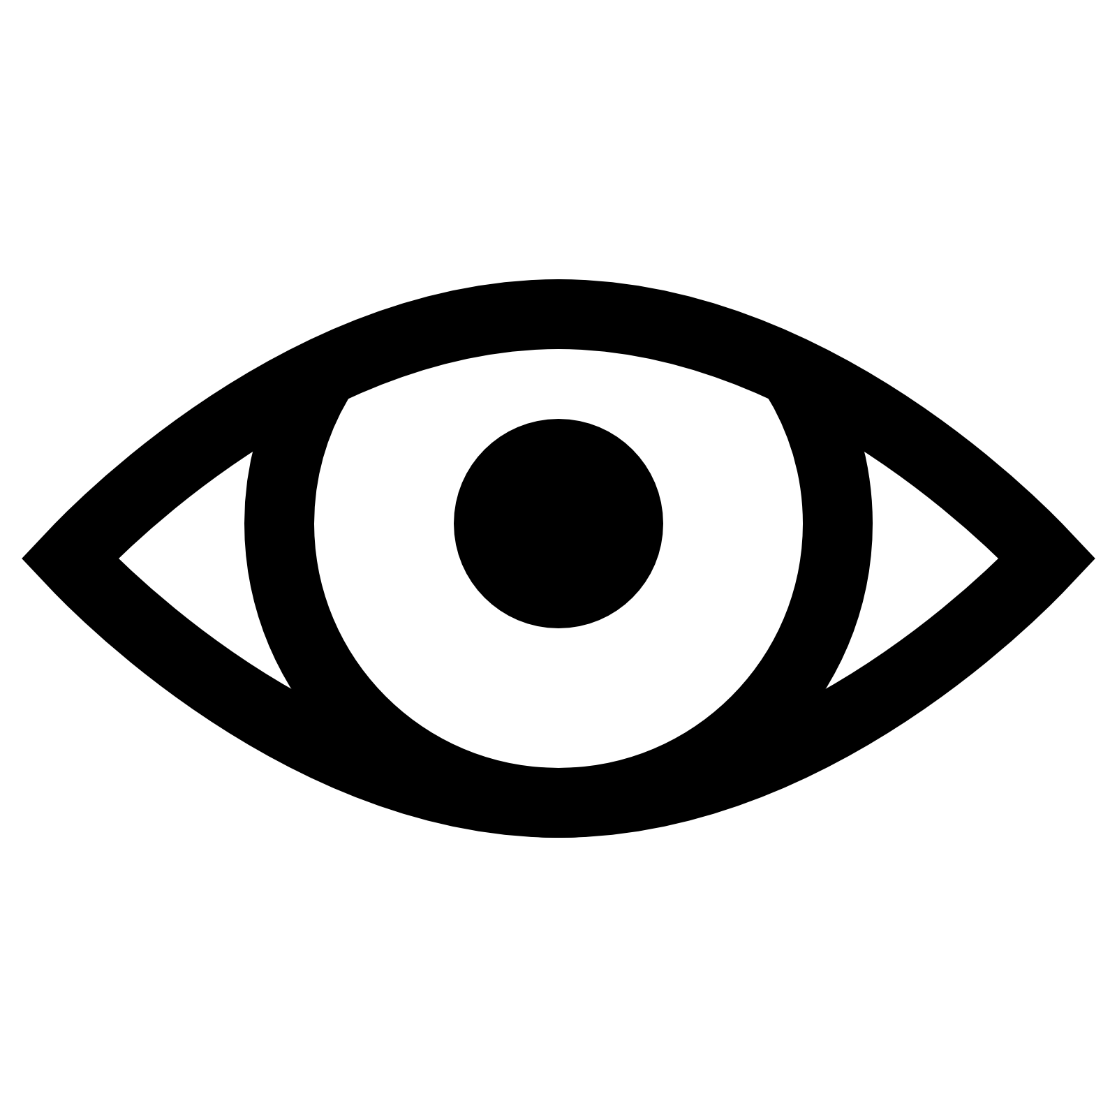 Build A Webserver Using nodejs (pg. 2)
*  Sept. 1st: Github practice assignment (assigned in-class)
*  ***[data missing]***



# Changes:

* Department and Name required on front of DocPacs
* Permanent changes made to DocPacs are now listed here each week
* Each week’s important events are now listed on the front of the DocPac
* A new icon (  ) means this needs to be reviewed and signed off on by Mr. Smith during the week, before final submission of your DocPac. It also means you must be present in class to receive this assignment.
* DocPacs are now in a Github repository for students to fork and make pull requests. Having pull requests accepted yields extra credit.
* Checkboxes circled with “OK” decrease the maximum number of checks available for grading, but can still count towards your score if completed anyways.

# Events:

* Aug. 30th: Pictures
* Aug. 30th: Lesson: Reviewing Data Sharing and Cloud Services
* Aug. 31st: ***[data missing]***
* Sept. 1st: Lesson: Git Review
* Sept. 3rd: No school until Sept. 7th

# Build A Webserver Using nodejs:

* Your system has nodejs preinstalled.
* Find a tutorial online that will show you how to:
  + Start a nodejs project
    - Atom IDE is a great tool for this
  + Initialize a nodejs project
  + Use node modules
  + Create an HTTP listen server
  + Find your computer’s internal IP
  + Run the nodejs application from a batch file or command prompt
  + Log something to the console if someone tries to connect to your IP:Port via http from a web browser
  + Sends HTML data back to the user who connects via a browser, so that they can see a simple web page
* When complete, demonstrate your webserver functioning as intended to Mr. Smith.
  + Have your DocPac ready for Mr. Smith to sign off for credit.
  + If your DocPac is not signed off, your program is not complete.

# Reflection

**What was the most impactful thing you learned this week?** **How can/will you use it in the future?**

|  |
| --- |
|  |
|  |
|  |
|  |
|  |
|  |
|  |
|  |
|  |
|  |
|  |
|  |
|  |
|  |
|  |
|  |
|  |
|  |

**What did you do *wrong* this week that you could do better in the future, and how?**

|  |
| --- |
|  |
|  |
|  |
|  |
|  |
|  |
|  |
|  |
|  |
|  |
|  |
|  |
|  |
|  |
|  |
|  |
|  |
|  |
|  |
|  |

**What is an obstacle to succeeding in class that you can foresee, and what plan do you have to overcome it?**

|  |
| --- |
|  |
|  |
|  |
|  |
|  |
|  |
|  |
|  |
|  |
|  |
|  |
|  |
|  |
|  |
|  |
|  |
|  |
|  |
|  |
|  |

# Grading

|  |  |  |  |  |
| --- | --- | --- | --- | --- |
|  | | Complete | Followed Instructions | |
| Reflection | | ❑ | ❑ | |
|  | | Present | Complete |  |
| Eye Icon - Free Download at Icons8 Sept. 1st: Github practice assignment | | ❑ | ❑ |  |
|  | | Present | Complete |  |
| Eye Icon - Free Download at Icons8C:\Users\csmith\AppData\Local\Microsoft\Windows\INetCache\Content.MSO\6867D38F.tmp ***[data missing]*** | | ❑ | ❑ |  |
|  | | Present | Complete |  |
| Eye Icon - Free Download at Icons8 Build A Webserver Using nodejs (pg. 2) | | ❑ | ❑ |  |
|  |  | | | | |
|  | | | | |