Screenshots: 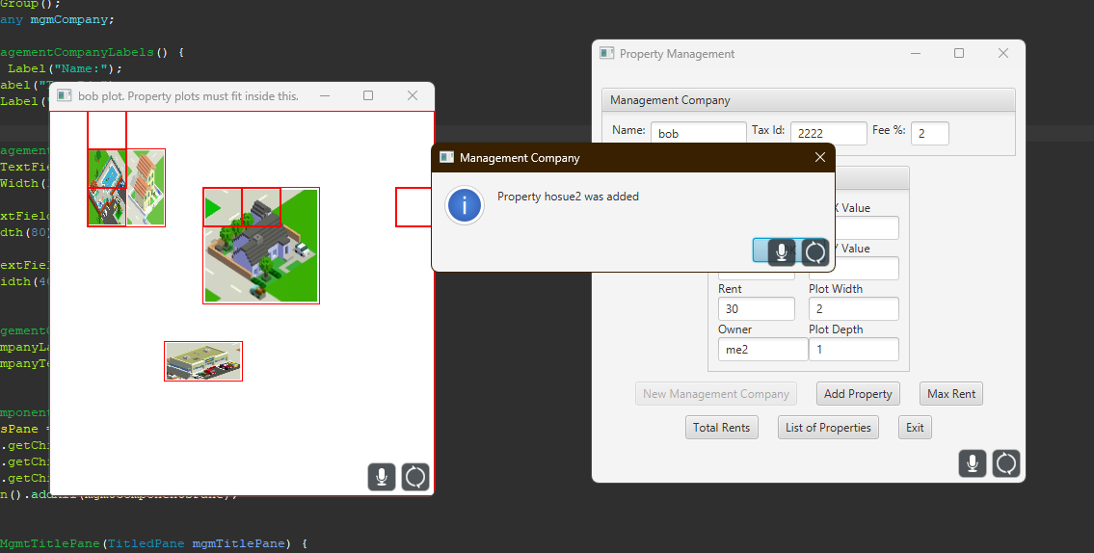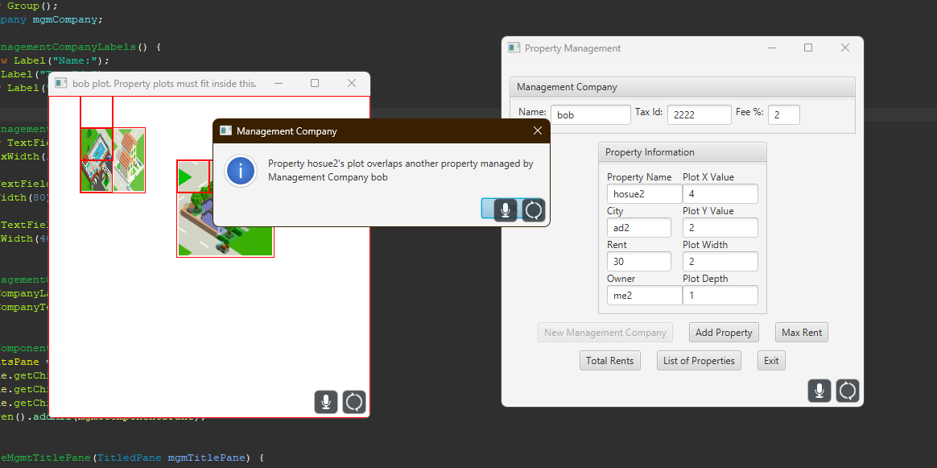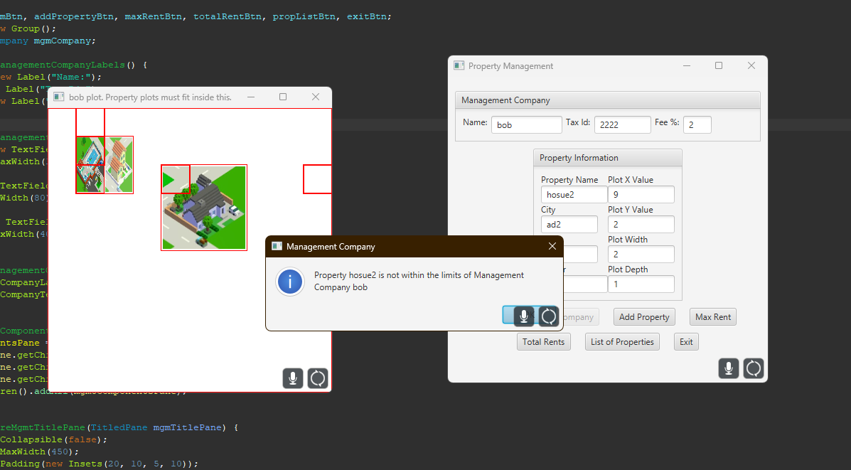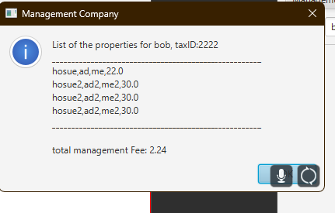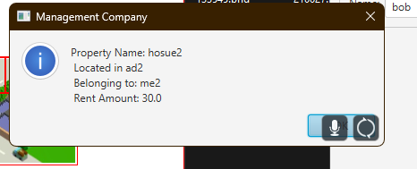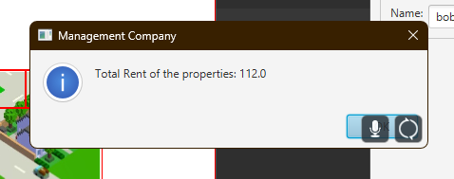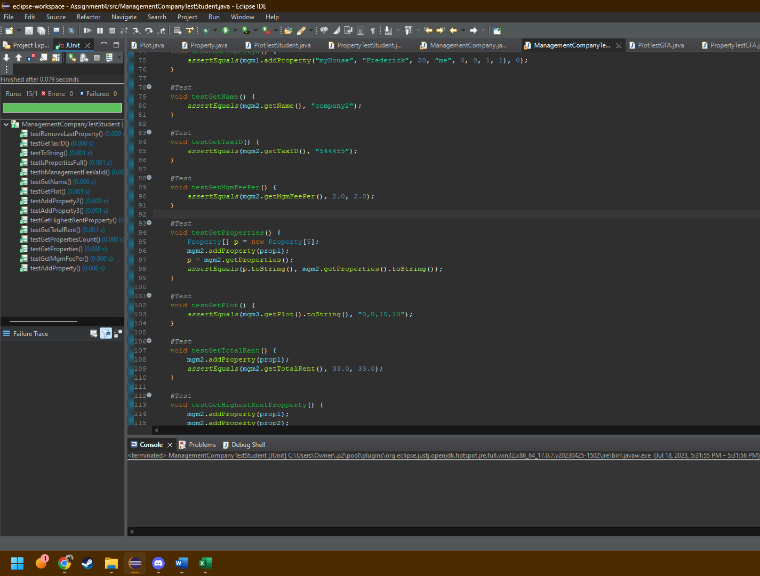
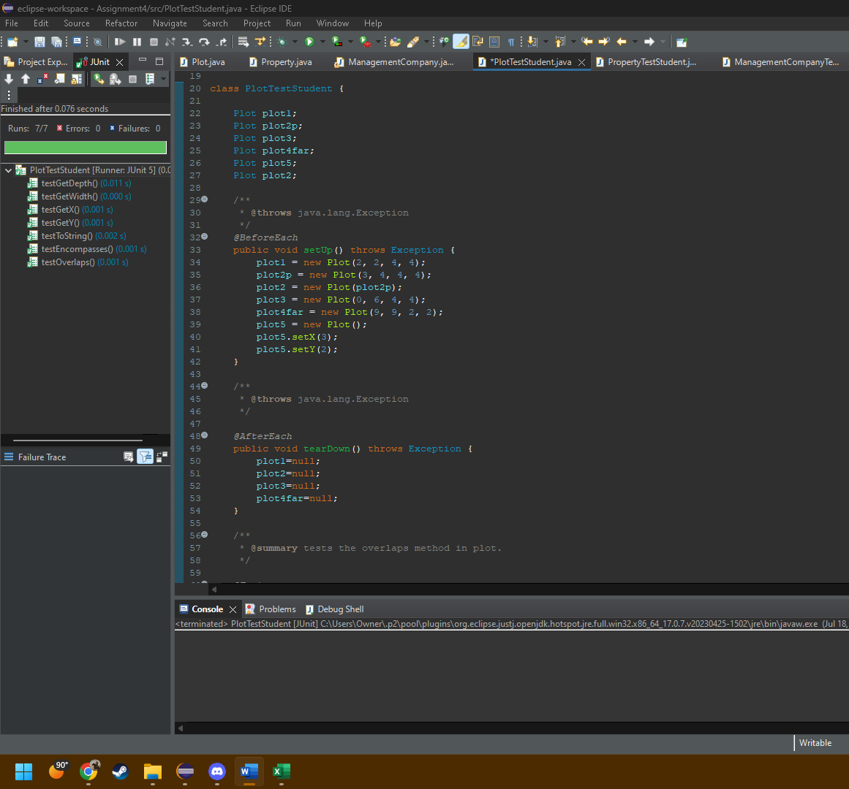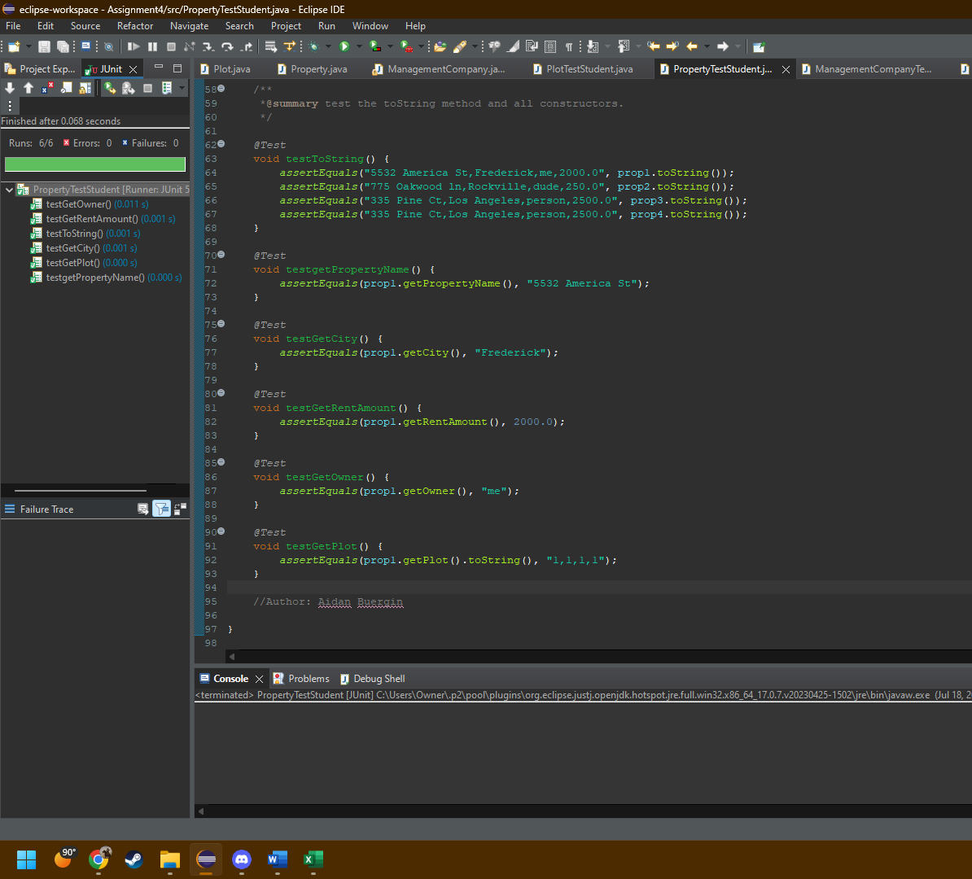
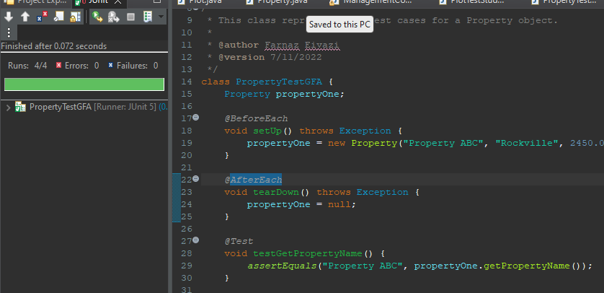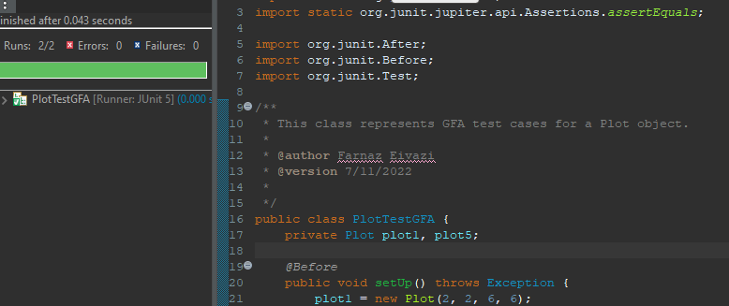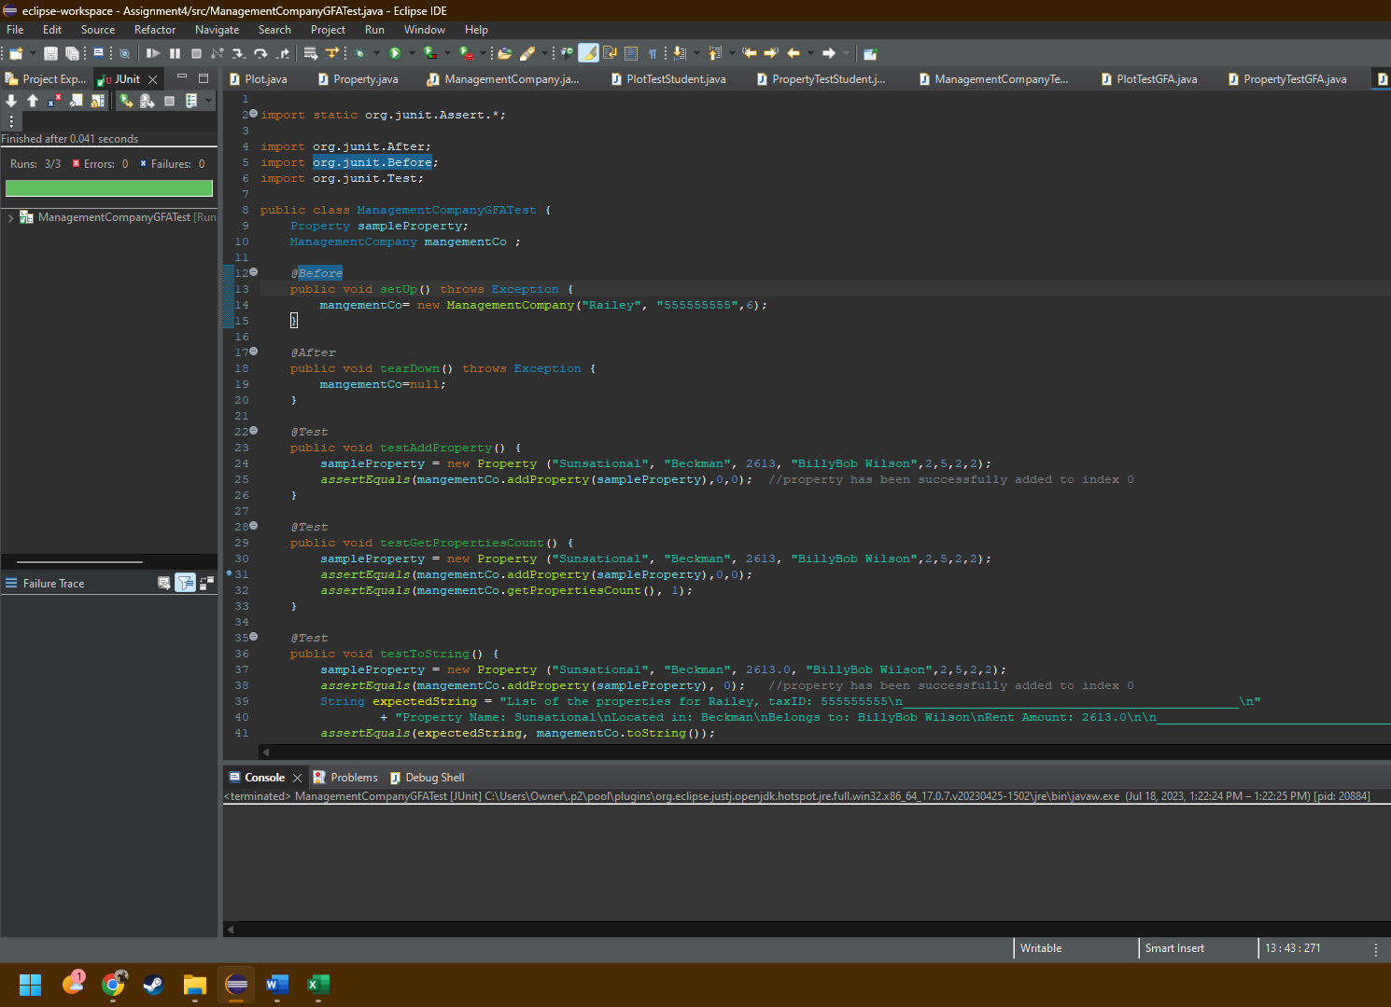

Lessons Learned:
In this assignment, I learned a lot more about Junit tests and became more familiar with having classes as fields of other classes.
I struggled a lot with the logic behind the overlapping and encompasses methods, because I was under the impression that the x and y coordinates were to be placed like coordinates on a mathematical graph, instead of a pixel layout on a screen. Because this was not explicitly stated anywhere, I wrote my logic wrong the first time and had to rewrite it when I realized that the grid for the plots was a pixel layout based one.

