About the Project:
This project is a Python web dashboard for the Grazioso Salvare scenario using the Austin Animal Center animal shelter dataset. The dashboard connects to the MongoDB database named aac and works with the animals collection through the reusable AnimalShelter CRUD Python module from Project One. The goal is to let a user search and filter animal records through a dashboard instead of typing MongoDB shell commands each time.
This project builds from the earlier MongoDB setup, user authentication, CRUD Python module, and dashboard milestone work. It combines the database with a client-facing dashboard that includes rescue filters, a data table, a breed distribution chart, and a geolocation map.

Motivation
The motivation for this project is the Grazioso Salvare search-and-rescue dog training scenario. Grazioso Salvare needs a way to view animal shelter data and identify dogs that match different rescue training needs. A dashboard makes the data easier to use because the client can choose a rescue category and immediately see the matching dogs, their breeds, and their locations.

Getting Started
MongoDB has to be running in Codio and the AAC animal shelter outcomes data has to be imported into the aac database for this project to run. The animals collection is created from the aac_shelter_outcomes.csv file. The dashboard also needs the Grazioso Salvare logo image to be in the same folder as the notebook.
The main files used for this project are:
- ProjectTwoDashboard.ipynb - contains the dashboard layout, filters, data table, pie chart, and map callbacks.
- CRUD_Python_Module.py - contains the AnimalShelter class and the create, read, update, and delete methods from Project One.
- Grazioso Salvare Logo.png - contains the client logo used for dashboard branding.
- README Document - explains the project tools, usage, testing, screenshots, and challenges.

Installation
The tools used for this project are the tools from the CS 340 Codio/Jupyter starter environment: Python, MongoDB, PyMongo, Jupyter Notebook, JupyterDash/Dash, Pandas, Plotly Express, Dash Leaflet, and Codio. The database was prepared earlier in the course by importing the AAC CSV file into MongoDB and creating the aacuser account.
Database import command:
cd ./datasets
mongoimport --db aac --collection animals --type csv --headerline --drop ./aac_shelter_outcomes.csv
MongoDB user setup command:
use admin
db.createUser({
user: "aacuser",
pwd: "aacpass",
roles: [
{ role: "readWrite", db: "aac" }
]
})
The Python dashboard connects to the AAC MongoDB database through PyMongo and the AnimalShelter class. This keeps the database connection and database queries separate from the dashboard layout and callback code.

Usage
The dashboard starts by creating an AnimalShelter object and reading records from the MongoDB animals collection. The user can then choose one of the rescue filter options. When a filter is selected, the data table, breed chart, and map update together.
- Water Rescue - returns dogs that match the preferred water rescue breeds, sex, and training-age range.
- Mountain or Wilderness Rescue - returns dogs that match the preferred mountain/wilderness rescue breeds, sex, and training-age range.
- Disaster or Individual Tracking - returns dogs that match the preferred disaster/tracking breeds, sex, and training-age range.
- Reset - returns the dashboard to the original unfiltered animal collection.
The data table supports filtering, sorting, pagination, and selecting a single row. Selecting a row updates the geolocation map marker using the selected animal record.

CODE EXAMPLE
This example matches the general pattern used in ProjectTwoDashboard.ipynb. The dashboard imports the CRUD module, creates the AnimalShelter object, reads records from MongoDB, and uses a query for the selected rescue filter.
from CRUD_Python_Module import AnimalShelter
import pandas as pd

username = "aacuser"
password = "aacpass"

# Connect to MongoDB through the CRUD module
db = AnimalShelter(username, password)

# Retrieve all records for the Reset view
df = pd.DataFrame.from_records(db.read({}))

# Example Water Rescue query
water_rescue_query = {
"animal_type": "Dog",
"breed": {
"$in": [
"Labrador Retriever Mix",
"Chesapeake Bay Retriever",
"Newfoundland"
]
},
"sex_upon_outcome": "Intact Female",
"age_upon_outcome_in_weeks": {"$gte": 26, "$lte": 156}
}

water_rescue_records = db.read(water_rescue_query)

Dashboard Functionality
The finished dashboard includes the required client branding, interactive filter options, a data table, a breed distribution pie chart, and a geolocation map.
- The Grazioso Salvare logo is shown at the top of the dashboard and links to the SNHU website.
- The dashboard includes the creator identifier: Created by Aidan.
- The rescue filter options run MongoDB queries through the CRUD module.
- The Dash data table changes based on the current query results.
- The breed distribution pie chart changes based on the filtered records.
- The Dash Leaflet map uses location_lat and location_long to show the selected animal location.
Tools and MVC Design
This dashboard follows the model-view-controller idea described in the Project Two directions. MongoDB is the model because it stores the AAC animal shelter records in the aac.animals collection. The AnimalShelter CRUD Python module keeps the database connection and query code separate from the dashboard, which makes the code easier to reuse and maintain.
The dashboard is the view because it displays the logo, filter options, data table, breed distribution chart, and map for the user. The callback functions are the controller because they react to filter selections and row selections, run the correct database query through the CRUD module, and update the table, chart, and map.
The main tools used were Python, MongoDB, PyMongo, Jupyter Notebook, JupyterDash/Dash, Pandas, Plotly Express, Dash Leaflet, and Codio. These tools were part of the CS 340 Codio/Jupyter starter environment and were used because they support MongoDB queries, Python dashboards, interactive tables, charts, and geolocation mapping.
Steps Taken to Complete the Project
- Reviewed the Project Two guidelines and Dashboard Specifications Document to identify the required rescue filter options and dashboard widgets.
- Reused the MongoDB setup, aacuser authentication, and AnimalShelter CRUD module from the earlier project work.
- Built the dashboard layout with the Grazioso Salvare logo, creator identifier, rescue filter options, data table, breed distribution chart, and geolocation map.
- Created callback functions so the dashboard could run the correct MongoDB query and update the table, chart, and map when a filter or row was selected.
- Tested the reset view and each required rescue filter to confirm the dashboard returned matching records and updated the visual widgets.
How to Run the Project
- Open the CS 340 Codio/Jupyter Lab environment and make sure MongoDB is running.
- Keep ProjectTwoDashboard.ipynb, CRUD_Python_Module.py, and Grazioso Salvare Logo.png in the same code_files folder.
- If the database has not already been loaded, import aac_shelter_outcomes.csv into the aac.animals collection with mongoimport.
- Open ProjectTwoDashboard.ipynb, run the notebook cells, and open the dashboard link or inline output.
- Use the radio-button filters to switch between Reset, Water Rescue, Mountain or Wilderness Rescue, and Disaster or Individual Tracking. Select a row in the table to update the map marker.

Tests
The ProjectTwoDashboard.ipynb notebook was tested by running the dashboard in Codio and selecting each required filter option. Each test checked that the table, breed chart, and map responded to the selected filter.
- Reset/unfiltered view loaded the full animal collection.
- Water Rescue returned dogs matching the required breed, sex, and age criteria.
- Mountain or Wilderness Rescue returned dogs matching the required breed, sex, and age criteria.
- Disaster or Individual Tracking returned dogs matching the required breed, sex, and age criteria.
- Selecting a row in the data table updated the map marker and popup for that animal.
These results show that the dashboard widgets worked together and that the dashboard connected successfully to the MongoDB database through the AnimalShelter CRUD module.

Screenshots
These screenshots below show the Project Two dashboard running with the required dashboard widgets and rescue filter options.
Reset / unfiltered dashboard showing the data table, breed distribution chart, geolocation map, logo, and creator identifier.
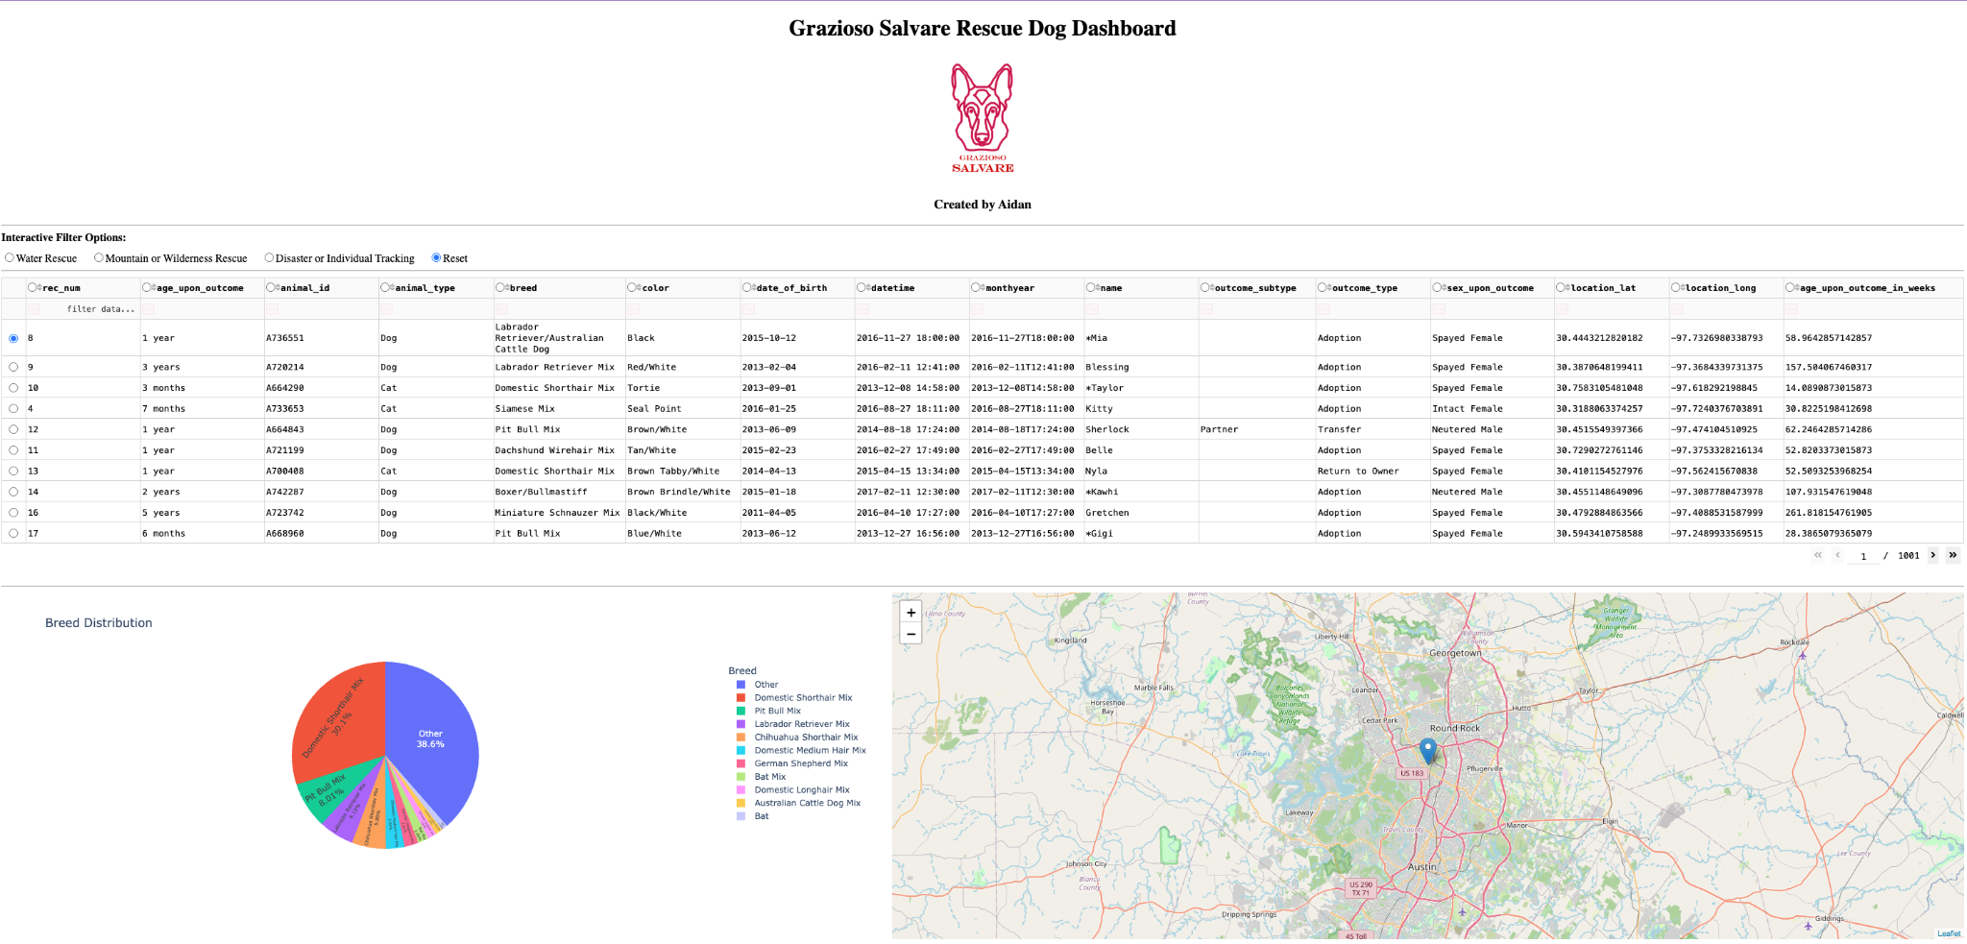

Water Rescue filter showing matching rescue candidates and updated dashboard widgets.
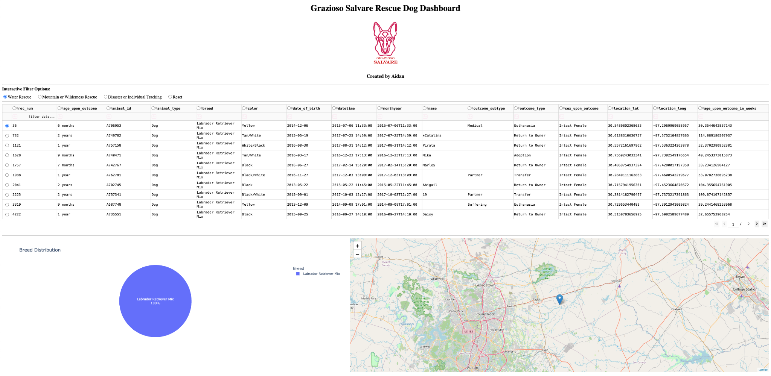

Mountain or Wilderness Rescue filter showing matching rescue candidates and updated dashboard widgets.
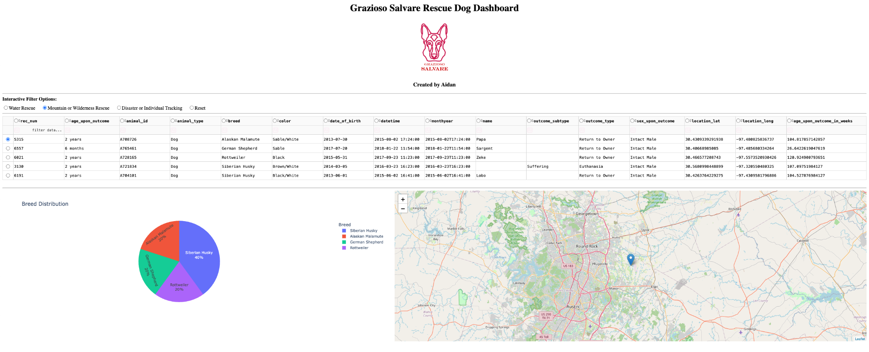

Disaster or Individual Tracking filter showing matching rescue candidates and updated dashboard widgets.
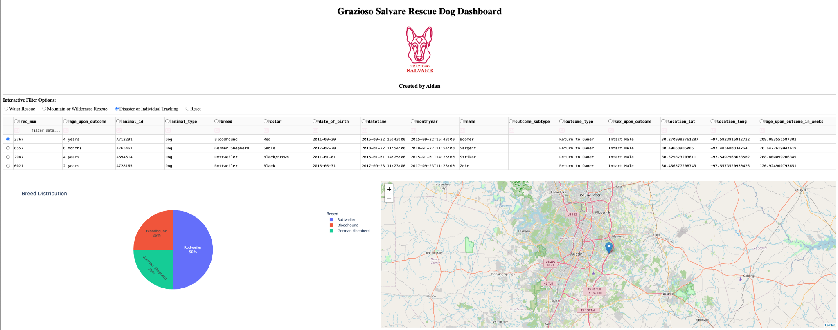

Challenges
One challenge was running the dashboard in the hosted Codio/Jupyter environment. The dashboard needed to use the JupyterDash/Codio proxy instead of relying only on a normal local browser address.
Another challenge was keeping the breed distribution chart readable when many different breeds were shown in the unfiltered data. The dashboard groups smaller categories together so the chart is easier to read while still showing the filtered results clearly.
A final challenge was making sure the table, chart, and map stayed connected. The dashboard solves this by using callbacks that update the visible records, breed chart, and selected map marker when the user changes filters or selects a row.

References
- CS 340 Project Two Guidelines and Rubric.
- CS 340 Dashboard Specifications Document.
- Austin Animal Center Outcomes data set provided in Codio.
- Grazioso Salvare logo provided in the course materials.
- CS 340 Codio/Jupyter starter notebook and course resources.
- Make a README guide: https://www.makeareadme.com/
- Dash documentation: https://dash.plotly.com/
- MongoDB documentation: https://www.mongodb.com/docs/

