WELCOME TO CS-521!!!

Tue - Thu, 6-7:30 p.m.

Instructor: Eugene Pinsky

Facilitators:

1. Joshua Bond (lead)
2. Bisrat Gebrehivot
3. Edward Orsini
4. Joshua Purvis
5. Anatoliy Aleksandrov

Weekly quizzes and homework

Homework 1:

1, 2, 3, 4, 5, 6, 7, 8, 11, 12 (pages 78-79)

Submit in word document

Required Textbook: The Practice of Computing Using Python, by W. Punch and R. Enbody

3-rd edition, Pearson Publishing,

ISBN 978-0-13-437976-0

1. Homework
2. Quizzes (6) 10 questions, multiple choice, 30 minutes

Reminder: use back/forward arrows in the blackboard (not in the browser)

1. Project (open-ended)
2. Final exam (15 multiple choice, questions, 2 hours)

All exams (quizzes and final) are closed-book

* Think of interviews

ALL EXTRA MATERIALS INCLUDING REQUIREMENTS WILL BE POSTED UNDER “from your professor and facilitators” in the discussion tab in the blackboard

in most languages, you need to explicitly allocate storage for variables

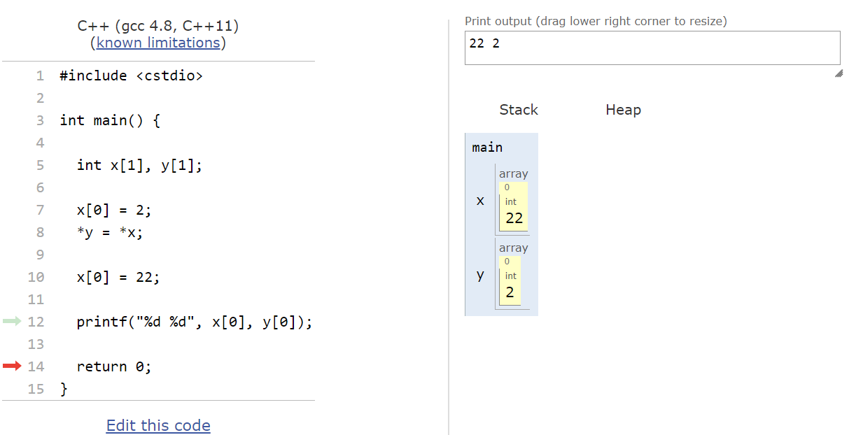

in the example above, x and y have separate memory locations

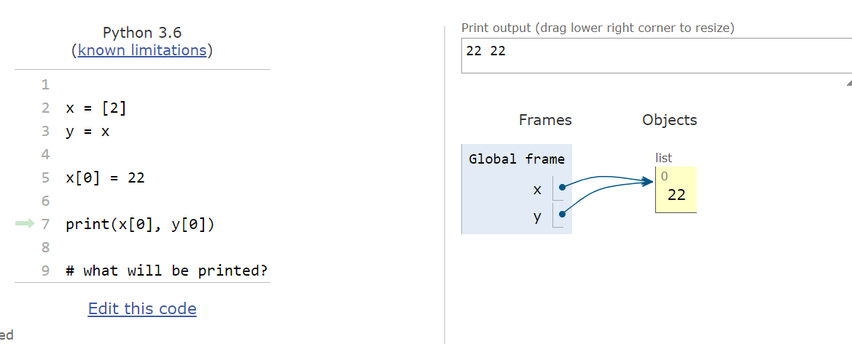

in Python, there is no declaration of storage

C++ int x = 5;

int y = 5;

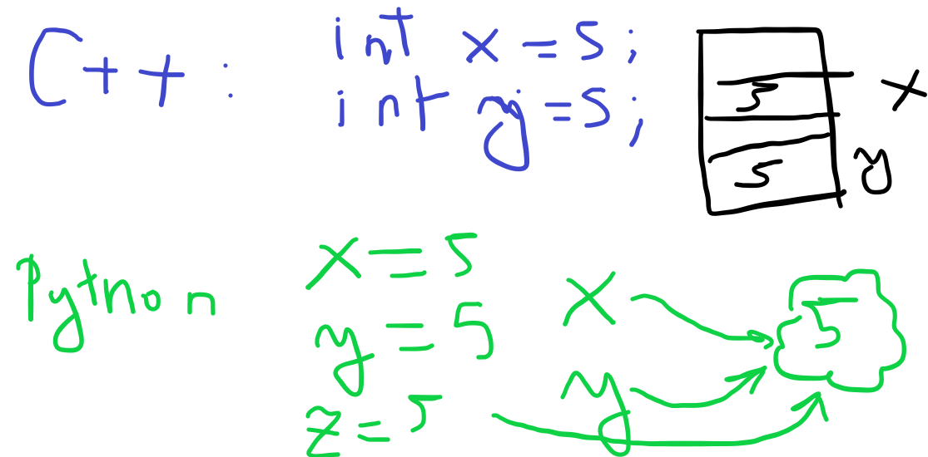

in python, statements like x = 5 mean that at this moment, x “tags” (pointer to) a unique object in Python that contains 5

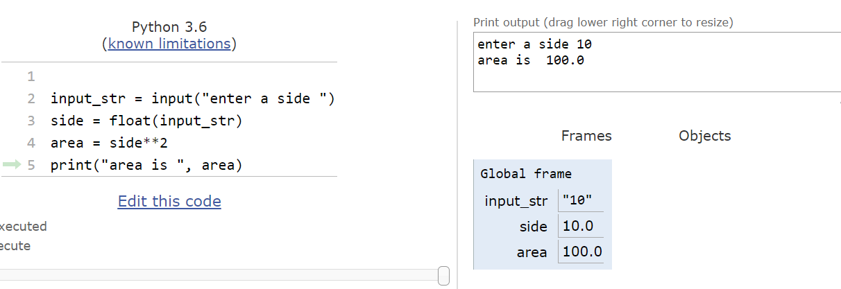

no explicit declaration of types or storage

STAY HEALTHY AND WELL!

SEE YOU BACK ON THURSDAY !!!!