WELCOME TO CS-521!!!

Tue - Thu, 6-7:30 p.m.

Lecture 2 (Nov 5, 2020)

Instructor: Eugene Pinsky

Facilitators:

1. Joshua Bond (lead)
2. Bisrat Gebrehivot
3. Edward Orsini
4. Joshua Purvis
5. Anatoliy Aleksandrov

Weekly quizzes and homework

Homework 1:

1, 2, 3, 4, 5, 6, 7, 8, 11, 12 (pages 78-79)

Submit in word document

Required Textbook: The Practice of Computing Using Python, by W. Punch and R. Enbody

3-rd edition, Pearson Publishing,

ISBN 978-0-13-437976-0

1. Homework
2. Quizzes (6) 10 questions, multiple choice, 30 minutes

Reminder: use back/forward arrows in the blackboard (not in the browser)

1. Project (open-ended)
2. Final exam (15 multiple choice, questions, 2 hours)

All exams (quizzes and final) are closed-book

* Think of interviews

ALL EXTRA MATERIALS INCLUDING REQUIREMENTS WILL BE POSTED UNDER “from your professor and facilitators” in the discussion tab in the blackboard

Projects:

1. individual
2. can use external libraries

Python: object = data + methods that operate on this data

x = object # typical statement

it means that x “tags” (points to) that object

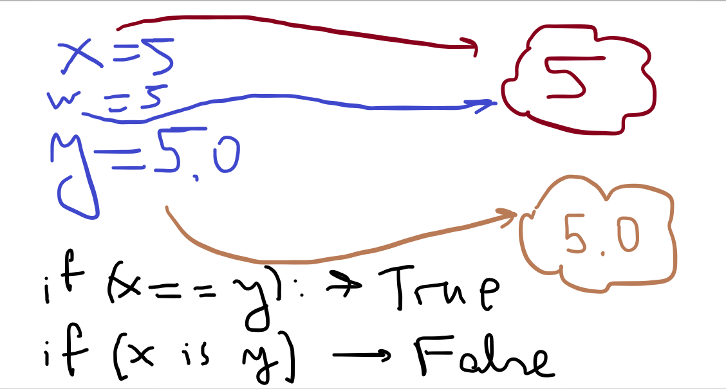

data types in Python could be simple (“primitive” ~ “atoms”) or collections (“molecules”)

10 data types – 5 “atom” types and 5 “collections”

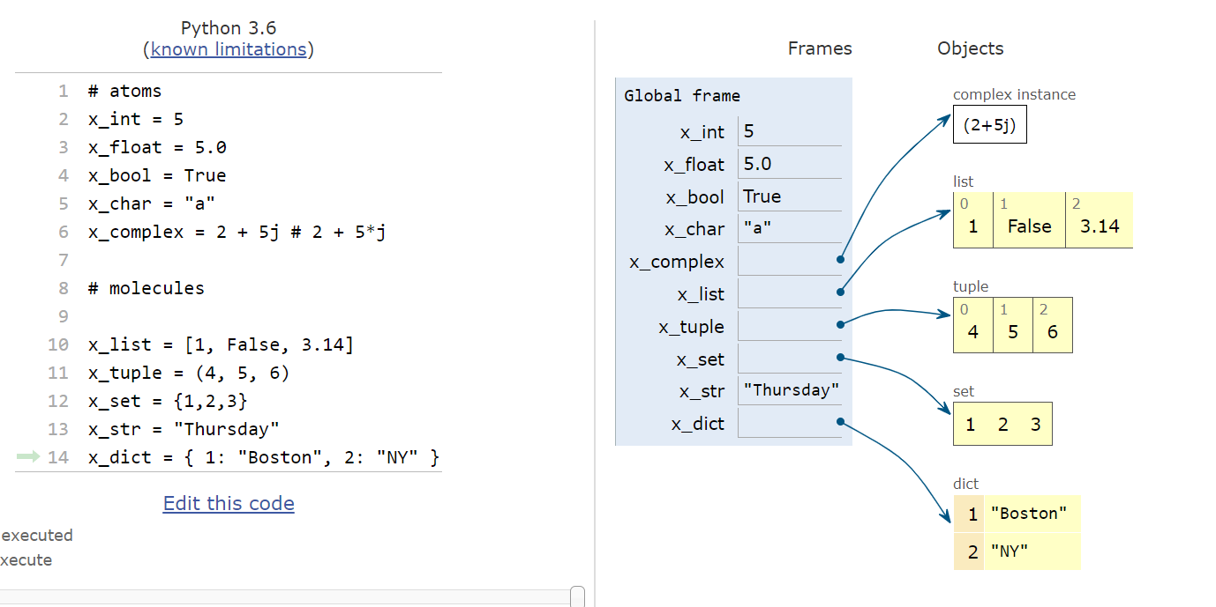

suppose you have a list of numbers x

construct a list y with no duplicates

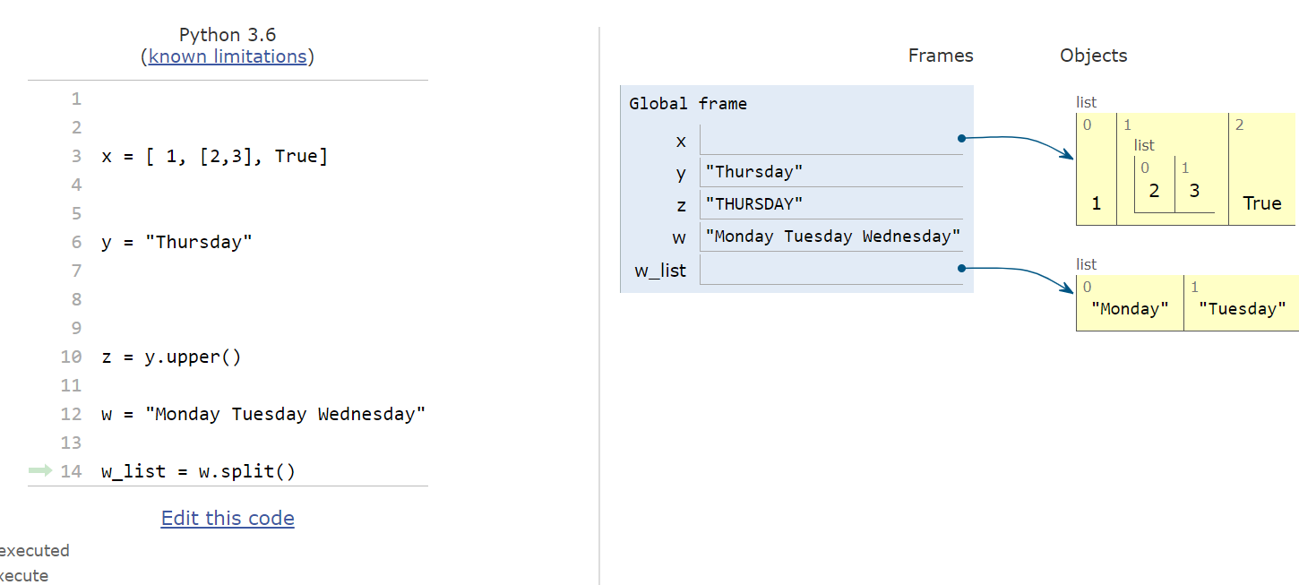

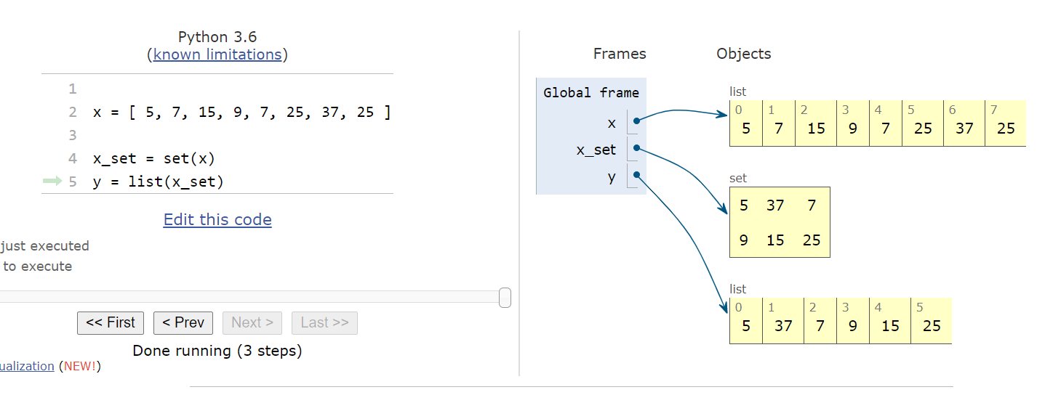

x = “four”

y = “FouR”

if (x==y) -----------🡪 true