WELCOME TO CS-521!!!

Tue - Thu, 6-7:30 p.m.

Lecture 3 (Nov 10, 2020)

Instructor: Eugene Pinsky

Facilitators:

1. Joshua Bond (lead)
2. Bisrat Gebrehivot
3. Edward Orsini
4. Joshua Purvis
5. Anatoliy Aleksandrov

Homework 2

Quiz 2

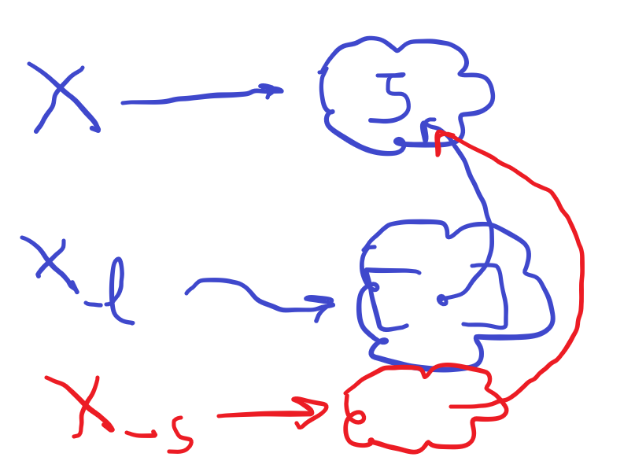

In python x=5 means a tag to a unique object containing 5 (type of that object is integer)

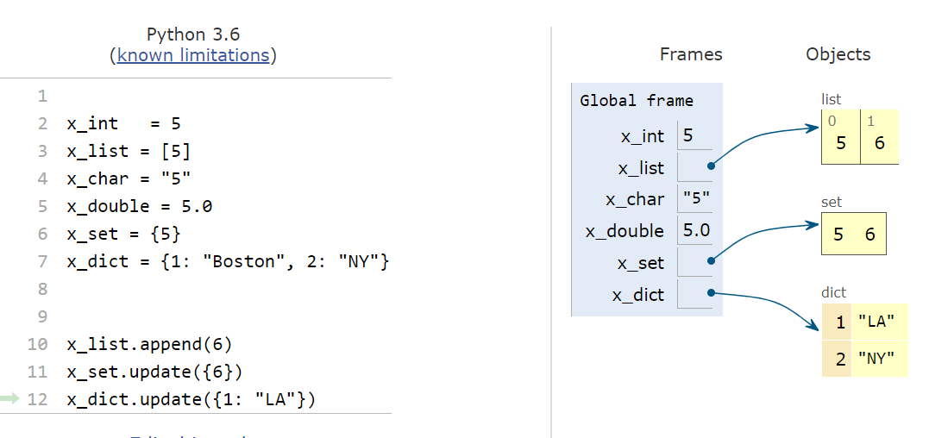

in Python there are many functions with the same name that could be applied to different data types

Such functions are called “polymorphic” functions

(many forms)

examples: len() length

In set example, update means 6 added into the set, but 5 sill be kept, right? Then what is the difference here between list and set in your example here

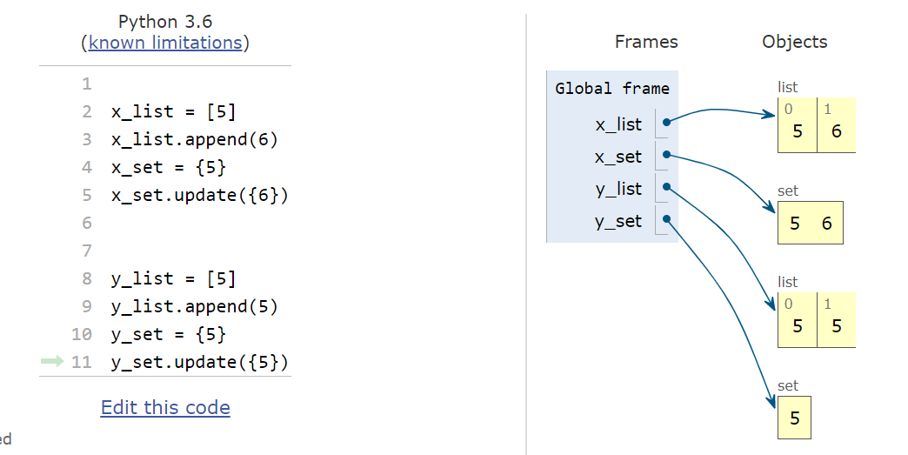

data types:

10 data types + 2 special types

5 simple (“primitive”) atoms

5 molecules (collections)

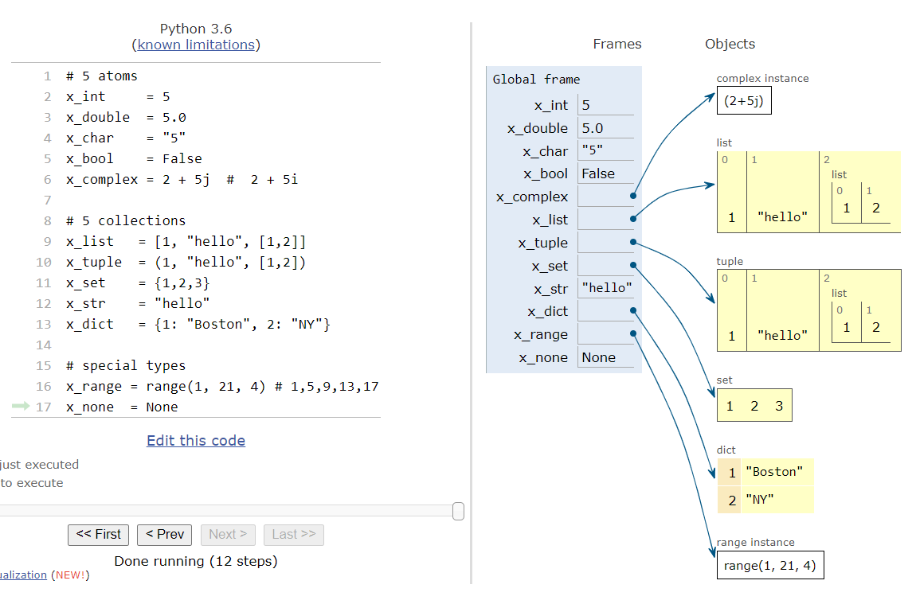

x = 5

y = 5.0

compare x and y by value:

if x == y: True

compare if x and y point to the same object:

if x is y: False

What is the difference between these 2 statements?

if x == True:

if x is True: preferred !!!!

Same for comparison to None

if z == None vs if z is None preferred

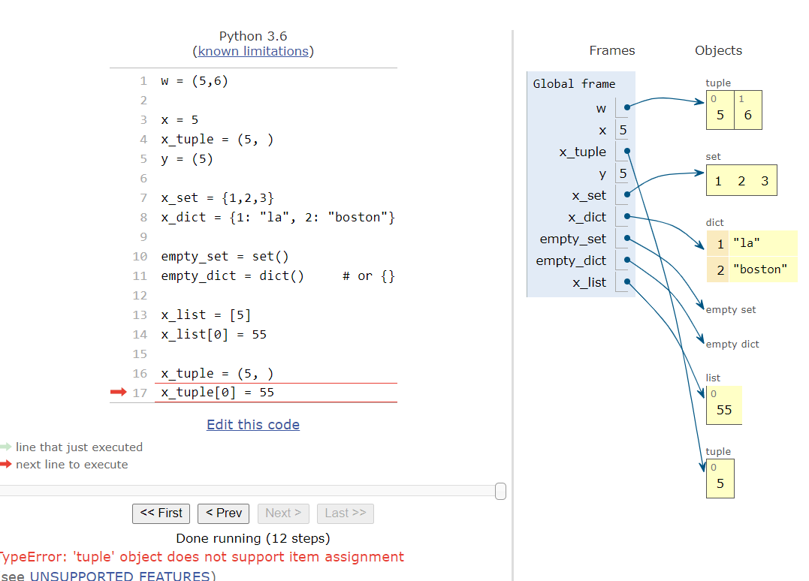

f : ----------🡪 res

-🡪 None

a = f(…..)

if a is not None:

Stay health and well

think about project ideas!

See you all on Thursday !!!!

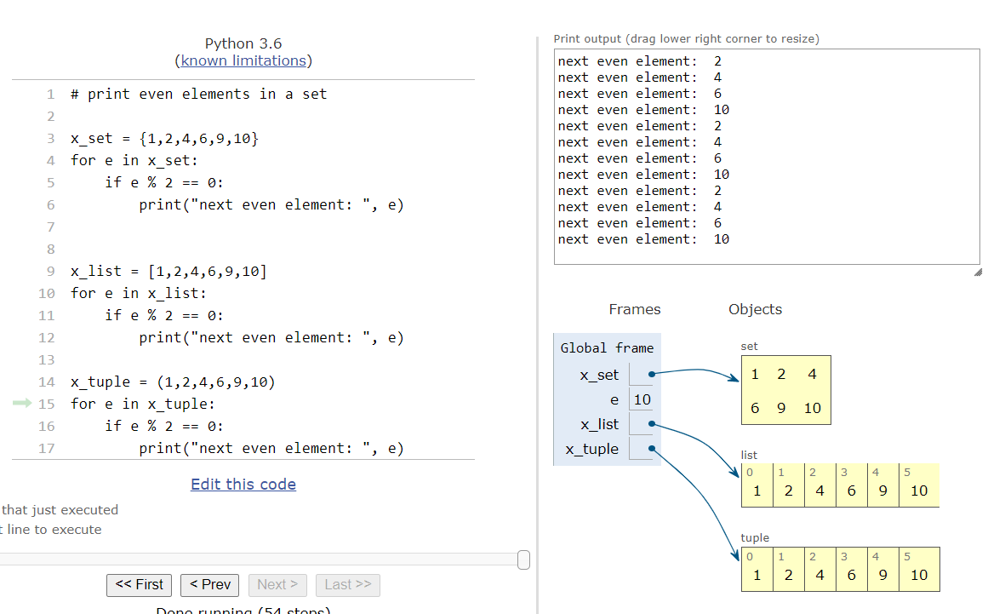

in Python we use the same constructs for iteration across collections

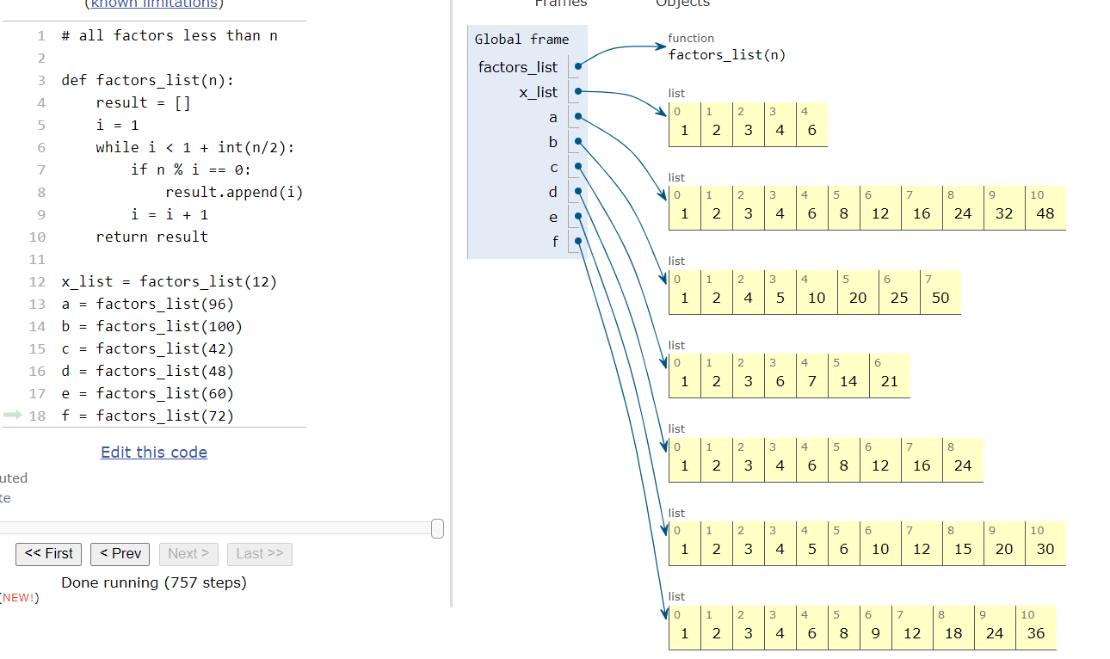

is there a python code to find that answer? to find the number with the most factor?