9/21/2021

# Assignment 4: Reasoning with Uncertainty Using Fuzzy Rules

## The instructions—about this Word file template, the evaluation matrix, no more than 4 pages, and appendices—are as before.

## Problem Specifications

In 1-3 sentences, specify a problem that is amenable to Fuzzy rules and that (to your best knowledge) has not been approached with fuzzy rules. There should be two inputs and one output. At least one nontrivial input pair of values should be known that produce an output value that is known independently of this work, which can be used for validation (as in the next section).

*Example: Estimate the sale price of a house in a designated town during a designated time, based on its floor area (in square feet) and lot size (in acres).*

Your responses replace this.

## A Known Input/Output Instance

Identify a known input value pair (i.e., conventional crisp values) and known corresponding (crisp) output, independently of this work. If possible, the instance should be published. Make this a good example, and do not alter it after specifying it. It is for validating your design and implementation.

*Example: the sale price of* [*526 Winter St, Framingham*](https://www.zillow.com/homedetails/526-Winter-St-Framingham-MA-01702/165992418_zpid/?)*, MA (3,128 sq ft, 0.41 Acres) was $588,000, sold on 09/15/21.*

Your responses replace this.

## Rules

Provide at least 3 rules. Keep in mind that your rules will be tested with the instance that you provided in Part 2.

*Example for the “house value” application: (1) IF floor area is small and lot size is small THEN sale price is low; (2) IF floor area is large and lot size is large THEN sale price is very high; (3) IF floor area is large and lot size is small THEN sale price is higher than average.*

Your responses replace this.

## Values

## On 3 (or more) figures, show the possible fuzzy values for each of the two input variables and for the output variable. Show multiple values as in the example.

## *Example: the figure shows an example for a temperature variable[1]. “House sale price” would have 0 - $1,000,000 on the x-axis, and figures like this for Low, Medium, and High (or more if more refined).*

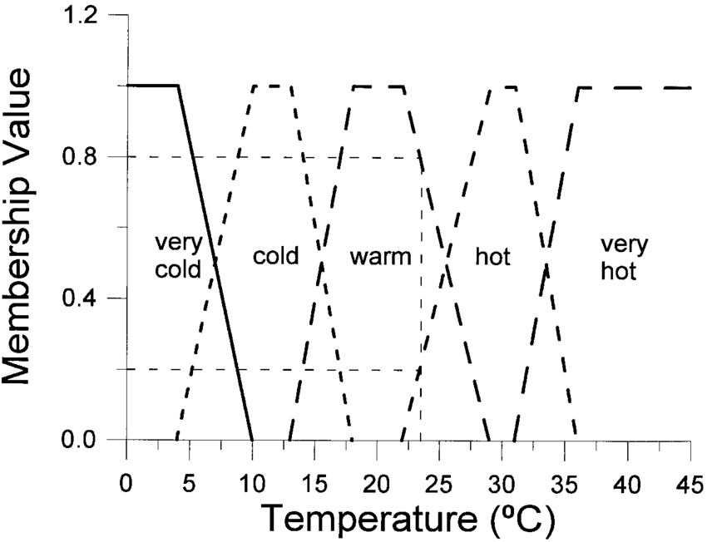

**INPUT 1:** Your variable name replaces this.

Your responses replace this.

**INPUT 2:** Your variable name replaces this.

Your responses replace this.

**OUTPUT:** Your variable name replaces this.

Your responses replace this.

## Output Effects of Rules on the Given Sample Input

Show the effects graphically of the rules operating on your known Instance in Part 2.

*An example of the output of a single rule is the following. You are free to use it as a template.*



Your responses replace this and the above figure.

## Output Effects of Rules on the Given Sample Input

Show the effects graphically together *on a single diagram*, including an estimate of the areas and the centers of gravity.

*An example (which you may use as a template) is below. For convenience, it is sufficient to express the areas as fractions of a selected area.*



Your responses replace this and the above figure.

## Crisp Output of the Instance

Use the above diagram to compute the crisp (conventional) output for the instance selected in Part 2.

*Example from the above figure: (1×3.5 + 0.7×5.9)/ (1 + 0.7) = 7.63/1.7 = 4.49*

Compare this with the output you expected in Part 2 (do not change it!). Explain the difference as best you can.

Your responses replaces this.

# Evaluation



1. <https://www.researchgate.net/figure/Examples-of-fuzzy-logic-linguistic-values-for-the-linguistic-variable-temperature_fig5_49677005>