WELCOME TO CS-521!!!

Tue - Thu, 6-7:30 p.m.

Lecture 10 (Dec 3, 2020)

Week 5:

Homework 5

Quiz 5

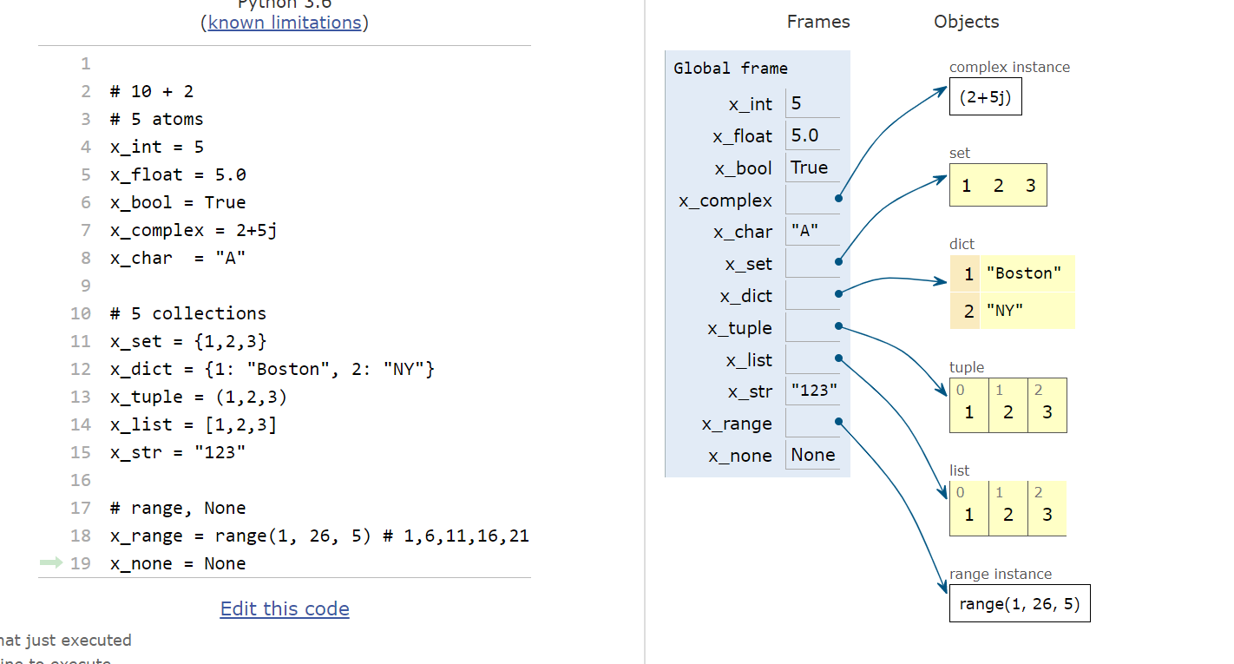

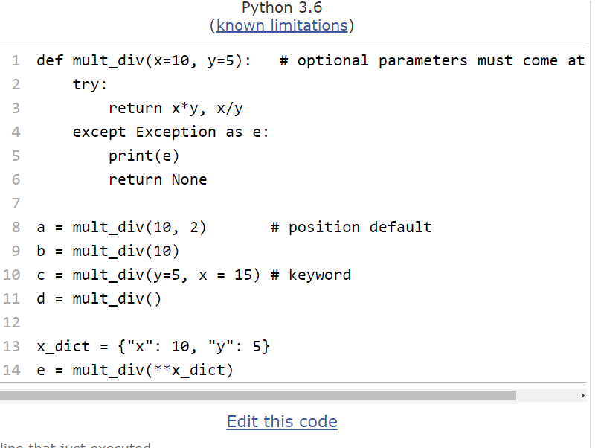

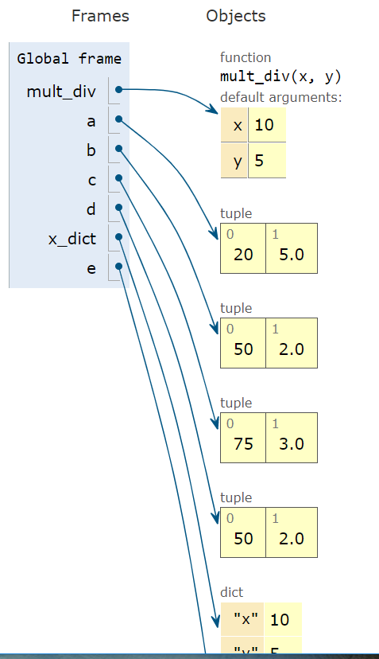

in C/C++ the function signature tells you whether you pass by reference or by value

in VBA (visual basic for applications)

function do_something(byref x as double, byval y as string) as double

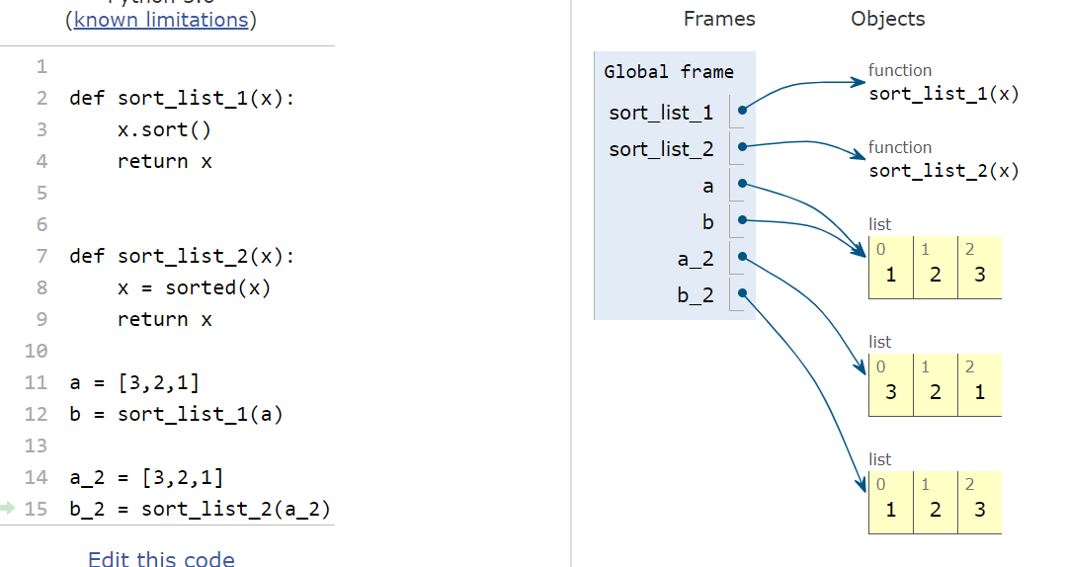

sort_list_1(x) modifies the input object (similar to call by reference)

sort_list_2(x) makes a new object, similar to call by value

How does Python implement “for” loops (internally)?

or in general, how does Python return the next element in a collection?

Answer: Python uses “yield” statement

recursive functions & functional programming

* f(n) = n!
* defined as n*(n-1)*(n-2)*…*1 =

n*f(n-1)

0! = 1

1! = 1 * 0! = 1

2! = 2 * 1! = 2

3! = 3 * 2! = 6

4! = 4 * 3! = 24

f(n) = n * f(n-1)

NOTE: you must make sure that you have the base case (n=0) otherwise you may get an infinite recursion calling

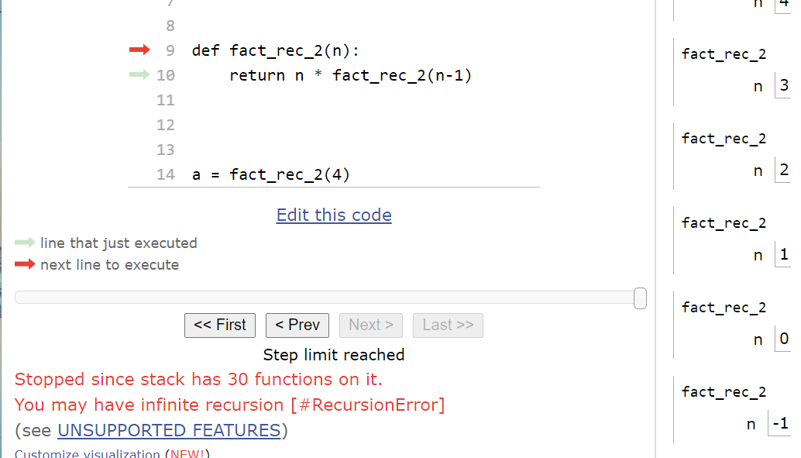

recursive and non-recursive computation for n!

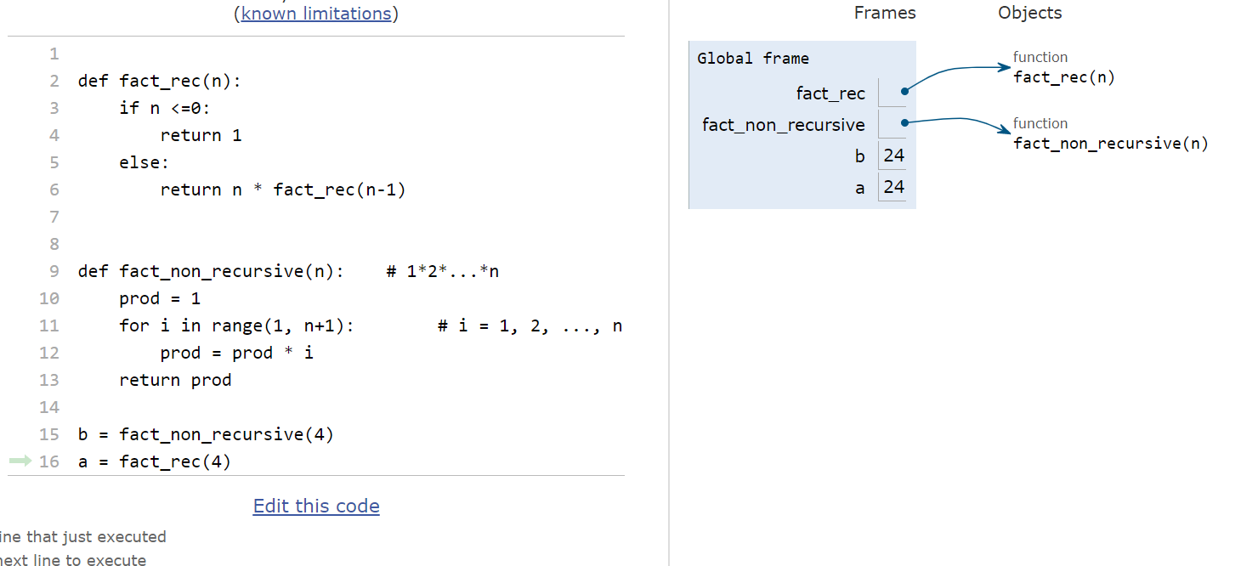

Q: what are advantages and disadvantages of recursive and non-recursive computation?

Advantages of recursive function:

1. less code
2. process hierarchies
3. many algorithms are more easily specified in terms of recursion

Disadvantages:

1. stack overflow
2. insure base cases (possible infinite loops)
3. harder to debug
4. uses more memory and resources

* compute the sum of the first n integers
* 10 --🡪 1+2 + …. + 10

Functional Programming:

filter and map functions

------------------------------------------------------

object oriented programming

x == y

__str__()

STAY HEALTHY AND WELL

See you all next Tuesday !!!!