WELCOME TO CS-521!!!

Tue - Thu, 6-7:30 p.m.

Lecture 5 (Nov 17, 2020)

Week 3:

Homework 3

Quiz 3

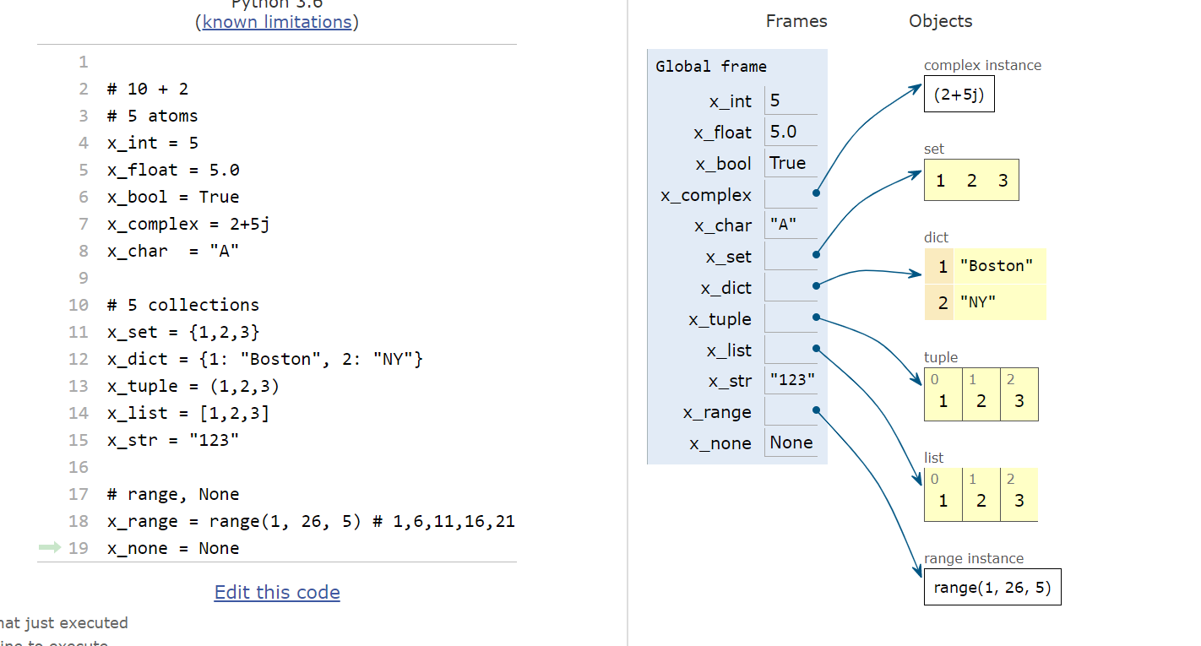

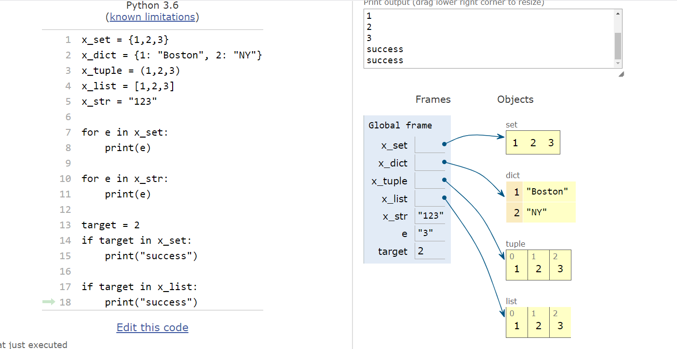

Mutability:

MUTABLE OBJECT: can change the composition of the object and the object “stays” in the same location (its id() does not change)

Example:

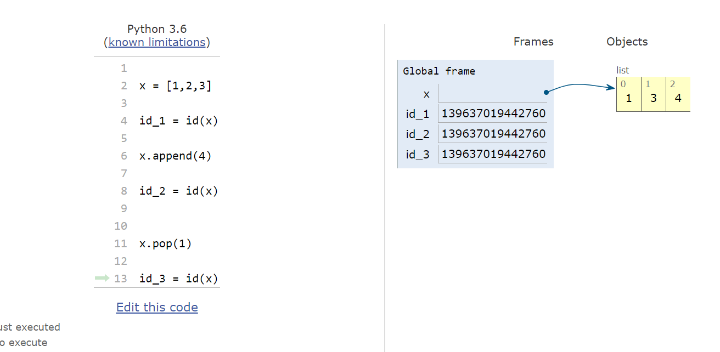

How different is this from:

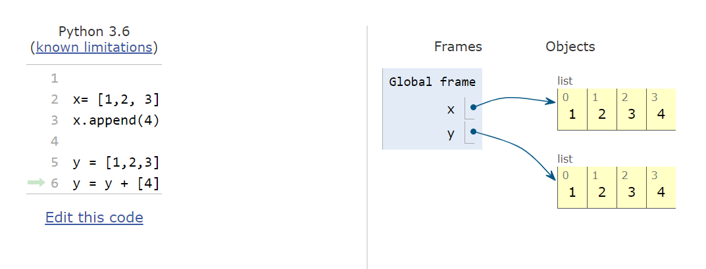

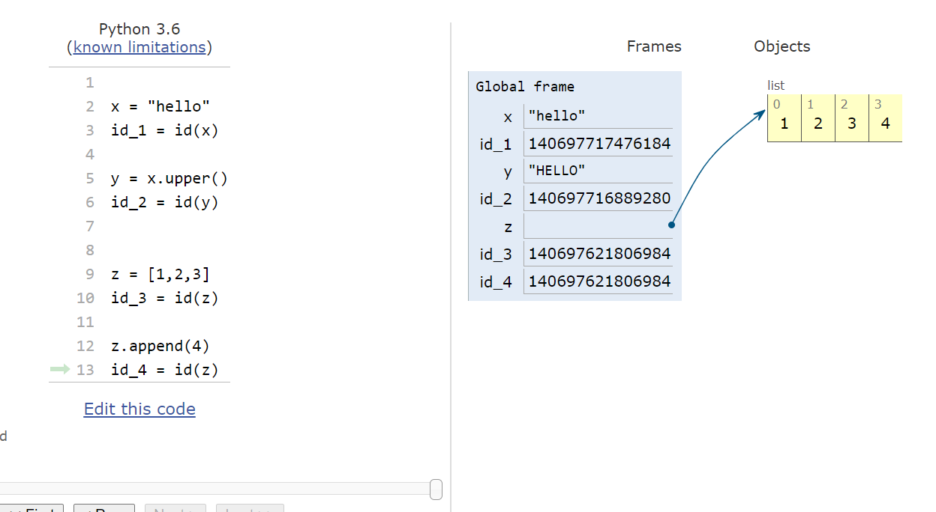

sort vs sorted

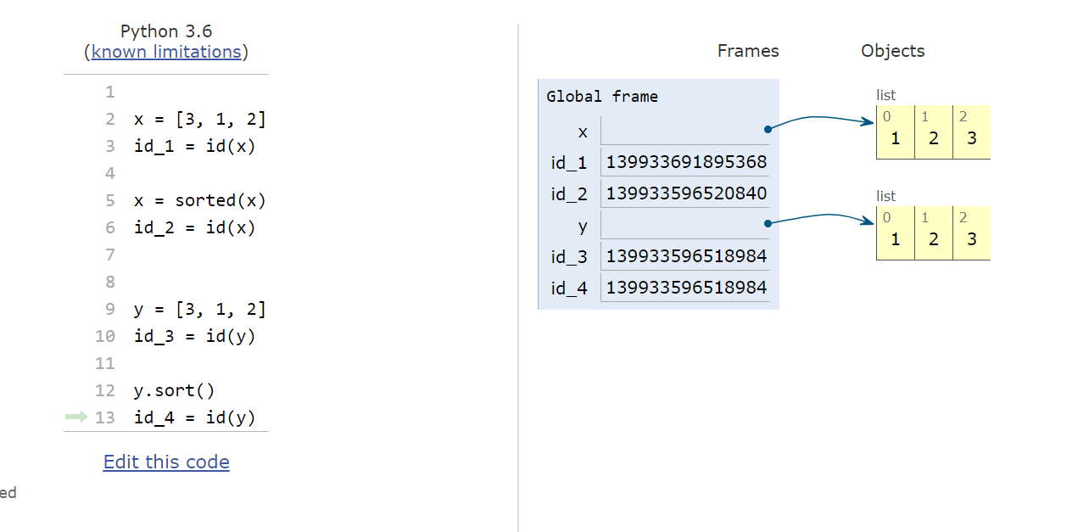

|  |  |  |
| --- | --- | --- |
| Data type | mutable | Could contain mutable elements? |
| “atoms” | no | n/a |
| string | No | No |
| list | **yes** | **yes** |
| tuple | no | **yes** |
| set | yes | no |
| dict | yes | keys: NO,  values: YES |

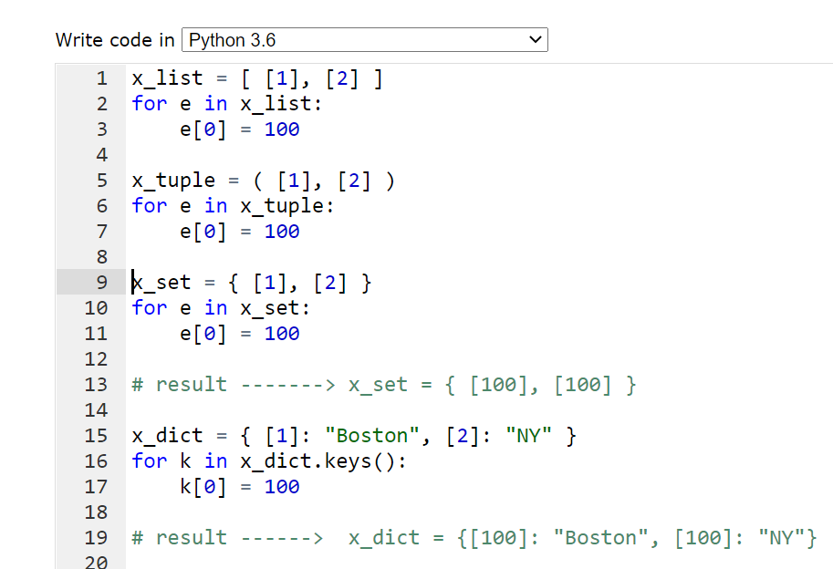

mini-quiz: name two collections A and B:

A: mutable but only with immutable elements

B: non-mutable but could contain mutable elements

A: set (or dictionary)

B: tuple

Collections , then strings

pi:

Rhind Papyrus (23/7)

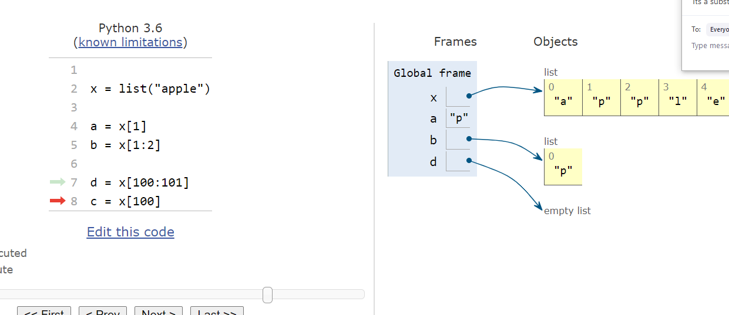

using a slice we never get errors (may get empty list, null string or empty tuple)

using illegal index will generate an error!

task:

given a list, remove all even elements

x = [ 24, 32, 37, 46, 49]

Method:

1. use enumerate to get index and element
2. if element even, pop the element

NEXT: STRINGS

STAY HEALTHY AND WELL

SEE YOU BACK IN TWO DAYS!