# COS30018 Assignment B – Task 2

Aidan Grimmett: 103606838 – Friday 12:30 class

I created a new Python file with the following new function:

Firstly the user inputs the start and end dates for the sampling period

Then it will create a file path that will be used to either retrieve or save a data file

To deal with any NaN records, we drop those values:  
  
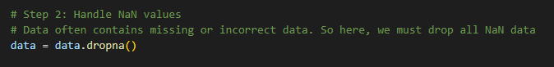  
  
Then the user can choose how the data will be split out of ratio, random or from a specific date into the training and test data sets

Then we scale the data so that all features fit within a specific range. This should enhance the performance of the model in recognising and being able to predict patterns in the data.

Here is the function being used in the main script:

Proof that the code still executes and works:  
  
