# Question 1:

## The two game engines are Unity and Construct 2. I chose to use Unity for this project because:

## Unity can be linked with scripts of code for more complicated tasks, unlike Construct which only has drag-and-drop features for manipulating objects in game.

## Unity provides an exhaustive amount of documentation and tutorials, unlike Construct which is really easy to start with but in depth documentation of how thing work is still helpful to start off without any hassle.

## Unity is building an ever-growing community which can be helpful sometimes for resolving any situations confronted with. Construct 2 has support groups which are helpful as well but not as much in detail as Unity.

## Unity can be more accessible because of its modular system and usability which allows quick development. It has features like drag & drop editing, shaders, animation and other systems already in place to allow diving right into developing a game. It also can produce 3D games unlike Construct.

## The two programming languages are Python and C#. Unity is supported by C#, so the four features of C# are:

## C# is a simple, modern, object oriented language derived from C++ and Java, which where the main languages used in their time.

## C# type safe code can only access the memory location that it has permission to execute. Therefore, it improves a security of the program.

## C# is still updated frequently for more improvements and to keep track with its competitors.

## C# has a rich library, which provides a lot of inbuilt functions that make the development procedure faster.

# Question 2:

## 

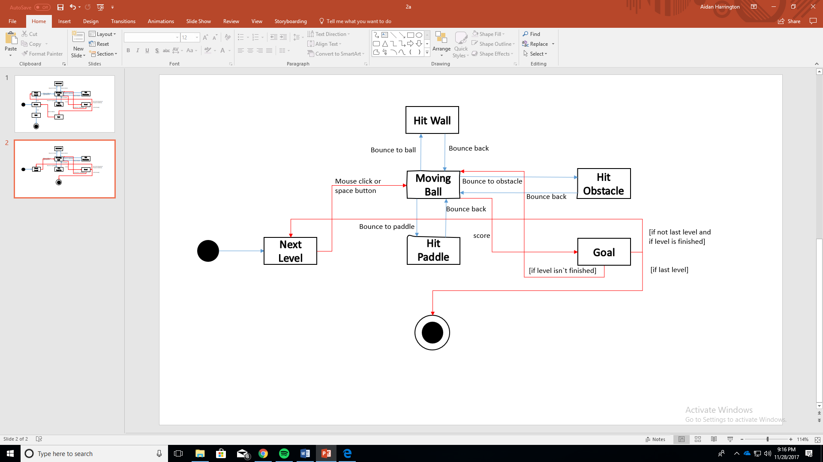

# Question 3

In any case, even if it is online or downloaded for offline, fewer bytes makes a big difference in speed. And so, to take advantage of the computer`s capabilities, we have to make the startup process of the game faster. We do this by making the size of the game`s assets smaller, or otherwise said compressing. This lets you reduce the overall number of bits and bytes so it can be transmitted faster over slower Internet connections, or take up less space on a disk. E.g. Any games must have sprites or images. These can be compressed into smaller files when downloading and after, when opening, your computer uses a special program to resize the files to their normal size.