MEGA

BLASTER

2

Sega Genesis / Mega Drive Video Game Music Player

*User Manual*

Aidan Lawrence

[www.aidanlawrence.com](https://www.aidanlawrence.com)

February 2021

Contents

Quick Start 3

Device Guide 4

SD Card Setup 5

Chip Verification 6

Video Game Music (VGM) Files 7

VGZ vs VGM 7

The Main Menu 8

File Browser (Music Menu) 9

Track Information Screen 10

Info Screen Controls 11

Play Modes 12

Adjust Number of Loops 13

Loop One-offs 14

Rebuild Manifest 14

Audio Performance Considerations (Ground Loops) 15

Firmware Updates 16

Windows, MacOS, and Linux 16

# Quick Start

The Mega Blaster 2 is designed to play both uncompressed (.vgm) and compressed (.vgz) Video Game Music (VGM) files. The device will read-in VGM files from the SD card, parse them, and send the data inside of those files to the sound chips, accurately recreating the music using authentic hardware.

In order to use the Mega Blaster 2, you must have:

* A microSD card formatted to FAT32 (plus an SD card reader for your PC).
* A standard USB-B cable and a USB port (for power. Standard USB phone chargers also work).
* 3.5mm audio cable for external speakers/line devices OR headphones with a 3.5mm jack.
* (Optional USB support) Windows 7 and 8 users will need a driver, which you can [download here.](https://github.com/adafruit/Adafruit_Windows_Drivers/releases/download/2.3.4/adafruit_drivers_2.3.4.0.exe)

Format the SD card to FAT32. Load the SD card with VGM files on your PC. Be sure to remove any non-VGM files (album art images, txt files, m3u files, etc. should not be placed on the SD card). Eject the card and insert it into the Mega Blaster 2. Plug-in the Mega Blaster 2 via USB to power-on. The device will begin to index your files. After indexing, use the menu system to select your tracks.

If you have any questions about the operation of the Mega Blaster 2, feel free to send me an email. You can reach me via my Contact page on my website:

<https://www.aidanlawrence.com/contact/>

# Device Guide

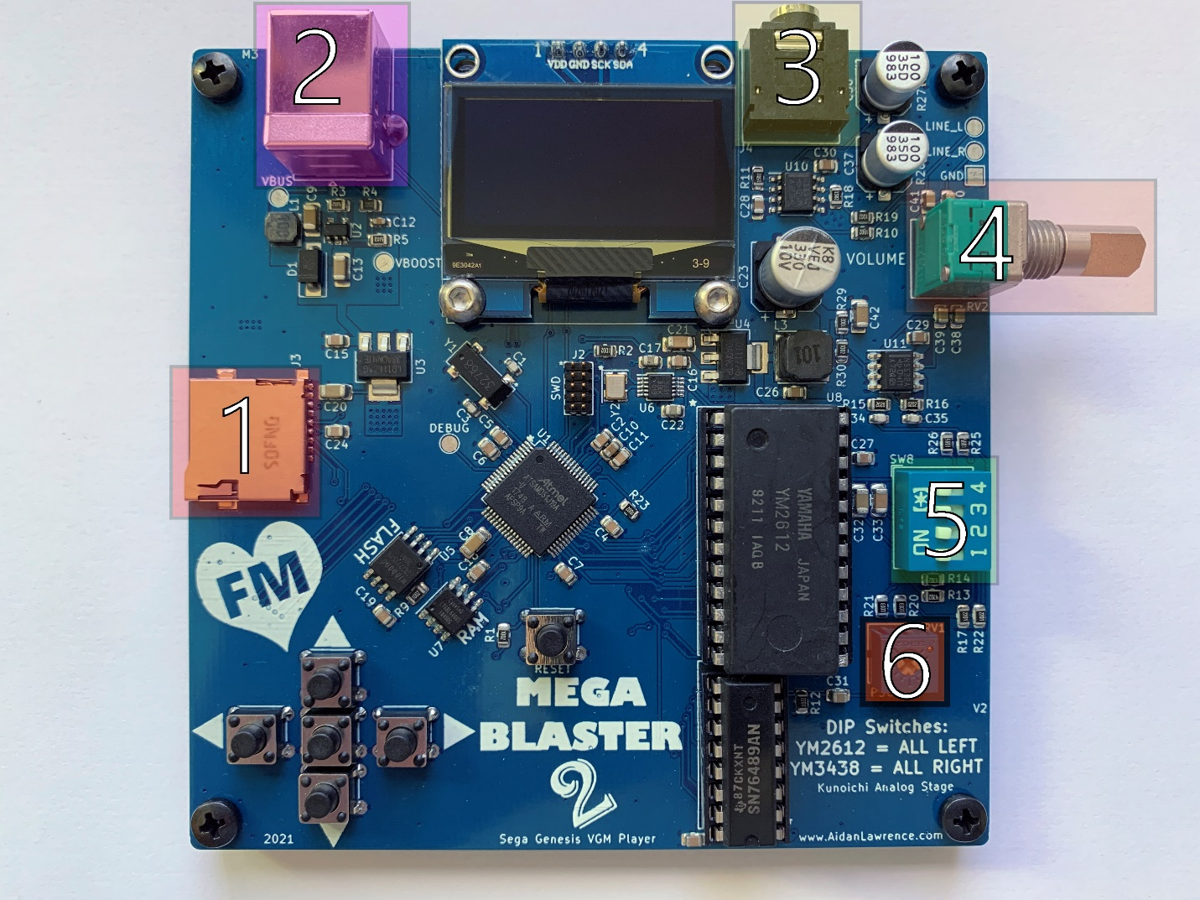

1. **SD Card Socket:** Push your SD card in until you hear a click. Push the card again to eject.
2. **USB Connector:** Power your device using a USB-B cable. Any USB port should be able to supply enough power to the Mega Blaster 2, including PC USB ports and 5V cellphone chargers.
3. **Audio Out Jack:** TRS amplified audio out. The Mega Blaster 2 features a small headphone amplifier, so directly driving phones is OK. Line level outputs are broken out on the upper right-side of the board, though, it’s probably much easier to simply lower the volume for driving line-level input devices if clipping is occurring.
4. **Volume Knob:** A simple volume potentiometer. Clockwise turns increase the volume, counterclockwise turns decrease the volume.
5. **YM2612/YM3438 Selection DIP Switches:** YM2612’s and YM3438’s have different output impedances. Use these DIP switches to select the correct mixing resistors.
   1. **For YM2612:** Set all DIP switches to the LEFT side.
   2. **For YM3438:** Set all DIP switches to the RIGHT side.
6. **PSG (SN76489) Mix Volume:** This potentiometer adjusts the PSG square wave volume. You can use a screwdriver to turn this potentiometer. Clockwise for a quieter PSG, counterclockwise for a louder PSG.

# SD Card Setup

You must format your SD card as a **FAT32** device. You may simply use your built-in operating system’s tools to format your card or use the official formatting tool from the [SD Association.](https://www.sdcard.org/downloads/formatter/)

Folders/directories are supported on the Mega Blaster 2. However, due to memory restrictions, the device will only read one level deep into a directory structure. Basically, that means **you can have folders, but you cannot have folders-within-folders.** Files placed on the root directory of the SD card are also OK.

Please only include .vgm and .vgz files for best performance (.vgz files may take slightly longer to start playing due to decompression). Make sure to delete any non-VGM files.

If your SD card fails to read, the display will warn you on start-up.

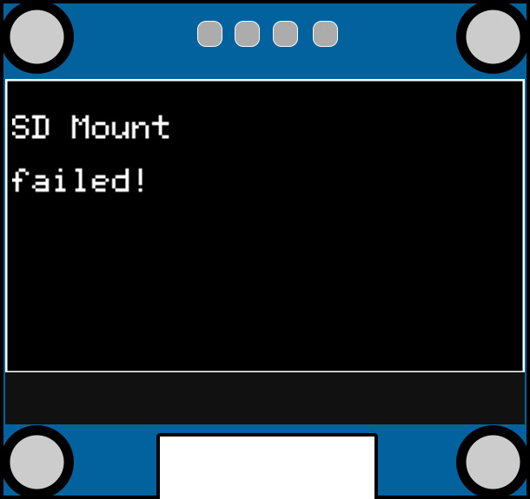

Check that your card is formatted to FAT32 and is not physically damaged. If you happened to have interrupted the card via a reset, programming cycle, or the player has crashed; remove the card, reinsert the card, and then press the RESET button.

On Windows, drives larger than 32GB will lose their option to be formatted as FAT32 devices in the default Windows formatting tool. You can use a tool like [FAT32 Format GUI](http://ridgecrop.co.uk/index.htm?guiformat.htm) to get around this limitation.

# Chip Verification

The Mega Blaster 2 will automatically verify your YM2612/YM3438 chip on every startup by setting the internal timers and listening for specific interrupt intervals from the IRQ pin. If the Mega Blaster does not detect these specific pulses from the IRQ pin within one second after startup, the player will lock up and flash a warning on the screen prompting you to power the device down and remove the offending sound chip. This procedure is to combat the growing number of fraudulent chips being passed as YM2612/YM3438’s and to warn the user before any possible damage occurs from using a counterfeit chip.

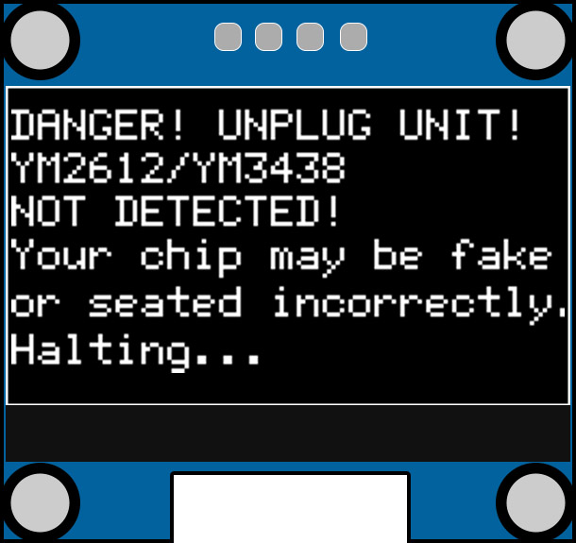

If you see the above message after you power up your device, immediately remove power and remove the YM2612/YM3438. Your chip has likely been detected as a fake. You may also see this message if your chip isn’t seated correctly or there is a hardware fault such as a short circuit or a damaged component.

Regardless of the issue, if you see this screen, then something is not right!

# Video Game Music (VGM) Files

Video Game Music files, referred to as “VGM files,” are essentially log files of the data that was sent to the sound hardware on the real versions of their target consoles/arcade machines. The Mega Blaster will interpret these data logs and send commands to the sound chips at exactly the same times as the real hardware would have sent data over to its sound chips. The result is a 1:1 recreation of the original sound on-demand that’s fed through modern amplification circuitry to produce a crystal-clear output. There is absolutely no emulation here – everything is being synthesized on-the-fly using the genuine sound chips.

You can download Genesis/Mega Drive VGM files here: <https://project2612.org/list.php>

The Mega Blaster 2 also supports any VGM file that leverages the SN76489 PSG, such as Sega Master System VGMs.

Additional VGMs can be found here: <https://vgmrips.net/packs/>

Please note that **Sega CD and 32X VGMs are not supported** as they used separate sound hardware. 3rd party tracks that utilize DAC streams are supported, however. VGMs that use chips other than the YM2612/YM3438 and SN76489 PSG are not supported.

# VGZ vs VGM

VGZ files are compressed VGM files. The Mega Blaster 2 supports both compressed and uncompressed VGM files natively. However, it’s a better idea to use decompressed VGM files on your Mega Blaster 2 as it will drastically increase your performance as no decompress cycle needs to happen before each track.

You can use a tool like [7zip](https://www.7-zip.org/download.html) to easily extract the VGM files out of VGZ files.

File extensions, or lack thereof, do not matter.

Once you’ve added your files, the Mega Blaster 2 will detect any changes in the SD card capacity and will build a file manifest in a newly created “_SYS” folder. You can generally ignore this manifest file as it is only used by the device itself.

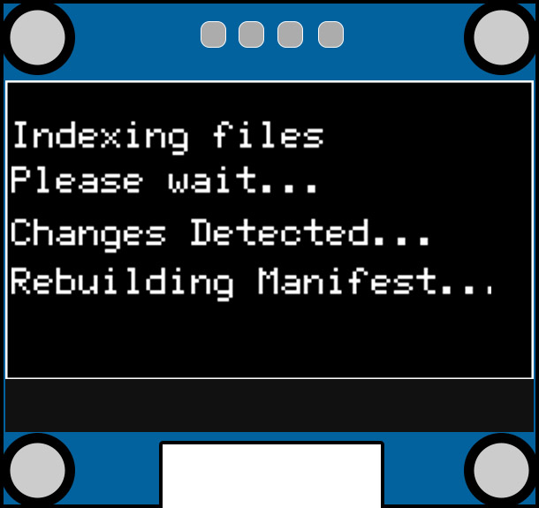

# The Main Menu

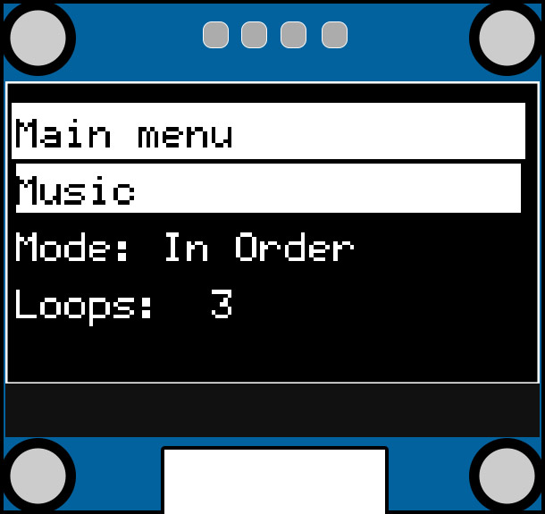

Once your Mega Blaster 2 boots, you will be placed onto the main menu screen. Here, you can access your music browser, change settings, and force a manifest rebuild if need be.

You can use the directional buttons on the bottom left of the Mega Blaster 2 to move around this menu. The middle “select” button (and the right arrow button) can be used to enter menus and options. 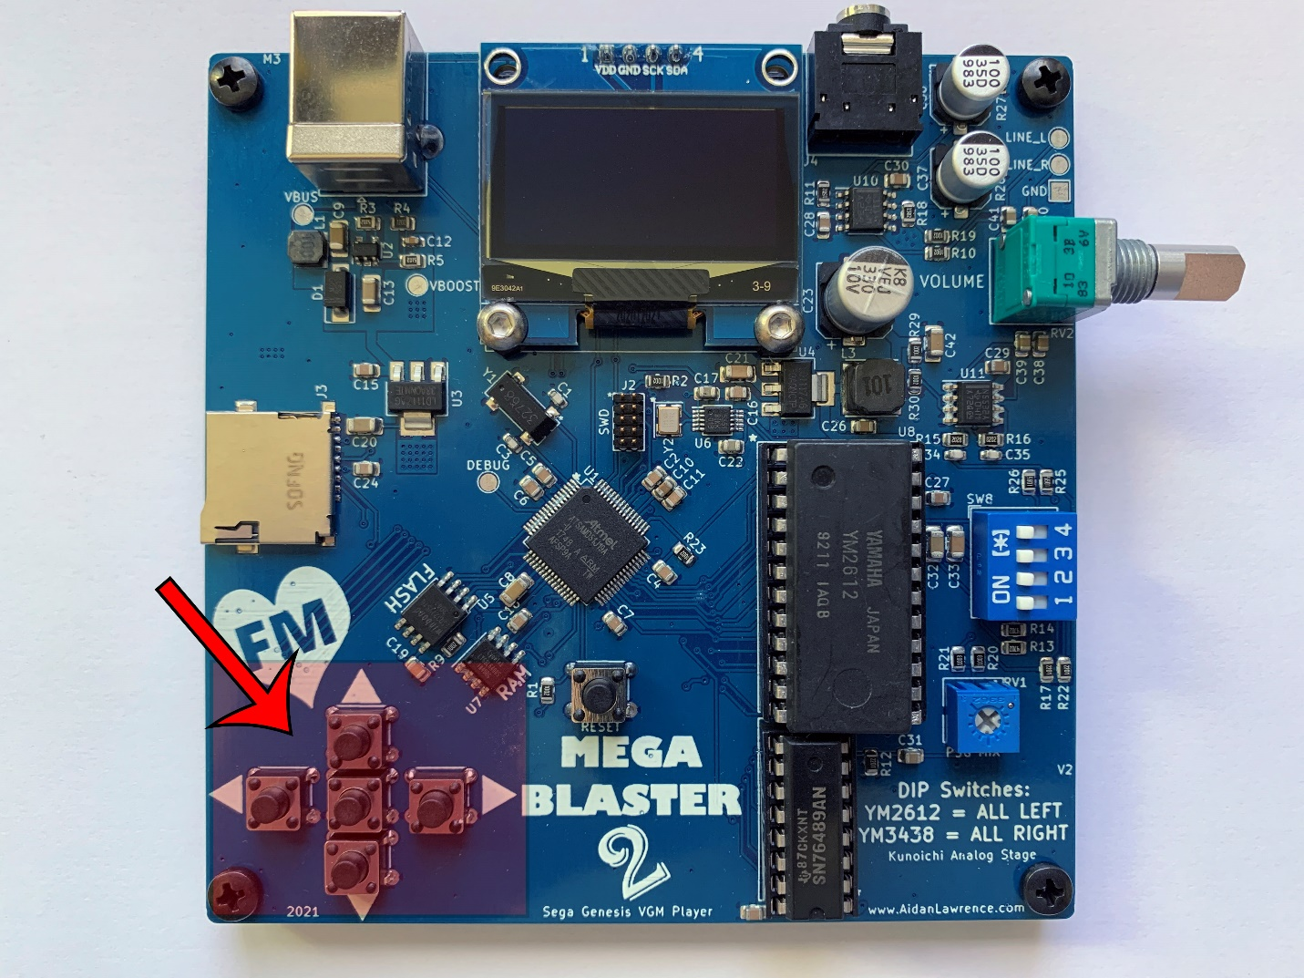

# File Browser (Music Menu)

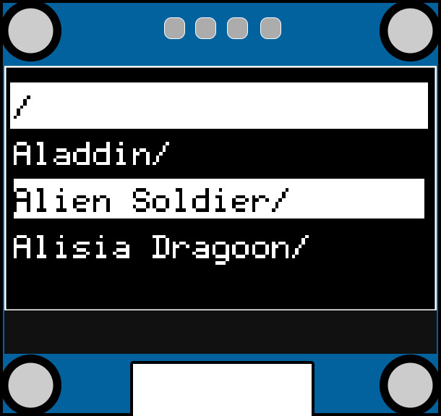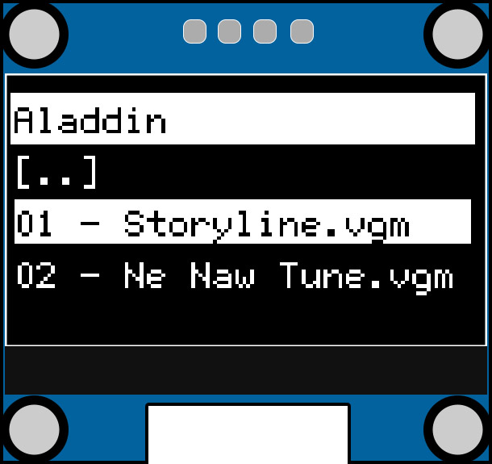

To access your video game music tracks, you will need to interface with the file browser found under the “Music” main menu option.

Simply use the up and down keys to scroll through your folders and files. You can enter directories and select files using the middle select button or the right arrow button. You can leave a directory by using the left arrow button, or by selecting the [..] entry.

Once a valid VGM or VGZ file is selected, the player will automatically verify it and begin playing. You will be taken to the Track Information screen.

Note: the _SYS directory is created by the Mega Blaster 2 itself and should simply be ignored. This directory is where the manifest file is stored. The _SYS directory is also where file decompression occurs.

Files are read in-order directly from the SD card. They are not sorted in alphabetical order. If you’d like your SD card to be sorted in alphabetical order, you will need a tool that sorts your files in advance.

[SD Sorter](https://www.trustfm.net/software/utilities/SDSorter.php) does this admirably.

# Track Information Screen

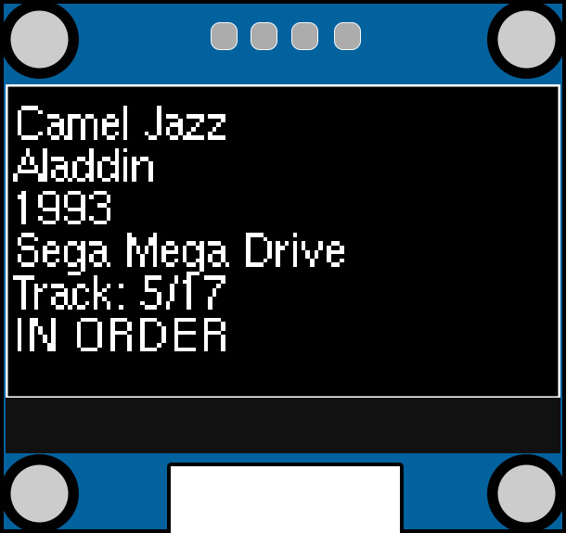

While the device is playing a track, the information screen will appear. Here, you will see the following information:

**Track name**

**Game Name**

**Date of Game Release**

**Game System**

**Track #/# of total tracks in directory**

**Play Mode (IN ORDER/LOOP/SHUFFLE DIR/SHUFFLE ALL)**

You can exit this screen at any time and return to the menu system by pressing the middle select button.

If you idle in the menu system, the Mega Blaster 2 will automatically return to this screen.

If you are in the “Shuffle Dir” or “Shuffle All” play mode, the current track number is not shown.

# Info Screen Controls

While in the information screen, your controls will automatically change to playback controls.

The up and down keys are disabled.

The middle select button will return you to the menu system.

The left and right buttons will move you forwards or backwards through the tracks depending on your current play mode.

If you are set to the “In Order” or “Loop” play mode, your left and right buttons will cycle through the files in your current directory in order.

If you are set to the “Shuffle All” or “Shuffle Dir” play mode, your left and right buttons can be used to travel in-order through the random shuffle history. Once you’ve reached the near-end of the random shuffle history using the left arrow button, you won’t be allowed to go back any further. Once you’ve reached the far-end of the shuffle history using the right arrow button, a new track will be randomly selected and stored in the shuffle history in case you’d like to go back to it at any point.

# Play Modes

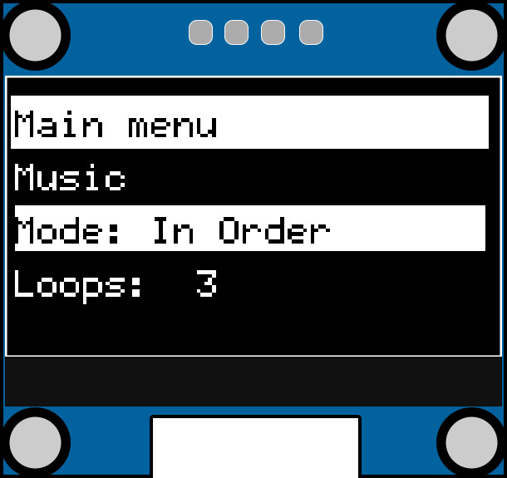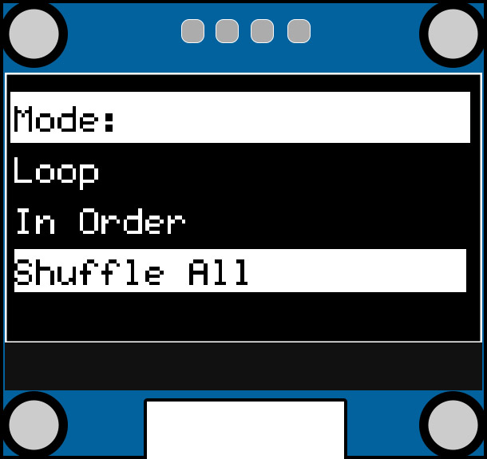

The Play Mode menu allows you to select the player’s automatic track swapping behavior.

There are 4 possible play modes to choose from:

**Loop:** Re-play the current track perpetually until manually changed by the user.

**In Order:** Once a track is chosen, the player will automatically proceed to the next track file in the current directory after the previous track ends.

**Shuffle All:** This option will automatically start playing the *entire SD card*in a random order. Every single VGM track on-board is eligible to be selected at random after each track ends.

**Shuffle Dir:** Similar to the “Shuffle All” function, but the pool of tracks to pick from is confined to a single directory.

The default value is “In Order.”

# Adjust Number of Loops

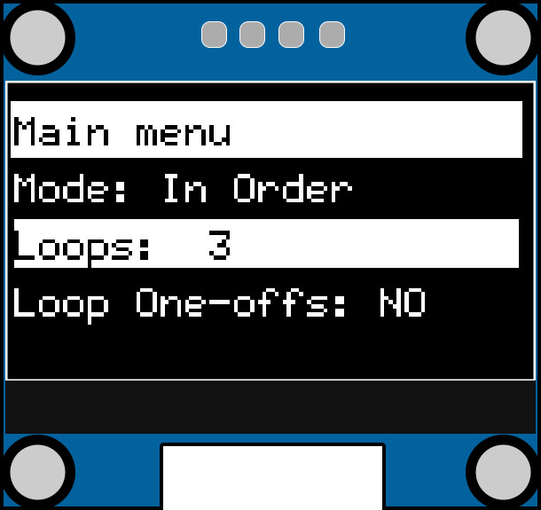

The “Loops” option will allow you to change the number of times a track will loop before ending. To change the loops value, highlight it with your cursor and hit the middle select button.

For fine control, hit the select button once. A colon character ( : ) will appear next to the value. Use the up and down buttons to adjust the loops by 1.

For coarse control, hit the select button once again. An angle bracket character ( > ) will appear next to the value. Use the up and down buttons to adjust the loops by 10.

Finally, hit the selection button once more to exit.

The default value is “3.”

Note: If your play mode is set to “Loop,” this value will be set to 65535 (Internally, the Mega Blaster 2 reads this as 0xFFFF, indicating that a track should be looped forever).

# Loop One-offs

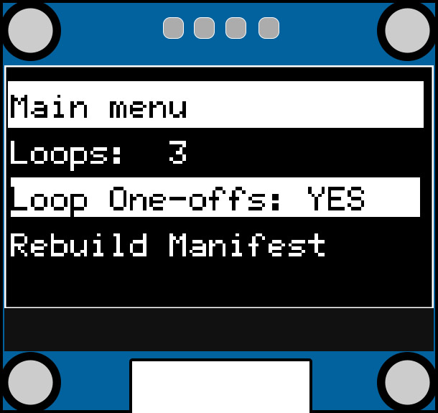

This option will give you the ability to change if one-off tracks will loop just like any other track. Usually, one-off tracks are things like game-over themes, intro themes, or other minor jingles.

You can adjust this setting by highlighting the option, hitting the middle select button, then using the up and down buttons to change the value. Once you’ve selected your value, hit the middle select button again to set.

This option defaults to “NO.”

# Rebuild Manifest

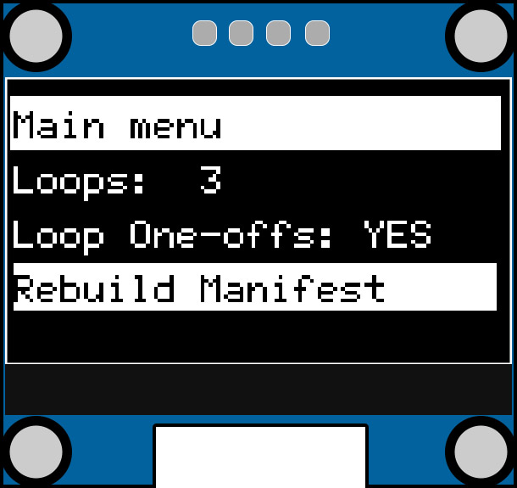

The Mega Blaster 2 creates a manifest file that stores information about the files on the SD card. Normally, this manifest is automatically built on startup when changes to the SD card are detected. However, if you’d like to manually force a manifest rebuild, selecting this option will do so. This option is useful if your manifest file is ever damaged or undetectable changes (such as renaming files) occur.

# Audio Performance Considerations

The Mega Blaster 2 uses custom power filtering circuitry and careful PCB routing to ensure the best possible signal-to-noise ratio. Any device with a USB port should be able to power the Mega Blaster 2 just fine, but there are still a few considerations to make depending on your configuration.

Ground Loops

If you power your Mega Blaster 2 via your computer’s USB port *and* connect the audio output to the same computer’s line-in, you will form a ground loop and will likely hear a loud buzzing noise or amplified electromagnetic interference. You can easily solve this issue with a cheap ground loop isolator. They look like this:

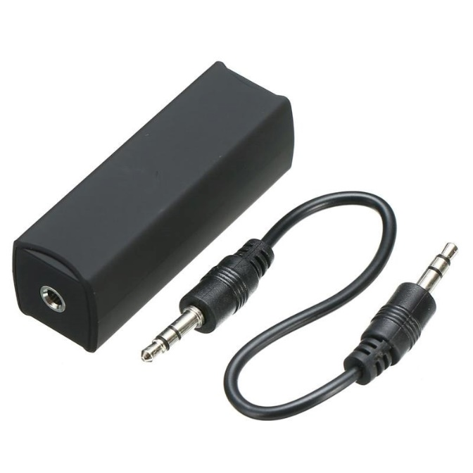

Keep in mind that many ground loop isolators are designed with a low-pass filter built-in and this can affect audio quality, so please do your research before purchasing one. Users with headphones directly connected to the Mega Blaster 2 will not have to worry about such ground loops.

On the topic of headphones: The Mega Blaster 2 does feature a small headphone amplifier on its output. The onboard headphone amplifier is the TPA6111A2 and is capable of delivering up to 150mW of power directly to headphones. The TPA6111A2 is a linear class AB amplifier. You can read more about its specifications in the [TI datasheet.](https://www.ti.com/lit/ds/symlink/tpa6111a2.pdf?ts=1612621494673)

Finally, it’s important to distinguish the noise floor differences between the YM2612 and the YM3438. The YM2612 has a higher noise floor than the YM3438. YM2612 users may be able to hear a very slight white-noise hiss when the unit is not playing any music. This is totally normal and is an artifact of the time-division multiplexor cycling through each of the FM channels. There is no way around this noise floor as it is literally the YM2612 itself producing it. It’s one of the quirks of using real hardware instead of an emulator! The YM3438 has a noticeably lower noise floor.

# Firmware Updates

The Mega Blaster 2 features an easy-to-use UF2 bootloader which makes updating the onboard firmware as easy as dragging a file to a flash drive.

## Windows, MacOS, and Linux

If you’re using a Windows 10, MacOS, or Linux computer, your driver should install automatically. Otherwise, Windows 7 and 8 users should install the [Adafruit drivers found here.](https://github.com/adafruit/Adafruit_Windows_Drivers/releases/download/2.3.4/adafruit_drivers_2.3.4.0.exe)

Updating your firmware is as simple:

1. Download the latest .uf2 firmware file from the [GitHub Repository Releases](https://github.com/AidanHockey5/MegaBlaster2/releases/) page.
2. Double-tap the RESET button on your Mega Blaster 2. A new “drive” named “MB2BOOT” should pop up and/or be available in your “This Computer” or drive browser.
3. Drag the UF2 firmware file on to this “drive” just like a flash drive. Once the Mega Blaster 2 verifies the file, it will automatically flash itself and reboot.
4. You may need to remove and reinsert your SD card, then hit the RESET button a single time.

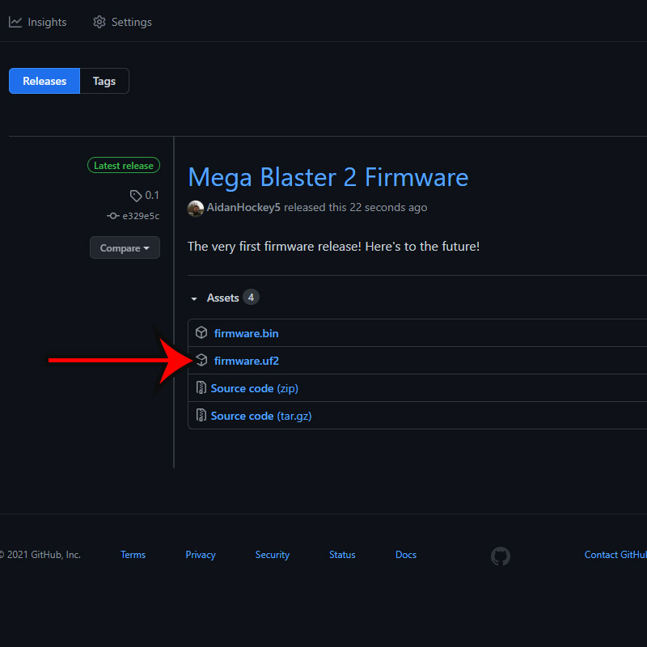

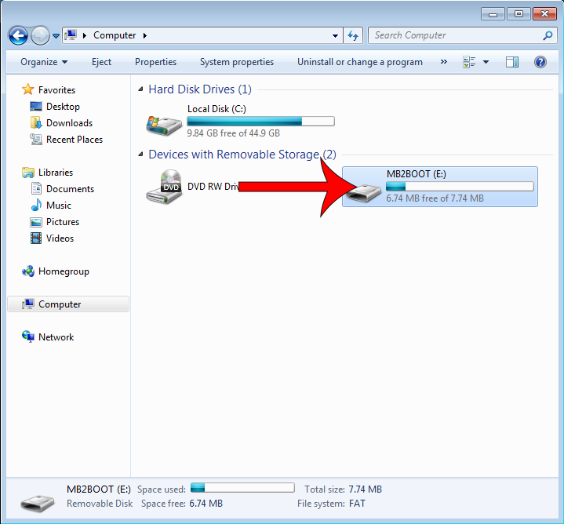

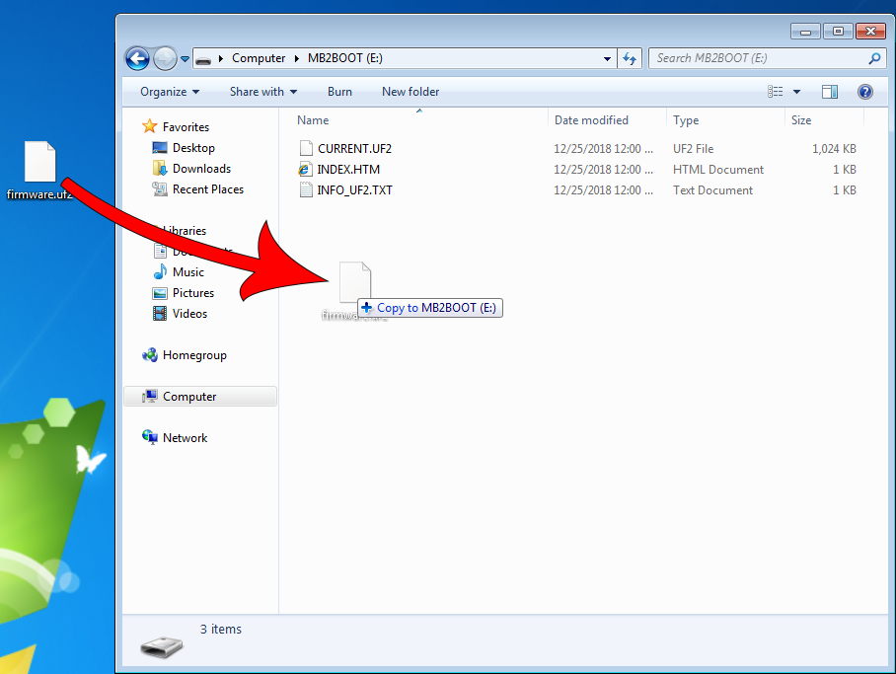

The process is the same for MacOS and Linux (lubuntu shown here).

