**Comp 1004**

**Computing Practice**

**2023/2024**

**Library Management System**

**By Aidan Scoles**

Github repo link: <https://github.com/AidanJWS/Final-Year-Project>

# Introduction

This report presents the project plan for the COMP1004 module coursework. I have chosen to make a library management system to allow librarians to manage the books by allowing them to add, remove and edit details about the books. This library system will also make it much easier for the patrons to access the library's resources quickly and efficiently, allowing them to view what books are available and what is not. This report discusses the Software Development Lifecycle (SDLC) and explains how this is applied to the current project.

# Software Development Lifecycle

I have been producing this assignment by using the Agile software development lifecycle. I believe I have successfully followed the steps in an agile project. I realise that I was not very consistent with my sprints, however, as I was not particularly managing my time every week throughout the project's lifetime.

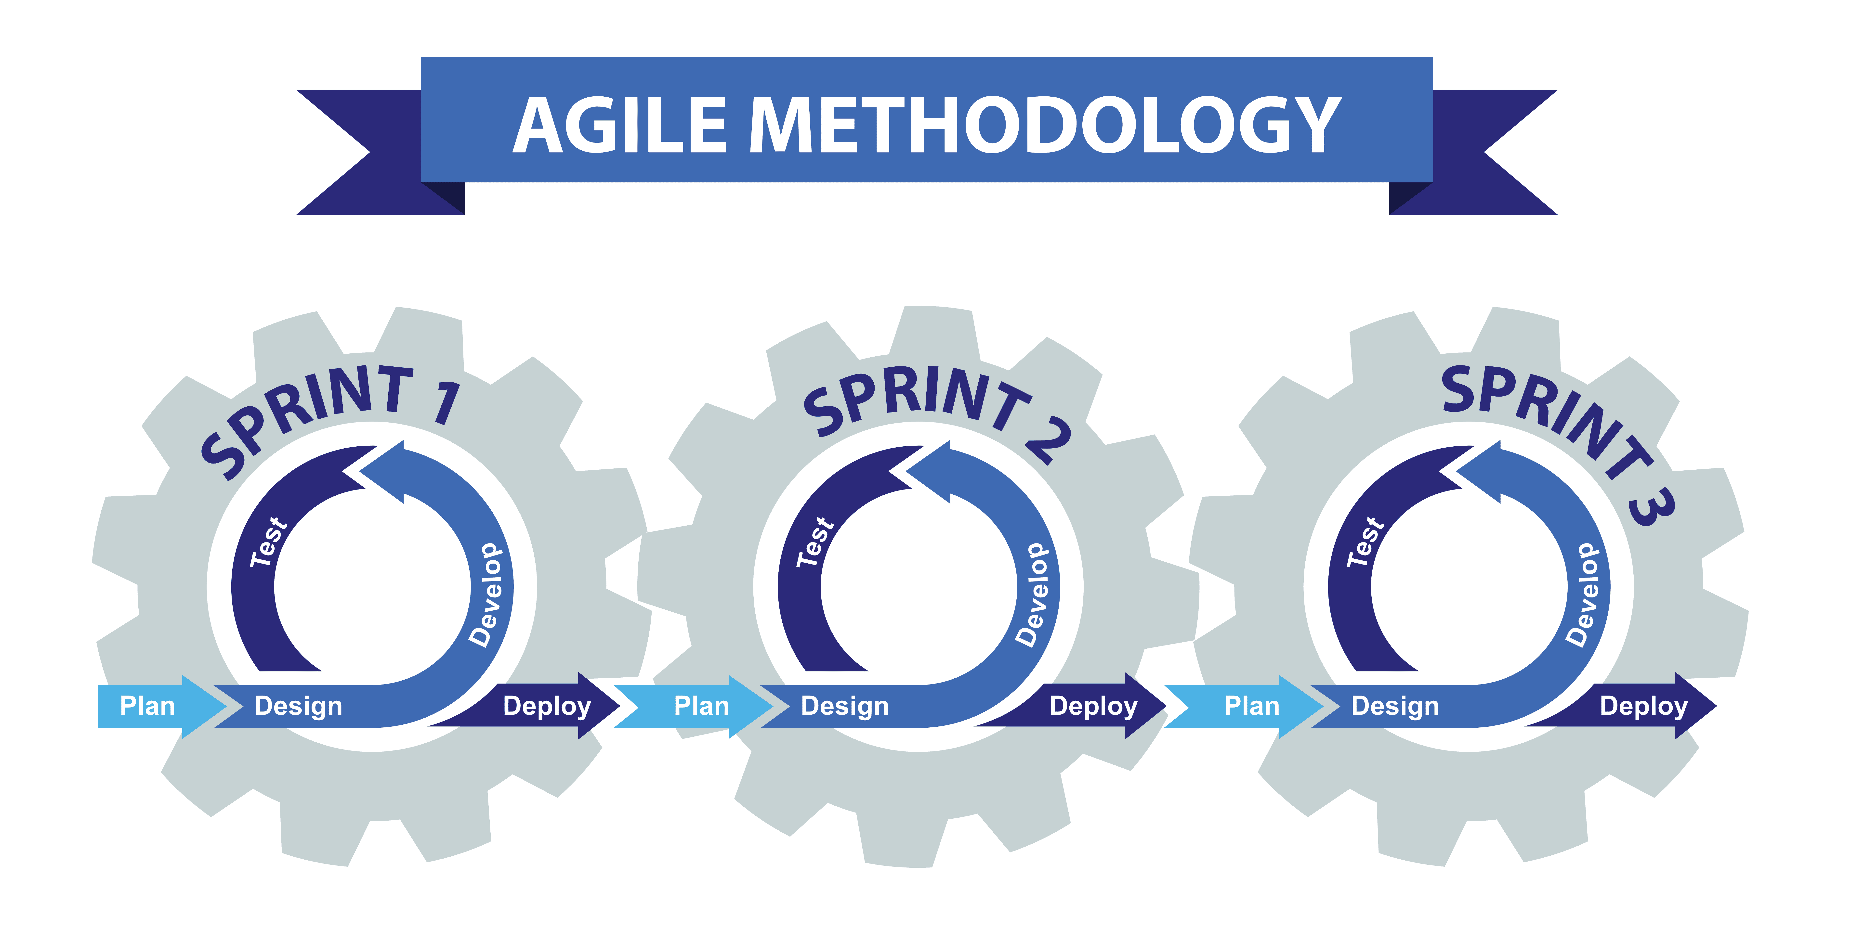

(Mungfali. (n.d.). *Phases Of Agile Methodology)*

I do believe that I somewhat followed a waterfall methodology at the start of the project. Still, after the planning was all done, I fully started using the agile method as I was adding new features, testing them constantly, and then moving on to the next after I finished with them.

# Design Documentation

This section provides the key elements of the design documentation.

## Project Vision

Transforming libraries with an advanced Management System for seamless operations, enhanced user experiences, and enriched community engagement.

## Background

The Library Management System (LMS) project is designed to modernise and optimise library operations, providing a comprehensive solution for effective library management. Libraries, essential knowledge repositories, face challenges in manual processes, resource tracking, and accessibility. The LMS project aims to address these challenges by leveraging technology to enhance the library's overall efficiency, accessibility, and user experience.

## User Stories and Associated Use Case Scenarios

This section examines the user stories identified and provides the accompanying use case scenarios.

## User Stories

|  |  |
| --- | --- |
| Library Patron | Librarian |
| As a library patron, I want to be able to search for books by title, author, or genre so that I can easily find the books in which I am interested. | As a librarian, I want to be able to add new books to the library's catalogue, including title, author, genre, and ISBN, so that the library's collection is up to date. |
| As a library patron, I want to place holds on books that are currently checked out so I can reserve a copy for when it becomes available. | As a librarian, I want to be able to mark books as "checked out" and "returned" in the system to keep track of which books are currently in circulation. |
| As a library patron, I want the application to have a simple and easy-to-understand UI so I can easily navigate through the application. | As a Librarian, I want to be able to edit details about the books to ensure they are kept up to date and to correct details that aren’t accurate. |

## Use Case Diagram

This section shows the Use Case Diagram and how I expect for the website to work when each button is pressed.

*(Visual Paradigm (2019))*

## Use Case Descriptions

In this section, I am making Use of Case Descriptions to give more depth and detail to the Use Case Diagrams by using actual examples of what to expect when they are entered and what other processes could happen if they are not put in correctly.

The template for this is from UML @ Classroom book (Seidl, Brandsteidl, Huemer and Kappel, 2012)

|  |  |
| --- | --- |
| Name | Add Book |
| Short Description | Adds a new book |
| Precondition | The librarian must have all the book details. |
| Post Condition | The book has been added to the library. |
| Error Situations | Field data are not correct/ not formatted correctly. |
| System State in the event of an error | The book cannot be added |
| Actors | Librarian |
| Triggers | Librarian requires to add a new book. |
| Standard Process | 1. Librarian presses Add new book button. 2. The librarian enters all details for the book, such as title, author, ISBN, genre, and published year and status. 3. The librarian clicks on the add new book button. 4. System checks to ensure all fields have data and are formatted correctly. 5. The system then adds the book to the library system. |
| Alternative Process | 3’ The fields do not contain data or are formatted incorrectly.  4’ System does not add the book to the library.  5’ Librarian enters all details again |

|  |  |
| --- | --- |
| Name | Remove Book |
| Description | Removes a book |
| Precondition | The librarian must have all the book details. |
| Post Condition | The book has been removed from the library. |
| Error Situations | Field data are not correct/ not formatted correctly. |
| System State in the event of an error | The book cannot be removed |
| Actors | Librarian |
| Triggers | Librarian requires to remove a book. |
| Standard Process | 1. Librarian presses remove button book. 2. The librarian enters all details for the book, such as title, author, ISBN, genre, and published year and status. 3. The librarian clicks on the remove book button. 4. System checks to ensure all fields have data and are formatted correctly. 5. The system then removes the book from the library. |
| Alternative Process | 3’ The fields do not contain data or are formatted incorrectly.  4’ System does not remove book from system  5’ Librarian enters all details again. |

|  |  |
| --- | --- |
| Name | Edit book |
| Description | Edits the book details |
| Precondition | Librarian has new details for the book. |
| Post Condition | Details are updated |
| Error Situations | Book does not exist/ field data needs to be corrected/ appropriately formatted. |
| System State in the event of an error | Book details cannot be edited |
| Actors | Librarian |
| Triggers | Librarians require to change the details of the book. |
| Standard Process | 1. Librarian presses edit book button. 2. Librarians enter all the fields for the book they are looking for, such as title, author, ISBN, genre, published year, and status. 3. Librarian clicks on edit button. 4. System checks to see if book exists. 5. Librarian enters and fills in all the new details for the book and clicks confirm. 6. System checks to see if fields are filled in and formatted correctly. 7. The system then overwrites old book details with new ones and stores them in the library. |
| Alternative Process 1 | 3’ Book does not exist in the library  4’ System does not edit book details  5’ Librarian enters all details in again. |
| Alternative Process 2 | 5’ The fields do not contain data or are formatted incorrectly.  6’ System does not edit book details  7’ Librarian enters all details again. |

|  |  |
| --- | --- |
| Name | Search book |
| Description | Searches for a book in the library |
| Precondition | The user knows what book they want to look for. |
| Post Condition | Books are displayed based on user input. |
| Error Situations | The book does not meet any criteria of the user’s input. |
| System State in the event of an error | No books or details are displayed. |
| Actors | Patron |
| Triggers | Patron wants to look for a book. |
| Standard Process | 1. Patron clicks on the search bar. 2. Patron enters any keyword for any of the following: title, author, ISBN, genre, published year and status. 3. System checks to see if any of the books meet the criteria of the user’s search. 4. The System displays all the books that meet the criteria of the user’s search. |
| Alternative Process | 3’ The user’s search does not meet any criteria  4’ Nothing is displayed |

|  |  |
| --- | --- |
| Name | Check Availability and Hold book |
| Description | Check if the book is available; the user can put it on hold when it becomes available again. |
| Precondition | The user knows what book they want to look for. |
| Post Condition | Books are displayed, and the user can check availability and place the book on hold. |
| Error Situations | Books do meet the criteria. |
| System State in the event of an error | No books or details are displayed |
| Actors | Patron |
| Triggers | Patron wants to check the book's availability or place it on hold. |
| Standard Process | 1. Patron clicks on the search bar. 2. Patron enters any keyword for any of the following: title, author, ISBN, genre, published year and status. 3. System checks to see if any of the books meet the criteria of the user’s search. 4. The System displays all the books that meet the criteria of the user’s search. 5. Patron clicks on the book they want and click on the checkout button. 6. The system checks to see if the book has been checked out. 7. Patron can then check the book out or place it on hold for when it becomes available again. |
| Alternative Process | 3’ The user’s search does not meet any criteria  4’ Nothing is displayed |

# Architecture

This section discusses how the architecture for the single-page application is envisaged.

## Sequence Diagrams

Add Book Button

Remove Book Button

Edit Book Button

Search Bar

## Sitemap

This section provides an outline of how the application is designed. This is a single-page application, but the sitemap indicates how the user will navigate the topics.

## Wireframe Diagram

This section illustrates the wireframes, which show how the base layout of the website and each section will look when they are first loaded.

# Sprint Plans

At the beginning of each sprint, I will add activities to the Sprint backlog which I want to complete for that sprint. If I have started doing the task, it will be put in the “in progress” column, and once it is completed, it will then be moved to the “Finished in sprint” column.

At the end of each sprint, I will evaluate what I have managed to do in the sprint and the tasks that have been completed. I have taken a screenshot of the Kanban board at the start of each sprint to show what needs to be completed. I then reset the Kanban board for the beginning of the next sprint, moving everything in the “finished in sprint” column to the “done” column.

## **Sprint 1** 22/11/23 – 6/12/23

I plan to relearn the program languages and create the planning document.

**Start:**

**End:**

**Sprint Review**

I spent most of my time practising the programming languages I was taught for my project and making my library.json file containing the library's contents. I also quickly identified that since I was never taught anything about JSON files, I looked up how to read the JSON file on a website so it would hasten my time making the website. *(gomakethings.com. (2021))*

## **Sprint 2** 6/12/23 – 20/12/23

I am planning on researching and completing the diagrams for the documentation.

**Start:**

**End:**

**Sprint Review**

I spent most of my time researching and completing the planning documentation, as I had never heard of many of these diagrams before. I also started writing up some simple HTML and CSS for the website.

## **Sprint 3** 03/01/24 – 17/01/24

I am planning to create my prototype, presentation, and video by the submission deadline.

**Start:**

**End:**

**Sprint Review**

I spent most of the time on this sprint doing the presentation, prototype, and video for the submission. To ensure that I completed the video within 4 minutes, as stated in the criteria, I made a script to make sure what I said was clear, concise, and straight to the point.

## **Sprint 4** 07/02/24 – 21/02/24

I plan to focus on the website's layout, so it looks like my deigns.

**Start:**

**End:**

**Sprint Review**

Most of my time was spent working on the design and layout of the website and forms to make sure they looked like the designs that I made.

While producing the website during this sprint, I realised that I would have to consider getting some support on how I would make it so I can write back to the JSON file as I can currently read from the file but cannot write and save the data to it.

I have also talked with a friend about seeing which librarian has edited the books. It could have a unique ID to enter so it shows who the last person was to edit the details of the book/ add the book to the system. This is what I would like to have implemented in the future.

## **Sprint** **5** 21/02/2024 – 06/03/2024

I plan to focus on the website's functionality by programming all the buttons.

**Start:**

**End:**

**Sprint Review**

Most of my time was spent researching and trying to develop the buttons so they did exactly what I wanted. I had some problems with this, but I managed to complete half the buttons and made sure that all fields were formatted and filled in on the forms.

## **Sprint 6** 06/03/2024 – 20/03/2024

I plan to finish off the rest of the buttons this week and potentially work on developing the layout to make it more appealing to the user.

**Start:**

**After:**

**Sprint Review:**

I spent most of my time doing the buttons and did a lot of other assignment work this week, so little progress was made. I am pleased that all the buttons now output what is expected, but unfortunately, I still had issues with writing back to the JSON.

## **Sprint 7** 03/04/2024 – 17/04/2024

This is my last sprint before I hand in the year project. I will mainly focus on producing the poster and finishing all the documentation, so I have handed in everything on time for the hand-in date.

**Start:**

**After:**

**Sprint Review:**

As you can see, I only made the poster and finished the documentation, and I couldn’t finish the tasks where I had to improve the UI, as I did not have a lot of time to do them whilst I was finishing up the documentation.

# Noted Issues and Challenges

Embarking on Sprint 1, I realised the importance of refreshing my programming language skills. Over time, I had forgotten much, making it essential for the website project. While this decision meant sacrificing time that could've been used elsewhere, it was a necessary step to ensure the success of the project.

In Sprint 2, I stumbled upon a simple yet critical mistake in the sequence diagrams. They still referred to "actors" instead of specific roles like "librarian" or "library patron." Additionally, using free software posed challenges as it wouldn't let me save progress, forcing me to redo all the diagrams. This felt like a significant waste of time for a minor fix, leading to frustration and reevaluating my tool choices.

Sprint 3 encountered setbacks due to Christmas distractions, delaying progress on the video prototype. Juggling assignments added to the chaos, limiting the time I could dedicate to sprint tasks. Despite my best efforts to stay on track, external factors impeded my progress, underscoring the need for flexibility in project planning.

Sprint 4 saw me getting sidetracked by new units, forgetting about the Year project and missing two sprints. It served as a wake-up call to manage workload better and prioritise tasks effectively. Reflecting on this oversight, I recognised the importance of balancing exploring new opportunities and fulfilling existing commitments.

In Sprint 5, coding issues arose, particularly with writing JSON files back onto the system. Despite numerous attempts, I had to set it aside to focus on completing other tasks. This decision was not taken lightly, as resolving the issue was crucial for the project's functionality. However, with time constraints looming, I had to make tough decisions about where to allocate my resources for maximum impact.

Sprint 6 brought further struggles with code and time management. Despite my best efforts, I fell short of my goals for the week. As the pressure mounted, I sought support from peers and mentors to overcome technical challenges and stay motivated. This experience highlighted the importance of seeking needed help and leveraging resources effectively to overcome obstacles.

Transitioning to Sprint 7, other assignments occupied me, leaving little time for project work. Only towards the end did I realise the need to prioritise the poster and documentation, leaving UI improvements unfinished. While disappointing, this experience reinforced the importance of effective time management and prioritisation in achieving project goals.

In summary, these sprints presented various challenges that tested my skills and resilience as a developer. Each setback offered valuable lessons in project management and problem-solving, helping me grow personally and professionally. As I continue on this journey, I am confident that I will emerge more robust and more capable of overcoming future challenges that come my way.

Moreover, these sprints have fostered a deeper understanding of my capabilities and limitations, prompting introspection and growth. Through perseverance and determination, I've navigated through setbacks, emerging more resilient and adaptable. As I press forward, I remain committed to learning from each experience, harnessing newfound insights to propel me towards future successes.

# References

For helping me make my Use Case Diagram - Visual Paradigm (2019). Ideal Modeling & Diagramming Tool for Agile Team Collaboration. [online] Visual-paradigm.com. Available at: <https://www.visual-paradigm.com/>

This code helped me with uploading and processing a JSON file since I had no idea how to do it before: gomakethings.com. (2021). How to upload and process a JSON file with vanilla JS. [online] Available at: <https://gomakethings.com/how-to-upload-and-process-a-json-file-with-vanilla-js/>

This is the image of the agile methodology I used in my project: Mungfali. (n.d.). *Phases Of Agile Methodology*. [online] Available at:

<https://mungfali.com/explore/Phases-of-Agile-Methodology>

Seidl, M., Brandsteidl, M., Huemer, C. and Kappel, G., 2012. UML @ Classroom. Heidelberg: Dpunkt.verlag, p.Page 36.

‌