**Directed Graph_week1**

A *directed* graph is a set of nodes **V** and edges **E**, where E⊆V*V

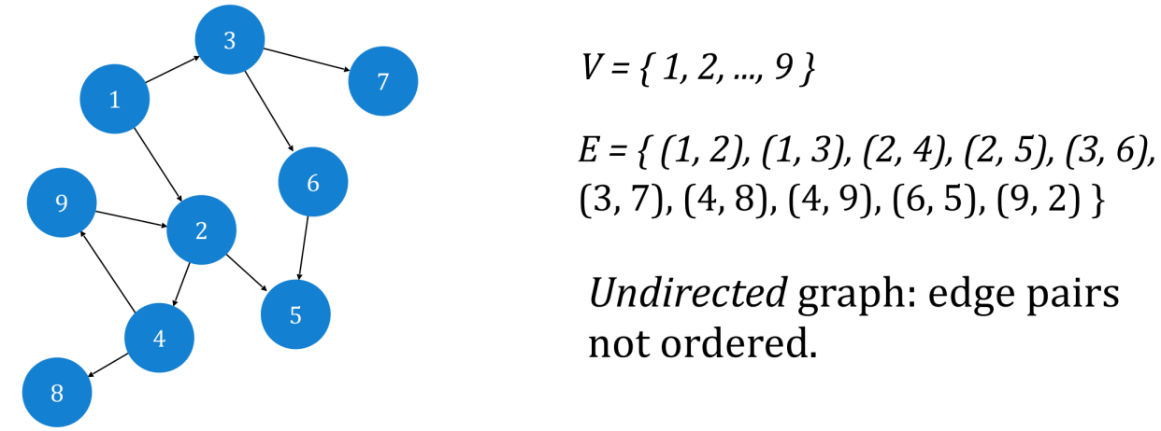

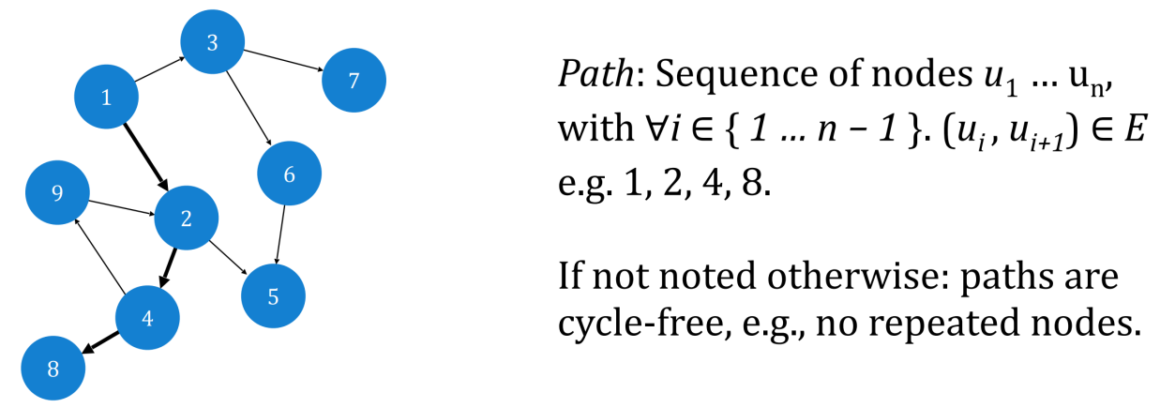

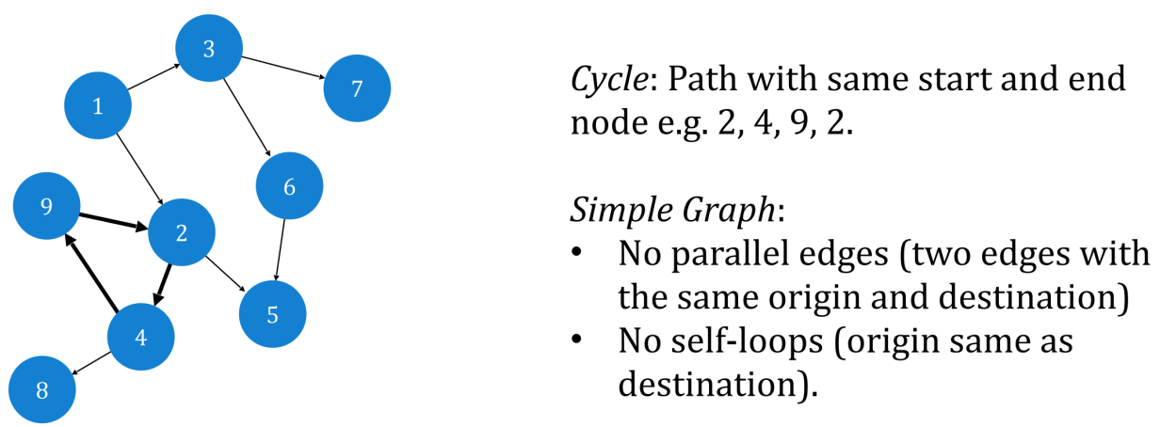

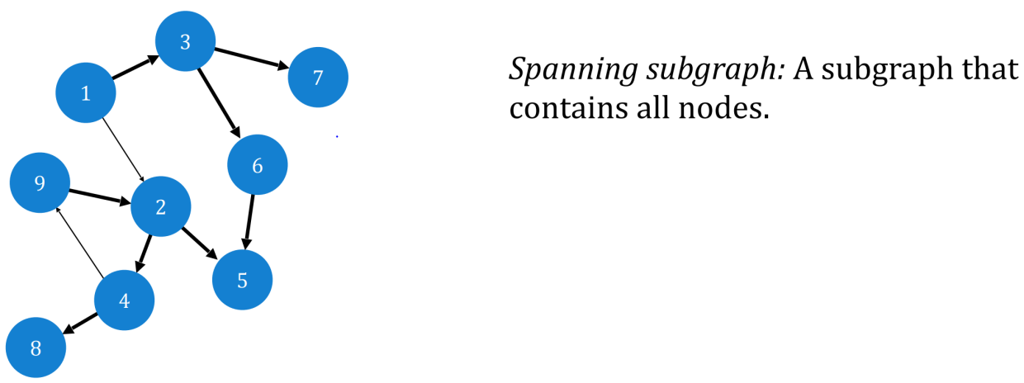

Adjacency Lists:

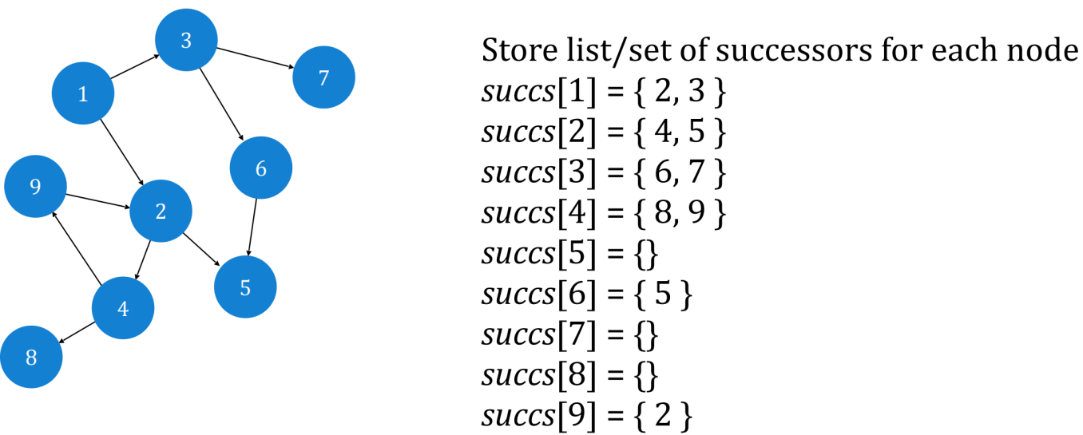

Adjacency Matrix:

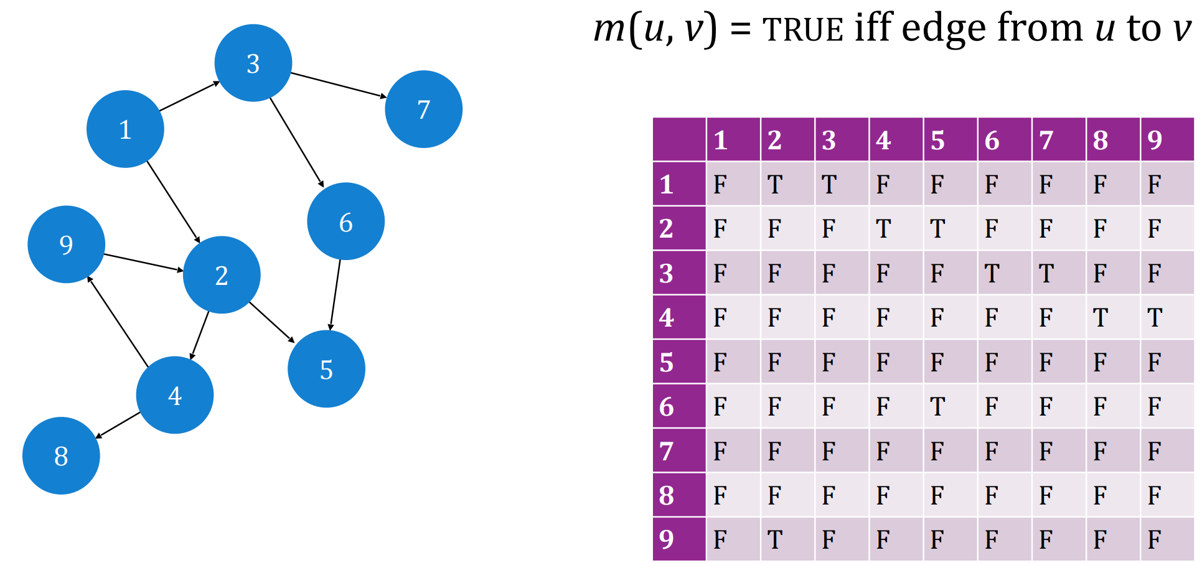

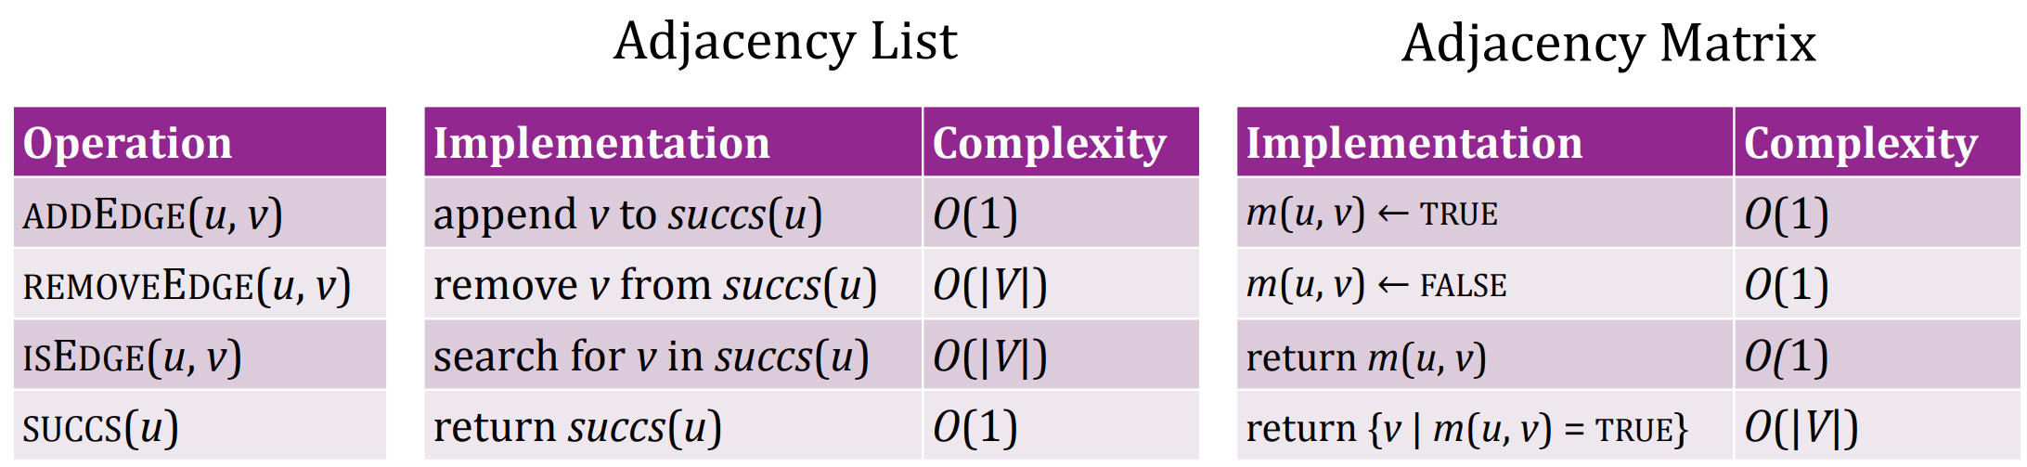

for a graph G with n vertices and m edges, an **adjacency list** representation uses **O(n + m)** space, whereas an **adjacency matrix** representation uses **O(n2)** space.

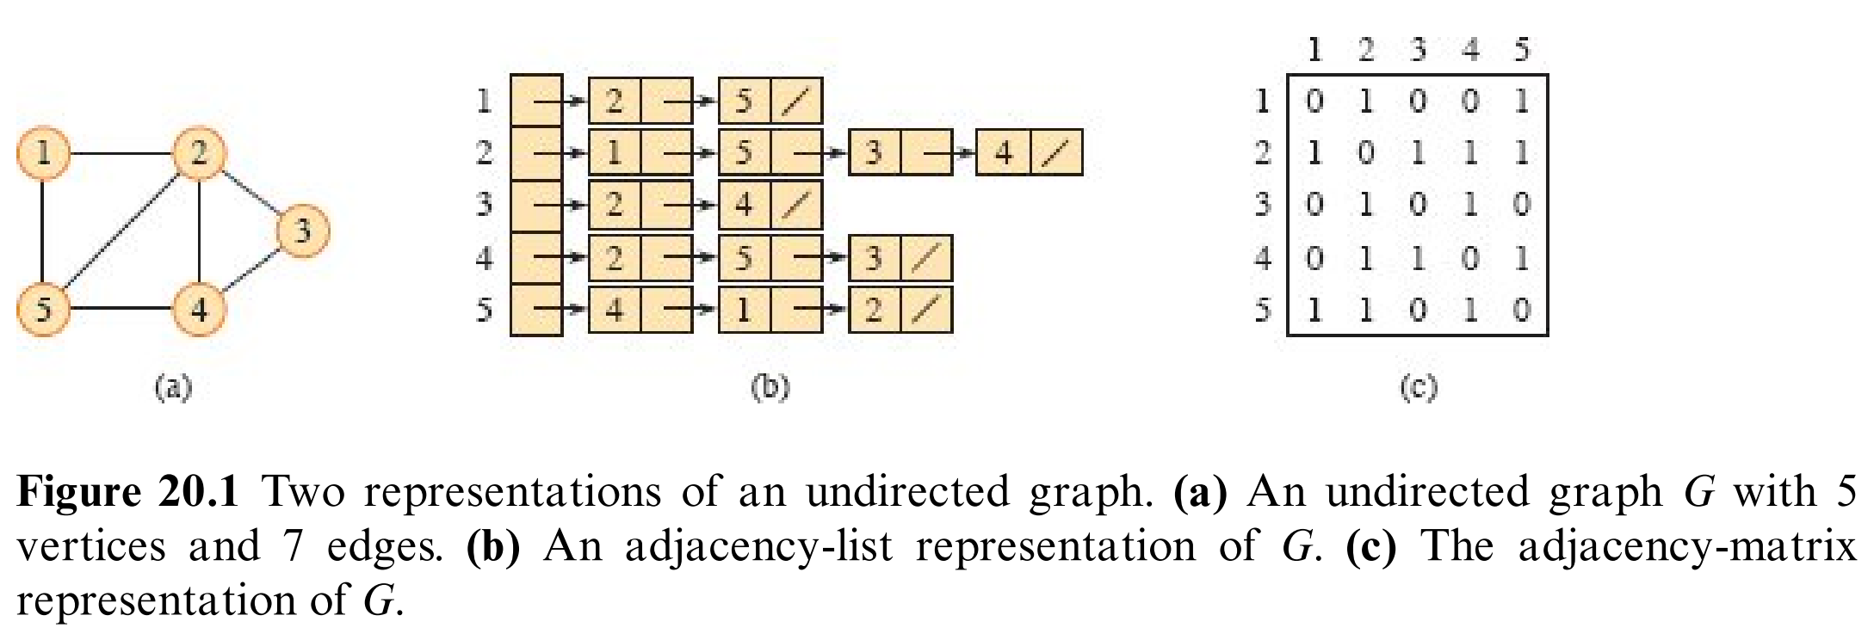

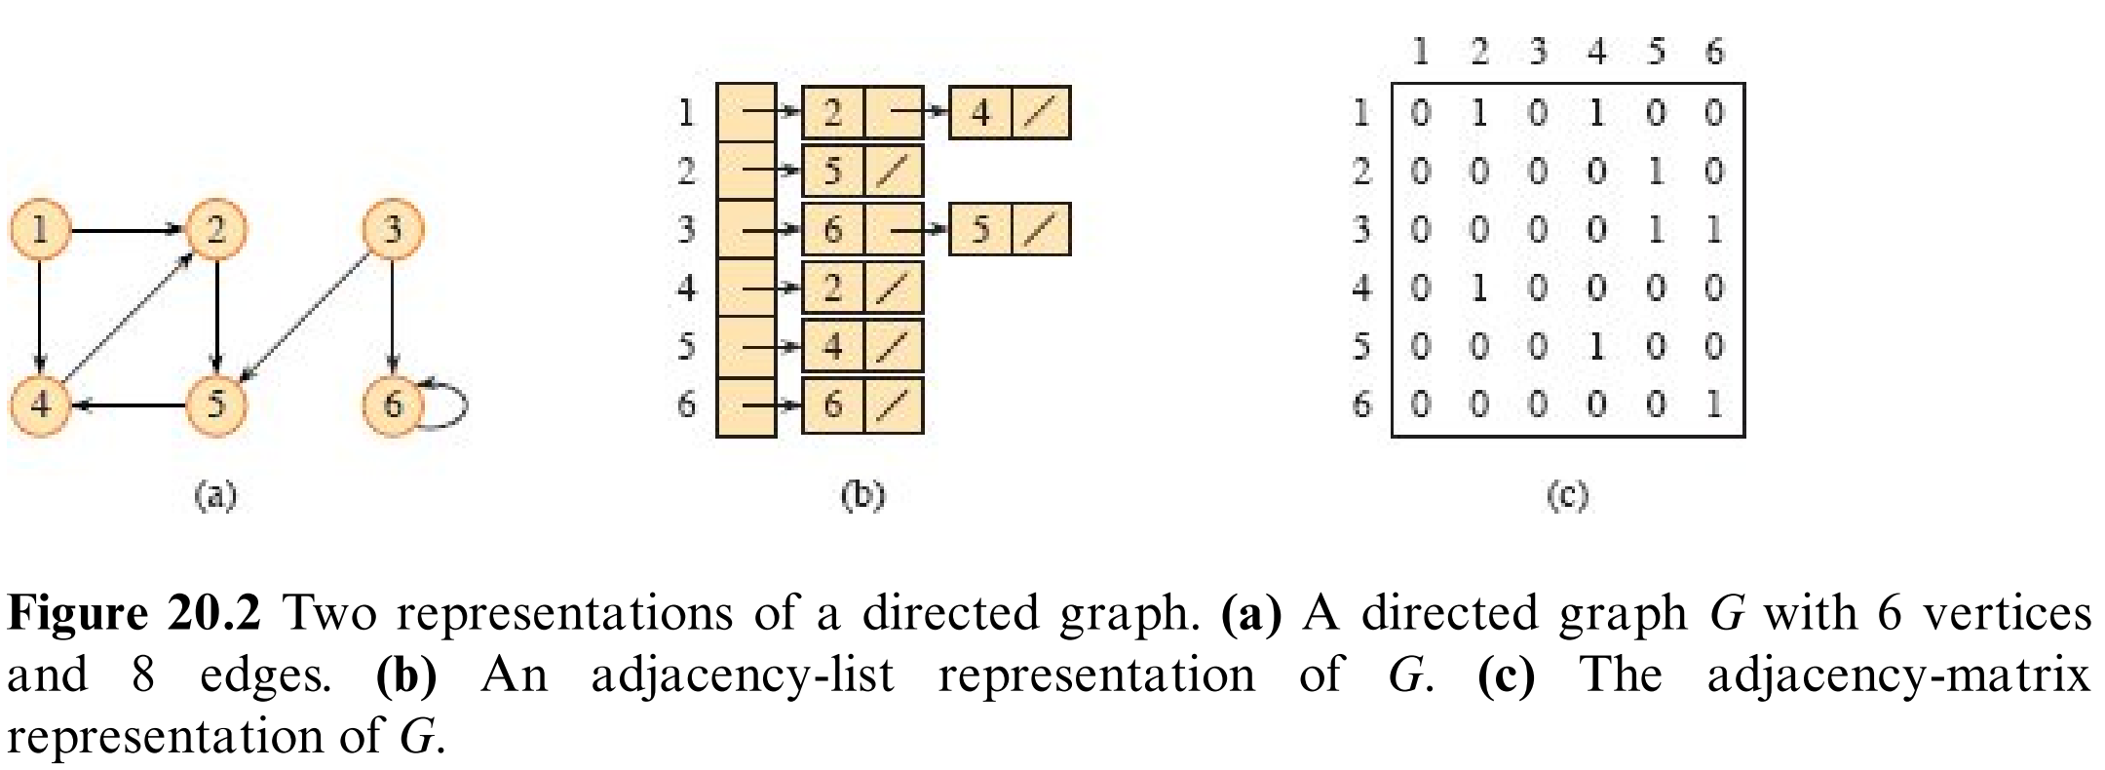

Topological Sort**:**

**·**O(|V| + |E|), where |V| is the number of vertices and |E| is the number of edges in the graph.

**·**The final result is NOT unique.

**·**If there is a cycle in the graph, it reports a cycle is discovered and no result produced.

**Shortest Path_week2**

BFS Shortest Path**:**

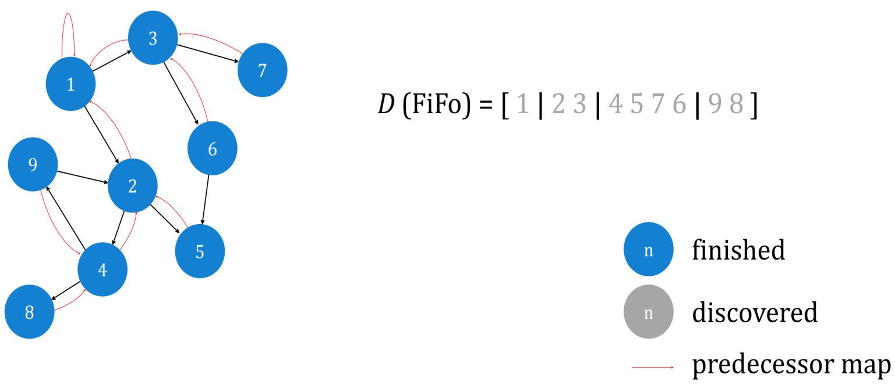

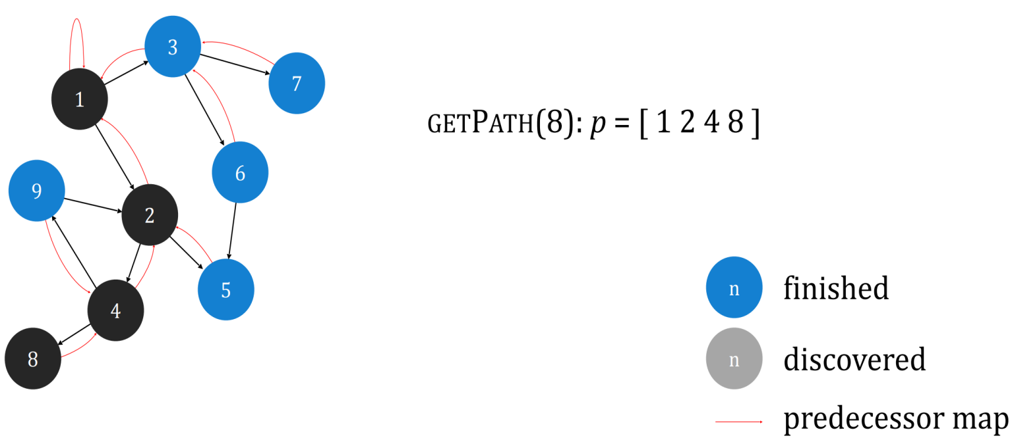

**shortest** = **minimal number of edges**

Shortest Paths in Weighted Graphs**:**

**Distance** **= weight of the shortest path**.

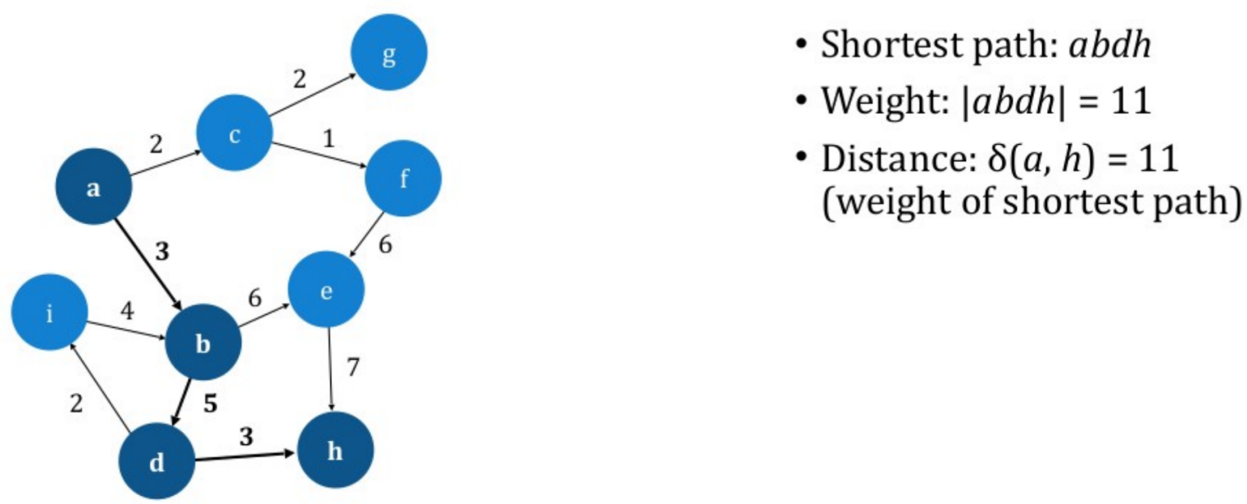

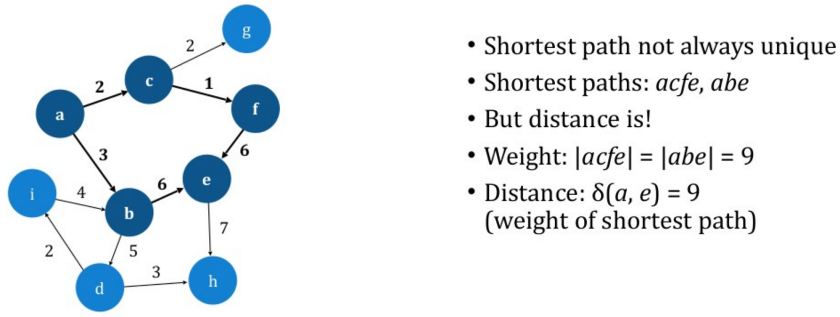

Bellman Ford Algorithm**:**

**·**O(|V||E|), where |V| is the number of vertices and |E| is the number of edges in the graph.

**·**O(1) for Relax.

**·**Repeat for |V|-1 rounds. Each round check |E| edges.

**·**Negative weights are allowed, but Negative Cycles NOT allowed. Negative Cycles can be detected if D still change in |V|th round.

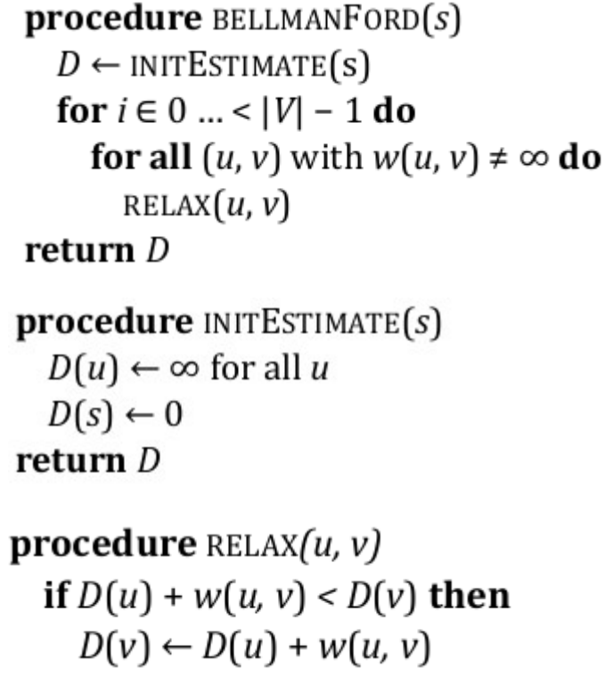

Dijkstra Algorithm**:**

**·**use MinHeap Priority Queue Negetive Weights NOT allowed.

**·**O((|V|+|E|)log(|V|)), where |V| is the number of vertices and |E| is the number of edges in the graph.

**·**Each node is relaxed at most once. Each node is added and removed from PQ at most once.

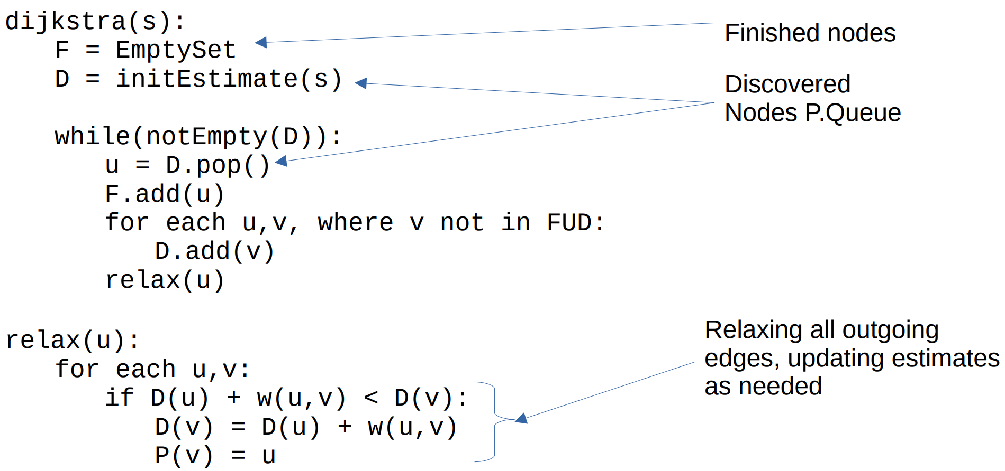

A* Algorithm**:**

