COSC 250 - MicroComputer Organization

**Final Review**

1. Convert the following:
2. Decimal 40 to Binary, Octal and Hexadecimal
3. Binary 100101010111 to Octal and Hexadecimal
4. Two’s complement 1111111110000101 to decimal
5. Decimal -100 to One’s complement using a 16-bit memory location
6. Simplify the following Boolean expressions by using algebraic manipulation
   * 1. F = A’ (B + C) (D’E + F)’ + (D’E + F)
     2. F = (V’W + UX)’ (UX + Y + Z + V’W)

1. Simplify the following Boolean function in **sum of product form** and **product of sum form** by only using K-map
2. F = (B’ + C) (B’ + D’) (A’+ D) (A + C + D’) (B + C’ + D)
3. F = ABCD + B’CD + A’B’ + BCD’
4. Draw a Logic diagram to represent the following function. Draw the same Logic diagram only using NAND gates (use minimum number of gates possible)

F = A(B+D’) + (B + C)(A + D)

1. Derive the Boolean Function and the Truth table for the following Logic Diagram

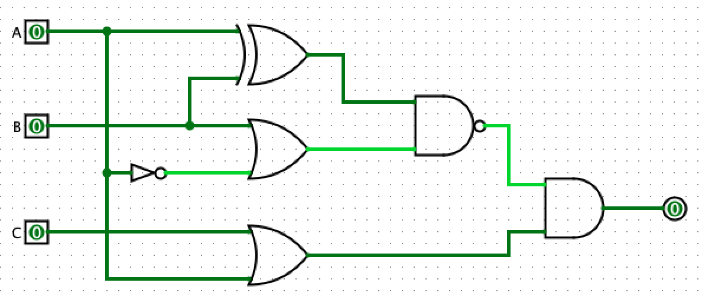

Simplify, find the simplified Boolean Function and draw the simplified version of the Logic Diagram (you can use any simplification method).

1. Implement the following Boolean Function only using a Multiplexer and inverters



1. Explain the operation of a 4-bit shift register. Draw the logic diagram to help

explain its operation

1. Draw the logic diagram of a Synchronous Binary Counter with JK Flip Flops
2. Design a NAND only configuration for the following Boolean expression:



Then design the NOR only configuration for the same function.

1. Build the logic diagram for a 3-8 Decoder. Discuss its operation and write its output Boolean functions.

1. Get simplified Boolean functions in **sum of product form** and **product of sum form** for following truth table by only using K-map

|  |  |
| --- | --- |
| **A B C D** | **F** |
| 0 0 0 0 | 0 |
| 0 0 0 1 | 0 |
| 0 0 1 0 | 1 |
| 0 0 1 1 | 0 |
| 0 1 0 0 | 1 |
| 0 1 0 1 | 1 |
| 0 1 1 0 | 0 |
| 0 1 1 1 | 0 |
| 1 0 0 0 | X |
| 1 0 0 1 | X |
| 1 0 1 0 | 1 |
| 1 0 1 1 | X |
| 1 1 0 0 | X |
| 1 1 0 1 | 1 |
| 1 1 1 1 | 1 |
| 1 1 1 1 | 0 |

1. Derive the State Diagram from the following State Table (Use D flip-flops)

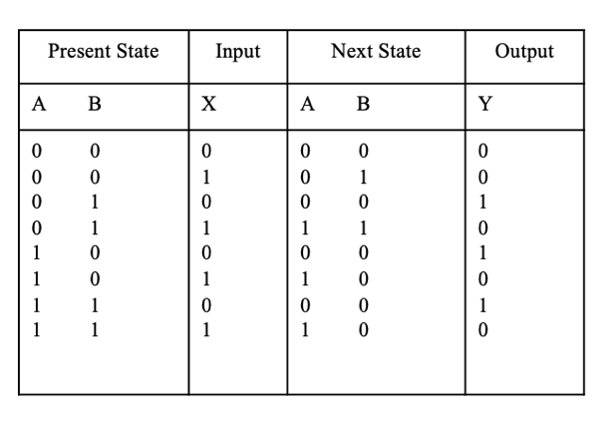

1. A combinational circuit is specified by the following two Boolean functions:

F1= (A,B,C) = m0+m3+m4

F2= (A’ + B’ + C’) (A + B + C’)(A + B + C)

Implement the circuit with a Decoder and external OR gates.

1. Derive the State Table and the State Diagram from the following Logic Diagram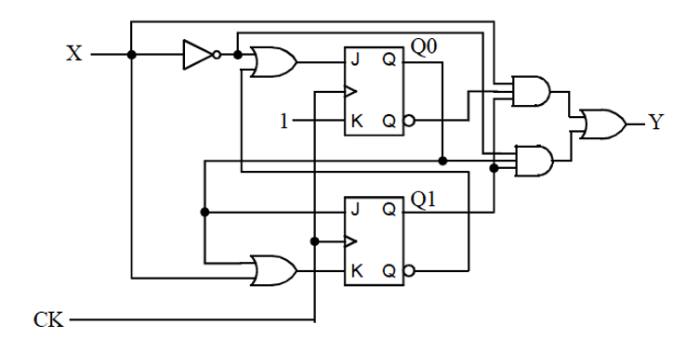
2. Calculate the complement of the following function using one of the techniques we studied in class (4 points)

F = (X + Y’ + Z) (X’ + Z’)(X + Y)

1. Explain how we could use existing RAM chips of 32K addresses by 8 bit words to make a RAM system that had 256K addresses by 32 bit words. You can use words OR a diagram.