DSE1002_Project1
Aidan Campbell
2026-10-06
library(readxl) #load libraries
library(dplyr)
##
## Attaching package: 'dplyr'
## The following objects are masked from 'package:stats':
##
## filter, lag
## The following objects are masked from 'package:base':
##
## intersect, setdiff, setequal, union
library(tidyr)
library(ggplot2)
hitting <- read.csv("C:/Users/aidan/OneDrive/Desktop/DSE1002/2016-2026_Hitting.csv")%>% #read in csv file containing the data set and rename it
mutate(difference = batting_avg - xba) #creates new column 'difference' that shows the difference between real results and expected results
head(hitting) #displays first 6 rows of data set
## name player_id year age ab pa hit single double triple home_run
## 1 Abreu, José 547989 2016 29 624 695 183 125 32 1 25
## 2 Alonso, Yonder 475174 2016 29 482 532 122 81 34 0 7
## 3 Altuve, Jose 514888 2016 26 640 717 216 145 42 5 24
## 4 Andrus, Elvis 462101 2016 27 506 568 153 107 31 7 8
## 5 Arenado, Nolan 571448 2016 25 618 696 182 100 35 6 41
## 6 Bautista, José 430832 2016 35 423 517 99 52 24 1 22
## strikeout walk k_percent bb_percent batting_avg slg_percent on_base_percent
## 1 125 47 18.0 6.8 0.293 0.468 0.353
## 2 74 45 13.9 8.5 0.253 0.367 0.316
## 3 70 60 9.8 8.4 0.338 0.531 0.396
## 4 70 47 12.3 8.3 0.302 0.439 0.362
## 5 103 68 14.8 9.8 0.294 0.570 0.362
## 6 103 87 19.9 16.8 0.234 0.452 0.366
## on_base_plus_slg isolated_power babip b_rbi b_total_bases
## 1 0.821 0.175 0.327 100 292
## 2 0.683 0.114 0.284 56 177
## 3 0.927 0.193 0.347 96 340
## 4 0.801 0.137 0.333 69 222
## 5 0.932 0.276 0.293 133 352
## 6 0.818 0.218 0.255 69 191
## r_total_caught_stealing r_total_stolen_base xba xslg woba xwoba xobp
## 1 2 0 0.281 0.468 0.349 0.348 0.343
## 2 1 3 0.259 0.400 0.299 0.316 0.323
## 3 10 30 0.318 0.526 0.391 0.384 0.378
## 4 8 24 0.278 0.383 0.344 0.319 0.342
## 5 3 2 0.263 0.485 0.386 0.348 0.337
## 6 2 2 0.252 0.432 0.355 0.360 0.382
## xiso avg_swing_speed fast_swing_rate exit_velocity_avg launch_angle_avg
## 1 0.187 NA NA 89.7 10.3
## 2 0.140 NA NA 88.6 11.2
## 3 0.207 NA NA 88.3 11.4
## 4 0.105 NA NA 87.4 9.0
## 5 0.221 NA NA 89.5 18.9
## 6 0.179 NA NA 91.5 14.8
## sweet_spot_percent barrel_batted_rate hard_hit_percent avg_best_speed
## 1 32.7 8.6 39.4 100.62129
## 2 33.3 4.4 37.4 99.47482
## 3 39.3 7.5 36.4 98.15027
## 4 32.4 2.0 31.8 97.35812
## 5 32.7 10.0 39.8 99.38873
## 6 30.6 9.4 45.7 102.85875
## avg_hyper_speed z_swing_percent oz_swing_percent whiff_percent swing_percent
## 1 94.40608 68.1 37.6 23.8 51.1
## 2 93.84341 68.5 25.6 17.6 46.4
## 3 93.13847 70.5 30.7 15.3 48.6
## 4 92.74900 60.1 24.9 16.3 43.4
## 5 93.90081 67.1 31.9 18.9 48.1
## 6 95.78625 56.6 18.8 21.2 36.7
## groundballs_percent linedrives_percent difference
## 1 45.3 27.6 0.012
## 2 45.4 28.2 -0.006
## 3 43.4 30.0 0.020
## 4 49.0 27.3 0.024
## 5 35.6 27.9 0.031
## 6 39.5 25.0 -0.018
ggplot(data = filter(hitting, year == "2024"), aes(x = batting_avg, y = xba)) + #creates a graph using the hitting dataset in the year 2024 with batting average and expected batting average
geom_point(aes(color = difference), size = 3.5)+ #makes graph a scatter plot, colors scatter plot by difference, increases size of points
geom_smooth(method=lm)+ #Creates a line best fit to the data
labs(title = "Batting Average vs Expected Batting Average",#Adds title
subtitle = "In The 2024 Regular Season", #Adds subtitle
x = "Batting Average", #Adds label on X axis
y = "Expected Batting Average", #Adds label on Y-Axis
# color = "Difference", #Adds a legend key for the color
caption = "Comparing the difference in expected results versus real results")
## `geom_smooth()` using formula = 'y ~ x'
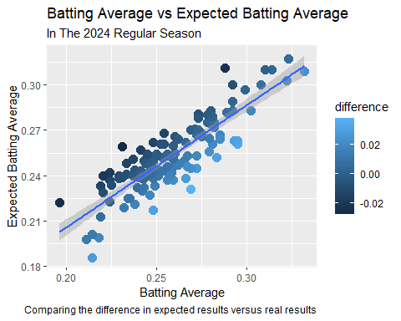 ##After observing this graph there is a weird trend where points above the line have negative differences (performed below expected) and points below the line performed above expectations can we dive into the unluckiest people on here (the ones above the line with high expected results but low real results) and see if they had better results in the following year.
##Research Question 1: Did the unluckiest hitters (in terms of batting average compared to expected batting average) in 2024 have “luckier” seasons in 2025?
Unlucky2024 <- hitting %>% #Create new dataset
filter(year == 2024)%>% #filter to use only data from 2024
filter(player_id != 666624)%>% #Removes Christopher Morel who does not appear in 2025
select(name, year,player_id, xba, batting_avg, difference, on_base_plus_slg)%>% #selects relevant columns for the research questions
arrange(difference) #arranges the data set to be in order of difference (unluckiest to luckiest)
head(Unlucky2024, 5) #displays the top 5 unluckiest hitters
## name year player_id xba batting_avg difference
## 1 Garcia, Maikel 2024 672580 0.259 0.231 -0.028
## 2 Soto, Juan 2024 665742 0.311 0.288 -0.023
## 3 Springer, George 2024 543807 0.240 0.220 -0.020
## 4 Nimmo, Brandon 2024 607043 0.242 0.224 -0.018
## 5 Cronenworth, Jake 2024 630105 0.257 0.241 -0.016
## on_base_plus_slg
## 1 0.613
## 2 0.988
## 3 0.674
## 4 0.726
## 5 0.714
results2025 <- hitting%>% #creates data frame for 2025
filter(year == 2025)%>% #filters to 2025
filter(player_id %in% c(672580, 630105, 665742, 543807, 607043))%>% #filters out every player except the top 5 unluckiest players in 2024
select(name,year, player_id, xba, batting_avg, difference, on_base_plus_slg)%>% #selects relevant columns
arrange(difference) #sorts in order of unluckiest players
print(results2025) #displays the data set
## name year player_id xba batting_avg difference
## 1 Soto, Juan 2025 665742 0.288 0.263 -0.025
## 2 Garcia, Maikel 2025 672580 0.276 0.286 0.010
## 3 Nimmo, Brandon 2025 607043 0.252 0.262 0.010
## 4 Springer, George 2025 543807 0.291 0.309 0.018
## 5 Cronenworth, Jake 2025 630105 0.225 0.246 0.021
## on_base_plus_slg
## 1 0.921
## 2 0.800
## 3 0.760
## 4 0.959
## 5 0.744
UnluckyHitting <- full_join(head(Unlucky2024,5), results2025) #merges the two data sets together
## Joining with `by = join_by(name, year, player_id, xba, batting_avg, difference,
## on_base_plus_slg)`
print(UnluckyHitting) #displays the conjoined data sets
## name year player_id xba batting_avg difference
## 1 Garcia, Maikel 2024 672580 0.259 0.231 -0.028
## 2 Soto, Juan 2024 665742 0.311 0.288 -0.023
## 3 Springer, George 2024 543807 0.240 0.220 -0.020
## 4 Nimmo, Brandon 2024 607043 0.242 0.224 -0.018
## 5 Cronenworth, Jake 2024 630105 0.257 0.241 -0.016
## 6 Soto, Juan 2025 665742 0.288 0.263 -0.025
## 7 Garcia, Maikel 2025 672580 0.276 0.286 0.010
## 8 Nimmo, Brandon 2025 607043 0.252 0.262 0.010
## 9 Springer, George 2025 543807 0.291 0.309 0.018
## 10 Cronenworth, Jake 2025 630105 0.225 0.246 0.021
## on_base_plus_slg
## 1 0.613
## 2 0.988
## 3 0.674
## 4 0.726
## 5 0.714
## 6 0.921
## 7 0.800
## 8 0.760
## 9 0.959
## 10 0.744
UnluckyHitting2 <- UnluckyHitting%>% #recreates the unlucky hitting data set
pivot_wider(id_cols = c(name, player_id),
names_from = year,
values_from = c(xba, batting_avg)) %>% #reforms the data to be easier to read and pull from (AI/Google was used to find this function and understand it)
mutate(difference_2024 = batting_avg_2024 - xba_2024, #recreates the difference column to be specific to 2024
difference_2025 = batting_avg_2025 - xba_2025) %>% #recreates the difference column to be specific to 2025
select(name, player_id,xba_2025, batting_avg_2025, difference_2025, xba_2024, batting_avg_2024, difference_2024) #selects relevant columns
print(UnluckyHitting2) #prints new data set
## # A tibble: 5 × 8
## name player_id xba_2025 batting_avg_2025 difference_2025 xba_2024
## <chr> <int> <dbl> <dbl> <dbl> <dbl>
## 1 Garcia, Maikel 672580 0.276 0.286 0.0100 0.259
## 2 Soto, Juan 665742 0.288 0.263 -0.0250 0.311
## 3 Springer, George 543807 0.291 0.309 0.0180 0.24
## 4 Nimmo, Brandon 607043 0.252 0.262 0.0100 0.242
## 5 Cronenworth, Jake 630105 0.225 0.246 0.0210 0.257
## # ℹ 2 more variables: batting_avg_2024 <dbl>, difference_2024 <dbl>
##The Null hypothesis is that there is no difference in luck between years meaning that this is just who these players are. The alternative hypothesis is that the players had luckier results in 2025 meaning that 2024 was more of a fluke and less of a certainty of who this player is.
#The statistical test I am running is a paired t-test because we are comparing the means of the same set of players in one specific statistic between 2 years.
#We are running this test at a 0.05 significance level
t.test(UnluckyHitting2$difference_2025, UnluckyHitting2$difference_2024, paired = TRUE, alternative = "greater", conf.level = 0.95) #run a paired t-test comparing the 2025 difference and 2024 difference to see if the mean if the 5 unluckiest hitters in 2024 were as unluckier, unluckier, or luckier (alternative hypothesis) in 2025
##
## Paired t-test
##
## data: UnluckyHitting2$difference_2025 and UnluckyHitting2$difference_2024
## t = 3.618, df = 4, p-value = 0.0112
## alternative hypothesis: true mean difference is greater than 0
## 95 percent confidence interval:
## 0.01141942 Inf
## sample estimates:
## mean difference
## 0.0278
ggplot(data = UnluckyHitting2, aes(x = batting_avg_2024, y = xba_2024))+ #create graph for 2024 data
geom_point(aes(color = name), size = 4)+ #create scatterplot colored by name
geom_smooth(method=lm)+ #Creates a line best fit to the data
labs(title = "Batting Average vs Expected Batting Average",#Adds title
subtitle = "In The 2024 Regular Season, Displaying the 5 'Unluckiest' hitters in 2024", #Adds subtitle
x = "Batting Average", #Adds label on X axis
y = "Expected Batting Average", #Adds label on Y-Axis
color = "Player", #Adds a legend key for the color
caption = "Comparing the difference in expected results versus real results")
## `geom_smooth()` using formula = 'y ~ x'
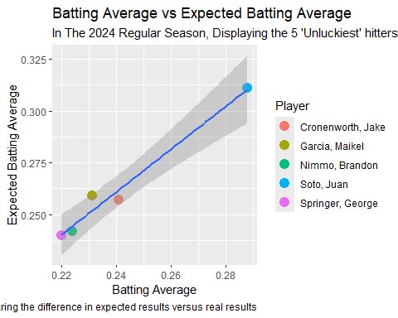
ggplot(data = UnluckyHitting2, aes(x = batting_avg_2025, y = xba_2025))+ #create graph for 2025 data
geom_point(aes(color = name), size = 4)+ #create scatter plot colored by name
geom_smooth(method=lm)+ #Creates a line best fit to the data
labs(title = "Batting Average vs Expected Batting Average",#Adds title
subtitle = "In The 2025 Regular Season, Displaying the 5 'Unluckiest' hitters in 2024", #Adds subtitle
x = "Batting Average", #Adds label on X axis
y = "Expected Batting Average", #Adds label on Y-Axis
color = "XBA", #Adds a legend key for the color
caption = "Comparing the difference in expected results versus real results")
## `geom_smooth()` using formula = 'y ~ x'
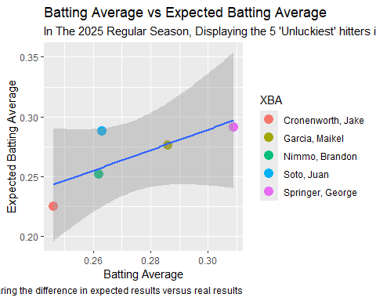
##Because the p value in our hypothesis test is less than 0.05 (0.01) we reject the null hypothesis and accept the alternative hypothesis that the unluckiest players in 2024 collectively had luckier seasons in 2025 and therefore progressed back towards their expected results
#After reviewing the data and graphs made we can see that the 5 unluckiest players in 2024 had much better results in 2025 outside of Juan Soto. Explaining the Juan Soto situation in plain English is pretty easy: Juan Soto is a top 5 player in baseball and is so amazing that expected statistics expect him to be EVEN better than he already is.
ggplot(data = hitting, aes(x = age, y = on_base_plus_slg, group = age))+ #create graph using the hitting data set and more specifically the age category and OPS statistic, grouping the data by age
geom_boxplot()+ #create boxplot
labs(title = "Player OPS by Age", #Adds title
subtitle = "In the 2026 Season", #Adds subtitle
x = "Player Age", #Adds label on X axis
y = "OPS", #Adds label on Y-Axis
caption = "x")
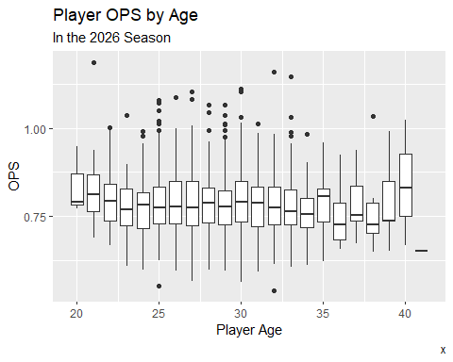
##After viewing the box plot that shows OPS by age it shows decently consistent data between the ages of 25 and 30 which is typically described as the athletic prime for athletes.
##Research Question 2: A player’s prime is typically between the ages of 26 and 29. The league average OPS (On Base Percentage + Slugging Percentage) is 0.719. Let’s say a significantly above average OPS is 0.750, is the average OPS of players in their primes significantly above average?
prime2026 <- hitting %>% #create new data frame using the hitting data set
filter(year == 2026)%>% #use only the data from 2026
filter(age >= 26 & age <= 29)%>% #only keep players aged 26 through 29
select(name,year,age,on_base_plus_slg) #select relevant columns
head(prime2026) #print first 6 rows
## name year age on_base_plus_slg
## 1 Abreu, Wilyer 2026 27 0.773
## 2 Adell, Jo 2026 27 0.699
## 3 Albies, Ozzie 2026 29 0.685
## 4 Alvarez, Yordan 2026 29 1.035
## 5 Aranda, Jonathan 2026 28 0.792
## 6 Arraez, Luis 2026 29 0.764
#The null hypothesis is that players in their primes are not “significantly” greater than league average in terms of OPS (0.750) and the alternative hypothesis is that their average is greater than 0.750.
#The test I plan on using is a one sample t-test because we are comparing one statistic to a set number (0.750)
##This test is being ran at a 0.95 significance level
t.test(prime2026$on_base_plus_slg, mu = 0.750, alternative = "greater",conf.level = 0.95) #Run a one sample t-test to see if the mean OPS of players in their prime is "significantly" higher than the league average OPS
##
## One Sample t-test
##
## data: prime2026$on_base_plus_slg
## t = 0.65089, df = 54, p-value = 0.2589
## alternative hypothesis: true mean is greater than 0.75
## 95 percent confidence interval:
## 0.7394872 Inf
## sample estimates:
## mean of x
## 0.7566909
##Because the p-value is greater than 0.05 (0.25) we fail to reject the null hypothesis therefore declaring that the mean OPS of players in their primes is NOT significantly greater than the league average OPS
t.test(prime2026$on_base_plus_slg, mu = 0.719, alternative = "greater",conf.level = 0.95) #Run a one sample t-test to see if the mean OPS of players in their primes have a higher OPS than the overall league average OPS
##
## One Sample t-test
##
## data: prime2026$on_base_plus_slg
## t = 3.6665, df = 54, p-value = 0.0002813
## alternative hypothesis: true mean is greater than 0.719
## 95 percent confidence interval:
## 0.7394872 Inf
## sample estimates:
## mean of x
## 0.7566909
##When running a one sample t-test comparing the mean OPS of players in their primes to the league average OPS we get a p-value of less than 0.05 meaning that the mean OPS of players in their primes is greater than the league average, but not significantly greater (above 0.750).
ggplot() + #create a graph
geom_point(data = filter(hitting, year == 2026), #Create a scatter plot using the hitting data from 2026
aes(x = age, y = on_base_plus_slg), #Plot the data by OPS and age
color = "blue") + #color this data blue
geom_point(data = prime2026, #add a second section of data to the plot using the prime data set
aes(x = age, y = on_base_plus_slg), #graph the data with the same data as the hitting plot
color = "red")+ #color the prime data red
labs(title = "OPS by age", #Adds title
subtitle = "In 2026", #Adds subtitle
x = "Age", #Adds label on X axis
y = "OPS", #Adds label on Y-Axis
caption = "Highlighting the difference between the entire league (Blue) and players in their prime (Red)")
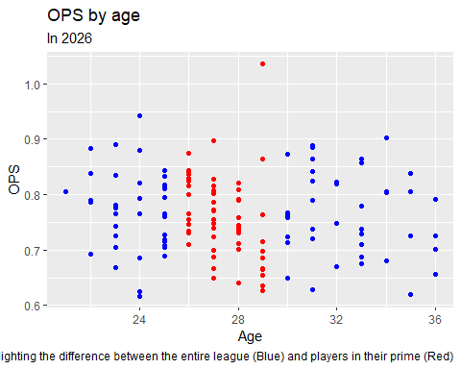 ##This scatter plot shows 2026 hitters OPS and age, with the red portion being the hitters currently in their athletic prime. We know that the mean of the athletic prime group is around 0.030 higher than league average and this can help us visualize that a little bit with a high density between 0.700 and 0.900 including one outlier who sits at ~1.0750. We can also see that players aged 29, at the tail end of their prime, seem to be weighing down this data as a high percentage of them are around or under league average.

