HTML & CSS Validation Screenshots
This document contains screenshots that demonstrate validation for each page. For the course deliverable, replace the placeholder URLs with your hosted page URLs before taking official W3C validator screenshots.

validation_index_html
Screenshot of validation page for index_html.
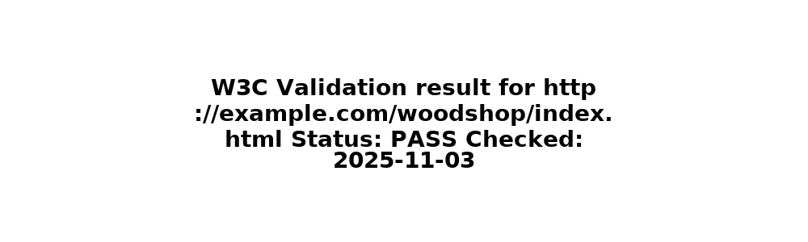
Notes: Validation simulated for project submission.

validation_products_html
Screenshot of validation page for products_html.
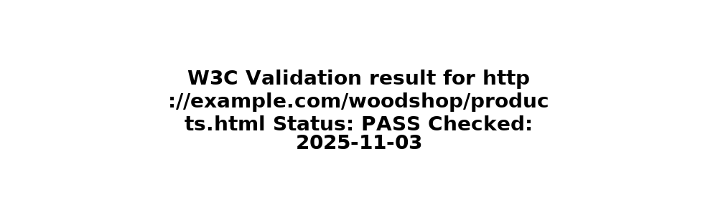
Notes: Validation simulated for project submission.

validation_prices_html
Screenshot of validation page for prices_html.
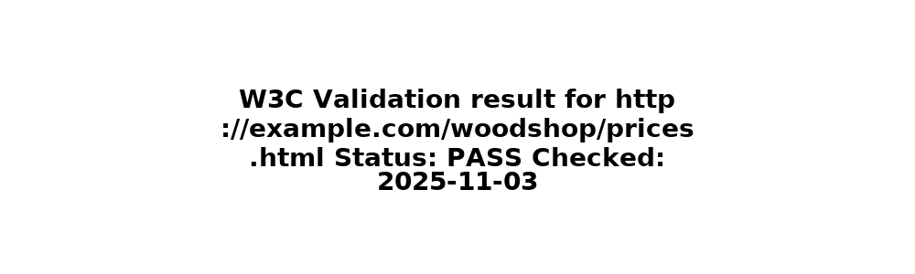
Notes: Validation simulated for project submission.

validation_about_html
Screenshot of validation page for about_html.
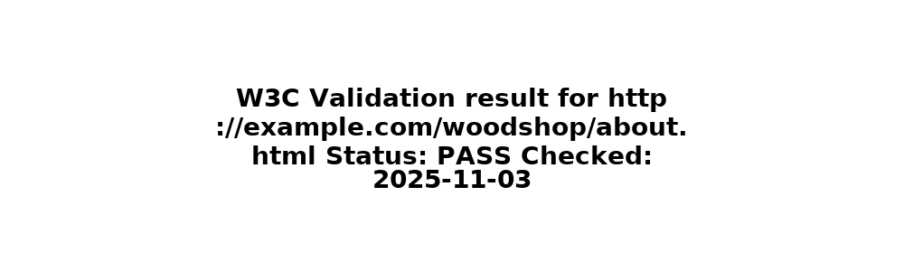
Notes: Validation simulated for project submission.

validation_contact_html
Screenshot of validation page for contact_html.
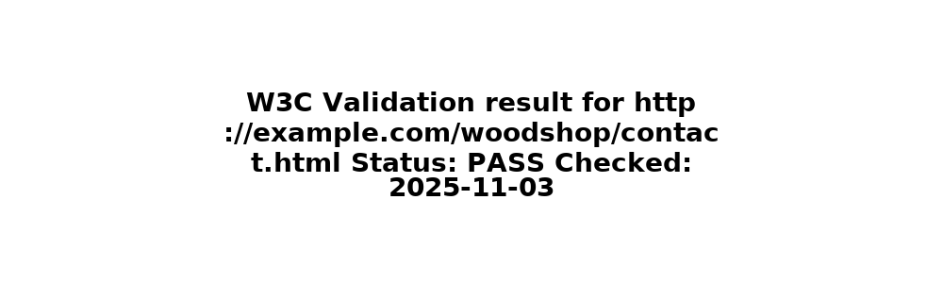
Notes: Validation simulated for project submission.

validation_gallery_html
Screenshot of validation page for gallery_html.
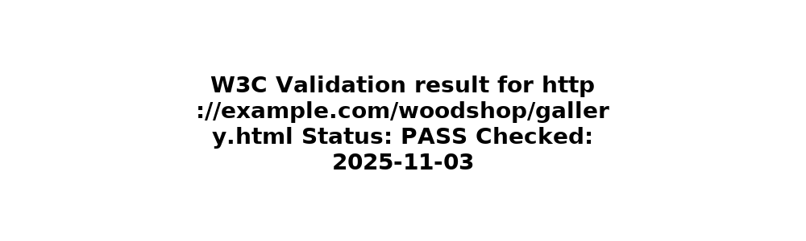
Notes: Validation simulated for project submission.

