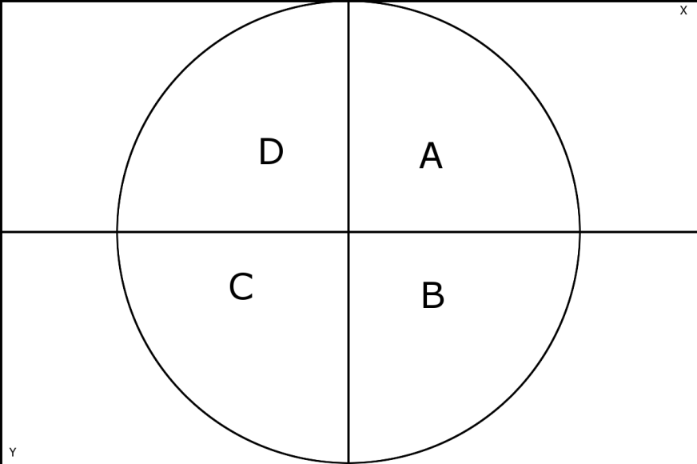

The graph here and all its quadrants

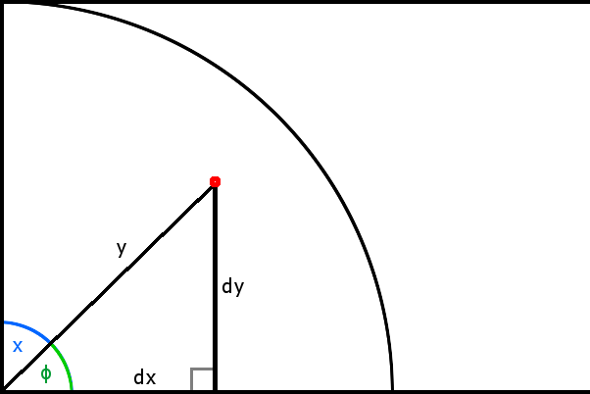

This is the first quadrant.

This situation happens if

is the azimuth

is the elevation

is the distance from the center

is the distance from the center

is one of the triangles angles

Note that the triangle is square.

Now to solve for and we create two formulas/algorithms to do it efficiently.

Now to get the overall coordinates you need to get the total width and height of the chart and use them to calculate the position of the dot.

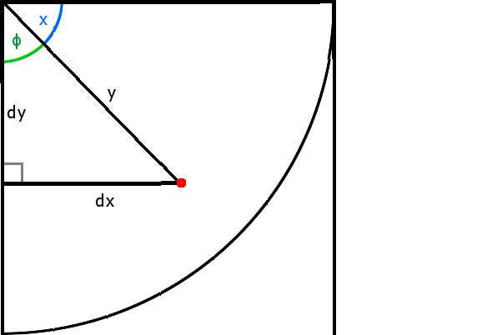This is quadrant number 2, when

is the azimuth - **90**

is the elevation

is the distance from the center

is the distance from the center

is one of the triangles angles

Note that the triangle is square.

Use the same formulas as above but handle the coordinates you need to add the distance and add the distance.

The third quadrant should do and .

The fourth should be and .