# AbstractRefreshableApplicationContext

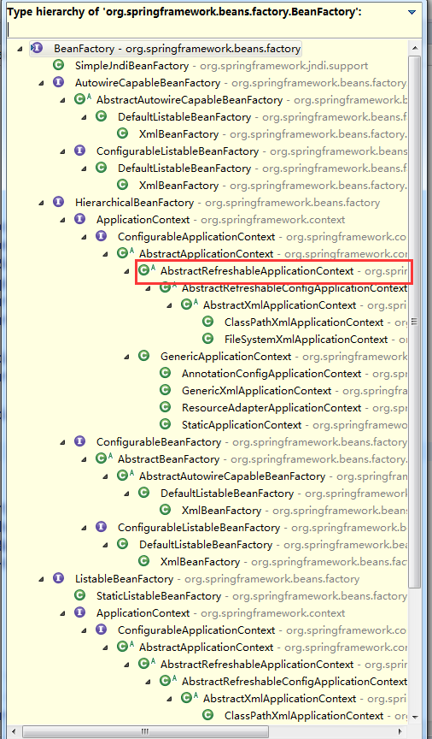

# AbstractRefreshableApplicationContext

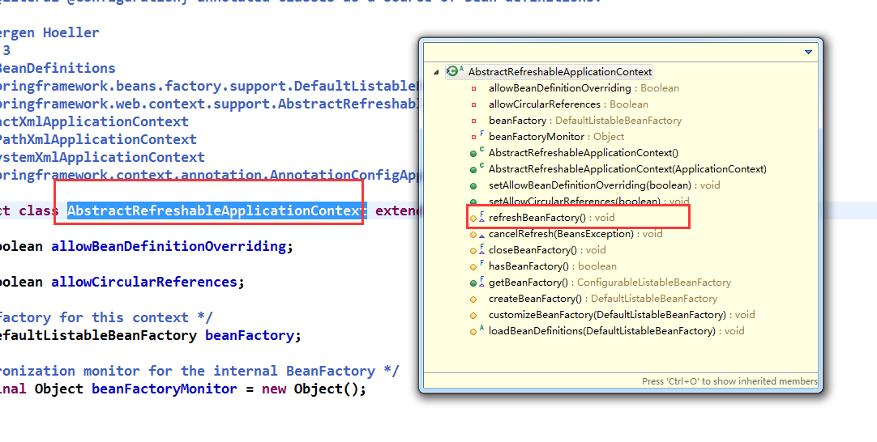

# refreshBeanFactory

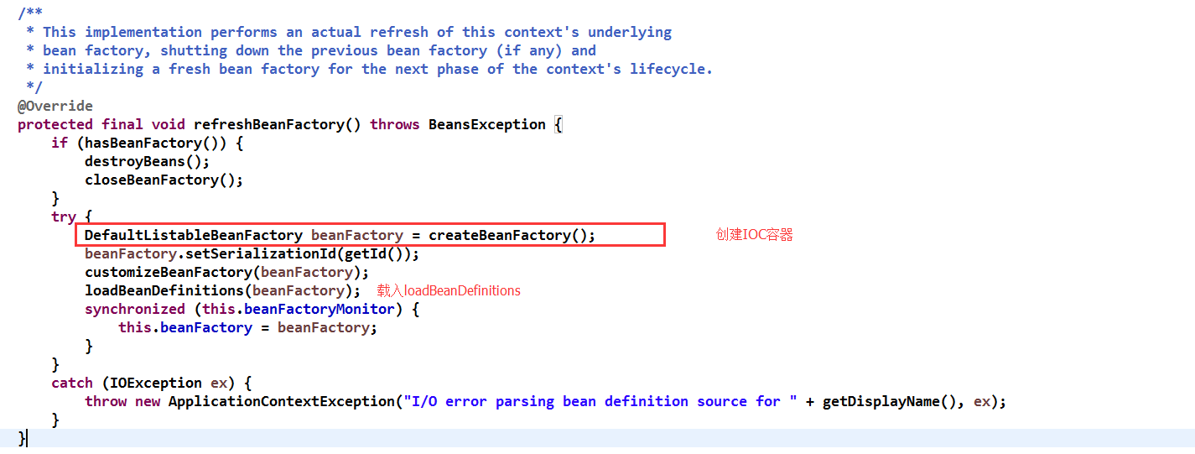

# 进入到refreshBeanFactory

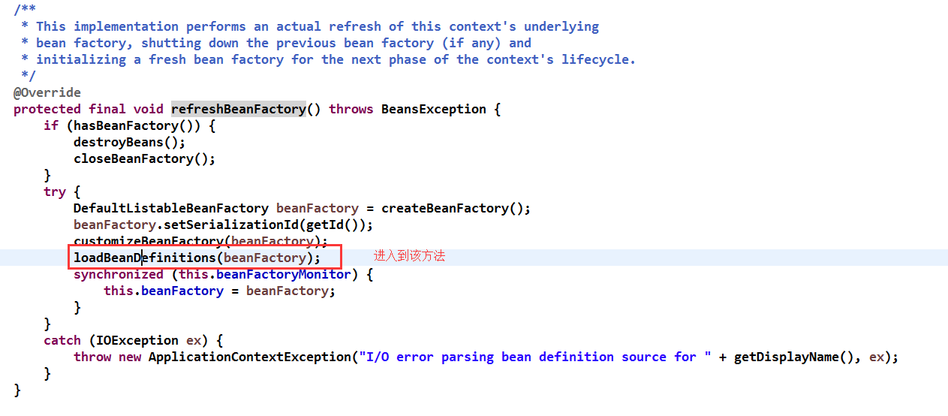

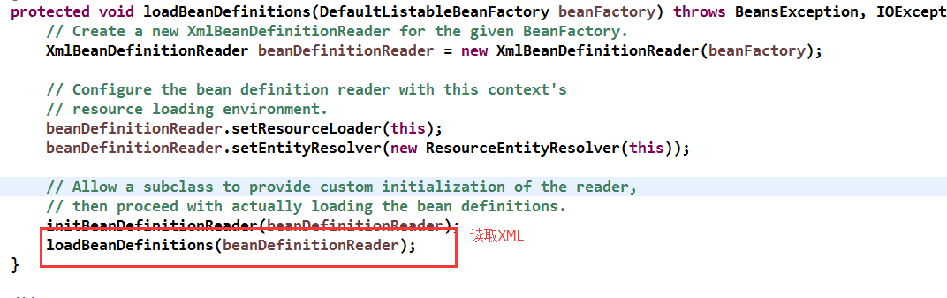

# 继续进入refreshBeanFactory

读取配置文件路径加载

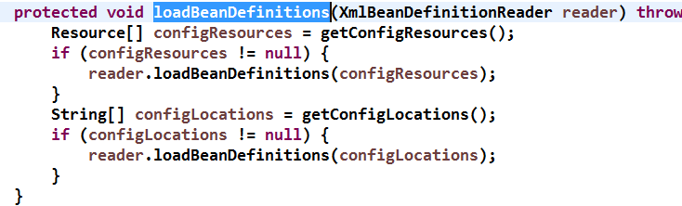

# refreshBeanFactory

# refreshBeanFactory

# refreshBeanFactory

# refreshBeanFactory

# refreshBeanFactory

# refreshBeanFactory

# refreshBeanFactory

# refreshBeanFactory

# refreshBeanFactory