**Data Structure Program Homework (Due: AM:12:00, April 24, 2020)**

**Goal:** learn how to designing C++ program with Template functions.

**Content:** A partially finished project program, T_sort, is provided for you to learn how to use Template in designing C++ program. For the following main program, its execution result is also provided for you reference in verifying your program.

#include "rectangle.h"

// demonstrating sorting an array of objects

int main() {

// Sort integers

int nums[6] = {3,2,4,5,6,7};

sort(nums, 6);

for (int i=0;i<6;i++) {cout << nums[i] << " ";}

cout << "end of sorting integer"<<endl << endl;

// Sort floating numbers

float rnums[6]={-1.0, -3.8, 4, 9.0, -18.2, 6.9};

sort(rnums, 6);

for (int i=0;i<6;i++) {cout << rnums[i] << " ";}

cout << "end of sorting floating numbers"<<endl<<endl;

// Sort rectangles by its Area

rect shapes[6]={rect(9, 9), rect(4,8), rect(5,2), rect(11, 11), rect(8, 10), rect(1,2)};

sort(shapes, 6);

for (int i=0;i<6;i++) cout << shapes[i];

cout << "end of sorting rectangle objects accroding to their area"<<endl;

return 0;

}

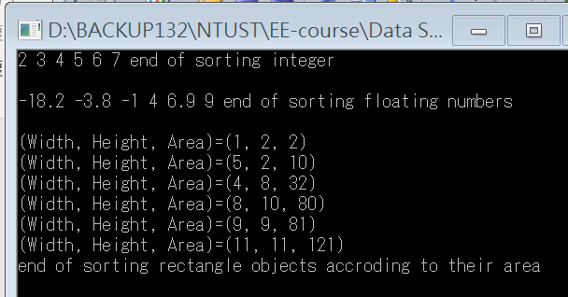

What to do:

1. Please finish the program such that the execution will look like the upper figure.
2. You have to write a short report to describe what you have done and how to make the program working.
3. Your program should be compressed with the report and be submitted to the moodle before the due date.