i make the project like a dictionary so that once you put the English word,then it can show the same meaning in other language.fisrtly infile the "dictionary txt",actually you can download from the web.For convinence,I write some simple letter in my txt( it looks like following)

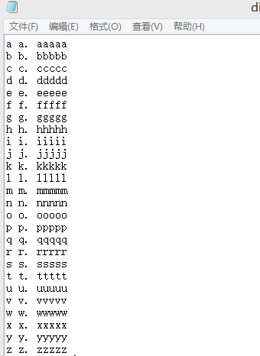

the first line of letter would be the "words" that you input, and the second line would be the “the property of this word", and the third line could be other language or the explanation of that word in English.

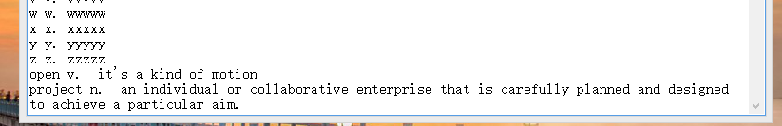

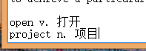（ I use chinese as the third line here)

After running the project,

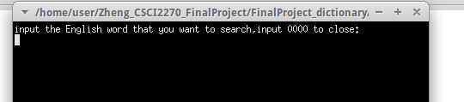

and input the word

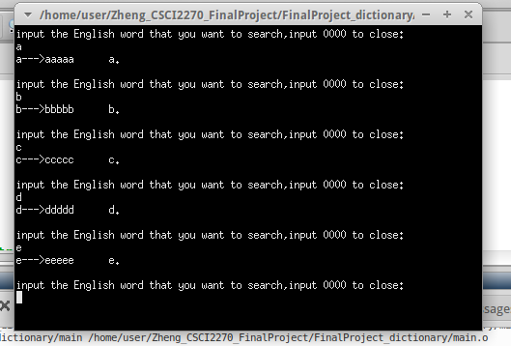

Hence you can DIY the content of "dictionary.txt", even the real dictionary

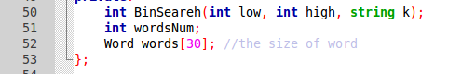

And remember to change the size of the word you make in the txt.

input 0000, four zero, it will close and show "Bye"

