**Discussion Questions for *Their Eyes Were Watching God***

Chapter 6

**I. Matt Bonner’s Mule: “Mule Talk” & “Mule-Baiting”**

1. In the sixth chapter of Hurston’s novel, the men sitting on the porch of Joe’s store make up entertaining stories about Matt Bonner’s mule. Although Joe Starks does not make up any stories, he does listen to and laugh at the stories of other porch sitters. “Laughed his big heh, heh laugh too. Yet Joe prohibits Janie from listening and contributing to the exchange of mule stories: “Janie loved the conversation and sometimes she thought up good stories on the mule, but Joe had forbidden her to indulge. He didn’t want her talking after such trashy people.” How does Joe perceive the men who tell stories about Matt’s mule? Why doesn’t Joe partake in the “mule talk”? Do Joe and Janie share the same perception of the porch sitters and their mule talk?

2. Later in the sixth chapter, the men on the porch transition from telling stories about Matt’s mule to playing abusive pranks on the mule. “Lum went out and tackled him. […] Five or six more men left the porch and surrounded the fractious beast, goosing him in the sides and making him show his temper.” Janie is the only character who sympathizes with the mule’s plight. Speaking privately to herself, Janie mutters, “Done been worked tuh death; […] and now they got tuh finish devilin’ ’im tuh death.” After Joe purchases Matt’s mule and begins to provide it with food, Janie appears to praise her husband: “Freein’ dat mule makes uh mighty big man outa you. Something like George Washington and Lincoln. Abraham Lincoln, he had de whole United States tuh rule so he freed de Negroes. You got uh town so you freed uh mule.” Is it significant that Janie speaks up in defense of the maligned mule? Is Janie being sincere when she remarks that freeing the mule makes Joe a “big man”? How might Hambo’s affirmation that Janie is a “born orator” be significant?

**II. Competing Symbols: High Chairs vs. Spring Blooms**

3. When they are living in Eatonville, Joe believes that Janie should feel grateful for how he has elevated her social status and increased her physical comfort: “Here he was just pouring all over her; building a high chair for her to sit in and overlook the world and she here pouting over it!” Indeed, on the day when Janie ran away with Joe Starks, she had joined him on an elevated seat in a hired rig that was described as a “high, ruling chair.” What might the symbol of a “high chair” represent? Should Janie feel grateful for how Joe has provided her with a high chair? Or can being put on a pedestal amount to a form of oppression?

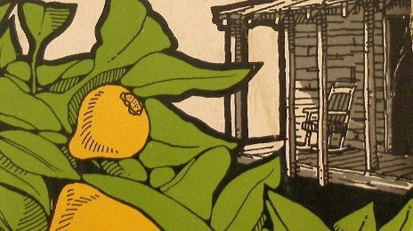4. In the fifth chapter, during the lamp-lighting ceremony, Joe had prevented Janie from making a speech by exclaiming that Janie “don’t know nothin’ ’bout no speech-makin’. […] She’s uh woman and her place is in de home.” To convey how she felt about being silenced by her husband, Janie invoked the metaphor of a flower losing its bloom: “It must have been the way Joe spoke out without giving her a chance to say anything one way or another that took the bloom off of things.” At the end of the sixth chapter, after Joe slaps her for cooking an imperfect meal, Janie uses another floral metaphor to register the change in her feelings about Joe: “She wasn’t petal-open anymore with him. [...] She had no more blossomy openings dusting pollen over her man.” At this point in the novel, does Janie agree with Joe’s assertion that a woman’s “place” is in the “home”? How does Hurston use floral metaphors to track the trajectory of Janie’s relationships?

**III. Figures of Self-Transformation: Janie Falls Out of Love**

5. After she is publicly insulted by her husband for misplacing a bill of sale, Janie begins to detect a shift in her feelings for Joe Starks. Hurston registers the shift in Janie’s feelings by making recourse to figurative language: “The spirit of marriage left the bedroom and took to living in the parlor. It was there to shake hands whenever company came to visit, but it never went back inside the bedroom again. So she put something in there to represent the spirit like a Virgin Mary image in a church. The bed was no longer a daisy-field for her and Joe to play in. It was a place where she went and laid down when she was sleepy and tired.” How many types of figurative language can you find in this passage? How does each type help to convey a change in Janie’s feelings for Joe?

6. After she is slapped by her husband, Janie experiences yet another shift in her feelings about Joe. Here too, Hurston uses figurative language to capture the shift in Janie’s feelings. “She stood there until something fell off the shelf inside her. Then she went inside there to see what it was. It was her image of Jody tumbled down and shattered. […] She found that she had a host of thoughts she had never expressed to him, and numerous emotions she had never let Jody know about. Things packed up and put away in parts of her heart where he could never find them. She was saving up feelings for some man she had never seen. She had an inside and an outside now and suddenly she knew how not to mix them.” How many types of figurative language can you find in this passage? How does each figure of speech help to convey a change in Janie’s feelings toward her husband? What does Hurston mean when she describes Janie as having “an inside and an outside”? Should Janie’s self-division be interpreted as a positive or negative development?

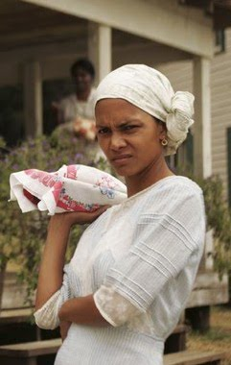**IV. The Suppression of Janie’s Hair & Voice**

7. At the end of the fifth chapter, some of the townspeople had wondered why Janie wears her hair in a kerchief while she is working in the store: “Whut make her keep her head tied up lak some ole ’oman round de store? Nobody couldn’t *git* me tuh tie no rag on mah head if Ah had hair lak dat.”One of the men speculated that Joe makes Janie cover her hair: “Maybe he make her do it. Maybe he skeered some de rest of us mens might touch it round dat store. It sho is uh hidden mystery tuh me.” In the sixth chapter, Janie begins to express her frustration at Joe’s insistence that she cover her hair: “This business of the head-rag irked her endlessly. But Jody was set on it. Her hair was NOT going to show in the store.” Why does Joe prohibit Janie from showing her hair in the store? What does this prohibition reveal about Joe’s character?

Halle Berry as Janie in the 2005 film

8. At the very end of the sixth chapter, when the men on the porch speak dismissively about Mrs. Robinson, Janie is moved to raise her voice: “Janie did what she had never done before, that is, thrust herself into the conversation.” She tells the men assembled on the porch that they are going to be “surprised” when they find out that they “don’t know half as much ’bout us as you think you do. It’s so easy to make yo’self out God Almighty when you ain’t got nothin’ tuh strain against but women and chickens.” This is the second time in the chapter when Janie speaks up in defense of others. Joe retorts that Janie is getting “too moufy,” and he tells her to go “fetch” the checkerboard. Why might Zora Neale Hurston include this exchange at the very end of the chapter? Does the exchange enable readers to predict anything about what might happen next?