|  |  |
| --- | --- |
| **Surname:** | **Burgess** |
| **Forename(s):** | **Aiden** |
| **Student ID:** | **600280511** |

Declaration

By submitting this assessment, you confirm that:

* You have completed this assessment with integrity and honesty and not committed any academic misconduct (i.e. cheating, plagiarism, assisting others to cheat or copy, engaging the use of third party assistance including from your fellow classmates, families or friends).
* Your submission represents your individual effort and does not contain plagiarised material.
* You are responsible to ensure that no one copies your assessment.
* You are responsible to fully comply with the **University’s Regulations, Statues and Guidelines** as stated and available at <http://www.auckland.ac.nz/uoa/home/about/teaching-learning/honesty/tl-uni-regs-statutes-guidelines>

By typing your name below, you acknowledge that you are fully aware and abide by the conditions stated above.

|  |  |
| --- | --- |
| **Date** | 18-06-2020 |
| **Surname** | Burgess |
| **Forenames** | Aiden |

**QUESTION 1: Visual Design (max 10 sentences)**

Overall the design is simple but densely packed with information, this allows high memorability. The page contains several standard components such as the top bar, side bar, search bar, and logo, providing ease of learning for users. Subjective satisfaction is quite lacking, as the design is outdated and flat.

There is a top heavy balance to the page, as the “Welcome to Wikipedia” text is larger. Links are in blue, so they are contrasted against the normal black text; emphasising this element on the screen. The font is consistent throughout the page, complementing the design principle of unity.

The bullet points of different categories (“Arts”, “Biography”, etc.) follows the fate principle, relating these elements together into a group. Both article images (bird and plane) are small in area so are seen as figures, instead of the background due to the area principle.

**QUESTION 2: Implementation**

See galleryStore08.html.

**Q3.1 Mid-Fidelity Paper Prototype**

**Event and target audience:** Theatre event

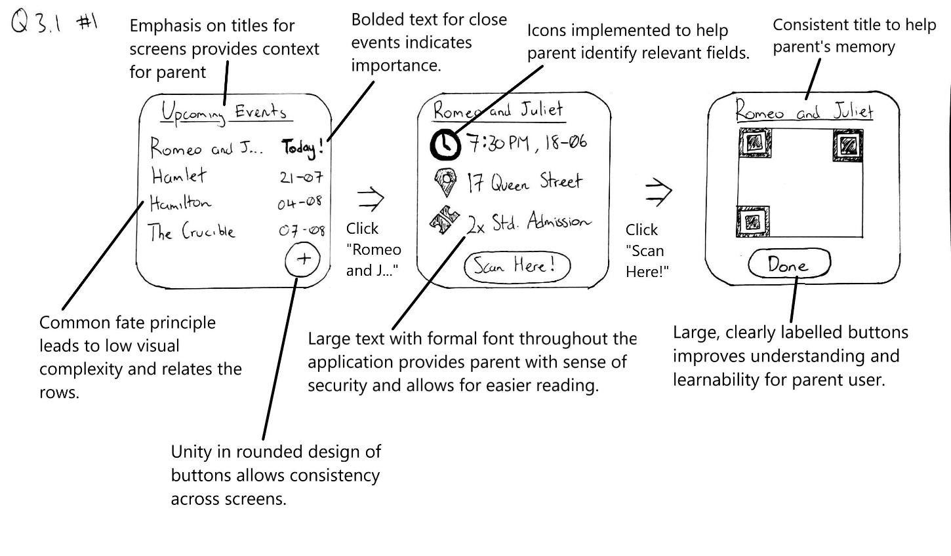**Target user and one ‘other’ person:** Parent, aged 37, who has one child aged 5

**Q3.2 A Persona**

Alice is a married 37 year-old stay at home mother with a son named Sam who is 5 years old. As her son is growing up, she wants to entertain him with theatre, a passion which she has held since childhood. Personally, Alice is a novice with technology, but is keen to learn and interact with new applications. She wants to watch theatre that both she and her son can enjoy, while not disturbing the audience to the theatre.

**Q3.3 Usage Testing**

Assumption for Q3.3: Only one usage test task.

**Hypotheses:** The user will click on the “Romeo and J…” card without confusion. The user will then click on the “Scane Here!” button without confusion.

**Task:** Navigate to the QR code for a specific event from the home screen.

**Prompt:** You have just opened up this app for theatre events, and you want to scan the QR code for an event called “Romeo and Juliet”. How would you get this QR code to appear?

**Start time:** As soon as the participant guide finishes the prompt.

**Finish time:** When the “Romeo and Juliet” QR code page is reached.

The two quantitative measures to be used for this usage test are: time taken to complete task, and scores derived from Likert scales.

The time taken to complete a task is measured from as soon as the participant guide has finished the prompt to when the specified end point has been reached. The sessions should be recorded and timed afterwards to prevent participants feeling rushed during the session. To increase accuracy the scores can be averaged across participants. This is useful as it allows scores to be compared to previous versions of the application, or with competitors. It also allows outliers to be spotted, which can be examined to extract possible usability issues.

Scores derived from Likert scales will be collected from a standardised questionnaire after the usage testing has completed. These scores can be averaged for groups of people to see overall trends in versions or across competitors. As many usage tests use similar/standardised questionnaires, the results are more comparable than time to complete measures.

Two qualitative measures to be used for this usage test are: direct observations from observer in usage test, and open question answers from a questionnaire.

Direct observations are recorded during the usage test by an observer. They will record the user’s perceptions, emotions, and any nonverbal expressions or observations. This information can help pinpoint where the user is hesitant and where they are confident. Design decisions can then be made to improve or maintain elements which were commented on.

Answers from open questions will be collected from a questionnaire after the usage test is completed. The questions can be standardised, so the results can be compared with other applications and users. This also provides users with an opportunity to comment on elements that were not directly addressed in scenarios. For example, a specific element which was not interacted with may seem jarring, but in the tasks given there was not an opportunity to comment on this element.

**Q3.4 Agile UX**

Instead of going through the entire design process iteratively, UX must be done in UX design sprints, which are much shorter in time. The UX designer needs to create ideas and sketches to support stories, then create designs and prototypes for story features, and finally create wireframes of these prototypes before passing these on to the software engineers.

Two example artefacts which are produced during the agile approach are high-fidelity click-through prototypes, and specific questions for new features or elements. While user testing, users would go through scenarios using the click-through prototypes. These research questions are included in questionnaires given to the participants, to discover their reactions and thoughts.