Aiden Ramsey Lab 10 Report

Generating Random Data:
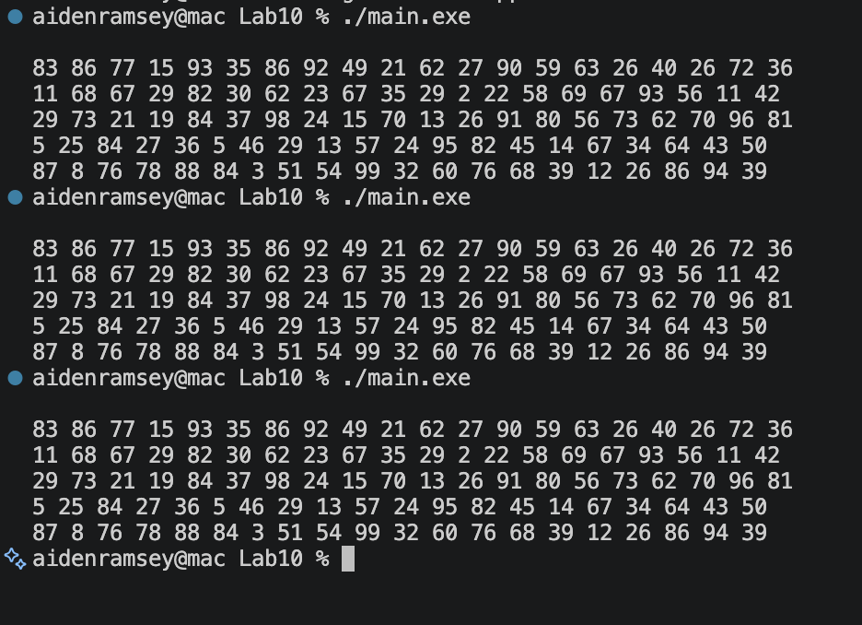

Creating Mostly Random Sorted Data with swap values 100, 10, and 0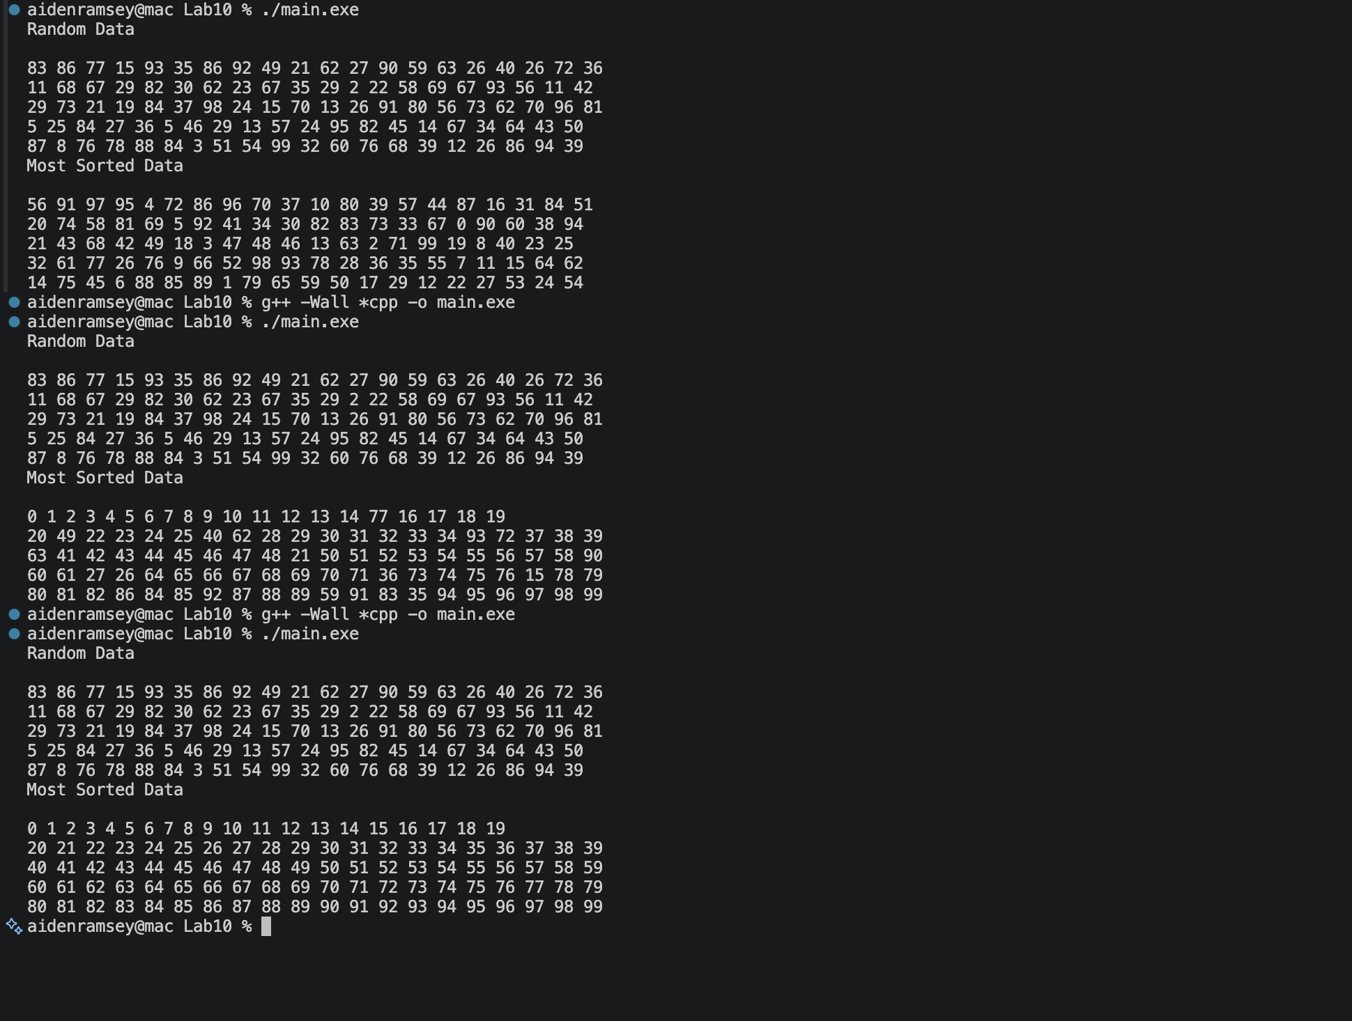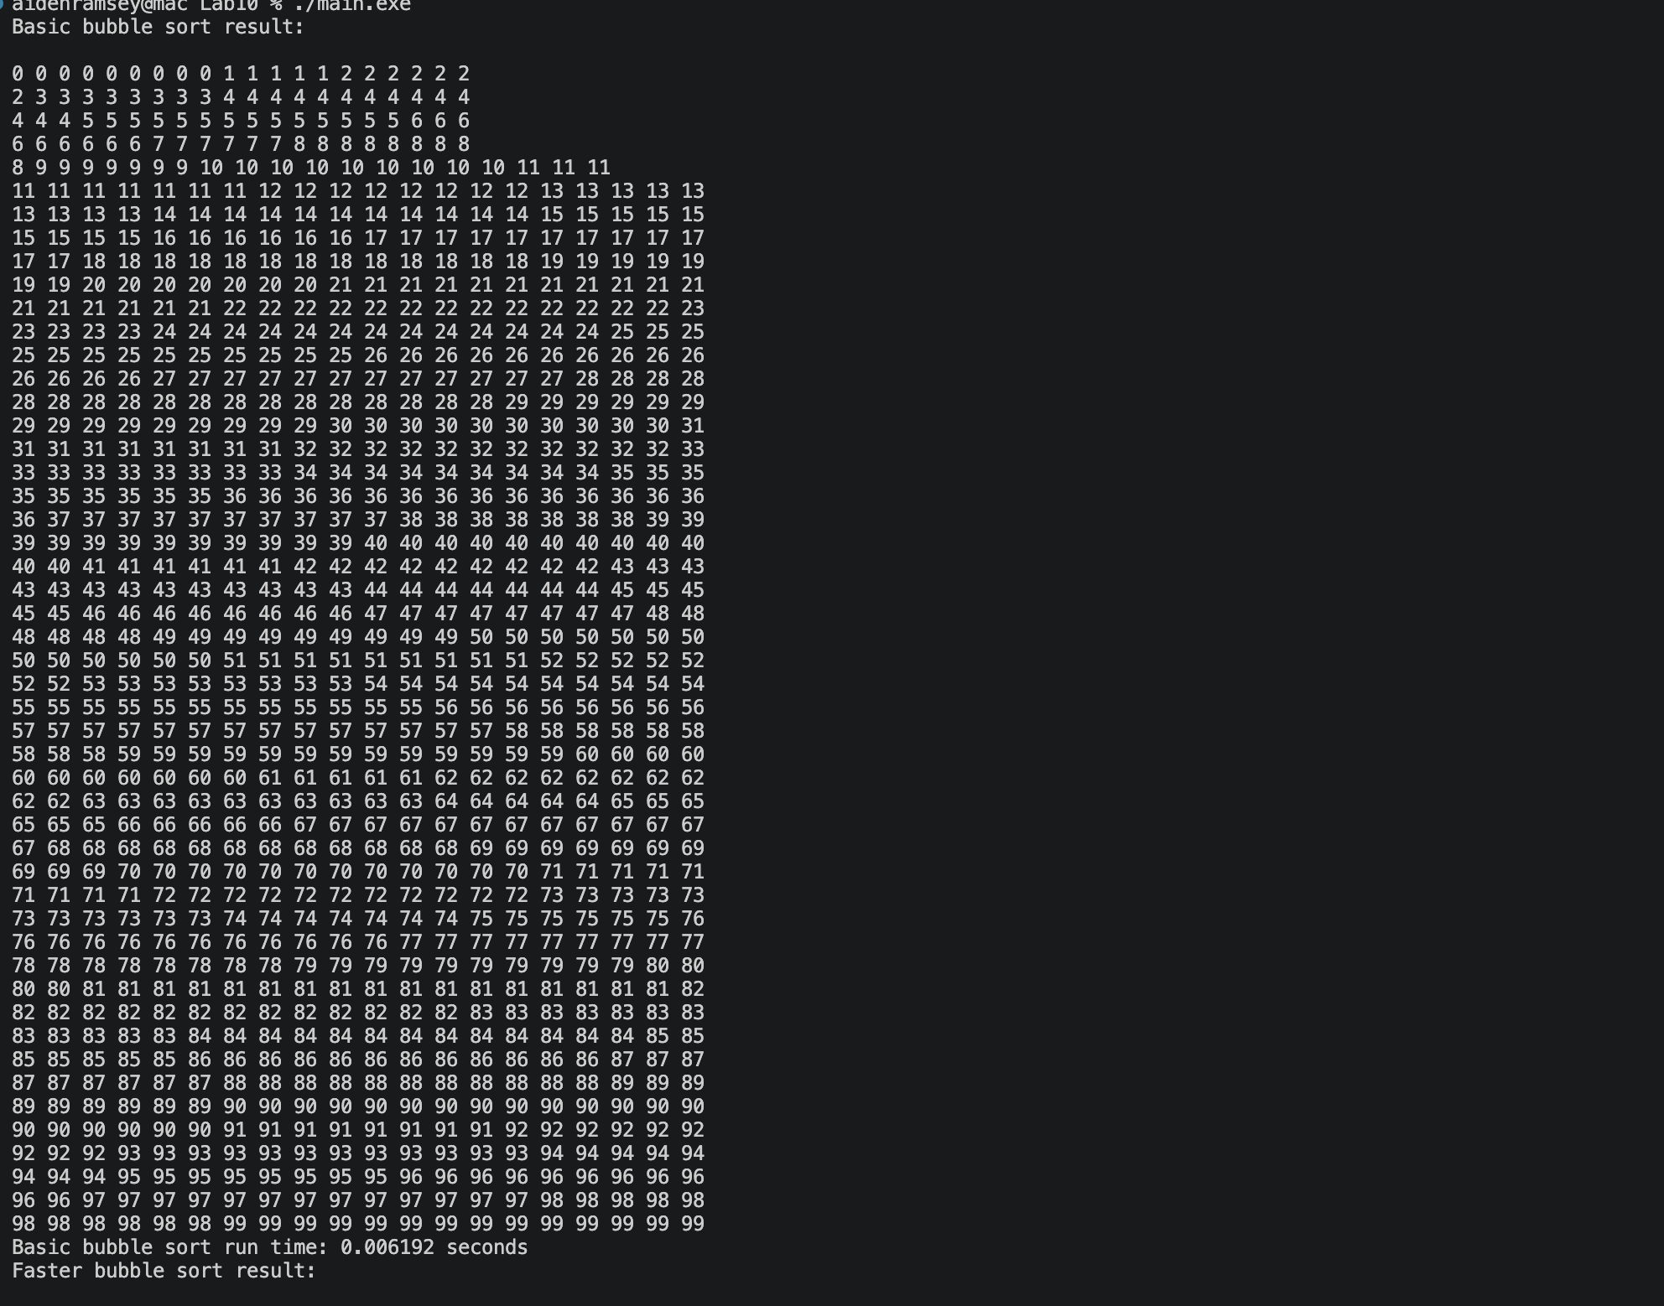

Basic Bubble Sort Result vs Faster Bubble Sort Result

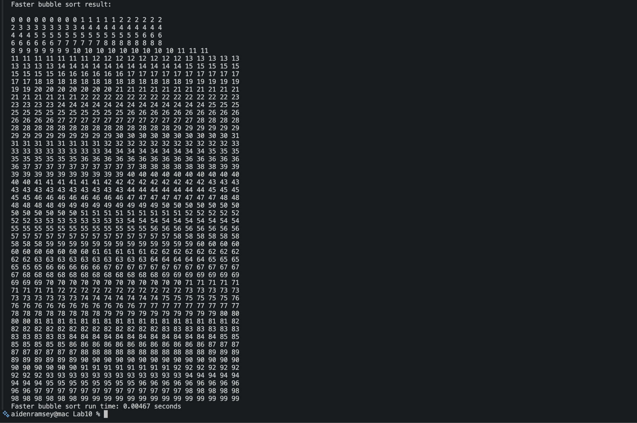
Selection Sort:
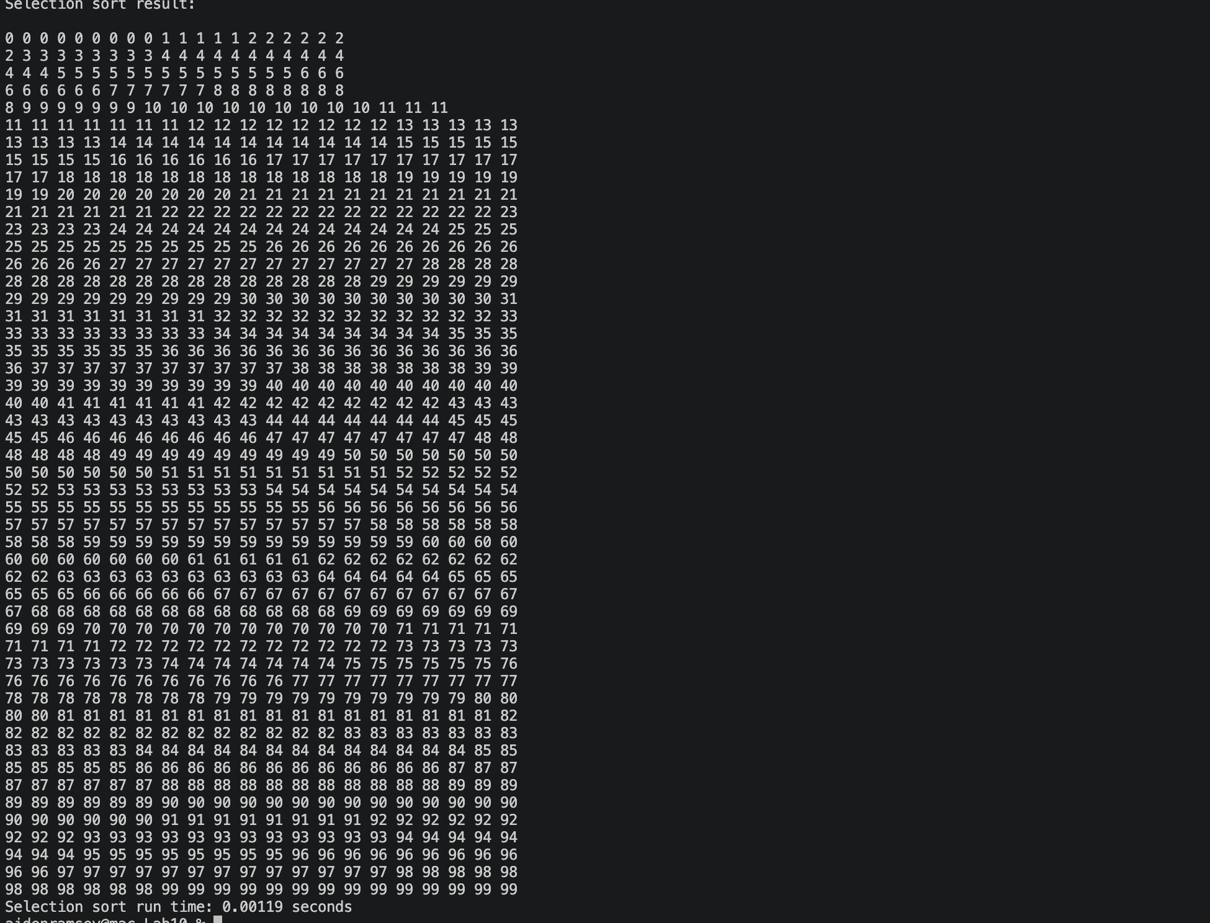
Sorts Compared with N=15,000
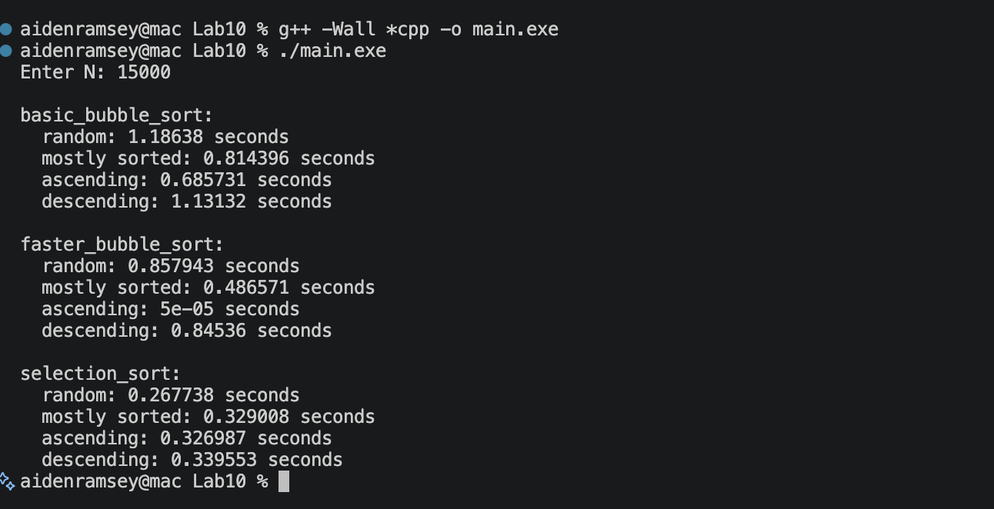
For these measurements, faster bubble sort had the largest spread in CPU time across input patterns, while selection sort had the smallest. The faster version finishes super quickly since it terminates as soon as it detects no swaps are needed. For Basic bubble sort and selection sort they still do their nested loops on sorted data. In general, basic bubble sort and selection sort take O(N²) time across input patterns; faster bubble sort is O(N) in the best case and O(N²) on average and in the worst case.
AI Answer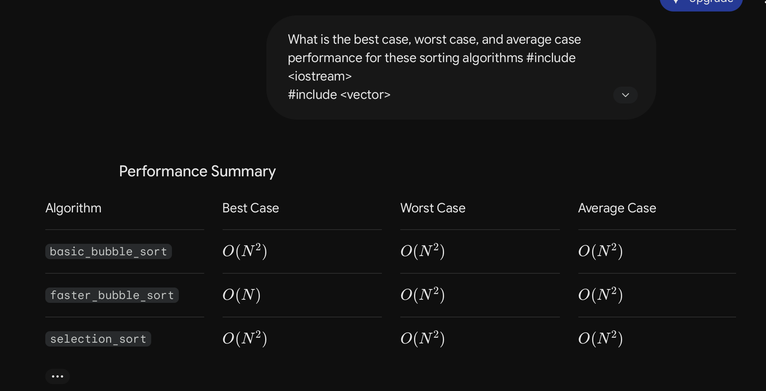
My code for the lab:
#include <iostream>
#include <vector>
#include <ctime>
using namespace std;

//------------------------------------------------------------------
// Initialize vector with random values
//------------------------------------------------------------------
vector<int> create_random_data(int count, int range)
{
// Error checking
if (count < 1) count = 1;
if (range < 1) range = 1;

// Insert count random values between 0..range-1 into vector
srandom(1);
vector<int> data(count);
for (int index = 0; index < count; index++)
data[index] = random() % range;
return data;
}

//------------------------------------------------------------------
// Initialize vector with sorted values
//------------------------------------------------------------------
vector<int> create_sorted_data(int count, bool ascending)
{
// Error checking
if (count < 1) count = 1;

// Insert sorted values into vector
vector<int> data(count);
for (int index = 0; index < count; index++)
{
if (ascending)
data[index] = index;
else
data[index] = count-index;
}
return data;
}

//------------------------------------------------------------------
// Initialize vector with mostly sorted values
//------------------------------------------------------------------
vector<int> create_mostly_sorted_data(int count, int swaps)
{
// Error checking
if (count < 1) count = 1;

// Create vector of sorted values
vector<int> data = create_sorted_data(count, true);

// Unsort vector by swapping random pairs of values
srandom(1);
for (int index = 0; index < swaps; index++)
{
int pos1 = random() % count;
int pos2 = random() % count;
int temp = data[pos1];
data[pos1] = data[pos2];
data[pos2] = temp;
}
return data;
}

//------------------------------------------------------------------
// Print vector to screen
//------------------------------------------------------------------
void print_data(const vector<int> &data)
{
// Print the data
for (int i = 0; i < (int)data.size(); i++)
{
if (i % 20 == 0)
cout << endl;
cout << data[i] << " ";
}
cout << endl;
}

//-----------------------------------------------------------------
// Basic bubble sort algorithm
//-----------------------------------------------------------------
void basic_bubble_sort(vector<int> &data)
{
// Error checking
if (data.empty()) return;

// Loop over entire vector
int low = 0;
int high = (int)data.size()-1;
for (int loop = low; loop < high; loop++)
{
// Loop over unsorted part of vector
for (int index = low; index < high; index++)
{
// Swap two data values if out of order
if (data[index] > data[index + 1])
{
int temp = data[index];
data[index] = data[index + 1];
data[index + 1] = temp;
}
}
}
}

//-----------------------------------------------------------------
// Faster bubble sort algorithm
//------------------------------------------------------------------
void faster_bubble_sort(vector<int> &data)
{
// Error checking
if (data.empty()) return;

// Loop over entire vector
int low = 0;
int high = (int)data.size()-1;
bool sorted = false;
for (int loop = low; loop < high; loop++)
{
// Loop over unsorted part of vector
sorted = true;
for (int index = low; index < high-loop; index++)
{
// Swap two data values if out of order
if (data[index] > data[index + 1])
{
int temp = data[index];
data[index] = data[index + 1];
data[index + 1] = temp;
sorted = false;
}
}

// Stop looping when vector is sorted
if (sorted) return;
}
}

//---------------------------------------------------------------
// Selection sort algorithm
//---------------------------------------------------------------
void selection_sort(vector<int> &data)
{
// Error checking
if (data.empty()) return;

// Loop over entire vector
int low = 0;
int high = (int)data.size()-1;
for (int first = low; first < high; first++)
{
// Find index of smallest value in unsorted vector
int smallest = first;
for (int index = first + 1; index <= high; index++)
if (data[index] < data[smallest])
smallest = index;

// Swap with first element in unsorted vector
int temp = data[first];
data[first] = data[smallest];
data[smallest] = temp;
}
}

int main()
{
int count;
cout << "Enter N: ";
if (!(cin >> count) || count < 1)
{
cerr << "N must be a positive integer." << endl;
return 1;
}

vector<int> random_data = create_random_data(count, count);
vector<int> mostly_sorted_data = create_mostly_sorted_data(count, count / 10);
vector<int> ascending_data = create_sorted_data(count, true);
vector<int> descending_data = create_sorted_data(count, false);

const char *case_names[] = {
"random", "mostly sorted", "ascending", "descending"
};
const vector<int> *inputs[] = {
&random_data, &mostly_sorted_data, &ascending_data, &descending_data
};
const char *algorithm_names[] = {
"basic_bubble_sort", "faster_bubble_sort", "selection_sort"
};

for (int algorithm = 0; algorithm < 3; algorithm++)
{
cout << "\n" << algorithm_names[algorithm] << ":\n";
for (int test_case = 0; test_case < 4; test_case++)
{
vector<int> data = *inputs[test_case];
clock_t time1 = clock();
if (algorithm == 0)
basic_bubble_sort(data);
else if (algorithm == 1)
faster_bubble_sort(data);
else
selection_sort(data);
clock_t time2 = clock();
double run_time = (time2 - time1) / (double)CLOCKS_PER_SEC;
cout << " " << case_names[test_case] << ": "
<< run_time << " seconds\n";
}
}
return 0;
}

