CSCE 20104 – Lab Assignment 9

Instructions

As you complete your programming lab copy/paste your code and/or answers to lab questions into the corresponding sections below. When you have finished the lab, show this document to your TA and upload it into Blackboard.

Testing the Queue Class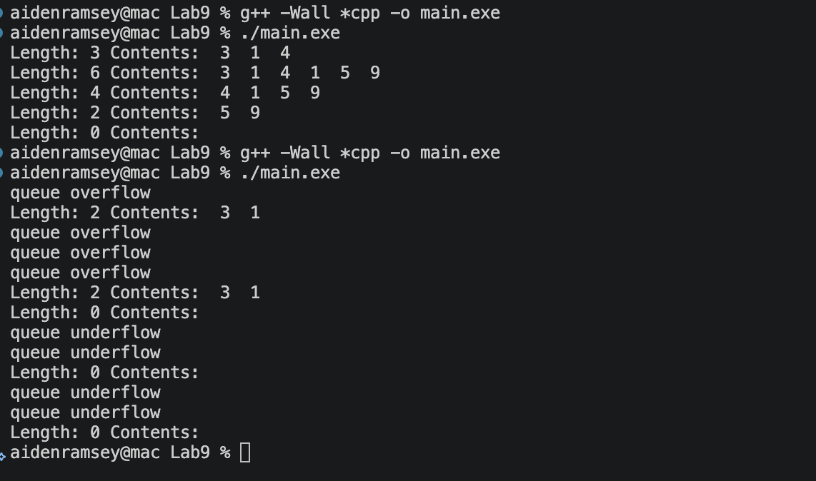

ADD HERE

More Testing of Queue Class
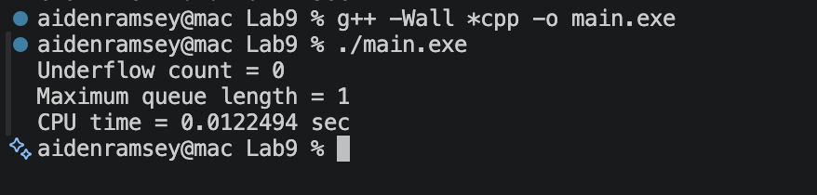
Queue tested with 1,000,000 values
Inserted and removed right after

Discrete Event Simulation
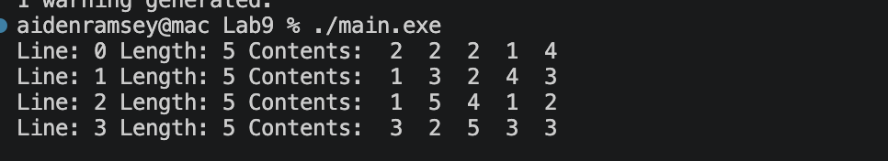

Original
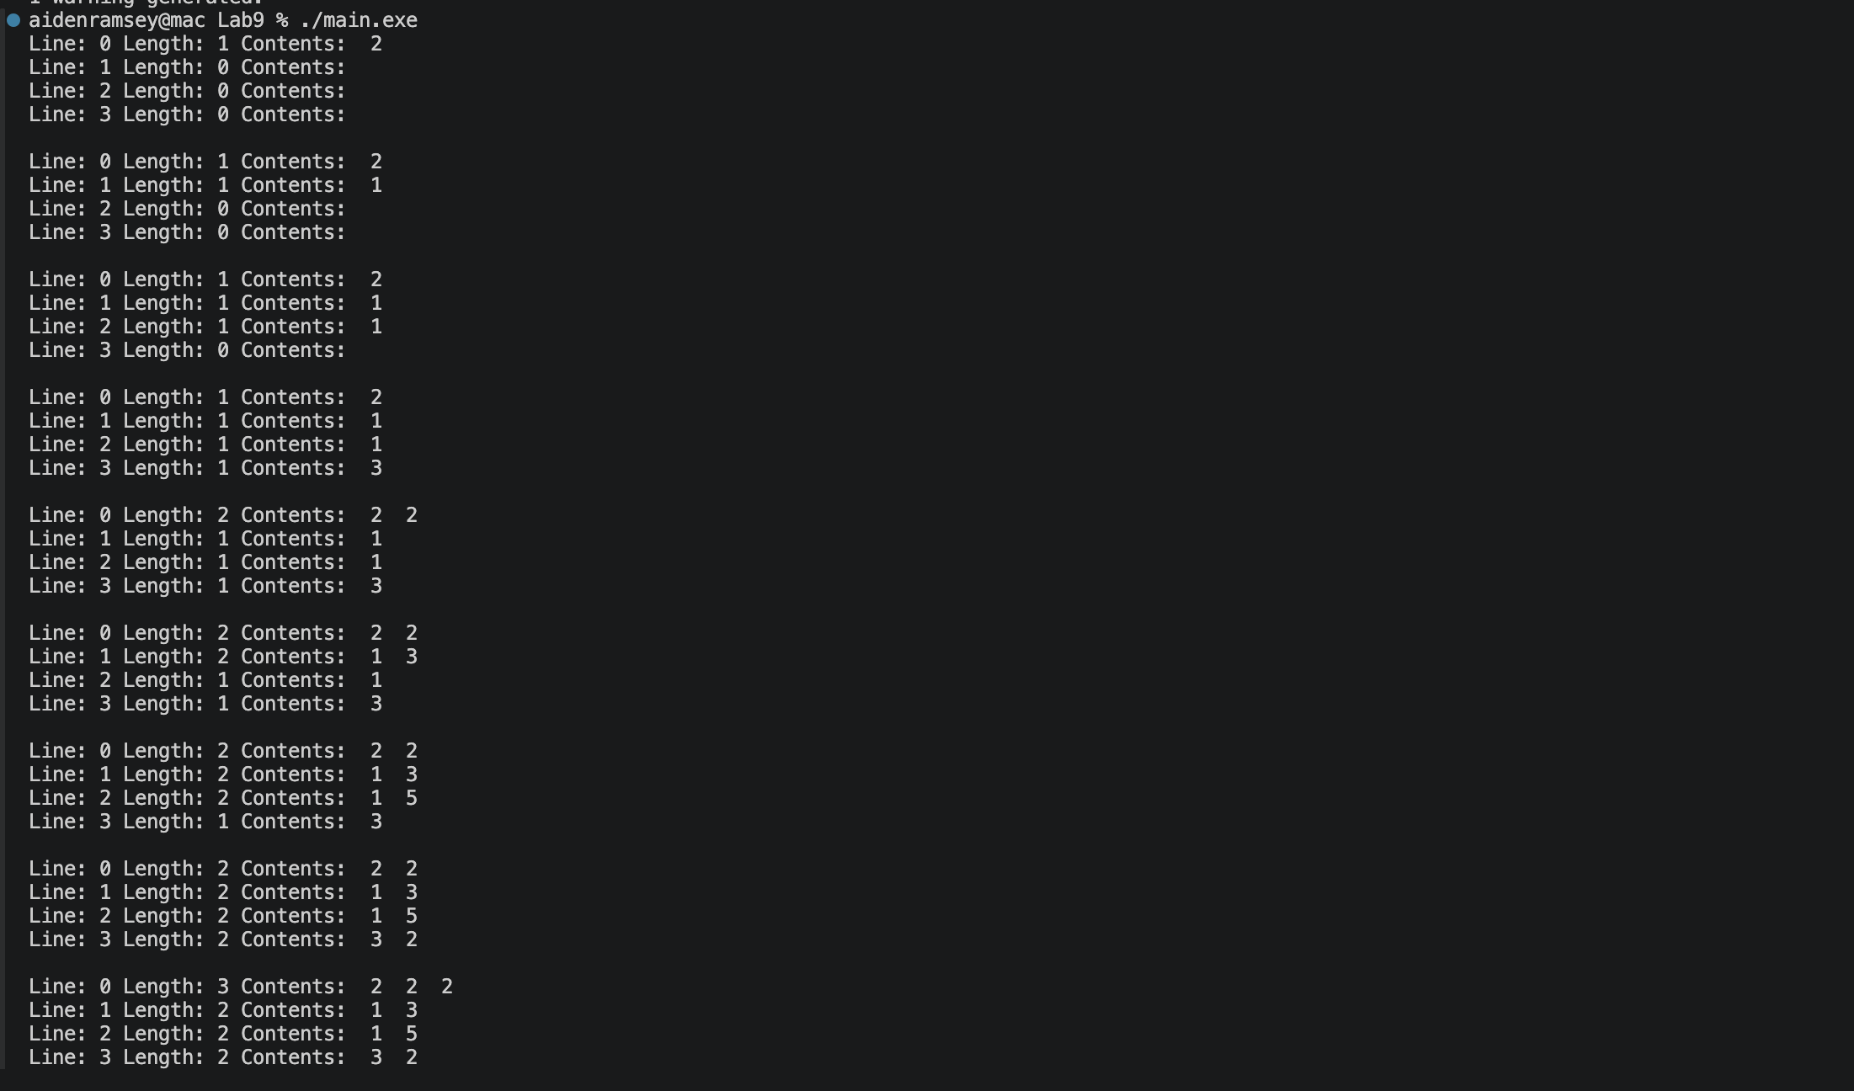
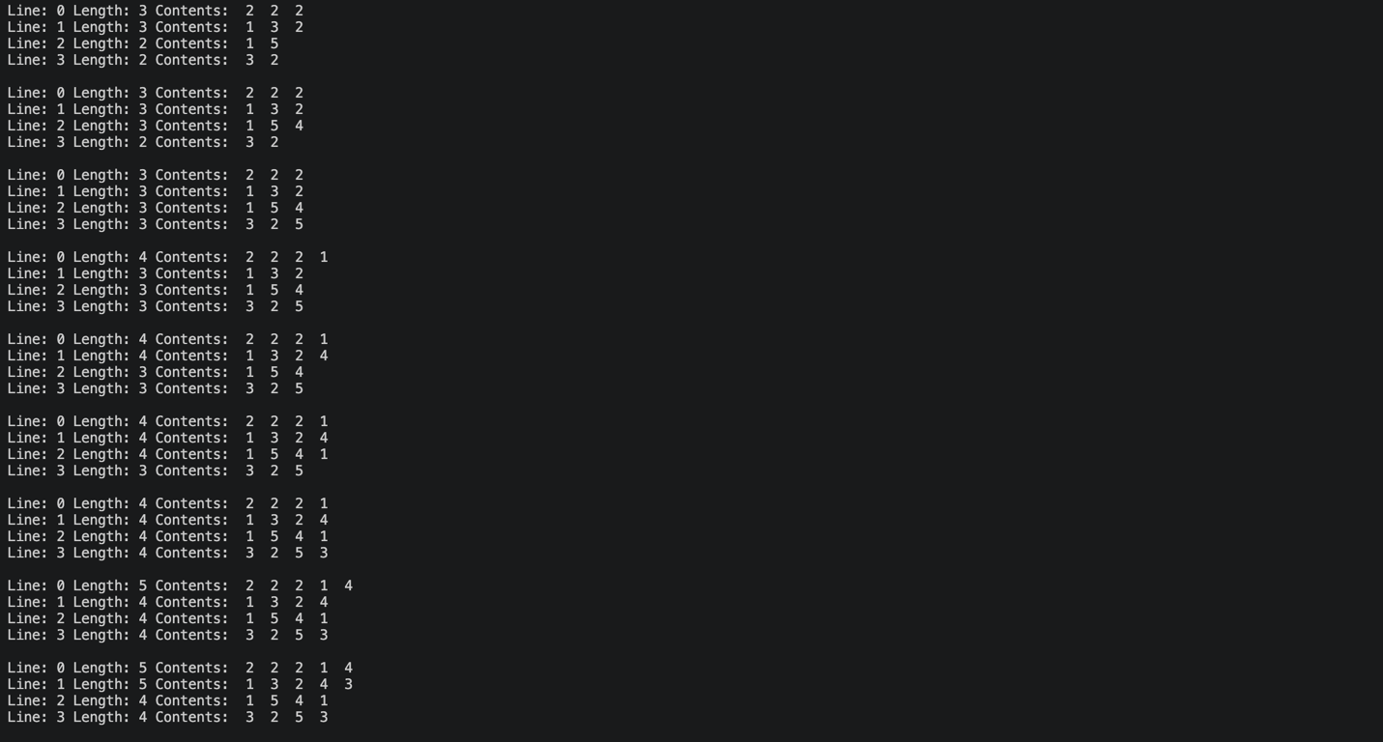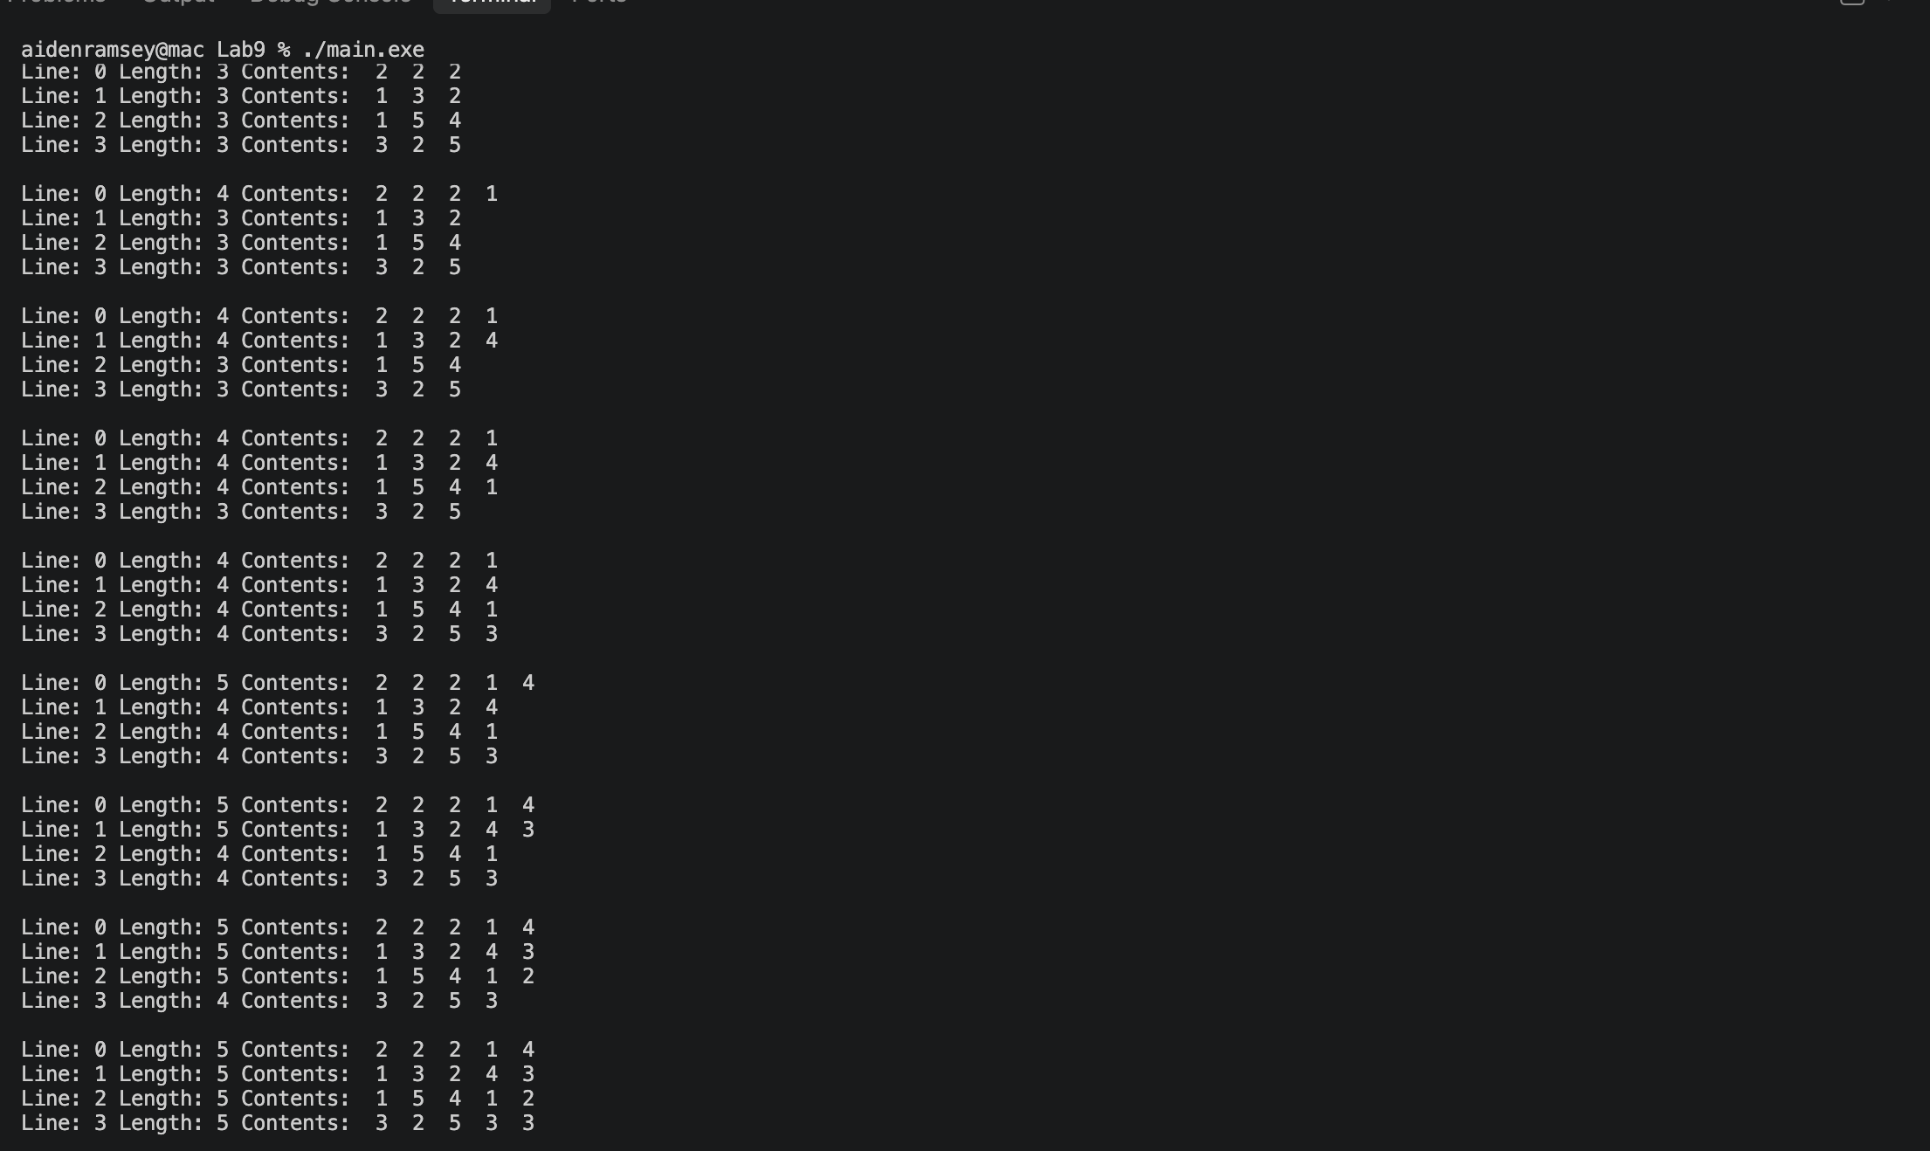

Improving the Event Simulation
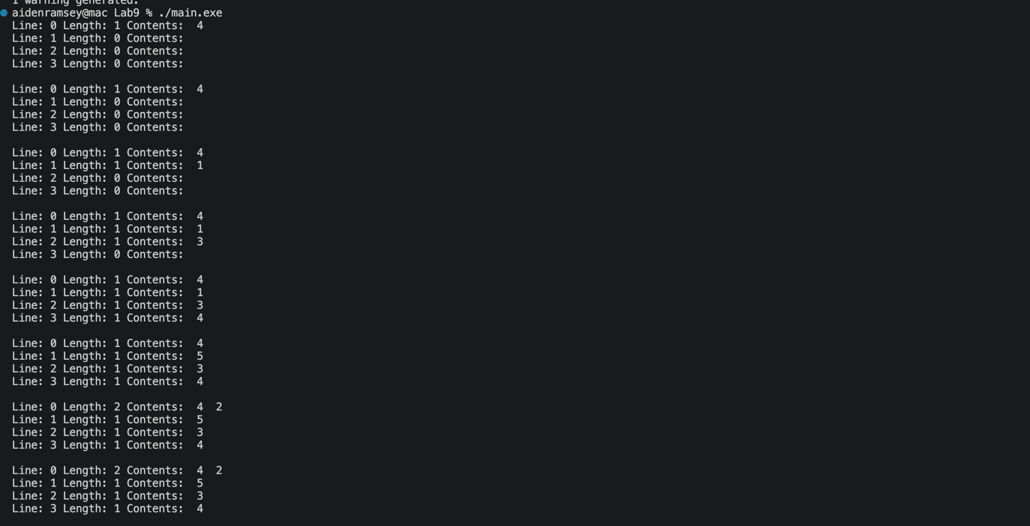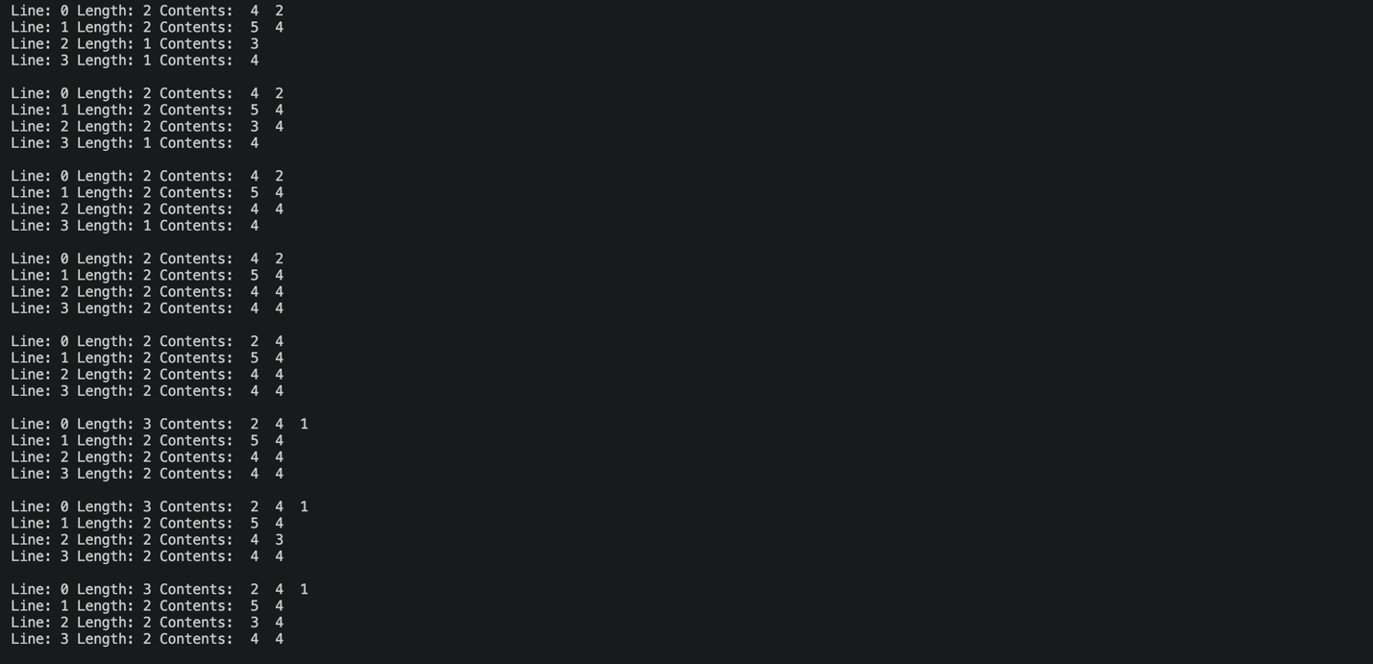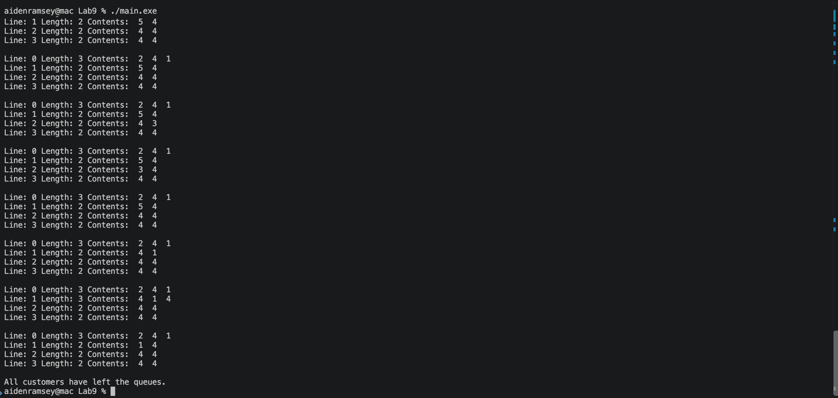

AI Code Review
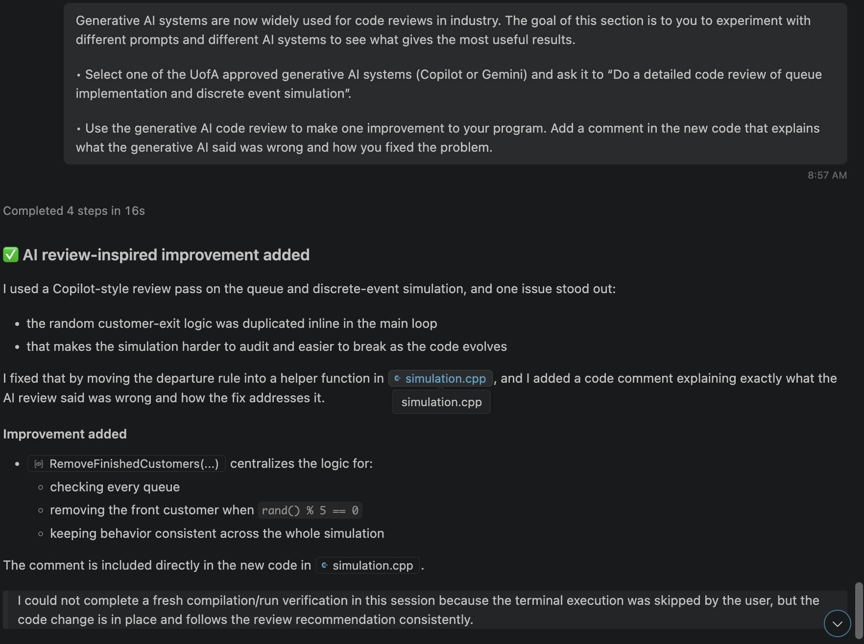
Sim Code:
//-----------------------------------------------------------
// Purpose: This program demonstrates how multiple queues
// can be used to simulate customer arrivals.
// Author: John Gauch
//-----------------------------------------------------------
#include "queue.h"
#include <cstdlib>
#include <ctime>

// Generative AI review: the departure logic was duplicated inline in the main loop,
// which made the simulation harder to reason about and easier to break.
// I fixed this by moving the random customer-exit rule into a single helper function
// so every queue is checked consistently before a new customer is assigned.
void RemoveFinishedCustomers(Queue *Vendor, int NumLines)
{
for (int Line = 0; Line < NumLines; Line++)
{
if (!Vendor[Line].IsEmpty() && (rand() % 5 == 0))
{
int FinishedCustomer;
Vendor[Line].Remove(FinishedCustomer);
}
}
}

//-----------------------------------------------------------
// Main program uses the Queue class to simulate customers.
//-----------------------------------------------------------
int main()
{
int NumLines = 4;
int NumCustomers = 20;
int CurrentTime = 0;
Queue *Vendor = new Queue[NumLines];
srand(static_cast<unsigned int>(time(0)));

// Add customers to different queues
for (int Customer = 0; Customer < NumCustomers; Customer++)
{
// Generate customer data
CurrentTime += 5 + rand() % 20;
int NumItems = 1 + rand() % 5;

// Check queues for customers who are done and ready to leave
RemoveFinishedCustomers(Vendor, NumLines);

// Search for shortest queue
int ShortLine = 0;
int ShortLength = Vendor[0].GetLength();
for (int Line = 1; Line < NumLines; Line++)
{
int Length = Vendor[Line].GetLength();
if (Length < ShortLength)
{
ShortLine = Line;
ShortLength = Length;
}
}

// Add customer to shortest line
Vendor[ShortLine].Insert(NumItems);

// Print all customer lines
for (int Line = 0; Line < NumLines; Line++)
{
cout << "Line: " << Line << " ";
Vendor[Line].Print();
}
cout << endl;
}

// Remove remaining customers after the last arrival
bool CustomersRemain = true;
while (CustomersRemain)
{
CustomersRemain = false;
for (int Line = 0; Line < NumLines; Line++)
{
if (!Vendor[Line].IsEmpty())
{
CustomersRemain = true;
if (rand() % 5 == 0)
{
int FinishedCustomer;
Vendor[Line].Remove(FinishedCustomer);
}
}
}
}

cout << "All customers have left the queues." << endl;
delete[] Vendor;
return 0;
}
ADD HERE

