Part A Prompt:
Could you create me a c++ class structures based on the files below that does the following The data files we will be working with for this project
consists of 33,129 synthetic street addresses in the Fayetteville area. The
files contain one address record per line with the following four data fields
in this order:

· Latitude – a float value between 36.0300 and 36.1474
· Longitude – a float value between -94.1999 and -94.0846
· House number – an integer value between 1 and 231
· Street name – a string containing one or more
words

Each line in the “street_name.txt” file contains addresses
sorted by street name and then house number. Each line in the “locations.txt”
file contains addresses sorted by latitude and then longitude.

Your first task is to create a simple “Address” class to
store the address information above. Your class should have the standard
constructor functions, destructor, get/set methods and a print method.

Your second task is to create a “read_address” function that
reads all of the addresses from an input file into a vector of Address objects.
Your main program should call this function to read one of the data files, and
then print out the first and last Address in the vector.

You ARE allowed to use generative AI for these
two tasks if you wish. You
will need to be very specific about what code you want the AI to produce to get
something that is correct and easy to read and understand.
Below is the implementation for the Address class, the read_address function, and a demonstration main program based on your specified data structure requirements.
Code is the files in .zip
Part 2:
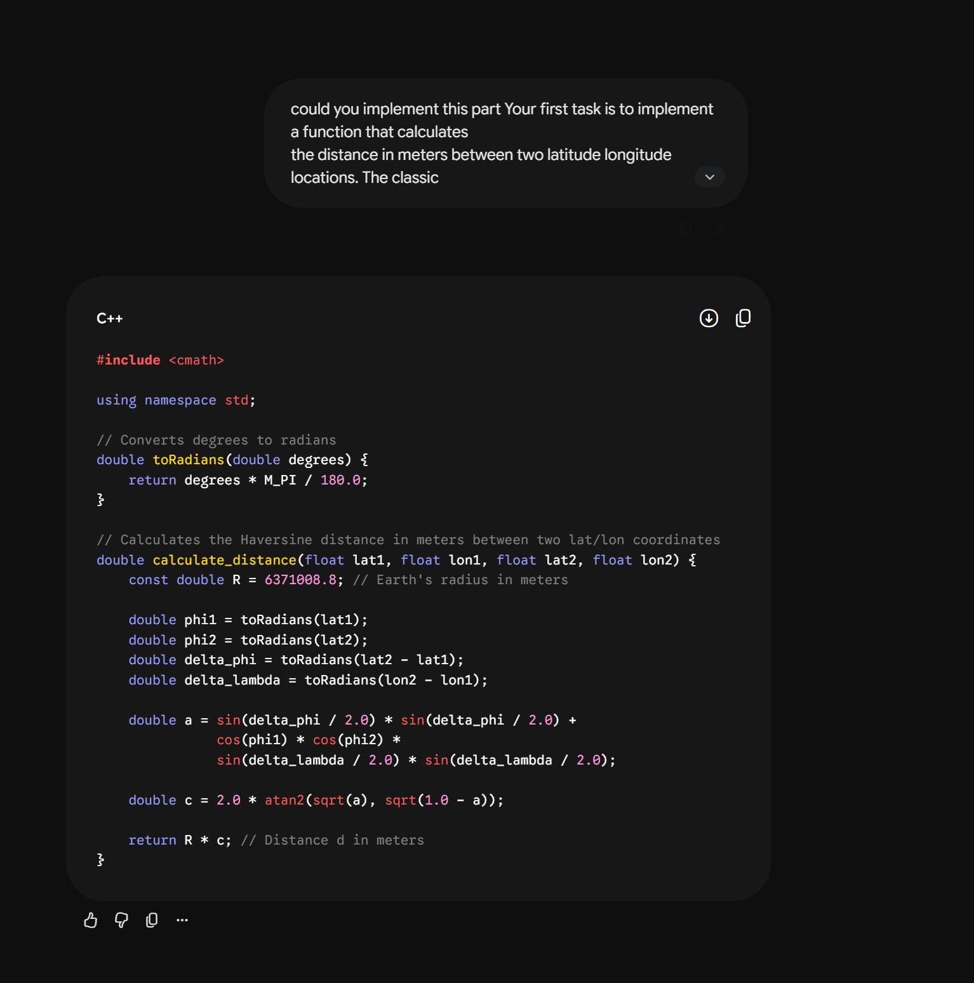
Code is in main

