已知：

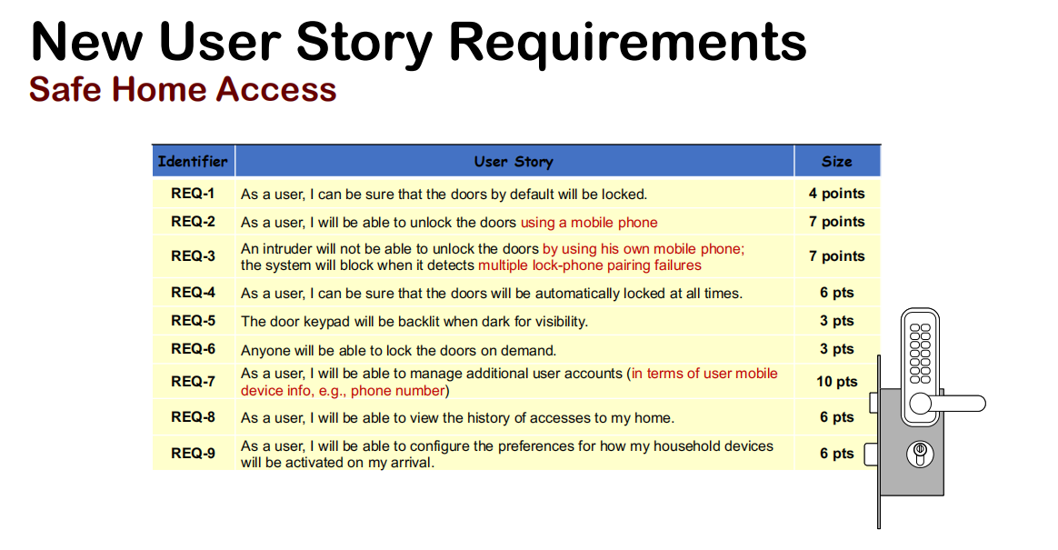

从系统需求中导出用例：

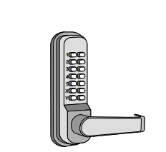





要求：

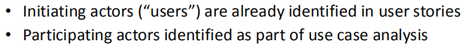

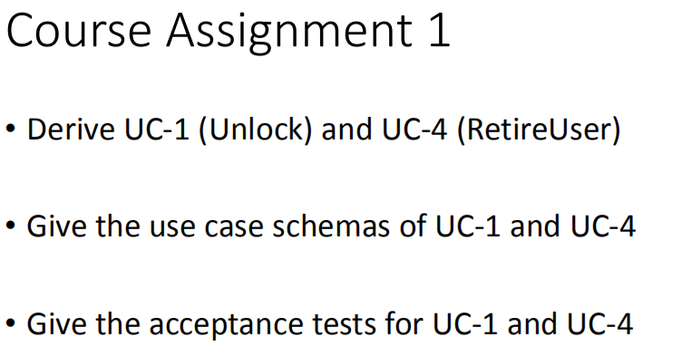

**1.Use Case 1: Unlock**

|  |  |
| --- | --- |
| Related Requirem pts: | REQ1, REQ2, REQ3 and REQ4 |
| Initiating Actor: | Tenant, Landlord |
| Goal: | Unlock and enter, the space automatically lights up |
| Participating Actors: | LockDevice, LightSwitch, Timer, Database and Mobile Phone |
| Preconditions: | 1.The set of valid Bluetooth MAC addresses stored in the system database is not empty  2.The sensor on the locking device is always active |
| Postconditions | The sensor on the locked device is always active |

**Flow of Events for Main Success Scenario:**

1. The tenant / landlord arrives at the door and puts the Bluetooth phone near the lockdevice
2. AuthenticateUser (UC-7)
3. The system (a) sends a lock status signal to the tenant/landlord, for example, "unlock", (b) sends a signal to unlock the locked device, and (c) sends a signal to turn on the light to LightSwitch
4. The system signals the timer to start the auto lock timer countdown
5. The tenant/landlord opens the door and enters the house [close the door and lock it
6. Lockdevice allows the tenant / landlord to try again when pairing fails (for example, the MAC address cannot be found in the database).
7. When the maximum pairing attempts are reached (for example, three failed attempts), the locked device will notify the landlord.
8. **Use Case 4: RetireUser**

|  |  |
| --- | --- |
| Related Requirem pts: | REQ7 |
| Initiating Actor: | Landlord |
| Goal: | Exit an existing tenant account and disable access. |
| Participating Actors: | Database |
| Preconditions: | 1.The set of valid tenant accounts stored in the system database is non-empty.  2.Each tenant account has additional information like his/her Mobile Phone number |
| Postconditions | The account of the tenant is removed from database. |

**Flow of Events for Main Success Scenario:**

1.The landlord queries the tenant account in the database.

2.The landlord removes the target tenant's account.

**Acceptance Test Case for UC-1 Unlock**

|  |  |
| --- | --- |
| Identifier | TC-1 |
| Use Case Tested | UC-1, main success scenario and alternate scenario |
| Pass/fail Criteria: | The test passes if the user put the Mobile Phone whose Bluetooth Mac |
| Input Data: | MAC address |

**Test Procedure:**

1.Put a Mobile Phone whose Mac address is not in the database.

**Result 1:**System beeps to indicate failure;  
records unsuccessful attempt in the database;  
prompts the user to try again

2.Put a Mobile Phone whose Mac address is in the database.

**Result 2:**System flashes a green light to indicate success;records successful access in the database

**Acceptance Test Case for UC-1 Unlock**

|  |  |
| --- | --- |
| Identifier | TC-2 |
| Use Case Tested | UC-1, main success scenario and alternate scenario |
| Pass/fail Criteria: | The test passes if the maximum attempts is reached, the landlord will be noticed. |
| Input Data: | Mobile Phone Bluetooth MAC addres |

**Test Procedure:**

1. Put a Mobile Phone whose Mac address is not in the database before reaching the maximum attempts.

**Result 1:**System beeps to indicate failure;records unsuccessful attempt in the database;prompts the user to try again；  
2.Put a Mobile Phone whose Mac address is not in the database again.

**Result 2：**System beeps to indicate failure;ecords unsuccessful attempt in the database;sensor shuts down;

**Acceptance Test Case for UC-4 RetireUser**

|  |  |
| --- | --- |
| Identifier | TC-3 |
| Use Case Tested | UC-4, main success scenario |
| Pass/fail Criteria: | The test passes if the landlord retrieve the target tenant account and delete it |
| Input Data: | The key word for the target tenant |

**Test Procedure:**

1. Make a query for the target tenant.

**Result 1:**Database returns the tenant’s account information including his/her phone number

1. Delete the target tenant in the database.

**Result 2：**Database remove the tenant’s account including his/her Bluetooth MAC address.

1. Put the removed tenant’s Mobile Phone.

**Result 3:** System beeps to indicate failure;records unsuccessful attempt in the database;  
prompts the user to try again