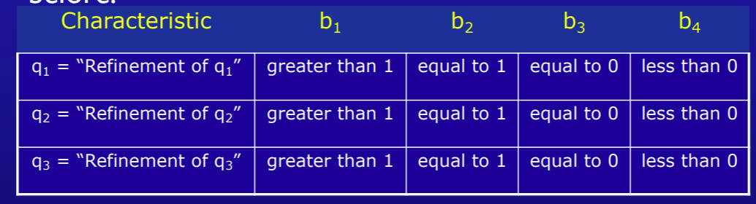

**@Test**

**public void ISP_testTriang_1(){**

**assertEquals(4,tri.Triang(2,2,2));**

**assertEquals(4,tri.Triang(1,1,1));**

**assertEquals(4,tri.Triang(0,0,0));**

**assertEquals(4,tri.Triang(-1,-1,-1));**

**}**

**@Test**

**public void ISP_testTriang_2(){**

**assertEquals(4,tri.Triang(2,2,2));**

**assertEquals(4,tri.Triang(2,1,1));**

**assertEquals(4,tri.Triang(2,0,0));**

**assertEquals(4,tri.Triang(2,-1,-1));**

**assertEquals(4,tri.Triang(1,2,1));**

**assertEquals(4,tri.Triang(1,1,0));**

**assertEquals(4,tri.Triang(1,0,-1));**

**assertEquals(4,tri.Triang(1,-1,0));**

**assertEquals(4,tri.Triang(0,2,0));**

**assertEquals(4,tri.Triang(0,1,-1));**

**assertEquals(4,tri.Triang(0,0,2));**

**assertEquals(4,tri.Triang(0,-1,1));**

**assertEquals(4,tri.Triang(-1,2,-1));**

**assertEquals(4,tri.Triang(-1,1,2));**

**assertEquals(4,tri.Triang(-1,0,1));**

**assertEquals(4,tri.Triang(-1,-1,0));**

**}**

**@Test**

**public void GC_testTriang_1(){**

**assertEquals(1,tri.Triang(2,3,4));**

**assertEquals(2,tri.Triang(3,3,4));**

**assertEquals(3,tri.Triang(3,3,3));**

**assertEquals(4,tri.Triang(1,2,7));**

**assertEquals(4,tri.Triang(-1,2,7));**

**}**

**@Test**

**public void GC_testTriang_2(){**

**assertEquals(1,tri.Triang(2,3,4));**

**assertEquals(2,tri.Triang(3,3,4));**

**assertEquals(2,tri.Triang(3,4,3));**

**assertEquals(2,tri.Triang(4,3,3));**

**assertEquals(3,tri.Triang(3,3,3));**

**assertEquals(4,tri.Triang(1,2,7));**

**assertEquals(4,tri.Triang(1,7,2));**

**assertEquals(4,tri.Triang(7,2,1));**

**assertEquals(4,tri.Triang(2,2,7));**

**assertEquals(4,tri.Triang(2,7,2));**

**assertEquals(4,tri.Triang(7,2,2));**

**assertEquals(4,tri.Triang(-1,2,7));**

**assertEquals(4,tri.Triang(1,-2,7));**

**assertEquals(4,tri.Triang(1,2,-7));**

**}**

**@Test**

**public void GC_testTriang_3(){**

**assertEquals(1,tri.Triang(2,3,4));**

**assertEquals(2,tri.Triang(3,3,4));**

**assertEquals(3,tri.Triang(3,3,3));**

**assertEquals(4,tri.Triang(1,2,7));**

**}**

**@Test**

**public void GC_testTriang_4(){**

**//triOut = 4**

**assertEquals(4,tri.Triang(1,2,7));**

**assertEquals(4,tri.Triang(1,7,2));**

**assertEquals(4,tri.Triang(7,2,1));**

**assertEquals(4,tri.Triang(2,2,7));**

**assertEquals(4,tri.Triang(2,7,2));**

**assertEquals(4,tri.Triang(7,2,2));**

**assertEquals(4,tri.Triang(-1,2,7));**

**assertEquals(4,tri.Triang(1,-2,7));**

**assertEquals(4,tri.Triang(1,2,-7));**

**}**

**@Test**

**public void testTriangMutantOne(){**

**assertEquals(4,triMt1.Triang(2,2,7));**

**}**

**@Test**

**public void testTriangMutantTwo(){**

**assertEquals(4,triMt2.Triang(2,2,4));**

**}**