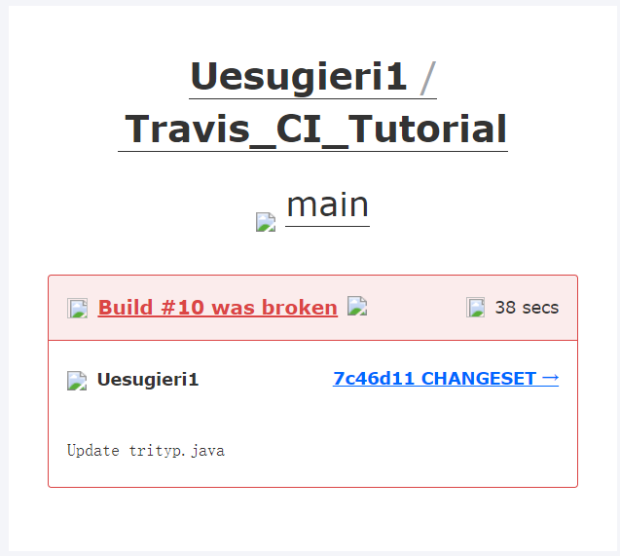

https://github.com/Uesugieri1/Travis_CI_Tutorial