Aiden Inglis

NMIT  322 Hardy St Nelson 7010

SDV602-Milestone 2

Contents

Description 2

Storyboards 2

Launching the App 2

Register 2

Register but have an account? 3

Login 4

Login but don’t have an account? 4

Lobby Logout 5

Lobby Exit 5

Opening a Chart 6

Exit a Chart 6

Chart +/- Zoom Button 7

Chart Chats 7

Change Graph Settings 8

Upload Data Source 9

Set Data Source 10

# Description

The purpose of this application is to allow data analysts to view and talk while observing and modifying charts on an interactive application. The users will be able to navigate through three DES screens and chat using an in-build chat system. In the final version of the app, they will be able to zoom, set source data and upload data for graphs and also change the graph settings.

# Storyboards

This is a list of storyboards that consists of possible storylines that can be taken as you explore and use this application.

## Launching the App

Navigate in the terminal to the folder that contains the main.py python code. Then ensure that PySimpleGUI and matplotlib are installed inside the virtual environment. You can then in your terminal run “python main.py” Then press enter and it should open up the login page.

## Register

When the player first launches the app they will be on the login page.

To register if they don’t have an account they must look to the bottom left of the screen and click on the button that says ‘Register’.

The user will then be sent to this page and will have to make some credentials for themselves, it does not matter what the credentials are as there will be no limitations on security protocols for this project. So your username and password for example could be Username: “Aiden”, Password: “Aiden”. The user must have to put something into the username and password input. Once they have finished deciding on their credentials they can press the ‘register’ button. They will be taken to the login page in which they will be able to type the same credentials in to login.

## Register but have an account?

If you accidentally end up on the register page when trying to login you may have to press the ‘login’ button on the bottom left of the page.

You will then be moved to the login page where you may enter your credentials to be logged in.

## Login

When the player first launches you will be sent to the login page

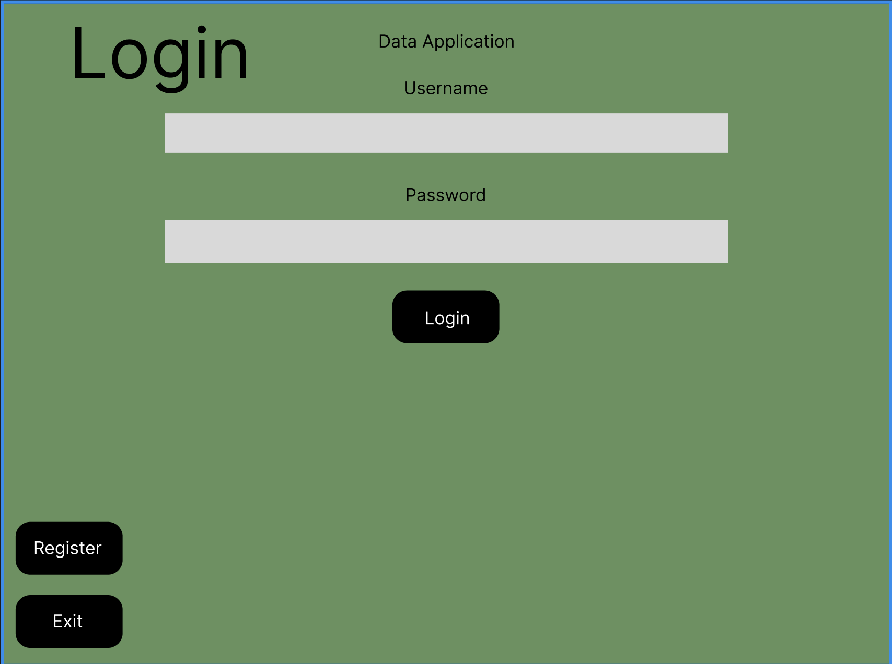

If you haven’t registered yet, follow the storyboard above labelled ‘Register’.

To login type in your credentials into the inputs, Your username goes into the bar below the label ‘username’ and your password goes into the label that says ‘password’. After entering your credentials you may then press the ‘login’ button and you will then be redirected to the lobby page.

## Login but don’t have an account?

If you have been redirected to this page on accident or have just started and want to login you will need to go to the register page and then follow the ‘register’ storyboard above to tell you how to register, then come back to this page after.

To get to the register page from the login page click the ‘register’ button on the bottom right of the page.

You will then be redirected to the register page to then complete your registration.

## Lobby Logout

Once you have finalised your registration and login and successfully made it into the application lobby.

You can go to the bottom right of the page and press the top button named the ‘Logout’ button.

When you press this button you will then be rerouted back to the login page.

## Lobby Exit

Once you have finalised your registration and login and successfully made it into the application lobby.

You can go to the bottom right of the page and press the button named the ‘Exit’ button.



When you press this button you will then be logged out of the application and then the application will close.

## Opening a Chart

To open a Chart in this application you will first need to login into the app either through registering a account and then logging into that account, or just login if you already have one.

You will then be sent to the lobby in which you will be faced with the three charts buttons, each leads to a different type of chart.

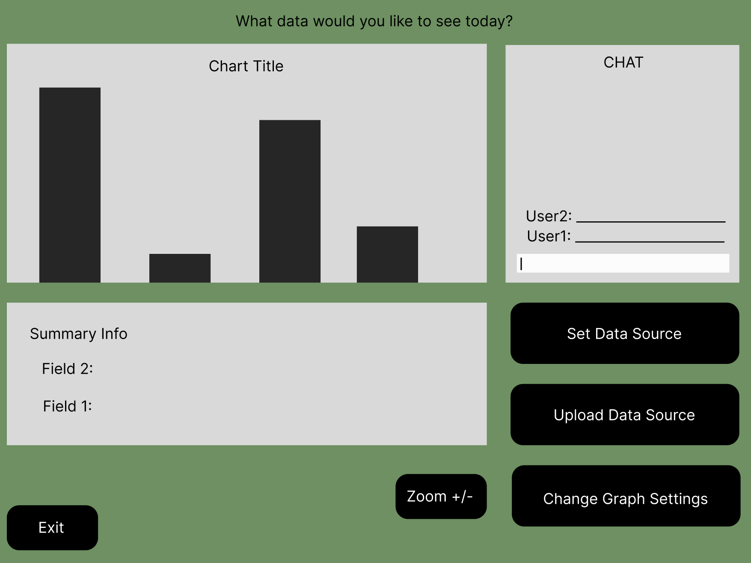`

## Exit a Chart

Continuing from the last storyboard you can likewise also exit this popup by pressing the exit button on the bottom left side of the screen.

## Chart +/- Zoom Button

The zoom button will allow you to increase the size of the graph to a bigger size by allowing you to toggle the size of the chart to a larger size.

Not Changed <<<<

Changed <<<<

## Chart Chats

Chart chats will be a pretty simple setup, the logged in and have a chart open. Users are able to type in a message into the message box and then when they press ‘enter’ on their keyboard then will then be able to send messages that anyone with the same chart open will then be able to see.

## Change Graph Settings

Follow the previous steps on how to get to a chat page. Try “opening a chart”

Follow the previous steps on how to set/upload a data source. Try “Set Data Source” Or “Upload Data Source”.

If you look to the bottom left You will see a button that says “Change Graph Settings”.

Once you click that a popup will show you three options, Chart one, chart Two or Chart three. Which ever one you click on, you will be sent to the correlating chart.

Once you have clicked on one of the charts, press set to be sent to the correlating graph.

## Upload Data Source

Follow the previous steps on how to get to a chat page. Try “opening a chart”

You will then after you have gotten to the chart page will then click the button on the right in the middle called ‘Upload Data Source’.

When you click the button on the chart page ‘upload data source’ the file explorer will open and you will be prompted to open a CSV or JSON file.

Once selected, and opened the file explorer will close and then the data from the CSV/JSON file will then be presented on the chart based on the data contained in the file.

## Set Data Source

Follow the previous steps on how to get to a chat page. Try “opening a chart”

You will then after you have gotten to the chart page will then click the button on the right at the top called ‘set data source’.

Once this button is pressed a popup will appear and it will prompt you to enter a URL in which data should come from after you click the set button. Then the popup should close and the data from the URL should show on the chart.