HCI-CA1-Notes

To-Do :

|  |  |  |
| --- | --- | --- |
| **Poster** |  |  |
|  | Title and footer with team member details. |  |
| (In | Introduction outlining the context, purpose and scope of the prototype. |  |
|  | Storyboarding |  |
| (Drafted) | Rich picture |  |
|  | User types |  |
| (In Progress) | Personas |  |
|  | Scenarios |  |
| (In Progress) | Service ecology map |  |
| (In Progress) | Journey map |  |
| (In Progress) | Service blueprint |  |
|  | Information architecture |  |
|  | Navigation map |  |
|  | Metaphors |  |
|  | Mood boards |  |
|  | Wireframes |  |
|  | References of the key sources and resources. |  |
|  |  |  |
| **Prototype** |  |  |

Don’t forget your **personal reflective report**.

Ref Links:

[Leaderboard Vector Art PNG, Leaderboard Vector Design Illustration, Game, Winner, Victory PNG Image For Free Download](https://pngtree.com/freepng/leaderboard-vector-design-illustration_5994197.html) - leader board png

[Content creator Generic Outline Color icon | Freepik](https://www.freepik.com/icon/content-creator_8164213) - content png

<https://www.figma.com/community/file/881830156311997001> - Figma Persona Template

<https://breakingbad.fandom.com/wiki/Mike_Ehrmantraut> Jon Jones Persona Picture

Mole png – chatgpt and [Remove Background from Image for Free – remove.bg](https://www.remove.bg/upload)

Arrow link for ui - <https://www.freeiconspng.com/thumbs/arrow-icon/right-arrow-icon-27.png>

**Prototype/PowerPoint :** [Presentation.pptx](https://365abdn-my.sharepoint.com/:p:/r/personal/u03so24_abdn_ac_uk/Documents/Presentation.pptx?d=weab10d5de4194bf081962e58ec3316f2&csf=1&web=1&e=wt9zXF)

## Step 1 :

We need to pick as a team what application to make. We are given these examples;

* Game for students
* Training for developers
* Exercise for online marketing officers

---

**Requirements :**

* Multi-user interface
* Educational
* Safe and accessible
* Consistency
* “The proof of concept should be based on the subject of Fitt’s Law”

---

**Ideas :**

A game for students

Multiplayer quiz

Students compete in quiz based on the subjects they are doing; could have point system.

Maybe team-based, introduce competition.

Leaderboards

Mockup could be interactive powerpoint

Poster could incorporate a pathway to show the design process.

---

### Chat GPT IDEA

### 1. **Fitts’ Whack-a-Mole**

**Concept:**  
A modern twist on the classic whack-a-mole game where targets (moles) pop up at various locations on the screen.

**Mechanics:**

* **Variable Target Sizes:** Some moles appear larger (easier to hit) while others are smaller (harder to hit).
* **Variable Distances:** The moles appear in different parts of the screen, so the distance from the previous target varies.
* **Feedback:** After each hit (or miss), the game displays statistics comparing the player’s reaction/movement time with what Fitts’ Law predicts based on the target’s width and distance.

**Educational Angle:**  
Students can see in real-time how smaller targets and longer distances increase movement time, reinforcing the concepts of Fitts’ Law.

### **New Game Mechanic Ideas**

To engage these users further:

* **"Accessibility Mode"**: Players experience simulated impairments (e.g., tremors) to understand design challenges.
* **"Corporate Leaderboards"**: Companies compete to optimize team reaction times.
* **"Research Challenges"**: Players contribute data to crowd sourced studies on Fitts’ Law.

**Fitts Law Equation**

T = a + b * log₂(1+d/w) => (total time takes to move from starting point to a target

* T is the time taken
* a and b are constants that vary depending on the type of pointer (e.g. mouse, finger)
* D is the distance to the target that has to be moved
* w is the width of the target (measured along the axis of movement)
* c is a constant related to dimensions (we use 0.5?)

ID = log2(2D/w) => the index of difficulty, measured in bits

**Analysis :**

Before attempting to design a UI/UX we need think who is going to use the application, who the end users and stakeholders are.

Poster must showcase the design process. Rich picture, identify stakeholders.

**End Users**

* Students
* Public
* Rehabilitation Patients
* Gamers
* Children
* Staff

**Stakeholders**

* Students -
* Children – any organisation that promotes or seeks to improve development in young children 3-10

**User Taxonomy?**

**Main tree:**

* Students
  + University
    - Postgraduate
    - Undergraduate
      * On-campus students
        + Disabled students
        + Abled students
      * Online Learners
        + Disabled students
        + Abled students
  + Secondary school
    - Private School
      * Specialist institutions
      * Normal schools
    - Public School
      * disability supporting institutions
      * Normal schools
    - Grammar School
  + Primary school
    - Private School
      * disability supporting institutions
      * Normal schools
    - Public School
      * disability supporting institutions
      * Normal schools
    - Grammar School
  + Nursery
    - Public Nursery
    - Private Nursery
    - Specialist institutions
* Staff
  + Lecturers
    - Course Co-ordinates
      * Individual
      * Shared
    - Tutors
    - Individual taught
    - Outside partnering organisations
    - Teaching Assistants
    - Demonstrators
      * PGTs
        + Part Time
        + Full Time
        + Suspended

* + Facilities and support staff
    - Cleaner
    - Canteen
    - Library Staff
* Public
  + Adults
  + Children
  + Content Creators
* Rehabilitation Patients
  + Sufferers of injuries and permanent disabilities
* Gamers
  + Covers a large demographic of all ages, skills and interests

**Rich picture**

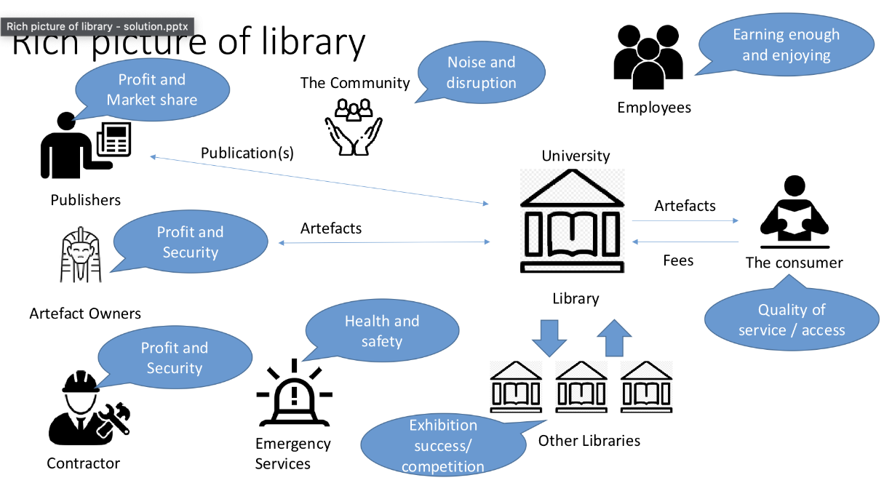

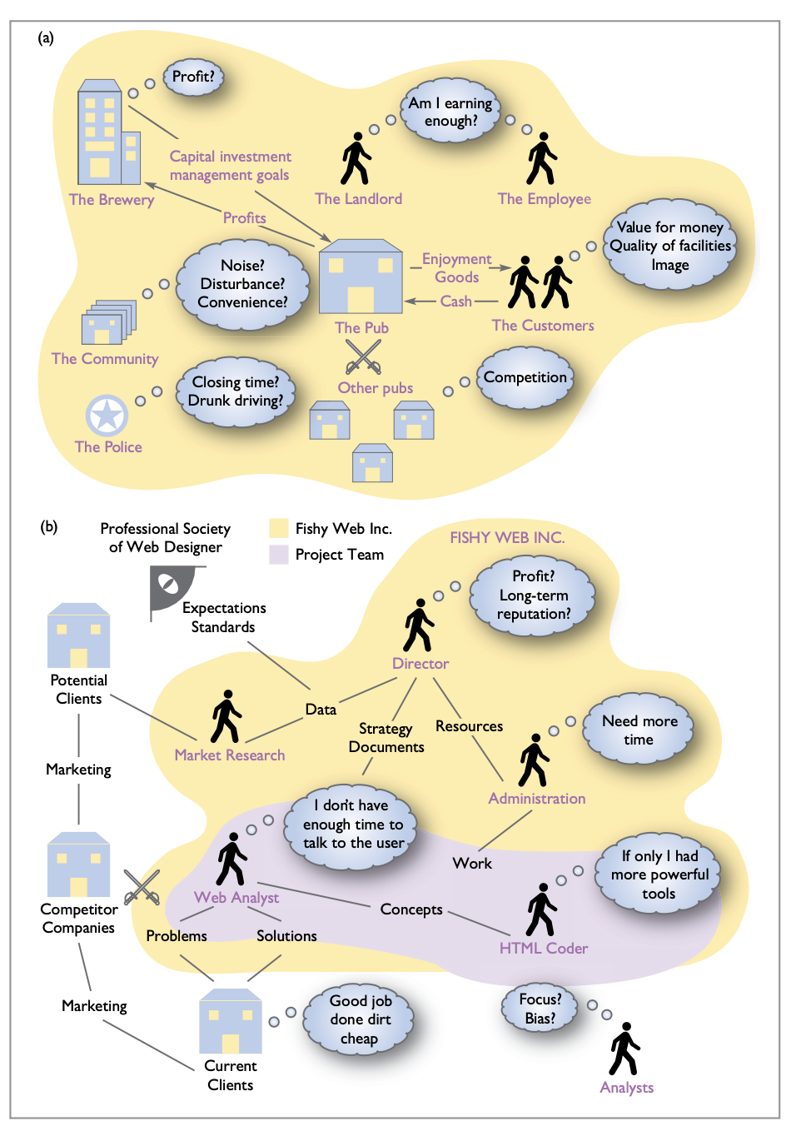

Persona

## SERVICE ECOLOGY MAP: WHY

* **Teach Fitts’ Law concepts**: Demonstrate how target size and distance affect movement time.
* **Create an engaging learning experience**: Use a fun, game-like approach to help students learn.
* **Encourage healthy competition**: Leaderboards or team-based modes can motivate students.
* **Study user behavior**: Gather data on how different people respond to varying target sizes/distances.
* **Promote accessibility awareness**: Show how design can be inclusive for users with different abilities.
* **Offer real-time feedback**: Help learners immediately see how changing W or D (width/distance) affects performance.

## WHAT

* **Multiplayer quiz or “Whack-a-Mole” style game**: Central mechanic that illustrates Fitts’ Law in action.
* **Leaderboards & scoring system**: Tracks performance and encourages improvement.
* **Interactive tutorial**: Explains the basics of Fitts’ Law before or during gameplay.
* **Accessibility features**: Options for larger targets, slower speeds, or adapted controls for users with impairments.
* **Analytics / metrics dashboard**: For instructors or administrators to see class-wide performance and engagement.

## WHO

* **Students**: Primary users (undergraduates, high schoolers, or whichever group you’re targeting).
* **Teachers / Lecturers / Instructors**: Want easy ways to integrate the game into lesson plans, see class results.
* **Staff / Administrators**: May need high-level performance metrics or usage data.
* **Game Designers / Developers**: Responsible for creating and maintaining the system.
* **Accessibility specialists**: Ensuring the game accommodates diverse abilities.
* **Researchers** (if collecting data for user studies): Interested in user performance and behavior.

## WHERE

* **In the classroom / computer lab**: Students play during class or lab sessions.
* **At home**: Homework or self-paced practice outside class hours.
* **Libraries or common areas**: Shared kiosks or tablets for quick sessions.
* **Online**: Via personal laptops or tablets—no physical constraints on location.
* **Workshops or training events**: Demonstrations at education conferences or teacher training days.

## WHEN

* **During scheduled class times**: Teachers incorporate it into lessons on HCI, UX, or general computing skills.
* **End of lesson recap**: Quick five-minute practice to reinforce the day’s topic.
* **Weekly competitions**: Motivate learners with a recurring challenge or leaderboard reset.
* **On-demand / flexible**: Students can practice anytime for extra credit or personal improvement.
* **Staff training sessions**: For professional development if you are also training developers or staff.

## HOW

* **Web-based or mobile app**: Accessible on various devices (tablets, smartphones, laptops).
* **Simple, intuitive UI**: Focus on quick tasks and minimal friction so users jump right in.
* **Multi-user interface**: Enable real-time competition or cooperative modes.
* **Data collection & analytics**: Record time-to-hit, accuracy, error rates for teacher or researcher insights.
* **Gamification**: Points, badges, or progress bars to keep learners engaged.
* **Safe & secure**: Protect user data, comply with any institutional or school data policies.

### Tips for Placing These Notes on Your Map

* **Cluster related ideas**: For instance, group anything about “analytics” or “feedback” near one another so you can see dependencies or connections.
* **Link stakeholders to their needs**: If “Teachers” is in the “Who” section, connect them to “What” they want (e.g., easy-to-read dashboards) and “Why” they need it (to track progress).
* **Check for coverage**: Does every important stakeholder have a reason (Why) to use the system, a clear activity (What), a context (Where, When), and a method (How)?

Filling out the Service Ecology Map with these details helps you see where your game or interactive tool fits into the bigger picture—who needs it, why it matters, what it does, and how, when, and where it is best deployed.