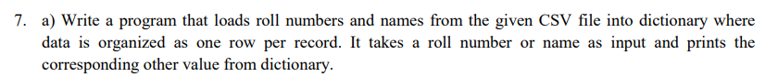
#download file from : https://github.com/akuldeepj/data/blob/main/students.csv
import csv
with open('students.csv','r') as f:
reader = csv.reader(f)
d = {}
print(reader)
for row in reader:
d[row[0]] = row[1]
roll = input("Enter roll number: ")
#capitalize letters in roll
roll = roll.upper()
if roll in d:
print("Roll number of the student is: ",d[roll])
else:
print("Roll number not found")

import csv
import re

def word_count(str):
counts = dict()
words = str.split()

for word in words:
if word in counts:
counts[word] +=1
else:
counts[word] = 1
return counts

with open('text.txt', 'r') as file:
data = file.read().replace('\n', '')

word_count_dict = word_count(data)

with open('word_count.csv', 'w') as csv_file:
writer = csv.writer(csv_file)
for key, value in word_count_dict.items():
writer.writerow([key, value])
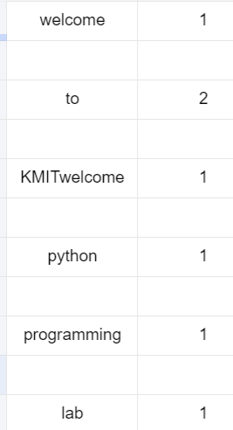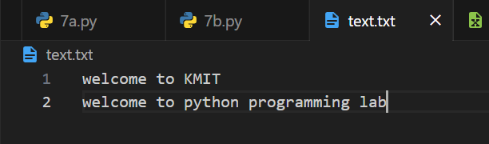

import pandas as pd
iris = pd.read_csv('https://archive.ics.uci.edu/ml/machine-learning-databases/iris/iris.data',header=None)
iris.columns = ['sepal_length','sepal_width','petal_length','petal_width','class']
print('mean :',iris['sepal_length'].mean())
print('median :',iris['sepal_length'].median())
print("standard deviation :",iris['sepal_length'].std())

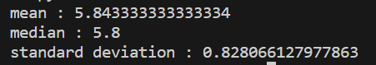

import pandas as pd

iris = pd.read_csv('https://archive.ics.uci.edu/ml/machine-learning-databases/iris/iris.data', header=None)
iris_2d = iris.iloc[:, [0,1,2,3,4]]
iris_2d.columns = ['sepal_length', 'sepal_width', 'petal_length', 'petal_width', 'class']

print(iris_2d[(iris_2d['petal_length'] > 1.5) & (iris_2d['sepal_length'] < 5.0)])
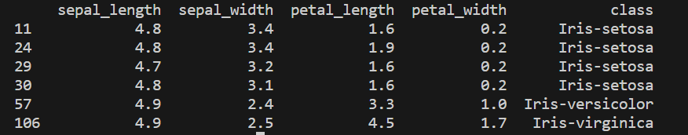

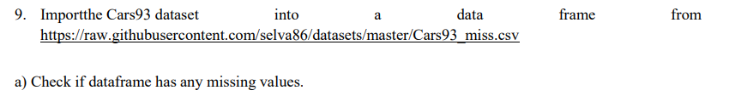
import pandas as pd

#why .sum().sum()?
#df.isnull().sum() gives the sum of null values in each column
#df.isnull().sum().sum() gives the total sum of null values in the dataframe

df = pd.read_csv('https://raw.githubusercontent.com/selva86/datasets/master/Cars93_miss.csv')
print(df.isnull().sum().sum())
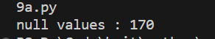
import pandas as pd

df = pd.read_csv('https://raw.githubusercontent.com/selva86/datasets/master/Cars93_miss.csv')
print(df.isnull().sum().sort_values(ascending=False))
print('max value:',df.isnull().sum().idxmax())
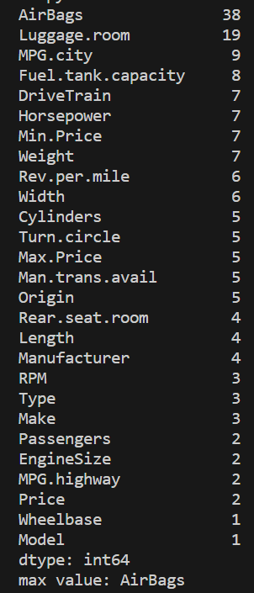

import pandas as pd

df = pd.read_csv('https://raw.githubusercontent.com/selva86/datasets/master/Cars93_miss.csv')
print('min :',df['Min.Price'].fillna(df['Min.Price'].mean()))
print('max :',df['Max.Price'].fillna(df['Max.Price'].mean()))

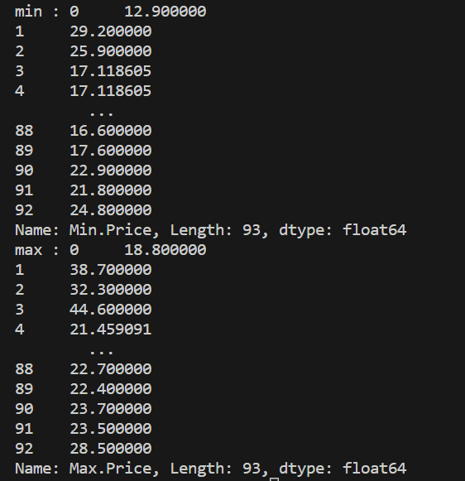

import matplotlib.pyplot as plt

x_values = list(range(1, 6))
y_values = [x**3 for x in x_values]

plt.scatter(x_values, y_values)

plt.title("Cubic Numbers", fontsize=24)
plt.xlabel("Value", fontsize=14)

plt.tick_params(axis='both', which='major', labelsize=14)

plt.show()

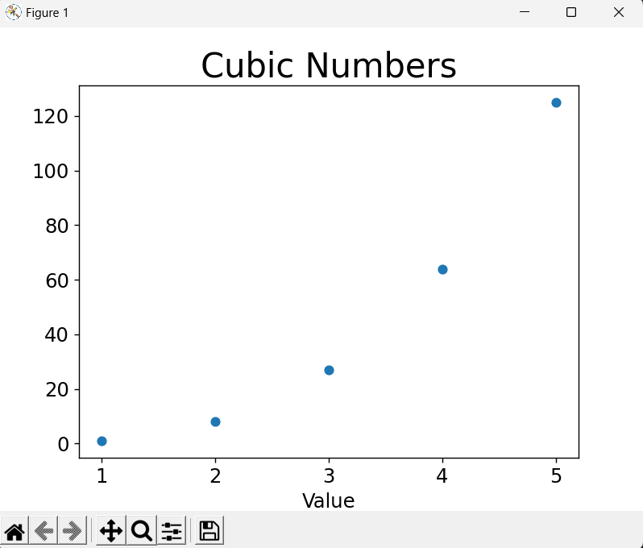
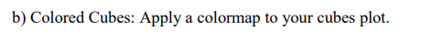
import matplotlib.pyplot as plt
x_values = list(range(1, 5001))
y_values = [x**3 for x in x_values]

plt.scatter(x_values, y_values, c=y_values)

plt.title("Cubic Numbers", fontsize=24)
plt.xlabel("Value", fontsize=14)
plt.ylabel("Cube of Value", fontsize=14)

plt.tick_params(axis='both', which='major', labelsize=14)

plt.show()

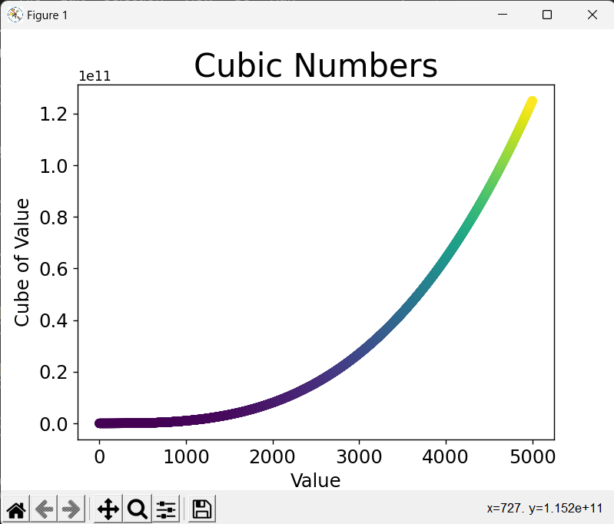
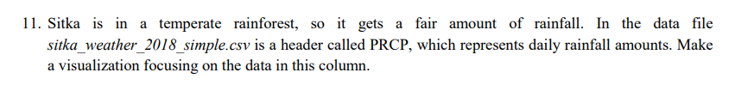
import matplotlib.pyplot as plt
import pandas as pd

url = 'https://raw.githubusercontent.com/ehmatthes/pcc_2e/master/chapter_16/the_csv_file_format/data/sitka_weather_2018_simple.csv'
df = pd.read_csv(url)

# Histogram
df['PRCP'].plot(kind='hist', bins=50, figsize=(6, 4))

# Scatter plot
df.plot(x='DATE', y='PRCP', kind='scatter', figsize=(6, 5), title='Rainfall in 2018')

# Box plot
df.boxplot(column='PRCP', by='TMAX', figsize=(10, 6))

# Average Rainfall by Date
df[['DATE', 'PRCP']].groupby('DATE').mean().sort_values(by='PRCP', ascending=False).plot.bar(figsize=(10, 6), rot=10, title='Avg Rainfall by Date')

# Average Rainfall by TMAX
df[['TMAX', 'PRCP']].groupby('TMAX').mean().sort_values(by='PRCP', ascending=False).plot.bar(figsize=(10, 6), rot=10, title='Avg Rainfall by TMAX')

plt.show()
