社区自治水龙头 DAICO 完整测试报告
测试日期：2026-06-06 项目路径：/Users/wu/Desktop/wu/AAaabaidu/《以太坊 DAICO 开发》考查

一、结论
本轮已删除旧版浏览器测试报告目录，保留并复跑当前 Hardhat 合约测试文件。合约编译通过，Hardhat 测试通过，前端生产构建通过，浏览器端完整链路通过。
- 编译结果：通过，npx hardhat compile 输出 Nothing to compile。
- 测试结果：通过，npx hardhat test 共 39 passing。
- 浏览器流程：通过，覆盖连接、募资、结算、水龙头、提案、投票、执行。
- 旧版文件处理：已删除 reports/browser-test 与 reports/chrome-test 下的旧截图和 README。
- 保留 test/CommunityDAICO.test.js：这是当前 39 个 Hardhat 测试的来源，不属于旧版截图报告。

二、环境与合约信息
项目 | 值
项目路径 | /Users/wu/Desktop/wu/AAaabaidu/《以太坊 DAICO 开发》考查
GitHub 仓库 | https://github.com/Aidenwu0209/ethereum-daico-community-faucet-coursework
前端地址 | http://127.0.0.1:5173/
E2E 测试页 | http://127.0.0.1:5174/e2e-provider.html
Hardhat RPC | http://127.0.0.1:8545
Chain ID | 31337 / 0x7a69
CommunityToken | 0x5FbDB2315678afecb367f032d93F642f64180aa3
CommunityDAICO | 0xe7f1725E7734CE288F8367e1Bb143E90bb3F0512
测试账户 | 0xf39Fd6e51aad88F6F4ce6aB8827279cffFb92266

三、测试文件检查
仓库内当前源测试文件为 test/CommunityDAICO.test.js，覆盖 ERC20、DAICO 募资、退款、水龙头、DAO 提案、投票和执行。旧版浏览器证据位于 reports/browser-test 与 reports/chrome-test，已从本地工作区删除，等待随本报告一起提交。
路径 | 处理 | 说明
test/CommunityDAICO.test.js | 保留 | 当前 Hardhat 源测试，39 passing 的依据。
reports/browser-test/* | 删除 | 旧版浏览器测试截图和 README。
reports/chrome-test/* | 删除 | 旧版 Chrome 截图和 README。
reports/full-chrome-metamask-test/* | 新增 | 本轮完整测试日志、截图、Word 报告。

四、自动化工具限制说明
Chrome 插件可以控制普通网页和本地页面，但访问 MetaMask 扩展页 chrome-extension://.../notification.html 时被工具安全策略拒绝。策略信息明确要求不得通过其他浏览器表面或底层 CDP 绕过该限制。
因此，本轮浏览器完整流程使用一个临时 EIP-1193 测试 Provider：它只在报告目录的 e2e-provider.html 中定义，直接转发到 Hardhat RPC；前端加载的仍是同一份 frontend/src/app.js，合约交易也真实写入本地 Hardhat 链。真实 MetaMask 手工测试信息仍保留在 METAMASK_TESTING.md。
Computer Use 已读取最终 Chrome 窗口状态，确认页面位于 127.0.0.1:5174/e2e-provider.html，最终显示“已连接”“已完成结算 / 成功”“单次领取 30 CFT”“提案已执行”。

五、命令级测试记录
命令 | 结果 | 关键输出
npm install | 完成 | audited 702 packages；存在 46 个 npm audit 提示。
npx hardhat compile | 通过 | Nothing to compile。
npx hardhat test | 通过 | 39 passing。
npm --workspace frontend run build | 通过 | 582 modules transformed；Vite 大包体积提示不影响构建通过。
npx hardhat run scripts/deploy.js --network localhost | 通过 | Token 与 DAICO 合约部署并写入 frontend/src/contracts.js。

关键日志摘录

npm install
up to date, audited 702 packages in 12s
122 packages are looking for funding
run `npm fund` for details
46 vulnerabilities (18 low, 24 moderate, 4 high)
To address issues that do not require attention, run:
npm audit fix
To address all issues (including breaking changes), run:
npm audit fix --force
Run `npm audit` for details.

npx hardhat compile
Nothing to compile

npx hardhat test
CommunityToken
✔ deploys with initialized ERC20 metadata and minter (243ms)
✔ rejects minting by non-minter accounts
CommunityDAICO funding
✔ deploys with initialized DAICO parameters
✔ accepts investment, records ETH, and mints investor and faucet tokens
✔ rejects zero-value investments
✔ rejects investment after the funding period ends
✔ rejects finalization before the funding deadline
✔ previews failed funding status after deadline before finalization
✔ previews successful funding status after deadline before finalization
✔ finalizes failed funding, closes minting, and leaves treasury empty
✔ refunds failed investors and clears investment records
✔ rejects repeated refunds
✔ rejects refunds after successful funding
✔ finalizes successful funding, closes minting, and records treasury
✔ rejects repeated finalization
CommunityDAICO faucet
✔ allows a token holder to claim faucet tokens after successful funding
✔ rejects faucet claims before funding is successfully finalized
✔ rejects faucet claims by non-token holders
✔ rejects repeated faucet claims during cooldown
✔ allows a second faucet claim after cooldown passes
CommunityDAICO DAO governance
✔ lets the project owner create a proposal
✔ lets a holder above the 5 percent threshold create a proposal
✔ rejects proposal creation below the 5 percent holder threshold
✔ validates proposal input parameters
✔ records support votes and voting status
✔ records against votes
✔ rejects duplicate voting by the same address
✔ rejects voting by accounts without tokens
✔ rejects proposal execution before the voting period ends
✔ executes a passed faucet amount proposal
✔ executes a passed faucet cooldown proposal
✔ executes a passed toggle proposal and disables faucet claims
✔ rejects execution of a proposal that misses quorum
✔ rejects execution of a proposal with majority against votes
✔ executes treasury withdrawals only after a DAO proposal passes
✔ rejects treasury withdrawals larger than the available treasury
✔ rejects repeated proposal execution
✔ allows prop
...（日志已截断，完整内容见报告目录 .log 文件）

frontend build
> community-faucet-daico-frontend@1.0.0 build
> vite build
vite v5.4.11 building for production...
transforming...
✓ 582 modules transformed.
rendering chunks...
computing gzip size...
dist/index.html 6.04 kB │ gzip: 1.80 kB
dist/assets/index-BszidWS1.css 10.38 kB │ gzip: 3.02 kB
dist/assets/index-DZLLKuxm.js 564.25 kB │ gzip: 166.47 kB
(!) Some chunks are larger than 500 kB after minification. Consider:
- Using dynamic import() to code-split the application
- Use build.rollupOptions.output.manualChunks to improve chunking: https://rollupjs.org/configuration-options/#output-manualchunks
- Adjust chunk size limit for this warning via build.chunkSizeWarningLimit.
✓ built in 926ms

deploy
Deploying with account: 0xf39Fd6e51aad88F6F4ce6aB8827279cffFb92266
Account balance: 10000.0 ETH
CommunityToken: 0x5FbDB2315678afecb367f032d93F642f64180aa3
CommunityDAICO: 0xe7f1725E7734CE288F8367e1Bb143E90bb3F0512
Funding goal: 10.0 ETH
Funding duration: 604800 seconds
Token rate: 1000 CFT per ETH
Faucet claim amount: 25.0 CFT
Frontend contract config written to: /Users/wu/Desktop/wu/AAaabaidu/《以太坊 DAICO 开发》考查/frontend/src/contracts.js

finalize funding
finalize tx: 0xa925a42095507ffb9a7d10947856d1589e78415cf80f9304e253543cc9ff17db
funding status: 3
funding successful: true
treasury balance: 10.0 ETH

advance proposal time
advanced seconds: 259201
proposal passed: true
proposal executed before: false
proposal endTime: 1781568400

六、浏览器端完整流程截图
以下截图均由 Chrome 自动化在同一轮本地 Hardhat 链运行中保存。每一步截图对应一次明确的页面状态或用户操作。

步骤 1：打开 E2E 测试页，页面处于未连接状态。
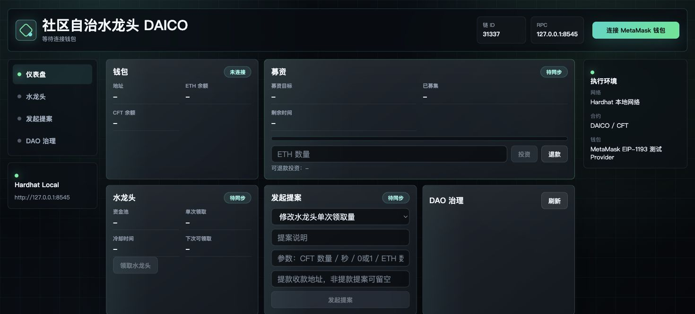
截图文件：reports/full-chrome-metamask-test/screenshots/01-e2e-initial.jpg

步骤 2：连接本地 EIP-1193 测试 Provider，钱包地址同步为 Hardhat 默认账户。
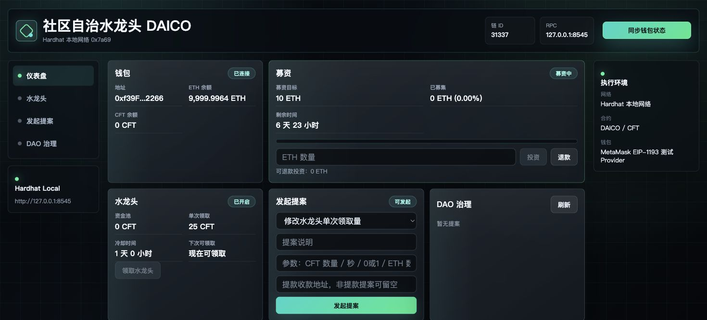
截图文件：reports/full-chrome-metamask-test/screenshots/02-wallet-connected.jpg

步骤 3：在募资模块填写 10 ETH 投资金额。
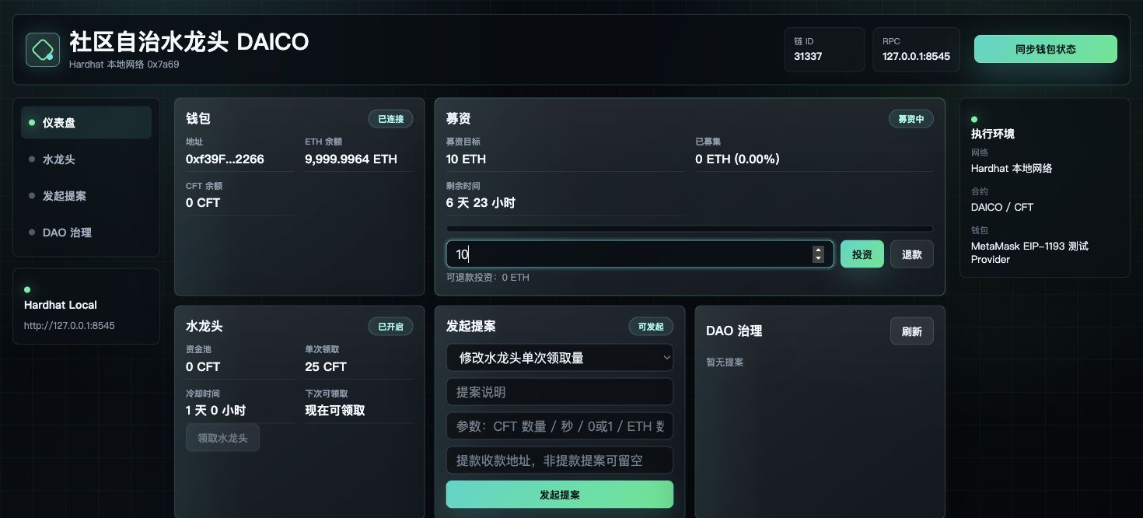
截图文件：reports/full-chrome-metamask-test/screenshots/03-invest-filled.jpg

步骤 4：点击投资后交易成功，已募集 10 ETH，获得 10,000 CFT。
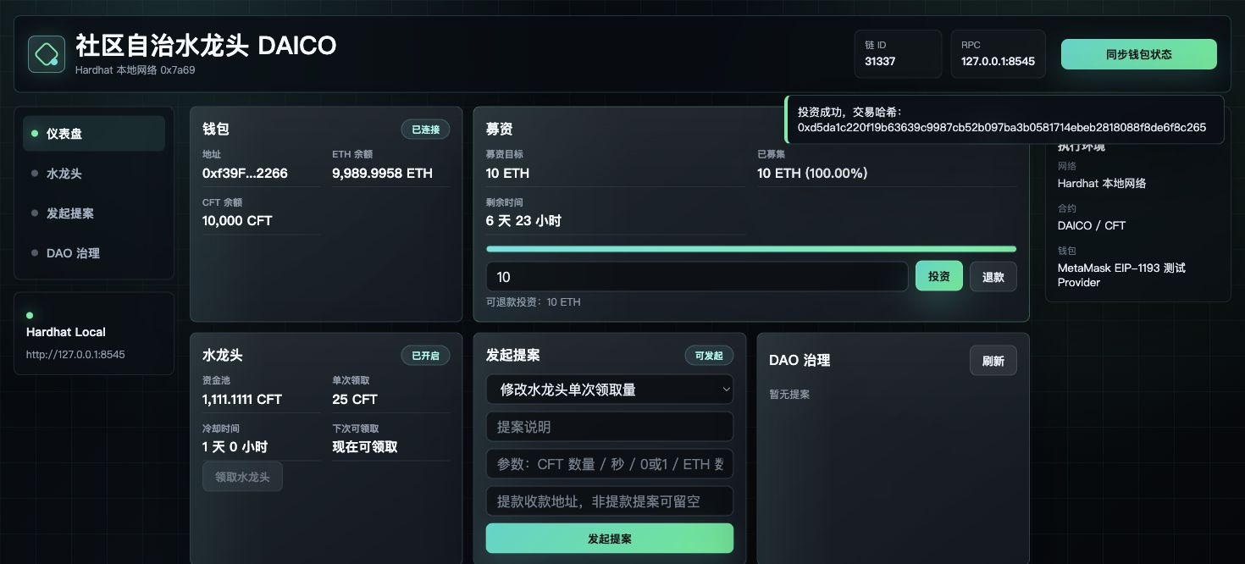
截图文件：reports/full-chrome-metamask-test/screenshots/04-invest-success.jpg

步骤 5：Hardhat 推进募资期并调用 finalizeFunding 后，前端显示已完成结算 / 成功。
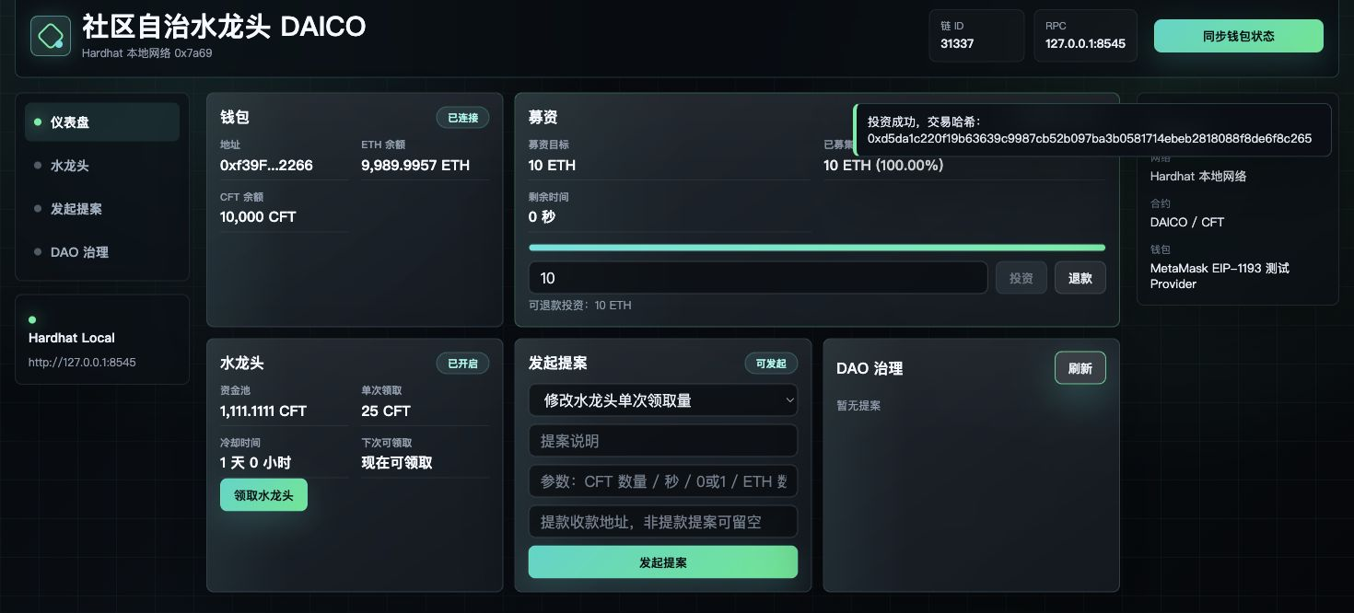
截图文件：reports/full-chrome-metamask-test/screenshots/05-funding-finalized.jpg

步骤 6：领取水龙头成功，CFT 余额增加，水龙头资金池扣减。
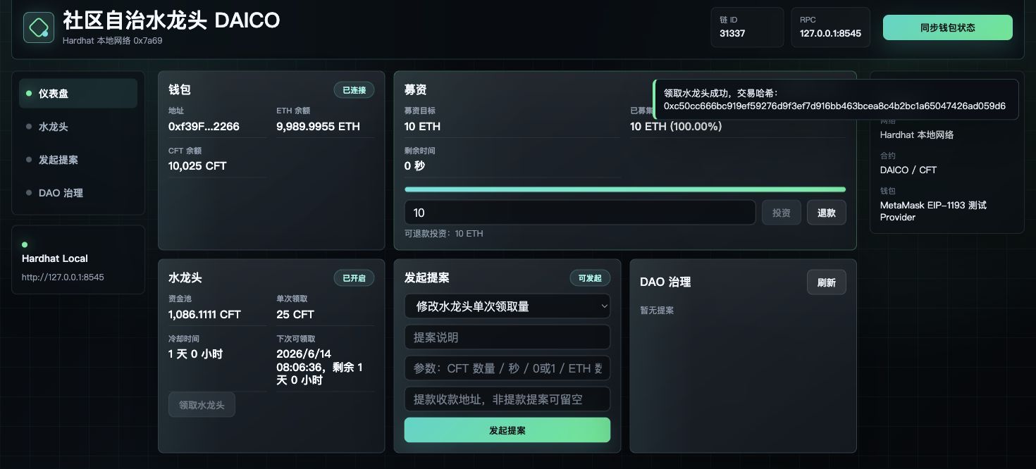
截图文件：reports/full-chrome-metamask-test/screenshots/06-faucet-claimed.jpg

步骤 7：填写 DAO 提案，把单次领取量调整为 30 CFT。
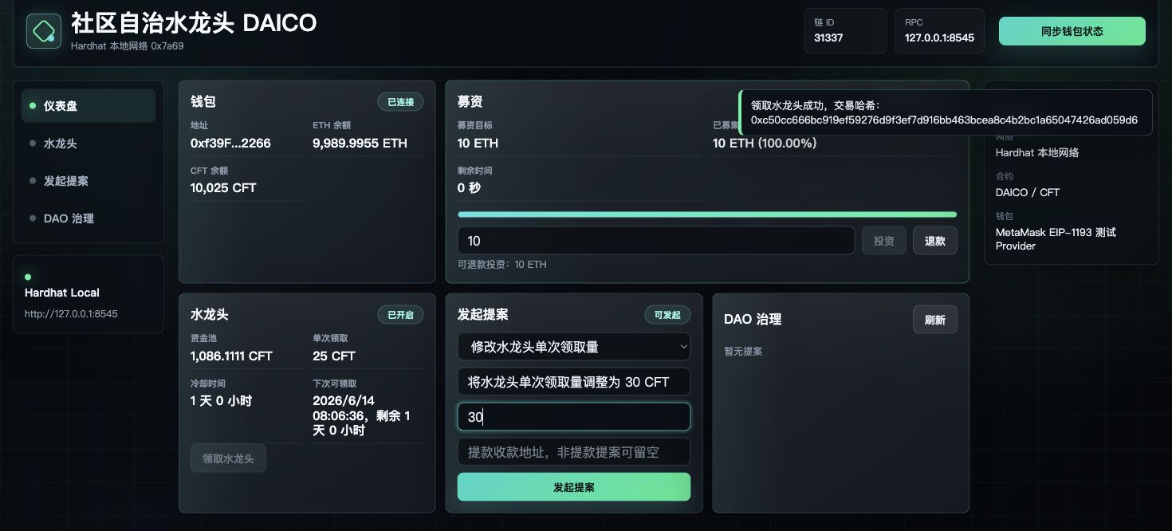
截图文件：reports/full-chrome-metamask-test/screenshots/07-proposal-form-filled.jpg

步骤 8：提案 #1 创建成功，进入 72 小时投票期。
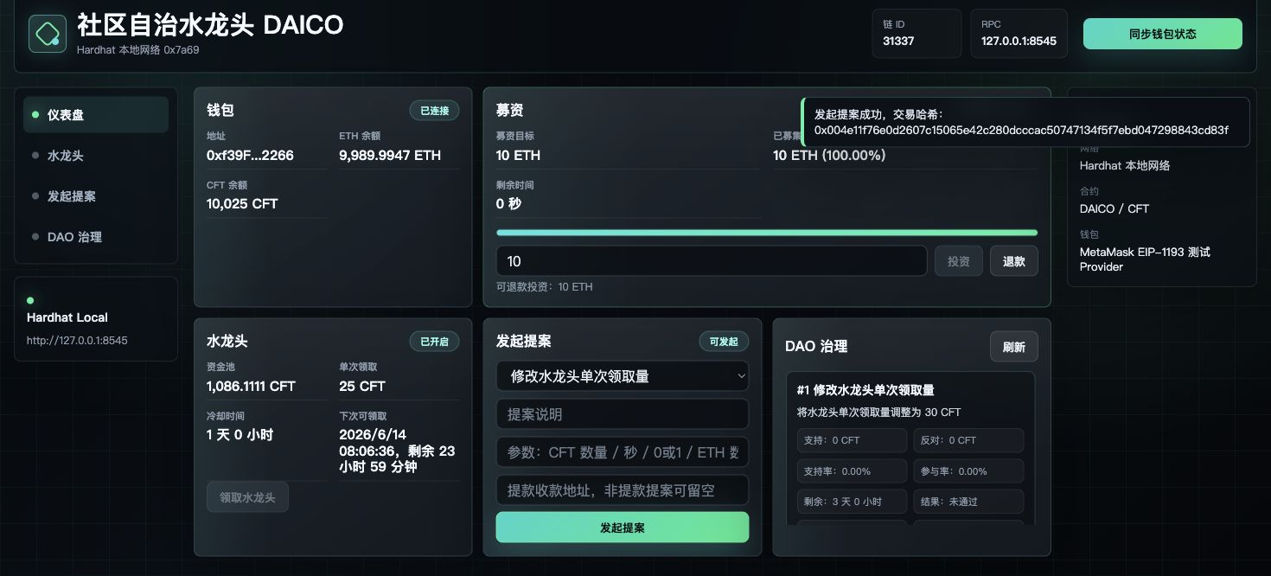
截图文件：reports/full-chrome-metamask-test/screenshots/08-proposal-created.jpg

步骤 9：投支持票成功，支持率 100%，参与率 90.22%，提案已通过。
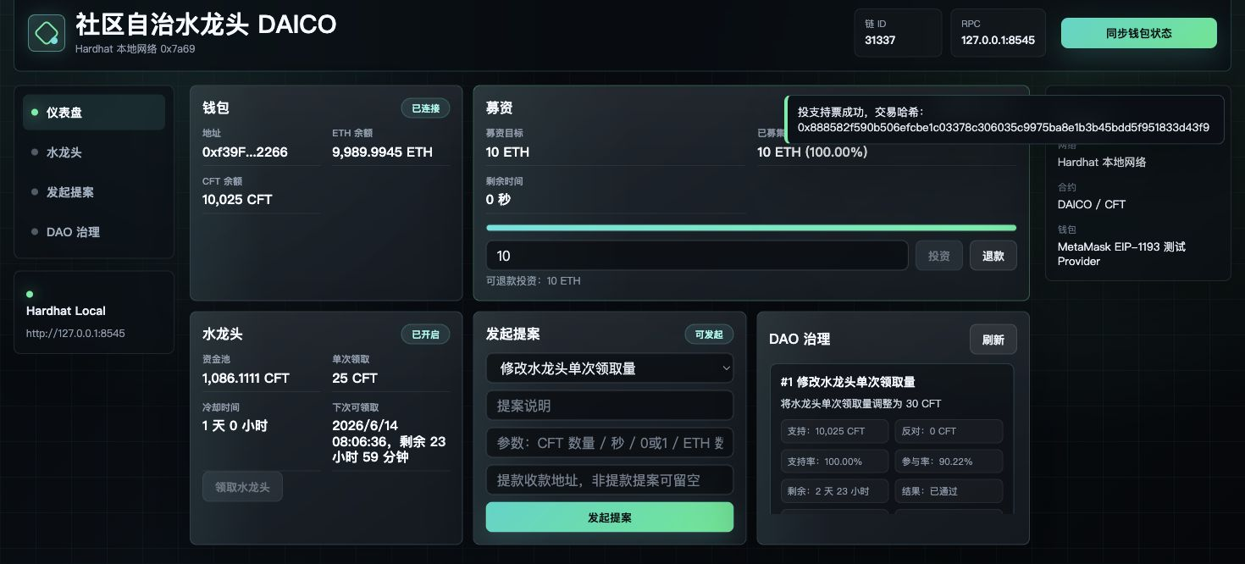
截图文件：reports/full-chrome-metamask-test/screenshots/09-proposal-voted.jpg

步骤 10：推进投票期后刷新页面，提案可执行。
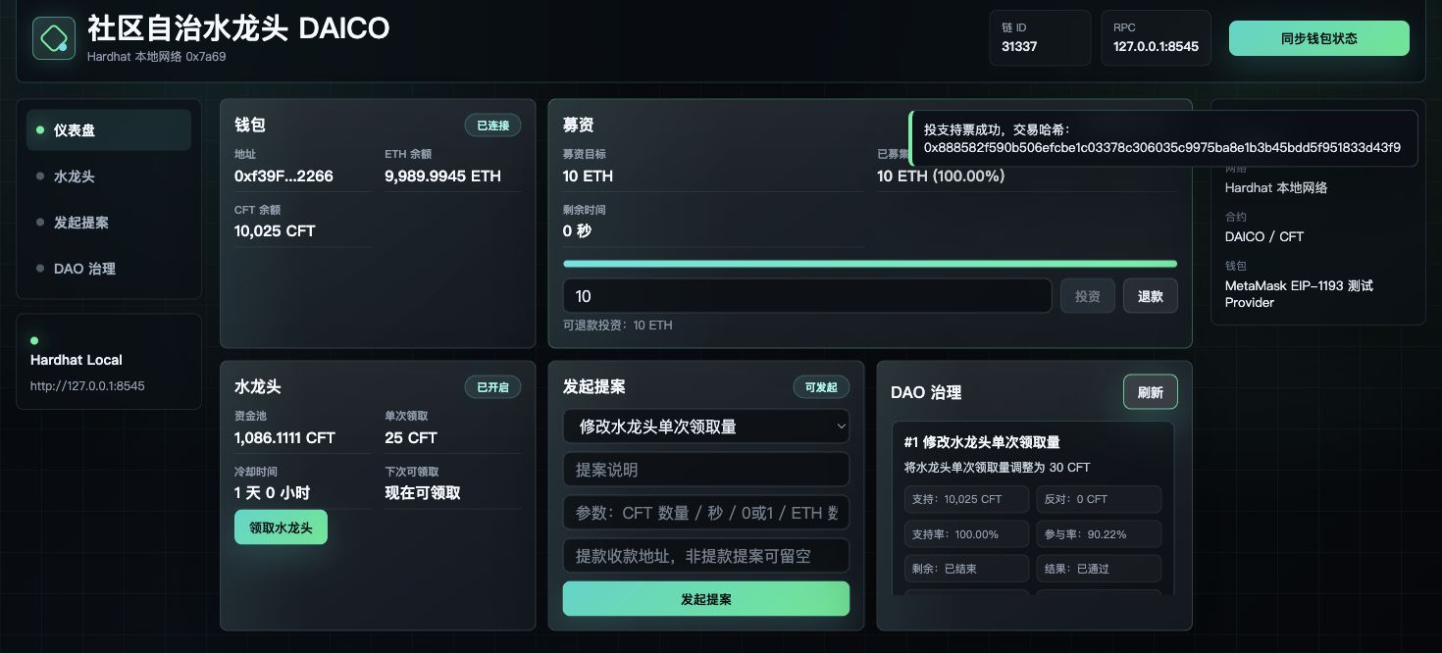
截图文件：reports/full-chrome-metamask-test/screenshots/10-proposal-ready-to-execute.jpg

步骤 11：执行提案成功，水龙头单次领取量更新为 30 CFT。
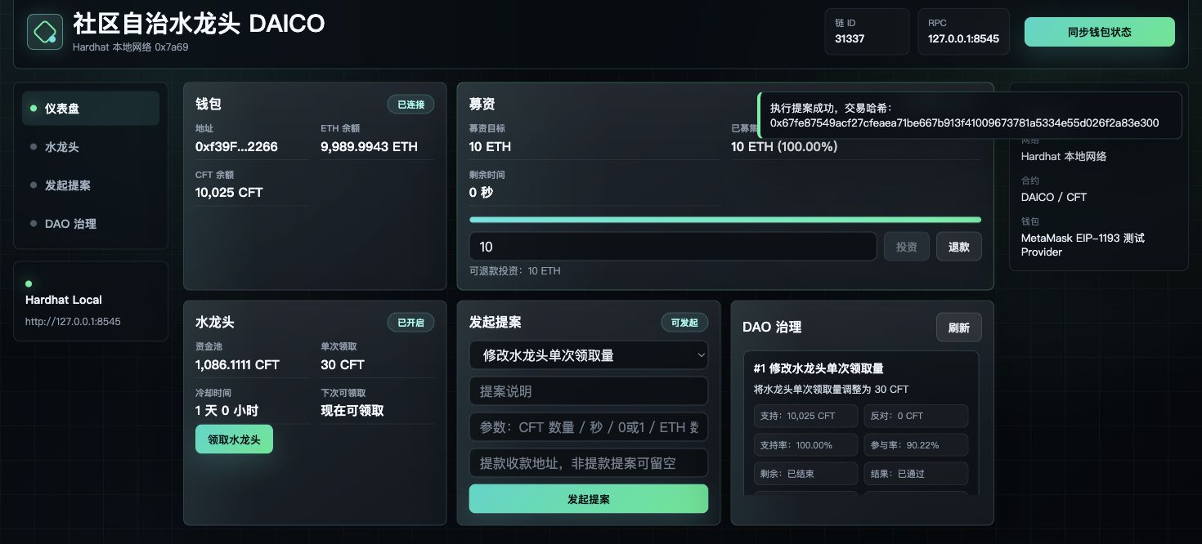
截图文件：reports/full-chrome-metamask-test/screenshots/11-proposal-executed.jpg

七、Hardhat 测试覆盖范围
- CommunityToken 部署、ERC20 元数据、铸币权限控制。
- DAICO 募资：正常投资、0 金额投资回滚、募资期结束后投资回滚。
- 募资结算与退款：失败结算、退款、重复退款回滚、成功结算、重复结算回滚。
- 水龙头：成功领取、未成功结算禁止领取、非持币用户禁止领取、冷却期限制、冷却后再次领取。
- DAO 治理：项目方/达门槛持币者发起提案、低门槛回滚、参数校验。
- 投票：支持票、反对票、无票权回滚、重复投票回滚。
- 执行：通过提案修改水龙头领取量、修改冷却时间、开启/关闭水龙头、金库提款。
- 异常执行：未达参与率、反对票多数、超额提款、重复执行、撤销后禁止投票。

八、残余风险与建议
- MetaMask 扩展页截图未自动化完成，原因是 Chrome 工具禁止访问 chrome-extension:// 页面；这属于自动化权限限制，不是项目功能失败。
- npm install 输出 46 个 audit 提示，本次作业依赖可运行；如后续长期维护，应单独评估依赖升级。
- 本轮全部交易均在 Hardhat 本地链完成，未连接 Sepolia 或主网。
- 旧版 GitHub 报告页面会在本次提交推送后消失；本地删除已完成。

