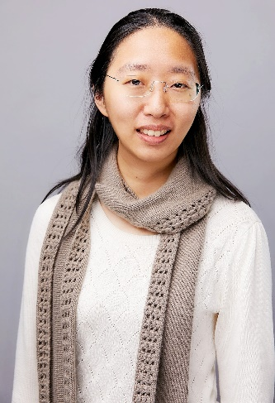

**Dr. Joyce Tzu-Yu Liu**

**Title:** Blood-based Early Cancer Detection Using Multiomics and Machine Learning

**Bio:** Joyce Liu is currently the Director of Machine Learning Science at Freenome. She leads the team to model biological signals and integrate them for cancer detection, contributing to all aspects of Freenome's research and development. Prior to her current position, she was a Simons Postdoctoral Fellow in the Departments of Mathematics and Biology at the University of Pennsylvania and with the Electrical Engineering and Computer Sciences department at the University of California, Berkeley. Joyce received her B.S. from National Taiwan University (2007) and her Ph.D. from the University of Michigan, Ann Arbor (2013), both in Electrical Engineering.

**Dr. Ya-Wen Teng**

**Title:** Data Mining for Epidemic Containment

**Bio:** Ya-Wen Teng received her Ph.D. degree in electrical engineering from National Taiwan University, Taiwan. She is currently a Postdoctoral Researcher with the Institute of Information Science, Academia Sinica, Taiwan. Her research interests include social network analysis, data mining, and graph neural networks. She received ASONAM Best Paper Award in 2015 and served as the Web Chair of DASFAA 2021.

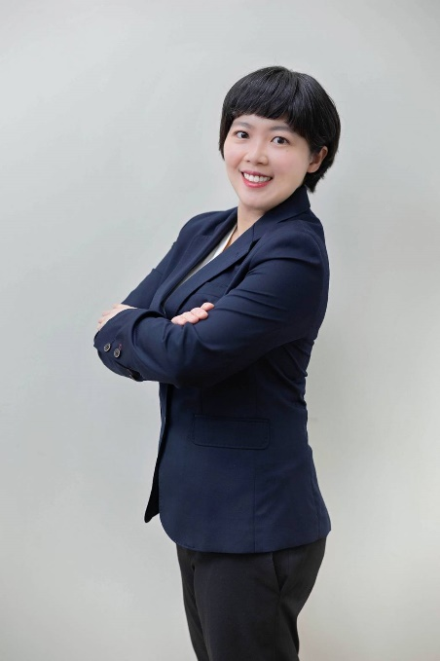

**Dr. Chia-Yu Lin**

**Title:** Big Data-Driven Smart Manufacturing ESG Innovation Services

**Bio:** Chia-Yu Lin received the B.S. and M.S. degree from National Chiao Tung University (NCTU), Taiwan, R. O. C. in 2010 and 2012, respectively, all in computer science. She received Ph.D. degree from the Institute of Communications Engineering, NCTU in 2019. She is an assistant professor at National Central University. She has cooperated with many manufacturing companies to increase production efficiency, improve defect detection accuracy, and save machine maintenance costs with AI techniques. Her research interests include AI for smart manufacturing, real-time AI model updating techniques, and recommendation systems.

**Dr. Shu-Han Hsu**

**Title:** Optimal Sampling for Accelerated Testing of 14nm FinFET Ring Oscillators

**Bio:** Shu-han Hsu is an assistant professor in the Department of Computer Science and Information Engineering at National Cheng Kung University. She received her Ph.D. degree in Electrical and Computer Engineering at the Georgia Institute of Technology, Atlanta, GA, USA in 2020. Her current research interests include machine learning and data analysis in the reliability of circuits and semiconductor manufacturing.