USE CASE DESCRIPTIONS
for
Antan Batura Watersports Booking Management System
Version 1.0

Prepared by:
Member's Name | Student ID
AQIL MUHAIMIN BIN ROSLAN | 2024786051
MUHAMMAD AIDIL AL-FAIZI BIN MOHD ZIN | 2023276732
MUHAMMAD HAZIEQ BIN ISMAZILAN | 2023637542
WAN MUHAMMAD FAIZ FIKRI BIN WAN RUSLAN | 2023698858

Prepared for:
Dr Nadhratunnaim Binti Nasarudin

Bussiness: Antan Batura Watersports
Persiaran Dato Menteri, Seksyen 14, 40000 Shah Alam, Selangor
Course: ISP550
Date Created: 5 July 2026

Revision History
Name | Date | Reason For Changes | Version
System Development Team | 5 July 2026 | Initial document creation | 1.0

Table of Contents

Revision History 2
Table of Contents 3
1.0 Introduction 4
1.1 Organisation Background 4
1.2 Problems / Issues 4
1.3 Purpose 5
1.4 Project Objectives 5
2.0 System Features 6
2.1 Use Case Diagram 6
2.2 Use Case Description 6
UC-1: Book Watercraft 6
UC-2: Check-in Booking 7
UC-3: Handover Equipment 8
UC-4: Return Equipment 9
UC-5: Process Payment 10
UC-6: Cancel Booking 10
UC-7: Manage Fleet Inventory (Admin Only) 11
UC-8: View Business Reports (Admin Only) 12
3.0 Conclusion 13
Appendix 14
Domain Class Diagram 14
Activity Diagram 14
Interview Questions & Answers 17
Related Documents (References) 18
Use Case List – Primary Actor / Use Cases 18

1.0 Introduction

1.1 Organisation Background
Antan Batura Watersports is a recreational water sports business located at Tasik Shah Alam, Persiaran Dato Menteri, Seksyen 14, 40000 Shah Alam, Selangor. The company provides water-based recreational activities to customers including families, students, tourists, and the general public.
The company offers six main recreational services:
- Cruise Boat
- Kayak Single
- Kayak Double
- Canoe
- Paddle Boat
- Paddle Boat Family

The business currently employs 5 workers and operates daily from 8:30 a.m. to 7:30 p.m., with peak hours on weekdays from 5:00 p.m. to 6:00 p.m., and throughout the day on weekends. The organisational structure consists of the Founders/Management, who manage business operations and decision-making, and Operational Roles. The interview session directly confirmed a Cashier and a Boat Driver; the company's organisational chart additionally lists Equipment Handling Staff.
The proposed system mainly involves four related operational areas: Booking Management, Payment Recording, Equipment Management, and Report Generation.
Currently, the business does not use a computerised system. Most operations are handled manually through:
- WhatsApp booking
- Paper records
- Manual receipt generation
- Manual audit tracking

1.2 Problems / Issues
Manual Booking Process: Bookings are handled manually through WhatsApp, which can cause missing information, double booking, and slow response time.
Miscommunication Among Staff: The company experiences staff miscommunication due to manual information sharing.
Difficulty Managing Crowded Customers: During weekends and peak hours, staff have trouble managing long queues, equipment allocation, and customer requests. Currently, one staff member is assigned to assist each customer, which helps but does not fully resolve the issue during the busiest periods.
Manual Equipment Tracking: Availability of kayaks, boats, and other equipment is recorded manually, increasing the risk of wrong availability information, equipment misuse, and delayed updates. For example, a customer previously reported a leaking paddle boat, highlighting the need for more systematic equipment condition tracking.
Manual Time Monitoring: Usage time is monitored through printed receipts, which may lead to human error, incorrect extra charges, and delayed monitoring.
Manual Reporting and Audit: Reports and audits are currently paper based. While the owner does not consider sales tracking to be difficult today, report generation and record retrieval could become slower and less efficient as the business grows, and manual processes leave more room for error.

1.3 Purpose
The purpose of this document is to define the functional use cases for the proposed Antan Batura Watersports Booking Management System. The document describes how each actor (Customer, Staff/Operator, and Administrator) interacts with the system to perform booking, check-in, equipment handover and return, payment processing, cancellation, fleet management, and reporting activities. This document is intended to guide the system design and development phases and to serve as a reference for validating that the delivered system meets stakeholder requirements.

1.4 Project Objectives
The proposed system aims to replace the current manual, paper- and WhatsApp-based process with a centralised computerised solution. The system supports:
- Online booking
- Equipment availability tracking
- Automated receipt generation
- Customer management
- Payment recording
- Automated report generation

The system will be accessible through mobile phones and computers, and is expected to:
- Increase operational efficiency
- Reduce staff workload
- Improve customer satisfaction
- Minimise communication errors among staff

2.0 System Features

2.1 Use Case Diagram
The diagram below illustrates the primary actors (Customer, Staff/Operator, and Administrator) and the eight use cases supported by the Antan Batura Watersports Booking Management System. The Administrator generalises the Staff/Operator role, inheriting all Staff capabilities in addition to admin-only functions.
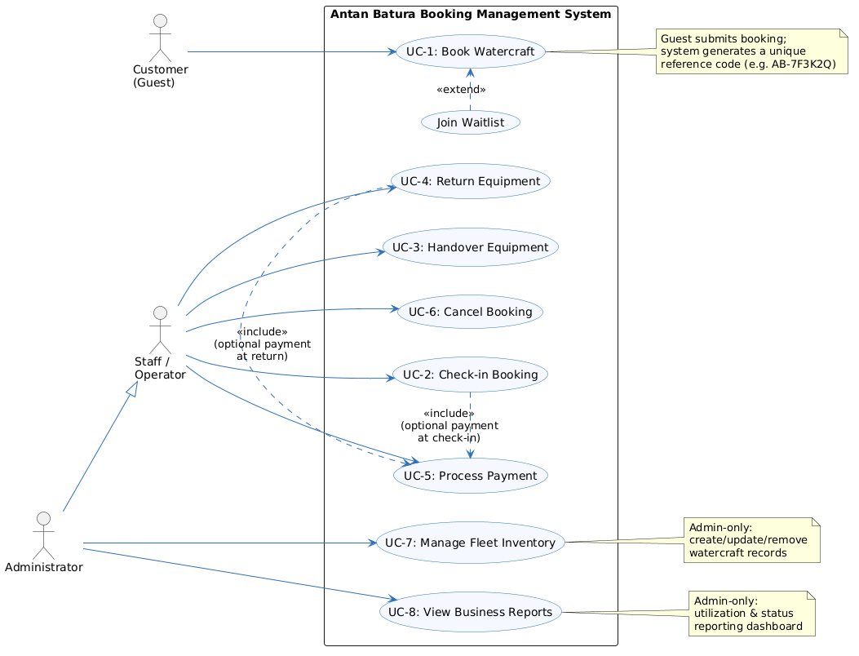

2.2 Use Case Description
This section provides a detailed description of each use case identified in the use case diagram above.

UC-1: Book Watercraft
Use Case ID | UC-1 | Priority | High
Use Case Name | Book Watercraft
Created By | System Development Team | Date Created | 5 July 2026
Actors | Customer (Guest) — Primary
Description | Allows a customer to search watercraft availability and submit a guest rental booking through the online portal.
Trigger | A customer wishes to rent a watercraft and accesses the customer booking portal.
Preconditions | Customer is on the customer portal page (web or mobile).
Postconditions | A booking is created in Pending or Confirmed status and a unique reference code (e.g. AB-7F3K2Q) is generated.
Normal Flow | Actor System  1. Customer visits the Booking page. System displays the booking page with available watercraft categories.  2. Customer selects a watercraft type (Kayak, Canoe, Pedal Boat, etc.) and date. System retrieves availability for the selected craft and date.  — 3. System displays available hourly timeslots for the selected craft.  4. Customer selects a timeslot and inputs contact details (Name, Email, Phone, Notes). System validates the input fields.  5. Customer reviews details and clicks “Submit Booking”. —  — 6. System creates the booking, assigns a unique reference code, and displays the success screen.
Alternative Flows | Slot Conflict (Waitlist Path): If the selected timeslot has just been occupied by another customer, the system offers the option to join the waitlist. If the customer accepts, the booking is flagged as “waitlisted” and saved.
Exceptions | Customer submits incomplete or invalid contact details → system displays a validation message and requests correction.
Includes | None.
Frequency of Use | High – multiple times daily, especially during weekend and peak hours.
Business Rules | Reference codes must be unique across the system. A timeslot cannot be double-booked; it may only be waitlisted once already occupied.
Special Requirements | The booking page must be accessible via mobile phones and computers.
Assumptions | Customer has basic internet access and provides a valid email address and phone number.
Notes and Issues | None identified at this stage.

UC-2: Check-in Booking
Use Case ID | UC-2 | Priority | High
Use Case Name | Check-in Booking
Created By | System Development Team | Date Created | 5 July 2026
Actors | Staff / Operator (Primary), Administrator
Description | Verifies guest check-in at the front desk, confirms the safety briefing, and issues safety gear.
Trigger | Guest arrives at the front desk with a booking reference code.
Preconditions | Staff is logged in; guest has arrived with a reference code; booking exists and is not already cancelled.
Postconditions | Booking status is updated to “Checked In”; check-in timestamp and staff ID are logged.
Normal Flow | Actor System  1. Staff views the Front Desk Page dashboard. System displays the list of today’s bookings.  2. Staff inputs the booking reference code in the lookup bar. System searches for the matching booking.  — 3. System displays the matching booking details.  4. Staff verifies customer details, checks “Safety Briefing Given”, and checks “Safety Gear Issued”. —  5. Staff clicks “Check In Customer”. 6. System saves the check-in timestamp, logs the staff ID, and updates the booking status to “Checked In”.
Alternative Flows | If payment has not yet been collected, staff may optionally process payment at this point (see UC-5: Process Payment).
Exceptions | Reference code not found → system displays a “Booking not found” message and prompts staff to re-enter the code.
Includes | UC-5: Process Payment (optional, at check-in).
Frequency of Use | High – occurs once for every booking.
Business Rules | A booking cannot be checked in more than once. Safety briefing and gear issuance must both be confirmed before check-in can be completed.
Special Requirements | None.
Assumptions | Staff has been trained on the safety briefing procedure.
Notes and Issues | None identified at this stage.

UC-3: Handover Equipment
Use Case ID | UC-3 | Priority | High
Use Case Name | Handover Equipment
Created By | System Development Team | Date Created | 5 July 2026
Actors | Staff / Operator (Primary), Administrator
Description | Records the time the customer takes possession of the watercraft and launches onto the lake.
Trigger | Customer is ready to leave the dock with the assigned watercraft.
Preconditions | Booking status is “Checked In”.
Postconditions | Booking status is updated to “In Use”; handover timestamp is recorded and the usage timer starts.
Normal Flow | Actor System  1. Staff loads the checked-in booking card on the operations dashboard. System displays the checked-in booking card.  2. Staff clicks “Hand Over Craft” as the customer leaves the dock. 3. System records the handover timestamp, starts the rental usage log timer, and updates the booking status to “In Use”.
Alternative Flows | None.
Exceptions | Craft is found damaged prior to handover → handover is postponed and the craft is flagged for maintenance instead of being handed over.
Includes | None.
Frequency of Use | High – occurs once for every booking.
Business Rules | Handover can only occur after check-in has been completed.
Special Requirements | None.
Assumptions | The craft has been visually inspected before handover.
Notes and Issues | None identified at this stage.

UC-4: Return Equipment
Use Case ID | UC-4 | Priority | High
Use Case Name | Return Equipment
Created By | System Development Team | Date Created | 5 July 2026
Actors | Staff / Operator (Primary), Administrator
Description | Logs the boat return time and registers any damages or notes about the returned equipment.
Trigger | Customer returns to the dock with the watercraft.
Preconditions | Booking status is “In Use”.
Postconditions | Booking status is updated to “Completed” (or “In Maintenance” if damaged); return timestamp is recorded and total rental hours are calculated.
Normal Flow | Actor System  1. Staff locates the active “In Use” card on the dashboard. System displays the active booking card.  2. Staff clicks “Log Return” as the customer docks. —  3. Staff inputs notes regarding return condition (e.g. “Perfect return” or “Paddle chipped”). —  4. Staff clicks “Confirm Return”. 5. System records the return timestamp, calculates total rental hours, and closes the usage log.  — 6. System updates the booking status to “Completed” or “In Maintenance” depending on the condition notes.
Alternative Flows | If equipment is reported damaged, staff flags the booking for maintenance instead of marking it “Completed”.
Exceptions | None identified.
Includes | UC-5: Process Payment (optional, at return, if payment was not already collected).
Frequency of Use | High – occurs once for every booking.
Business Rules | Total rental hours are calculated from the difference between the handover and return timestamps. Damaged equipment must be flagged before the booking can be closed.
Special Requirements | None.
Assumptions | Staff can accurately assess the condition of returned equipment.
Notes and Issues | None identified at this stage.

UC-5: Process Payment
Use Case ID | UC-5 | Priority | High
Use Case Name | Process Payment
Created By | System Development Team | Date Created | 5 July 2026
Actors | Staff / Operator (Primary), Administrator
Description | Records payment logs for the rental fees, either at check-in or at return.
Trigger | Staff opens the payment modal on a booking card.
Preconditions | Booking exists (payment can be processed at check-in or at return).
Postconditions | Payment is recorded and payment status changes to “Paid”.
Normal Flow | Actor System  1. Staff opens the payment modal on the booking card. 2. System shows the calculated fees (hourly rate × rental hours).  3. Staff selects the payment mode (Cash, QR, or Bank Transfer). —  4. Staff clicks “Submit Payment”. 5. System creates a payment transaction record linked to the booking and updates the payment status to “Paid”.
Alternative Flows | None.
Exceptions | Selected payment mode fails to process (e.g. QR payment or bank transfer not confirmed) → system displays an error and staff retries or selects an alternate payment mode.
Includes | Included by UC-2 (Check-in Booking) and UC-4 (Return Equipment).
Frequency of Use | High – occurs once for every booking.
Business Rules | Fee = hourly rate × rental hours. Each booking may only have one active (paid) payment record.
Special Requirements | System must support Cash, QR, and Bank Transfer payment modes.
Assumptions | None.
Notes and Issues | None identified at this stage.

UC-6: Cancel Booking
Use Case ID | UC-6 | Priority | Medium
Use Case Name | Cancel Booking
Created By | System Development Team | Date Created | 5 July 2026
Actors | Staff / Operator (Primary), Administrator
Description | Cancels a scheduled booking and releases the associated timeslot.
Trigger | Customer requests a cancellation, or staff identifies a booking that needs to be cancelled (e.g. a no-show).
Preconditions | Booking status is not already in a terminal state (Completed or Cancelled).
Postconditions | Booking status is updated to “Cancelled” and the timeslot is released back into availability.
Normal Flow | Actor System  1. Staff searches for the booking on the All Bookings or Front Desk list. System displays the matching booking.  2. Staff clicks “Cancel Booking”. 3. System prompts for confirmation.  4. Staff confirms cancellation. 5. System sets the booking status to “Cancelled” and releases the timeslot.
Alternative Flows | Staff declines the confirmation prompt → system returns to the previous view without cancelling the booking.
Exceptions | Booking is already Completed or Cancelled → system disables the “Cancel Booking” option.
Includes | None.
Frequency of Use | Low to Medium – occurs only when a booking needs to be cancelled.
Business Rules | Bookings already in Completed or Cancelled status cannot be cancelled again.
Special Requirements | None.
Assumptions | None.
Notes and Issues | None identified at this stage.

UC-7: Manage Fleet Inventory (Admin Only)
Use Case ID | UC-7 | Priority | Medium
Use Case Name | Manage Fleet Inventory (Admin Only)
Created By | System Development Team | Date Created | 5 July 2026
Actors | Administrator (Primary)
Description | Allows creation, update, or removal of watercraft records from the active fleet database.
Trigger | Administrator needs to register a new craft or update existing fleet information.
Preconditions | Administrator is logged in.
Postconditions | The fleet database is updated.
Normal Flow | Actor System  1. Admin navigates to the Fleet tab. System displays the current fleet list.  2. Admin clicks “Register Watercraft” (or selects “Edit” next to an existing craft). —  3. Admin enters or edits the craft name, category, serial number, hourly rate, and status. —  4. Admin clicks “Save Changes”. 5. System validates the inputs and updates the inventory logs.
Alternative Flows | None.
Exceptions | A duplicate serial number is entered → system rejects the save and displays a validation error.
Includes | None.
Frequency of Use | Low – performed as needed when fleet composition changes.
Business Rules | Serial numbers must be unique across the entire fleet.
Special Requirements | Restricted to the Administrator role only.
Assumptions | None.
Notes and Issues | None identified at this stage.

UC-8: View Business Reports (Admin Only)
Use Case ID | UC-8 | Priority | Medium
Use Case Name | View Business Reports (Admin Only)
Created By | System Development Team | Date Created | 5 July 2026
Actors | Administrator (Primary)
Description | Displays graphs and tables showing rental utilization rates, group metrics, and individual craft statistics.
Trigger | Administrator selects the Reports tab.
Preconditions | Administrator is logged in.
Postconditions | The reports dashboard is rendered.
Normal Flow | Actor System  1. Admin clicks the Reports tab. System queries the database and renders aggregated utilization counts by boat category.  — 2. System renders a status breakdown bar chart.  — 3. System shows a scrollable details table containing usage metrics for the entire fleet.
Alternative Flows | None.
Exceptions | No data is available for the selected period → system displays an empty-state message.
Includes | None.
Frequency of Use | Medium – reviewed daily or weekly by the owner/administrator.
Business Rules | Reports are generated automatically from booking, payment, and equipment records — no manual data entry is required.
Special Requirements | Restricted to the Administrator role only.
Assumptions | None.
Notes and Issues | Exact fleet size (total number of rental units) to be confirmed with the client during the System Design phase.

3.0 Conclusion
The proposed Antan Batura Watersports Management and Booking System aims to improve the company's current manual business process. It provides a computerised solution for booking management, payment recording, equipment tracking, and report generation.
The system is expected to:
- Increase operational efficiency
- Reduce staff workload
- Improve customer satisfaction
- Minimise communication errors among staff
With the implementation of this system, Antan Batura Watersports can manage its business operations more effectively and professionally in the future. The use cases documented above (UC-1 to UC-8) form the functional basis for the subsequent system design, development, and testing phases.

Appendix

Domain Class Diagram
The diagram below models the core entities of the system — Customer, Booking, Watercraft, Payment, Staff, Administrator, and Report — along with their key attributes, operations, and relationships.
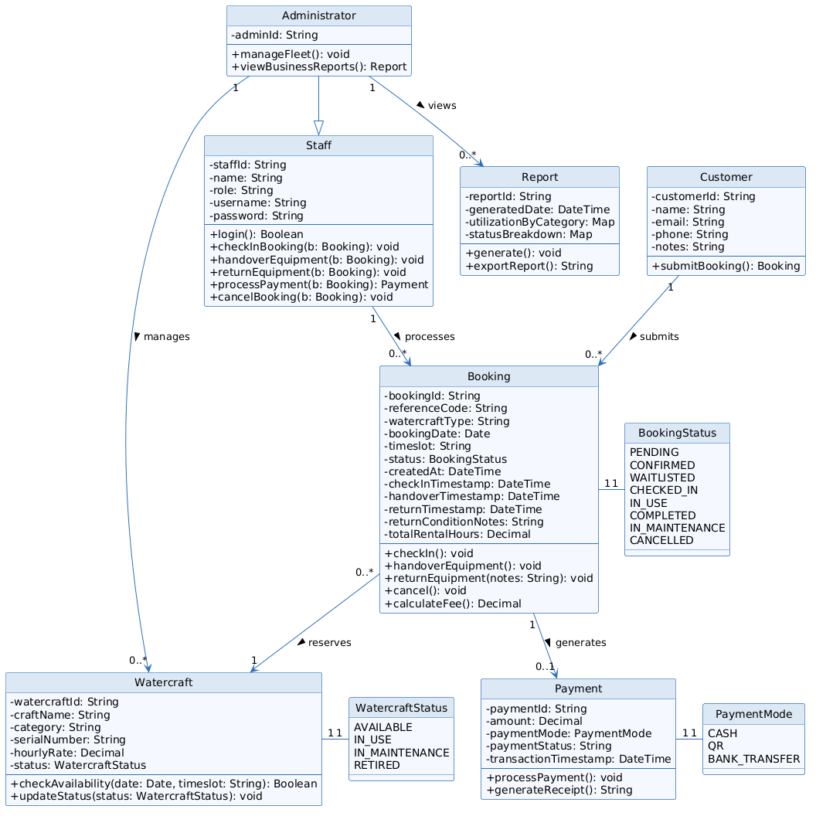

Activity Diagram
The activity diagram below illustrates the end-to-end operational flow across the Customer, System, and Staff/Operator swimlanes — from booking submission through check-in, handover, return, and payment — as well as the cancel-booking flow. As the diagram is tall, it is presented across the following two pages, with a small overlapping section retained at the split point for continuity.
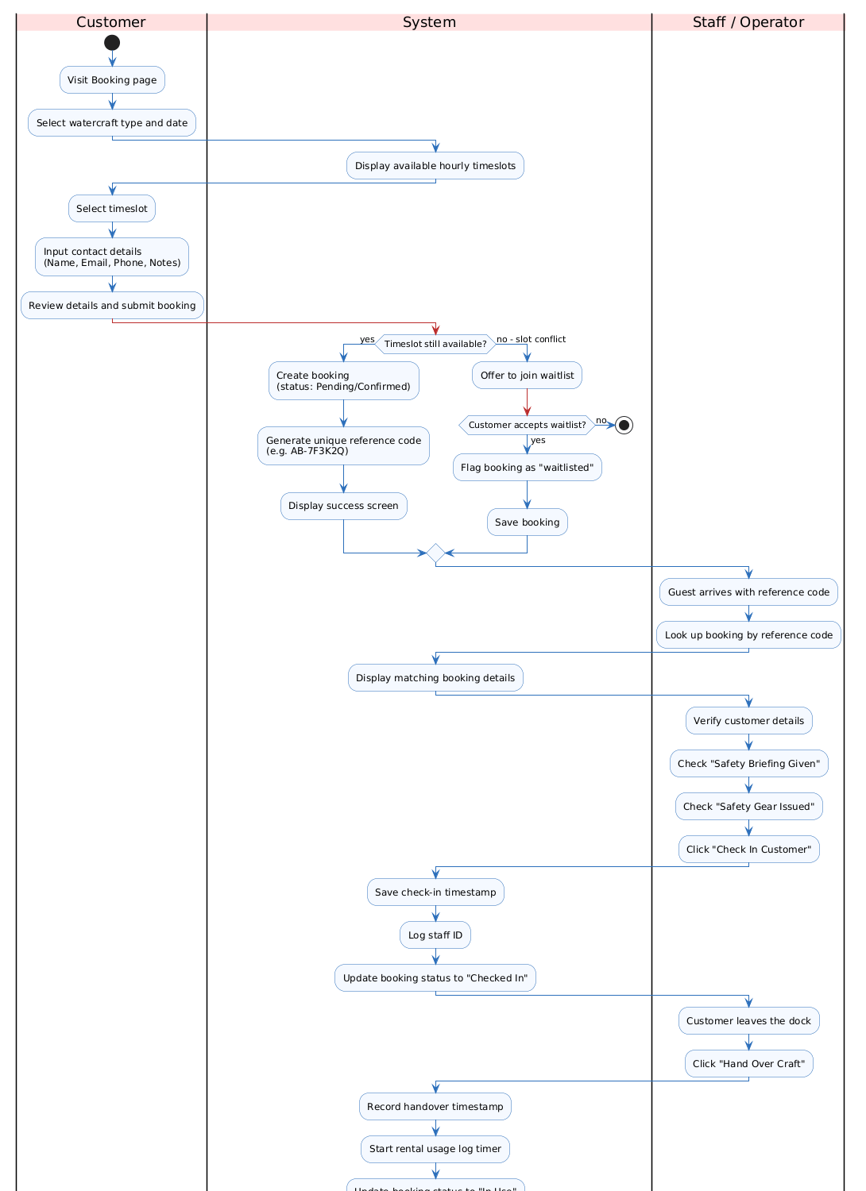
Activity Diagram (continued on next page)
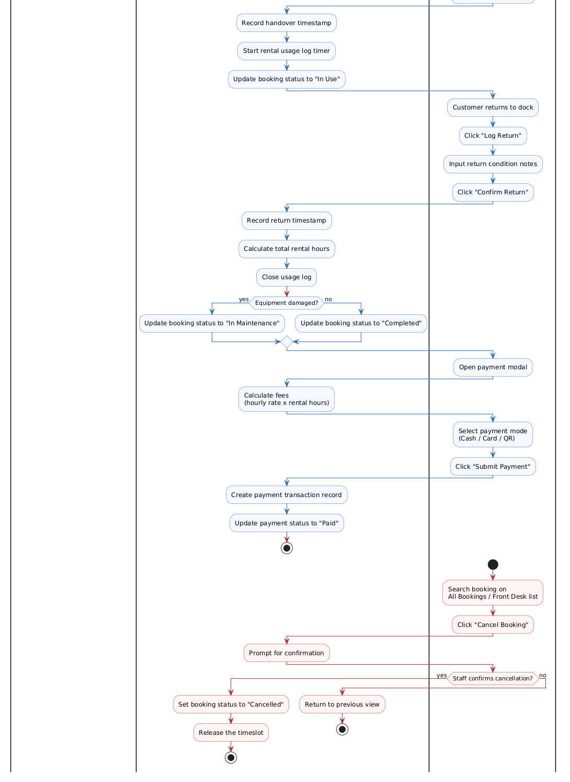
Activity Diagram (continued from previous page)

Interview Questions & Answers
Information for this document was gathered through the following methods, as outlined in the project's Communication Plan:
- Interview sessions with the owner and staff
- Observation of current business operations
- Review of existing receipts and manual records
- Customer feedback
An interview session was conducted with the Antan Batura Watersports owner/staff to gather requirements for the proposed system. The questions and answers recorded during this session are summarised below.
# | Question | Answer
1 | What kind of business/services does Antan Batura Watersports offer? | It offers 6 items: cruise boat (suitable for all people), kayak single, kayak double, canoe, paddle boat, and paddle boat family.
2 | How many staff/workers do they have? | 5 people.
3 | What are the operating hours? | Every day, 8:30 a.m. – 7:30 p.m.
4 | When do they receive the most visitors? | Weekday: 5 p.m. – 6 p.m. Weekend: throughout operating hours.
5 | Who are their usual customers? | Depends on the item: students (kayak), families (cruise boat, paddle boat), tourists (not too many), and foreigners (during public holidays / festive seasons).
6 | What roles exist in the business? | Cashier and boat driver.
7 | Do they use a system/software or manage the business manually? | Manually, through WhatsApp for booking.
8 | How do they deal with customers? | Through booking; all information is recorded manually via WhatsApp.
9 | How do they handle auditing? | Manually, on paper.
10 | How are transactions handled? | Payment via QR (bank statement receipt), bank transfer (bank statement receipt), or cash (recorded manually).
11 | How do they manage equipment availability (boat, kayak, canoe, etc.)? | Staff record it manually.
12 | How do they manage crowded customers / long queues? | One staff member is assigned to assist each customer with their request.
13 | How do they track equipment usage time? | They refer to the information on the generated receipts.
14 | What happens if usage exceeds the time limit? | The customer pays an extra charge, with the rate depending on how long the excess is.
15 | What happens if equipment is broken or not working? | There are rules customers must follow; if a customer causes damage, they must pay compensation.
16 | How do they issue a receipt to customers? | They print the receipt, which is also used as the customer's ticket.
17 | Have they faced any problems in running the business? | Mostly not, but among staff there have been cases of receiving wrong information (miscommunication).
18 | Is it difficult to track their sales? | No.
19 | Have there been any customer complaints? | Yes – regarding equipment: a paddle boat was reported leaking.
20 | When do they usually feel stressed? | During crowded periods, and when equipment is hard to manage.
21 | Which part of the business do they feel is lacking or problematic? | So far, none identified.
22 | Do they prefer online booking or walk-in booking? | Both are accepted, but customers usually prefer online booking.
23 | What do they want from the proposed system? | Management features (company side) and booking features (customer side). They prefer an app accessible on both phone and computer, with automatic report generation.
24 | Do they feel the proposed system would help staff and customers? | Maybe – yes.

Key stakeholders consulted included the Antan Batura Watersports Owner and Staff (Cashier, Boat Driver, Equipment Handling Staff).

Related Documents (References)
- ISP550 Antan Batura Watersports Booking Management System – Project Proposal Slides
- Use Case Description Template (ISP550)
- Use Case Diagram – Antan Batura Booking Management System (PlantUML)
- Domain Class Diagram – Antan Batura Booking Management System (PlantUML)
- Activity Diagram – Antan Batura Booking Management System (PlantUML)

Use Case List – Primary Actor / Use Cases
Use Case ID | Use Case Name | Primary Actor(s)
UC-1 | Book Watercraft | Customer (Guest)
UC-2 | Check-in Booking | Staff / Operator, Administrator
UC-3 | Handover Equipment | Staff / Operator, Administrator
UC-4 | Return Equipment | Staff / Operator, Administrator
UC-5 | Process Payment | Staff / Operator, Administrator
UC-6 | Cancel Booking | Staff / Operator, Administrator
UC-7 | Manage Fleet Inventory | Administrator
UC-8 | View Business Reports | Administrator

