# Assignment 4

# Flowchart:

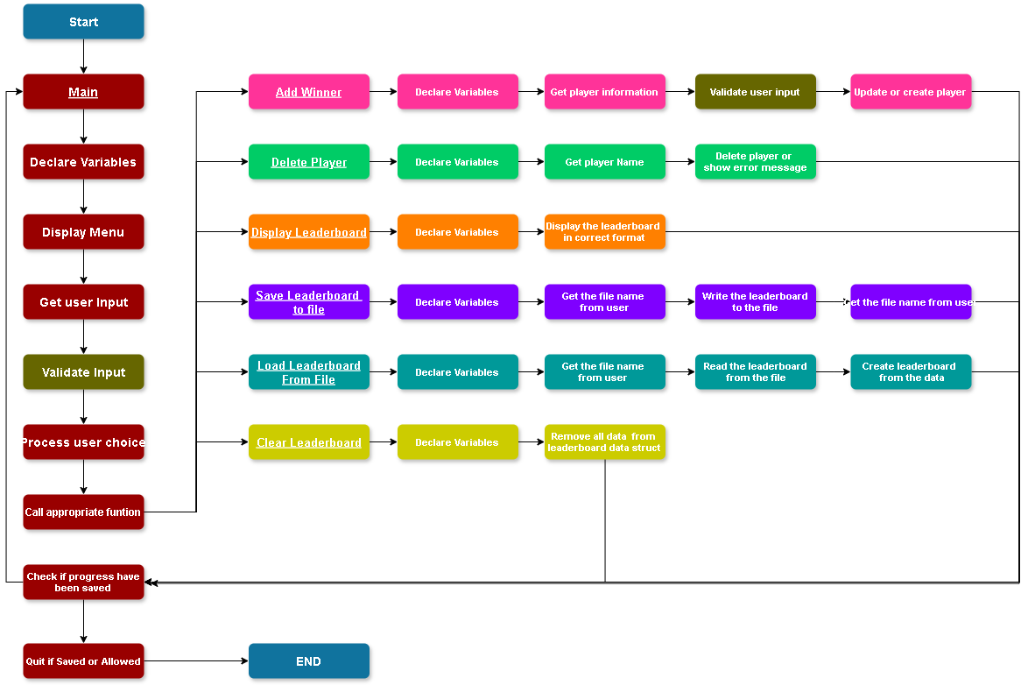

# Pseudocode:

### FUNCTION Main

DISPLAY program header

DECLARE leaderboard data structure

DECLARE filename

DECLARE unsaved changes flag

SET unsaved changes flag to false

DO

DisplayLeaderboard

DISPLAY menu options

GET user choice

SWITCH user choice

CASE "Add Winner":

AddWinner

SET unsaved changes flag to true

BREAK

CASE "Delete Entry":

DeleteEntry

SET unsaved changes flag to true

BREAK

CASE "Save Leaderboard":

GET filename

SaveLeaderboardToFile

SET unsaved changes flag to false

DISPLAY confirmation message

BREAK

CASE "Load Leaderboard":

GET filename

LoadLeaderboardFromFile

SET unsaved changes flag to false

DISPLAY confirmation message

BREAK

CASE "Clear Leaderboard":

ClearLeaderboard

SET unsaved changes flag to true

DISPLAY confirmation message

BREAK

CASE "Quit":

IF unsaved changes

CONFIRM quit

IF confirmed

BREAK

ENDIF

ELSE

BREAK

ENDIF

DEFAULT:

DISPLAY error message

ENDSWITCH

LOOP until user chooses "Quit"

DISPLAY program termination message

PAUSE

END FUNCTION

### FUNCTION AddWinner

GET player information

VALIDATE input

IF player exists

UPDATE player's score if new score is higher

DISPLAY update message

ELSE

CREATE new leaderboard entry

INSERT entry into leaderboard in list

DISPLAY addition message

ENDIF

END FUNCTION

### FUNCTION DeleteEntry

GET player name to delete

REMOVE entry from leaderboard list

DISPLAY deletion message

END FUNCTION

### FUNCTION DisplayLeaderboard

DISPLAY leaderboard entries

Highlight highest score entry

END FUNCTION

### FUNCTION SaveLeaderboardToFile

Get filename from user

SAVE leaderboard data to file in CSV format

END FUNCTION

### FUNCTION LoadLeaderboardFromFile

Get filename from user

LOAD leaderboard data from file

END FUNCTION

### FUNCTION ClearLeaderboard

Clear all entries from the leaderboard data structure

END FUNCTION