STUDENT NAME: AZYFF SHAZREL BIN NOOR AZLI
STUDENT ID: CA25073

Inteligent Library Management System

4.1 USE CASE DIAGRAM

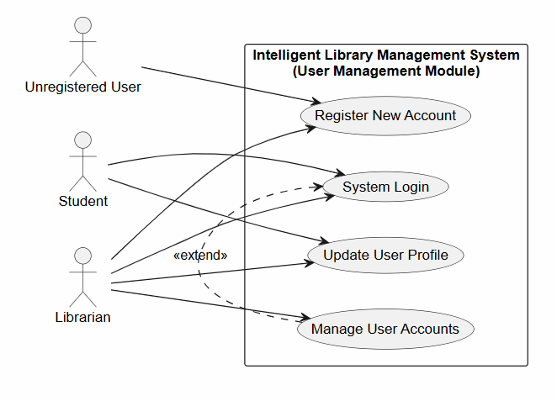

4.2 USE CASE DESCRIPTION
Use Case 1: Register New Account
Field | Description
Use Case Name | Register New Account
Actors | Unregistered User, Librarian
Brief Description | Allows a new user to register an account into the system database to access library services.
Pre-condition | The user has opened the library system interface and navigated to the registration page.
Post-condition | A new user entity record is initialized, saved, and assigned a unique User ID and default role.
Basic Flow | 1. User clicks on the "Register" button.  2. System displays a blank registration form interface.  3. User inputs identity fields (Full Name, Student/Staff ID, Email, Password).  4. User clicks the "Submit Registration" action button.  5. System validates fields, registers data, saves it to the database, and logs a success confirmation.
Alternate Flow | 3a Duplicate Identity Check  If the system finds that the inputted Student/Staff ID matches an active registration, it halts creation, alerts the user, and prompts them to log in instead.
Exception Flow | 4a Missing Crucial Data Fields  If mandatory fields (Name, ID, or Password) are completely empty when submitted, the system cancels verification and displays a field validation alert.
Constraints | The field containing the Student/Staff ID number must uniquely identify only one user within the system.

Use Case 2: System Login
Field | Description
Use Case Name | System Login
Actors | Student, Librarian
Brief Description | Authenticates registered users to access role-specific system features and dashboards.
Pre-condition | The user possesses an active, registered account in the system database.
Post-condition | The user is authenticated, their role is identified, and they are redirected to their specific dashboard.
Basic Flow | 1. User navigates to the login screen.  2. User enters their Student/Staff ID and Password.  3. User clicks the "Login" button.  4. System verifies the credentials against the database records.  5. System extracts the user's assigned role (Student or Librarian).  6. System grants access and renders the appropriate homepage view.
Alternate Flow | 4a Invalid Credentials  If the entered ID and password do not match any database entry, the system denies access, clears the password field, and displays an "Invalid credentials" error prompt.
Exception Flow | 4b Database Connection Timeout  If the system cannot reach the database to verify the user, it aborts the login attempt and displays a "Service Unavailable" message.
Constraints | Password input fields must be visually masked (e.g., using asterisks) during entry for security.

Use Case 3: Update User Profile
Field | Description
Use Case Name | Update User Profile
Actors | Student, Librarian
Brief Description | Allows active users to edit or modify their current contact details and password within their profile.
Pre-condition | The user is successfully logged into the system and has navigated to their profile settings.
Post-condition | Updated attributes safely overwrite the old values inside the database entry.
Basic Flow | 1. User clicks the "Edit Profile" button inside their active profile view.  2. System unlocks input text components, transforming them into modifiable fields.  3. User changes the outdated strings (e.g., Email address, Phone number).  4. User saves changes by clicking the "Update Details" option.  5. System checks form integrity, replaces the database object's data payload, and fires a success notification.
Alternate Flow | 4a Rollback and Discard Changes  If the user hits the "Cancel" option before committing, the form resets immediately back to the original unmodified data parameters.
Exception Flow | None.
Constraints | Immutable anchor attributes, specifically the Student/Staff ID, must remain locked from structural edits by the user.

Use Case 4: Manage User Accounts
Field | Description
Use Case Name | Manage User Accounts
Actors | Librarian
Brief Description | Enables staff to manage user accounts, including searching profiles, modifying roles, or deactivating accounts.
Pre-condition | The Librarian is logged into the system with administrative privileges and is on the User Management dashboard.
Post-condition | The target user account's status or role is successfully updated in the database.
Basic Flow | 1. Librarian accesses the "User Directory" navigation option.  2. System pulls up a list of all registered users.  3. Librarian searches for a specific user using their ID.  4. Librarian clicks "Edit User Status".  5. Librarian changes the user's role or sets the account to "Inactive".  6. Librarian clicks "Confirm Changes".  7. System updates the database record and refreshes the directory view.
Alternate Flow | 3a Lookup Index Failure  If the search parameter doesn't match any index key in the system, it returns a "User Record Not Found" prompt.
Exception Flow | None.
Constraints | A librarian cannot deactivate or alter the role of their own actively logged-in session account.

4.3 Sequence Diagrams
Use Case 1: Register New Account
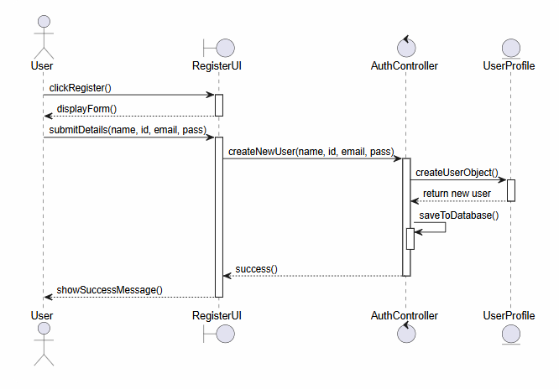

Use Case 2: System Login
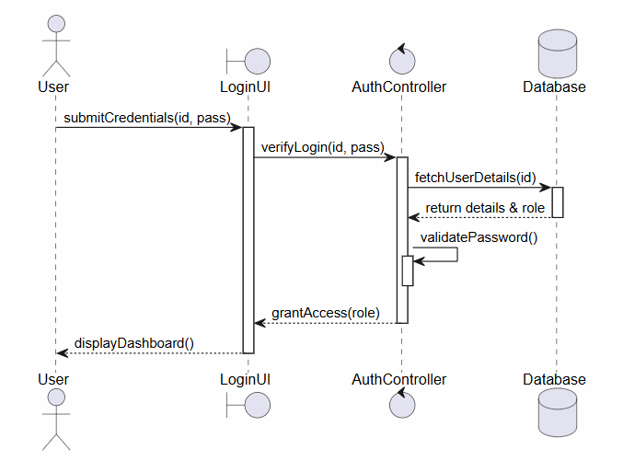
Use Case 3: Update User Profile
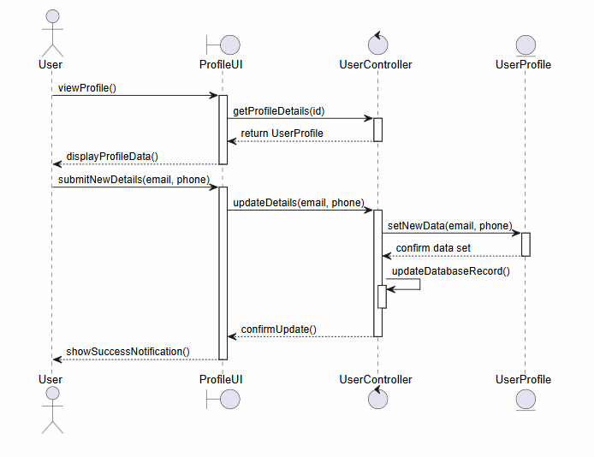
Use Case 4: Manage User Accounts
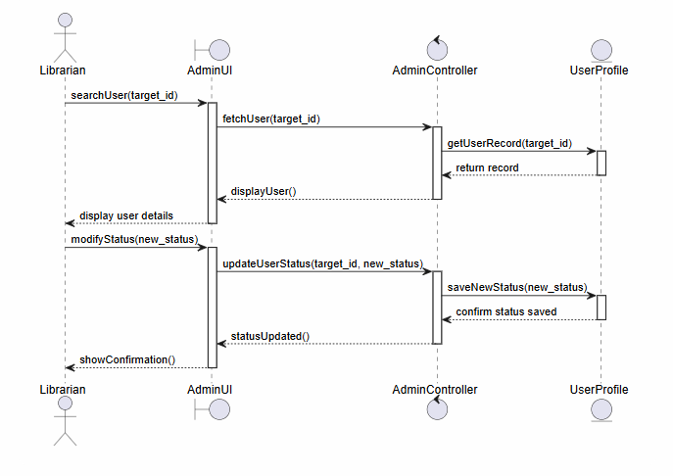
4.4 Class Diagram
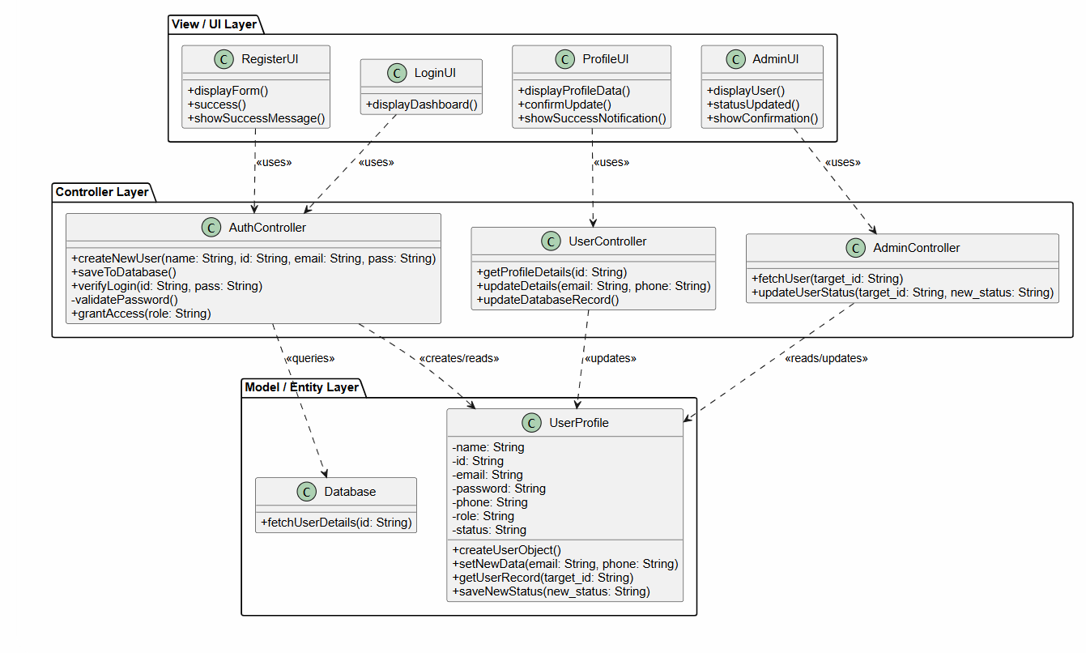

4.5 User Interface (UI) Design
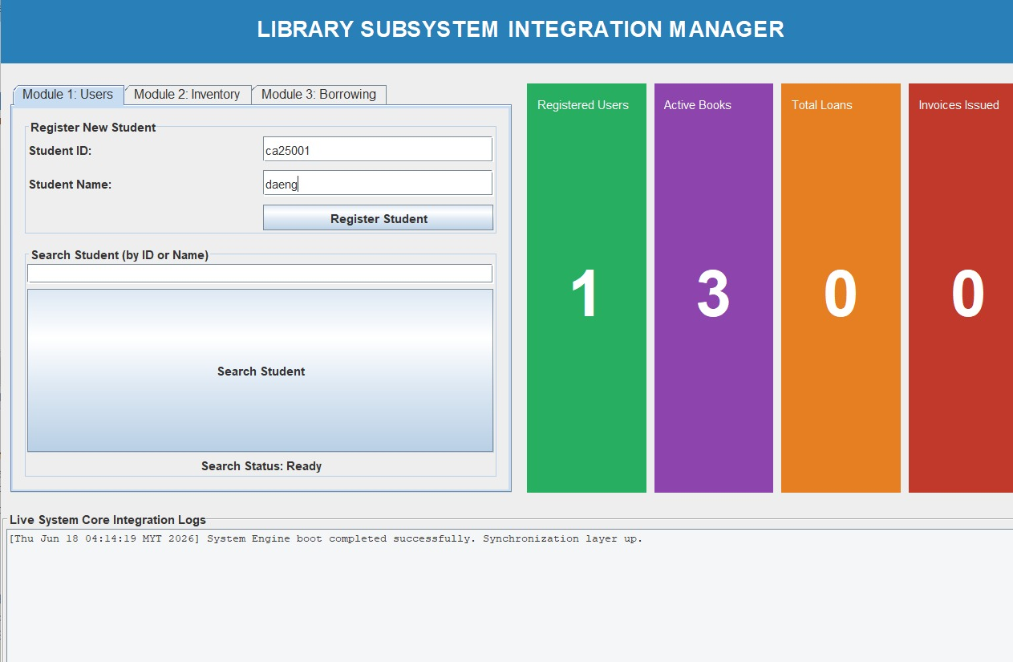
4.6 Program Implementation (Java)
The User Management Module is implemented using Java and strictly adheres to core Object-Oriented Programming (OOP) paradigms to ensure the system is secure, modular, and scalable.
- Encapsulation
Data hiding is strictly enforced to protect sensitive system records from unintended external modifications. In the entity classes (such as User.java, Student.java, and UserProfile.java), all state variables are declared with the private access modifier. Other subsystems can only safely interact with this data through authorized public getter, setter, and constructor methods.
Code Evidence:
Java
// From User.java & UserProfile.java
private String id;
private String name;
private String password;
private boolean isActive;

public String getId() {
return this.id;
}

public String getAccountStatus() {
// Returns the status string cleanly using a ternary operator
return this.isActive ? "Active" : "Inactive";
}
- Inheritance
To reduce structural redundancy, establish code reusability, and enforce a clean hierarchy across the application, the system utilizes inheritance. An abstract parent class, User, is defined to hold common attributes shared by all account types within the library architecture. The Student and Librarian classes utilize the extends keyword to inherit these base attributes, allowing them to focus exclusively on role-specific logic.
Code Evidence:
Java
// From Student.java
public class Student extends User {
private int maxBorrowLimit;

public Student(String id, String name, String email, String password) {
super(id, name, email, password); // Invokes the parent constructor abstractly
this.maxBorrowLimit = 5;
}
}
- Polymorphism
The system uses method overriding to achieve runtime polymorphism, ensuring that different sub-entities can be treated uniformly by the shared controller layers while behaving specifically. The abstract parent class User defines an abstract method signature: public abstract String getRoleDetails();. The Student class provides its own specific implementation using the @Override annotation to output distinct library profile metrics.
Code Evidence:
Java
// From Student.java
@Override
public String getRoleDetails() {
// Utilizes String.format for clean formatting logic
return String.format("Student ID: %s | Name: %s | Borrow Limit: %d", getId(), getName(), maxBorrowLimit);
}
- Proper Class Structure
The application architecture is cleanly decoupled into distinct packages, matching professional enterprise multi-tier standards and fulfilling the group blueprint:
- models package: Contains the data entities (User, Student, Librarian, UserProfile) which maintain encapsulation boundaries but execute zero controller operations.
- controllers package: Contains AuthController.java, UserController.java, and AdminController.java, acting as the business logic controller tier.
- database package: Contains Database.java, implementing the persistent data connection layer to manage the user directory.
- views package: Manages the Graphical User Interfaces (RegisterUI, LoginUI, ProfileUI, AdminUI), ensuring data entry forms remain isolated from storage handling code[cite: 2].

