
ASTANA IT UNIVERSITY
PROBATION PERIOD 1 REPORT
Development of a Mobile Application for Potential Allergen Detection Based on Hybrid Food Ingredient Analysis
Student: Aidos Aidaruly
Academic Group: SE-2413
Supervisor: Arailym Orazova
Astana, 2026

Table of Contents.
- Project Proposal ................................ 3
- Evidence of Relevance ........................ 5
- Literature Review ................................. 9
- Existing System Comparison ............. 14
- Technology Comparison ..................... 16
- Requirements Specification ................ 19
- Architecture and Diagrams ................. 21
- UX / Prototype .................................... 23
- Verification and Evaluation Plan ........ 26
- Project Management and Risks ........ 27
- Supervisor Feedback ........................ 29
Project Repository and Prototype Resources .... 29
References ................................................. 30

1. Project Proposal
1.1 Project Information
Project Overview:
TazaScan is an existing mobile food analysis application that allows users to identify packaged food products and view information about their ingredients, nutritional values, TazaScore, Nutri-Score, and Halal Check. The diploma project extends the existing system with a new module for detecting potential food allergens through hybrid ingredient analysis.

1.2 Problem Statement
Food product labels usually provide an ingredient list, but this information is not always easy to interpret from the point of view of potential allergens. An allergenic component may appear under a specific ingredient name or as part of a more complex formulation, so simply displaying the ingredient list does not directly help the user understand which components may require attention.
The current version of TazaScan already allows users to identify products by barcode, text search, or package photo and view nutrition information, ingredients, TazaScore, Nutri-Score, and Halal Check. However, allergen information is not analyzed automatically. At the moment, the application only displays a general notice when allergen information is unavailable.
Therefore, the diploma project focuses on adding a separate allergen analysis capability to the existing TazaScan system. The main problem is how to analyze the available ingredient information and identify potential allergens while also showing the user which ingredient caused the result. The project does not focus on personalized nutrition recommendations or meal planning.

1.3 Target Users
The primary users of TazaScan are consumers who want to quickly check the composition and nutritional information of packaged food products. The allergen analysis functionality is intended especially for users who need to pay attention to potentially allergenic ingredients and may find ingredient labels difficult to interpret.
Users can access product information by scanning a barcode, searching by product name, or using a photo of the package. A secondary user group consists of administrators who manage product information and review product submissions through the web administration panel.

1.4 Aim
The aim of the project is to develop and integrate into TazaScan a module for detecting potential food allergens through hybrid analysis of product ingredient information and to provide users with an understandable explanation of the detected results.

1.5 Objectives
- To analyze the current TazaScan system and define the requirements for integrating potential allergen detection into the existing product analysis workflow.
- To define the allergen categories, ingredient representations, and preprocessing rules required for analyzing product ingredient information.
- To design and implement a hybrid allergen detection method that combines rule-based analysis with NLP-based processing for more complex or ambiguous ingredient descriptions.
- To integrate the allergen detection module into the existing TazaScan backend and mobile application and provide users with the detected allergen together with the ingredient evidence that triggered the result.
- To prepare a labeled evaluation dataset containing product ingredient lists with known allergen information and use it to test the developed method.
- To evaluate the performance of the allergen detection module using Precision, Recall, and F1-score and compare the hybrid approach with a rule-based baseline.

1.6 Expected Outcomes
By the end of the project, the following outcomes are expected:
- A hybrid allergen detection module integrated into the existing TazaScan backend and mobile application.
- Automatic identification of potential allergens from product ingredient information, with the ingredient evidence that caused each detection shown to the user.
- A labeled evaluation dataset containing product ingredient lists and their known allergen information.
- Quantitative evaluation of the developed method using Precision, Recall, and F1-score, including comparison with a rule-based baseline.
- An updated TazaScan prototype in which allergen analysis works as part of the existing product analysis flow together with product information, ingredients, nutrition data, TazaScore, Nutri-Score, and Halal Check.
- Technical documentation describing the allergen analysis approach, system integration, evaluation procedure, and identified limitations.

1.7 Project Scope
The project covers the development and integration of a potential allergen detection module into the existing TazaScan system.
The scope includes:
- analysis of product ingredient information already stored or obtained by TazaScan;
- preprocessing and normalization of ingredient text before allergen analysis;
- rule-based detection of clearly identifiable allergenic ingredients;
- NLP-based processing for more complex or ambiguous ingredient descriptions;
- combination of rule-based and NLP results within a hybrid detection approach;
- integration of the allergen analysis module with the existing backend and mobile application;
- presentation of detected potential allergens together with the ingredient evidence that caused the result;
- preparation of a labeled evaluation dataset;
- evaluation of the developed method using Precision, Recall, and F1-score;
- comparison of the hybrid method with a rule-based baseline.
The allergen analysis functionality will be added to the current TazaScan product workflow rather than developed as a separate application.

1.8 Out of Scope
The following functionality is outside the scope of the diploma project:
- personalized nutrition recommendations;
- automatic meal planning or diet generation;
- medical diagnosis or medical advice related to allergies;
- user health profiles or recommendations based on personal medical information;
- development of a new food scoring system to replace the current TazaScore or Nutri-Score functionality;
- full production deployment and commercial release of TazaScan;
- replacement of the existing TazaScan platform with a new application.
TazaScan will remain a broader food information platform, while the diploma project will focus specifically on potential allergen detection and its evaluation.

2. Evidence of Relevance
2.1 Method

To verify whether the identified problem is relevant to potential users, five short semi-structured discussions were conducted with people who regularly purchase packaged food products.
The discussions focused on how participants read ingredient labels, whether they experience difficulties interpreting unfamiliar ingredient names, whether they pay attention to allergens or specific ingredients they want to avoid, and whether automatic allergen identification and ingredient-level explanations would be useful.
The same seven core questions were used for all participants to make their responses comparable. Additional clarification was obtained where necessary. To preserve anonymity, the participants are identified as P1–P5.
The discussions were exploratory and intended to identify user needs rather than produce statistically representative results.

2.2 Interview Questions
- Do you usually check the ingredient list before buying a packaged food product?
- Do you find long or unfamiliar ingredient names difficult to understand?
- Do you pay attention to allergens or specific ingredients that you want to avoid?
- Have you ever been unsure whether a product contained an ingredient you wanted to avoid?
- Would automatic identification of potential allergens be useful to you?
- Would you prefer the application to show which ingredient caused the allergen warning?
- What other product information do you usually consider important?

2.3 Interview Results
Participant | Ingredient Checking | Difficulty Understanding Ingredients | Ingredients of Concern | Uncertainty About Ingredients | Allergen Detection Useful | Ingredient Evidence
P1 | Sometimes, especially for new products | Yes; unfamiliar names are difficult to interpret | Certain ingredients to avoid | Yes; confusing terminology | Yes | Yes; wants to know the exact ingredient
P2 | Rarely, unless something seems unusual | Yes; complex ingredient names | Mainly sugar | Yes; unclear packaging | Yes | Yes; wants to assess the specific ingredient
P3 | Occasionally; also checks expiration dates | Yes; especially E-number additives | Carmine, pork-derived components, and additives | Yes; frequently checks for unwanted ingredients | Yes; also useful for family members | Yes
P4 | Regularly, especially for unfamiliar products | Yes; complex terminology and small text | Mainly sugar | Yes; unfamiliar products and unclear labels | Yes | Yes; wants the exact ingredient responsible
P5 | Usually, especially for new products | Yes; preservatives and stabilizers | Certain ingredients and additives | Yes; small text and technical terminology | Yes | Yes; wants to know what triggered the warning

Participants also identified other important product information:
- P1: Calories, sugar content, expiration date, and price.
- P2: Price, protein, calories, and expiration date.
- P3: Ingredient quality, additives, oils, and general product composition.
- P4: Product rating, additives, origin, production and expiration dates, alternatives, and dietary filters.
- P5: Nutritional values, calories, macronutrients, shelf life, and degree of processing.

2.4 Key Findings
The discussions revealed several recurring difficulties related to food ingredient information.
First, all five participants reported that unfamiliar or technical ingredient names can be difficult to understand. Common examples included E-number additives, preservatives, stabilizers, and other complex ingredient descriptions. Some participants also mentioned small or unclear label text. These findings suggest that displaying the original ingredient list alone may not always be sufficient for users to interpret product composition.
Second, all five participants described situations in which they were uncertain whether a product contained an ingredient they wanted to avoid. Their concerns included unfamiliar terminology, unclear packaging, and ingredient names that were difficult to recognize. The ingredients mentioned were not limited to allergens and also included sugar, additives, and ingredients avoided for dietary or personal reasons.
Third, all five participants considered automatic identification of potential allergens useful. Several participants explained that this functionality could reduce the time required to examine ingredient lists manually. One participant also mentioned its potential usefulness for family members with food allergies.
Another consistent finding was the importance of explainability. All five participants preferred an application that identifies the specific ingredient responsible for an allergen warning. Their responses suggest that a generic warning would provide less useful information than a result supported by a recognizable ingredient or ingredient phrase.
Participants also expressed interest in additional product information, including nutritional values, expiration dates, product ratings, pricing, and dietary compatibility. These responses indicate broader consumer interest in food information services. However, such features are not the primary focus of the diploma project.
Although the sample is small, the consistency of the responses provides preliminary qualitative evidence that ingredient interpretation and clear allergen explanations are relevant user needs.

2.5 Influence on Project Requirements
The discussions provided supporting evidence for several requirements already defined for the proposed TazaScan allergen analysis module.
Difficulties understanding unfamiliar ingredient names support the need for ingredient text normalization and NLP-assisted analysis, as addressed by FR-02 and FR-03.
Reported uncertainty about ingredient presence supports the need to handle missing or ambiguous ingredient information carefully, as described in FR-05.
The preference expressed by all five participants for identifying the ingredient responsible for a warning directly supports FR-04 and NFR-01, which require ingredient-level evidence and understandable explanations.
The results did not require a major change to the project scope. TazaScan will continue to provide general food product information, while the diploma contribution remains focused on explainable potential allergen detection and its evaluation. Additional suggestions, such as personalized dietary filters and alternative product recommendations, may be considered for future development but are not included in the current diploma scope.

3. Literature Review
3.1 Food Allergen Information and Label Interpretation
Food labels are the primary source of ingredient and allergen information available to consumers of packaged food. However, the presence of allergen information on a package does not necessarily make it easy to understand. Holleman et al. [1] investigated how allergic and non-allergic consumers interpret allergen information on packaged foods. Using 18 food products, the study found that fewer than half of the participants considered the allergen information clear. The wording of precautionary allergen labels also affected how consumers interpreted the potential risk. PubMed
Blom et al. [2] examined 288 packaged food labels and identified considerable variation in the way allergens were highlighted in ingredient lists and precautionary statements. The study showed that the usability of allergen information depends not only on whether the information is present, but also on how clearly it is communicated. Wiley Online Library
A separate issue is precautionary allergen labelling, such as “may contain.” Turner et al. [3] explain that these statements refer to possible unintended allergen presence rather than an allergen deliberately used as an ingredient. Their review also notes that the use of such labels remains inconsistent. For an automated application, this distinction is important because an allergen explicitly present in the ingredient list should not be represented in the same way as a possible trace. ScienceDirect
These findings influence the proposed TazaScan design in two ways. First, the application should not provide only a binary warning. It should show the ingredient or phrase that caused the result. Second, direct ingredient evidence, insufficient information, and precautionary statements should be represented separately rather than combined into a single “safe” or “unsafe” output.

3.2 Food Ingredient Text Processing and NLP
Automatic allergen detection depends on reliable processing of food ingredient text. Ingredient lists contain alternative names, compound ingredients, abbreviations, spelling variations, and domain-specific terminology. As a result, simple exact keyword matching may not cover all relevant cases.
Popovski et al. [4] developed the FoodBase corpus, a manually checked resource containing annotated food entities. The work demonstrates the importance of domain-specific annotated data for food-related Natural Language Processing tasks and provides a foundation for developing and evaluating food entity extraction methods. PubMed
Stojanov et al. [5] used FoodBase to develop FoodNER, a collection of BERT-based Named Entity Recognition models. The models achieved macro F1-scores between 93.30% and 94.31% when distinguishing food from non-food entities. However, performance decreased to approximately 73.39–78.96% for more detailed semantic classification. This difference is relevant to allergen detection because identifying that a phrase represents food is easier than correctly determining its specific semantic role or allergen relationship. ScienceDirect
Hu et al. [6] applied pretrained language models and machine-learning approaches to large food-label datasets for automated food categorization and nutrition quality prediction. Although their task was not allergen identification, their results show that contextual language models can process food-label text at scale and can provide advantages over simpler text representations. ScienceDirect
These studies support the use of NLP for handling variable ingredient descriptions. At the same time, they do not provide a reason to replace deterministic matching completely. For TazaScan, rule-based analysis remains suitable for clear and known allergen terms, while NLP can be applied to descriptions that are more difficult to interpret.

3.3 Automated Allergen Detection Approaches
Several studies address automatic allergen detection more directly.
Roither et al. [7] investigated automatic allergen and style classification from recipe ingredients. Their work demonstrates that allergen categories can be inferred from ingredient information. However, recipes are usually more structured than commercial ingredient labels and do not fully represent problems such as nested ingredients, unusual terminology, and precautionary statements.
Gadelha et al. [8] developed an NLP-based approach for identifying allergens on Brazilian food labels. Their system combined an allergen terminology database, text preprocessing, and Named Entity Recognition for different names associated with four major allergen groups. The reported evaluation achieved an average precision of 96.50%. The study is particularly relevant to TazaScan because it shows that one allergen may appear under several different ingredient names. At the same time, the authors worked with a limited allergen set and language-specific terminology, which reduces direct generalizability to other markets. jhi.sbis.org.br
Kına [9] studied real-time food allergen detection using OCR together with machine-learning techniques. The work evaluated both clean textual input and a real-time pipeline based on food-label images. The study reports that performance under practical OCR conditions was lower than results obtained using cleaner offline data. This is important for TazaScan because its photo-based product workflow can also introduce OCR errors before allergen analysis begins. OpenAlex
Badli et al. [10] developed a Flutter-based mobile application for packaged food allergen detection using OCR, NLP processing, and a curated allergen-name database. Their evaluation used 40 food-label images and reported a Character Error Rate of 4.76% and Word Error Rate of 13.72%. The work is technically close to TazaScan because it demonstrates a complete mobile scanning pipeline, but it also shows that allergen detection remains dependent on OCR quality and the coverage of the underlying allergen terminology database. DOI
Susanto et al. [11] investigated allergen detection from food-label text as a Named Entity Recognition (NER) task using transformer-based models, including IndoBERT, multilingual BERT (mBERT), and XLM-RoBERTa. The best-performing model, mBERT, achieved an entity-level F1-score of 0.686. The study demonstrates that contextual language models can recognize allergen expressions in food-label text, but their performance remains imperfect and depends on the quality of annotated data. These findings support the use of NLP for complex ingredient descriptions while highlighting the importance of comparing it with more predictable rule-based methods.

3.4 Hybrid and Explainable Ingredient Analysis
The reviewed methods reveal a trade-off between deterministic and NLP-based approaches. Rule-based or database-based matching is transparent and predictable, but its performance depends on the completeness of predefined terms and synonyms. NLP models can handle more diverse language, but they can introduce false positive and false negative results and are more difficult to explain.
A relevant methodological example is Food Additive Lens by Feng et al. [12]. Although this work focuses on food additives rather than allergens, the system uses a hybrid identification approach that combines direct database lookup with AI-based extraction. The hybrid identifier achieved an F1-score of 0.757 and was combined with an explanation component designed to make results understandable to users. ScienceDirect
Baryannis et al. [13] approach allergen information from a structured knowledge perspective through the Food Allergen Traceability Ontology. Their work shows that allergens, ingredient declarations, products, and evidence can be represented through explicit relationships instead of treating allergen information as isolated keywords. Sage Journals
These approaches support the architecture selected for TazaScan. Clearly identifiable ingredients and known synonyms can be processed using deterministic rules, while NLP processing can be used for more complex or variable descriptions. The final result should remain linked to the ingredient evidence that triggered the detection, regardless of which component produced it.

3.5 Critical Analysis and Research Gap
The literature shows that automatic allergen analysis is already technically feasible. Previous studies have applied terminology databases, rule-based matching, traditional machine learning, Named Entity Recognition, transformer models, OCR, and mobile applications. Therefore, the contribution of this diploma project is not based on the claim that allergen detection has never been implemented before.
However, several limitations remain relevant to the proposed TazaScan module.
First, some existing approaches depend heavily on manually defined terminology or cover a limited set of allergens. This can cause problems when ingredient names differ from the expected dictionary representation. Gadelha et al. [8], for example, focused on four major allergen groups and required language-specific processing. jhi.sbis.org.br
Second, NLP performance is strongly influenced by the availability of annotated domain data. FoodNER demonstrates high performance for broad food entity detection, while more detailed semantic classification is substantially more difficult. ScienceDirect
Third, real-world application performance can be affected before allergen analysis even begins. OCR-based studies show that errors introduced when extracting text from packaging can reduce the reliability of the final pipeline. DOI
Finally, label-communication research demonstrates that the technical detection itself is only part of the problem. A user also needs to understand why a result was produced and whether it represents a directly declared ingredient or only uncertain or precautionary information. PubMed Central (PMC)
The closest studies also leave several limitations relevant to this project. Gadelha et al. [8] demonstrated strong NLP-based allergen recognition, but their approach focused on four allergen groups and language-specific terminology. Badli et al. [10] developed a Flutter-based mobile system combining OCR and allergen identification, but detection depended on matching extracted text against a curated allergen database. Susanto et al. [11] investigated transformer-based allergen extraction and reported a best entity-level F1-score of 0.686, indicating that contextual NLP still faces recognition errors. These findings motivate investigating whether deterministic rules and NLP-based processing can complement each other, rather than relying on either approach alone.
Based on these limitations, the diploma project investigates a hybrid allergen detection approach within the existing TazaScan platform. The proposed method combines deterministic rules for clearly identifiable allergen terms with NLP-based processing for more complex or variable ingredient descriptions. Each detected potential allergen will be linked to the ingredient or ingredient phrase that caused the result. The system will distinguish between direct ingredient evidence, precautionary information such as possible traces, and cases where ingredient information is missing or insufficient. These cases will be represented using an explicit result status rather than being reduced to a binary “safe” or “unsafe” conclusion.
The developed approach will also be evaluated quantitatively. A labeled food-ingredient dataset will be prepared, and the hybrid approach will be compared with a rule-based baseline using the same evaluation conditions. Precision, Recall, and F1-score will be used to measure detection performance. This makes it possible to determine whether the additional NLP component provides a measurable improvement rather than assuming that a more complex method is automatically better.
For the local context of TazaScan, the system design will also take into account TR CU 022/2011 “Food Products in Terms of Their Labelling”, which establishes food-labelling requirements applicable in Kazakhstan. The regulation requires specified components that may cause allergic reactions or are contraindicated for particular diseases to be declared in the ingredient list regardless of their quantity. It also addresses situations where such components were not intentionally used but their possible presence cannot be completely excluded [14]. This distinction is relevant when defining direct allergen evidence and precautionary result statuses in TazaScan. However, the application will remain an informational tool rather than a medical or regulatory compliance system.
3.6 Structured Literature Analysis

Ref. | Year | Problem | Method | Main Findings | Main Limitation | Relevance to TazaScan
Holleman et al. [1] | 2021 | Consumers have difficulty interpreting allergen labels | Controlled experiments with packaged foods | Allergen information was unclear to many participants | Does not develop an automated detector | Supports understandable result presentation
Blom et al. [2] | 2021 | Inconsistent allergen communication on labels | Analysis of 288 packaged food labels | Strong variation in allergen presentation and PAL | Specific retail/regulatory context | Supports consistent ingredient-level explanations
Turner et al. [3] | 2024 | Inconsistent use of precautionary allergen labelling | Review of PAL practices | PAL represents possible unintended presence and should be distinguished from declared ingredients | Review rather than software evaluation | Supports separate result status
Popovski et al. [4] | 2019 | Lack of food-domain annotated NLP data | Development of FoodBase corpus | Demonstrates value of manually annotated food entities | Not allergen-specific | Supports labeled data preparation
Stojanov et al. [5] | 2021 | Extraction and semantic classification of food entities | BERT-based NER | High food/non-food F1; lower performance for detailed semantics | Not specifically allergen detection | Supports NLP component and demonstrates semantic difficulty
Hu et al. [6] | 2023 | Automated processing of large food-label datasets | Pretrained NLP and ML models | Contextual NLP can process food-label text effectively | Tasks concern categories/nutrition rather than allergens | Supports NLP over ingredient text
Roither et al. [7] | 2022 | Automatic allergen classification | Ingredient-based classification | Allergens can be classified automatically from ingredients | Recipe data differs from packaged food labels | Supports ingredient-based allergen analysis
Gadelha et al. [8] | 2024 | Different names used for allergens on labels | Terminology database + preprocessing + NER | Average reported precision of 96.50% | Limited allergen set and language-specific processing | Closely supports normalization and NLP
Kına [9] | 2025 | Allergen detection under real OCR conditions | OCR + ML/DL classification | Real-world OCR conditions reduce performance compared with cleaner data | Limited dataset and OCR dependency | Supports testing input quality and OCR effects
Badli et al. [10] | 2026 | Real-time mobile allergen detection | Flutter + OCR + NLP + allergen database | Demonstrates functioning mobile label-scanning workflow | 40 label images; depends on terminology database | Closest mobile-system comparison
Susanto et al. [11] | 2026 | Allergen extraction from variable label text | Transformer-based NER | Contextual models can identify allergen entities | Probabilistic output and dependence on annotated data | Supports NLP for difficult descriptions
Feng et al. [12] | 2026 | Identification and explanation of food ingredients/additives | Hybrid database + AI extraction | Hybrid identifier combines deterministic and AI analysis | Focuses on additives rather than allergens | Methodological support for hybrid design
Baryannis et al. [13] | 2026 | Structured allergen information and traceability | Food allergen ontology | Models relationships between allergens, declarations and evidence | Focus is traceability | Supports structured allergen/evidence representation

4. Existing System Comparison

A comparison of existing food scanning and ingredient-analysis applications was conducted to understand which functions are already available and which limitations are relevant to TazaScan. Four systems were selected: Yuka, Open Food Facts, Spoonful, and Fig.
The systems were compared using the same criteria: barcode scanning, ingredient information, nutrition information, allergen-related analysis, ingredient-level explanation, image or photo-based data input, personalization, product scoring, and important limitations.
Yuka focuses primarily on general food quality assessment. It provides barcode-based product analysis, nutritional information, a 0–100 food score, and recommendations for better-rated alternatives. Its Premium food preferences can warn users about selected ingredients such as gluten, lactose, soy, and sulfites, but Yuka explicitly states that precautionary traces such as “may contain” are not taken into account. help.yuka.io
Open Food Facts is an open collaborative food database and scanning application. It provides barcode scanning, ingredients, allergens, nutrition facts, Nutri-Score, and other food attributes. The platform can also use personal food preferences to highlight products that match or conflict with selected criteria. However, the information depends heavily on the completeness and accuracy of collaboratively submitted product data. blog.openfoodfacts.org
Spoonful is more focused on dietary restrictions, allergies, and intolerances. Users can select supported diets and allergens and scan products to check whether they fit those restrictions. Spoonful analyzes ingredient lists and allergen statements and can highlight ingredients that cause a warning. It also supports photo-based correction or submission of ingredient information. The application notes that it cannot fully determine manufacturing cross-contamination risks. Spoonful
Fig is built around a personalized dietary profile containing allergies, intolerances, diets, and individual ingredients to avoid. The application supports barcode scanning and compares product ingredients against the user’s selected restrictions. Users can inspect an ingredient to understand why it does not match their profile. Fig provides strong personalization, but its current consumer availability is primarily limited to the United States.

4.1 Comparison Table

Criterion | Yuka | Open Food Facts | Spoonful | Fig
Barcode scanning | Yes | Yes | Yes | Yes
Ingredient information | Yes | Yes | Yes | Yes
Nutrition information | Yes | Yes | Yes | Available as product-label information, but not the main focus
Allergen-related analysis | Limited / selected alerts | Allergen data and alerts | Yes, regulated allergens and diet restrictions | Yes, allergies and ingredient restrictions
Ingredient-level explanation | Limited | Limited | Yes, flagged ingredients and notes | Yes, user can inspect why an ingredient does not match
Photo / image-based data input | Product photos can be submitted | Product label photos can be contributed | Yes, label photos can update ingredient information | Not a main documented workflow
Personalization | Dietary preferences in Premium | Custom food preferences | Diet/allergy profile | Strong personalized dietary profile
Product scoring | 0–100 Yuka score | Nutri-Score / NOVA | Diet-specific color/result system | Compatibility/color-coded result rather than general food score
Important limitation | Does not account for “may contain” traces | Depends on completeness of community data | Cannot fully assess manufacturing cross-contamination | Mainly available in the U.S.

4.2 Findings and Relevance to TazaScan
The comparison shows that barcode scanning, ingredient display, dietary filtering, and allergen-related warnings already exist in several applications. Therefore, these functions alone are not sufficient to define the technical contribution of TazaScan.
For the diploma project, the focus is placed on the implementation and evaluation of an explainable allergen detection module within the existing TazaScan platform. The proposed module will combine deterministic ingredient rules with NLP-based processing for more complex ingredient descriptions and will return the ingredient evidence responsible for each detected potential allergen.
Unlike systems whose main purpose is personalized dietary matching, the diploma version of TazaScan does not build a personal diet profile or generate nutrition recommendations. Its main research and engineering focus is the detection of potential allergens from ingredient information and the quantitative evaluation of this detection method.

5. Technology Comparison
The main technical decisions were reviewed against reasonable alternatives. Since TazaScan already has a working codebase, the comparison considers not only general advantages of each technology but also compatibility with the existing system, implementation effort, maintainability, and suitability for the planned allergen analysis module.

5.1 Mobile Application Framework
Option | Advantages | Limitations | Decision
Flutter | One codebase for multiple platforms, mature UI toolkit, already used in TazaScan | Larger application size than some native solutions | Selected
React Native | Cross-platform development, large JavaScript ecosystem | Would require rewriting the existing Flutter application | Not selected
Native Android / Kotlin | Strong Android integration and native performance | Separate development would be required for other platforms and the current Flutter application would need to be replaced | Not selected

Flutter was retained because the existing TazaScan mobile application is already implemented with it. Replacing the framework would add significant development work without providing a clear benefit for the diploma objective.

5.2 Backend Platform

Option | Advantages | Limitations | Decision
Node.js + Express + TypeScript | Suitable for REST APIs, existing TazaScan backend, shared TypeScript ecosystem with the admin application | CPU-intensive processing may require additional handling | Selected
Spring Boot | Mature architecture and strong enterprise tooling | Higher migration effort and would require rewriting the current backend | Not selected
FastAPI | Convenient for Python-based ML/NLP integration and rapid API development | Would introduce another backend stack and duplicate existing API functionality | Not selected

5.3 Database Technology

Option | Advantages | Limitations | Decision
PostgreSQL | Strong relational model, transactions, constraints, good Prisma support | Schema changes require migrations | Selected
MySQL | Mature relational database and widely supported | No significant advantage over the existing PostgreSQL setup for this project | Not selected
MongoDB | Flexible document structure | Less suitable for the existing relational product, submission, certification, and user data model | Not selected

PostgreSQL was retained because TazaScan already uses a relational data model containing products, product submissions, users, product families, and Halal certification records. Prisma is already used as the data-access layer, so changing the database would add unnecessary migration work.

5.4 Allergen Detection Approach

Option | Advantages | Limitations | Decision
Rule-based only | Predictable, easy to explain, effective for known ingredient names and synonyms | May struggle with complex or ambiguous ingredient descriptions | Baseline
NLP-based only | Can potentially handle more complex language patterns | Less predictable and more difficult to explain; depends on data/model quality | Not selected as standalone approach
Hybrid approach | Combines explainable rules for clear cases with NLP processing for more complex cases | More implementation and evaluation work | Proposed approach

Node.js with Express and TypeScript was retained because the existing TazaScan backend already supports product management, authentication, scoring, OCR processing, Halal screening, and other application services. The planned allergen detection module can be integrated into this architecture through the existing REST API without rebuilding the backend. This approach reduces migration effort, preserves the current functionality, and allows development to focus on the allergen analysis module.
A hybrid approach is proposed for the diploma project. Rule-based detection will provide an explainable baseline for clearly identifiable ingredients, while NLP-based processing will be investigated for more complex ingredient descriptions. The final evaluation will determine whether the hybrid approach provides an improvement over the rule-based baseline.

5.5 Technology Selection Summary

The selected technologies preserve the existing TazaScan architecture and allow the diploma work to focus on the new allergen analysis functionality instead of rebuilding already implemented components. Flutter, Node.js/Express, PostgreSQL, and Prisma therefore remain part of the existing platform, while the hybrid allergen detection approach represents the main new technical decision introduced by the diploma project.

6. Requirements Specification
The requirements below describe the functionality that must be supported by the diploma version of TazaScan. The main focus is the integration of potential allergen detection into the existing product analysis workflow.

6.1 Functional Requirements

ID | Requirement | Priority | Acceptance Criteria
FR-01 | The system shall allow the user to open a product through the existing barcode, text search, or package photo flow. | Must | A product found through any supported search method can be opened in the product details screen.
FR-02 | The system shall use the available ingredient information of a product as input for allergen analysis. | Must | When ingredient data is available, it is passed to the allergen analysis module.
FR-03 | The system shall identify potential allergens using a hybrid approach combining rule-based analysis and NLP-based processing. | Must | The module returns potential allergens for ingredient lists used in the evaluation dataset.
FR-04 | The system shall provide evidence for each detected allergen. | Must | Each detected allergen is linked to the ingredient or ingredient phrase that caused the detection.
FR-05 | The system shall distinguish between a detected allergen and a case where there is not enough ingredient information for reliable analysis. | Must | Products with missing or insufficient ingredient data do not receive an unsupported allergen result.
FR-06 | The allergen analysis result shall be displayed as part of the existing TazaScan product details flow. | Must | The user can view the allergen result without leaving the product analysis flow.
FR-07 | The system shall preserve the existing product information functionality, including nutrition information, ingredients, TazaScore, Nutri-Score, and Halal Check. | Must | Existing product information remains available after integration of the allergen module.
FR-08 | The developed allergen detection method shall be testable using a labeled evaluation dataset. | Must | The module can be executed on the prepared dataset and its predictions can be compared with known labels.
FR-09 | The system should provide a confidence or result-status indicator where the available ingredient information is incomplete or ambiguous. | Should | The UI distinguishes normal detections from cases that require caution or additional review.

6.2 Non-Functional Requirements

NFR-01 — Explainability
The system shall present allergen detection results in a way that allows the user to understand which ingredient caused each result.
NFR-02 — Reliability
The system shall avoid presenting a definite allergen result when the available ingredient information is missing or insufficient.
NFR-03 — Maintainability
Allergen detection rules, allergen categories, and NLP-related components should be organized so that they can be updated without major changes to the rest of the TazaScan system.
NFR-04 — Compatibility
The allergen module shall be integrated with the existing TazaScan backend and Flutter mobile application without removing the current product analysis functionality.
NFR-05 — Testability
The allergen detection logic shall support automated testing and quantitative evaluation using Precision, Recall, and F1-score.
NFR-06 — Safety of Communication
The application shall present allergen results as informational detection of potential allergens and shall not present them as medical diagnosis or a guarantee that a product is safe.

7. Architecture and Diagrams
TazaScan follows a client-server architecture. The system consists of a Flutter mobile application for consumers, a React-based web administration panel, a Node.js/Express backend, and a PostgreSQL database accessed through Prisma.
The mobile application communicates with the backend through REST API endpoints. It is responsible for barcode scanning, text and photo-based product search, displaying product information, ingredients, nutrition data, TazaScore, Nutri-Score, Halal Check, history, favorites, and product submission functionality.
The administration panel uses the same backend and provides functionality for product management, product image management, Halal certification management, and moderation of user product submissions.
The backend contains the main application logic, including product services, scoring engines, Halal screening, OCR processing, image processing, data-quality checks, authentication, and access to persistent data through Prisma and PostgreSQL.
The planned allergen detection module will be added as a separate backend component and integrated into the existing product analysis workflow. It will receive ingredient information, preprocess and normalize the ingredient text, apply rule-based and NLP-based analysis, combine the results, and return potential allergens together with supporting ingredient evidence and result status.
Open Food Facts is used only through controlled import scripts to populate or update product data. It is not queried directly during the normal consumer product lookup flow.

7.1 System Context Diagram
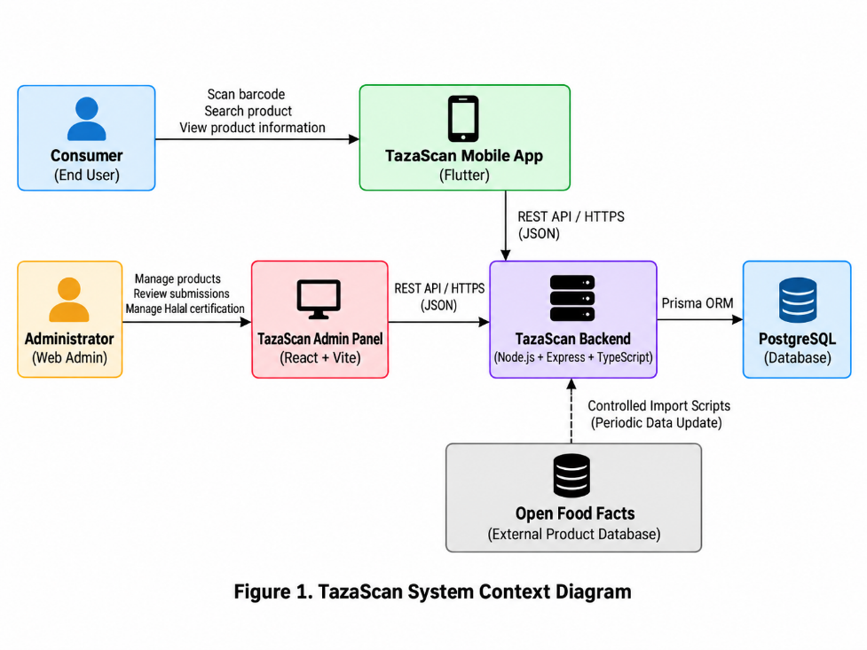

7.2 Use Case Diagram
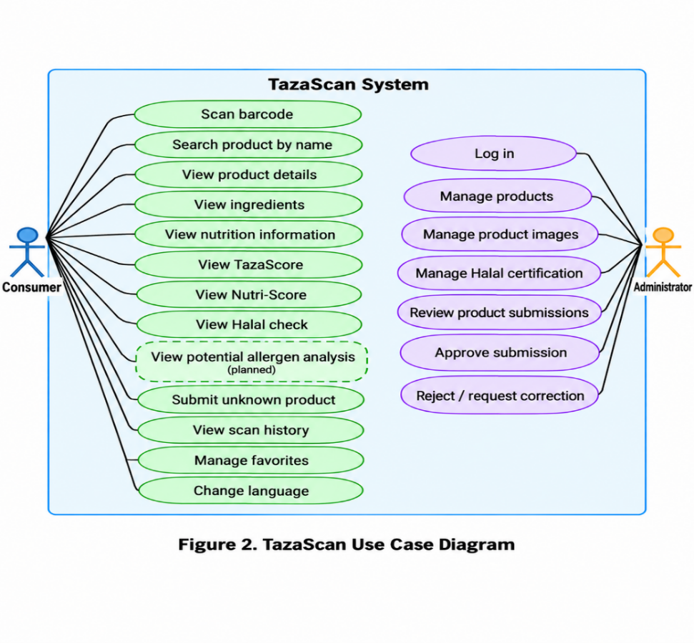
7.3 Component Diagram
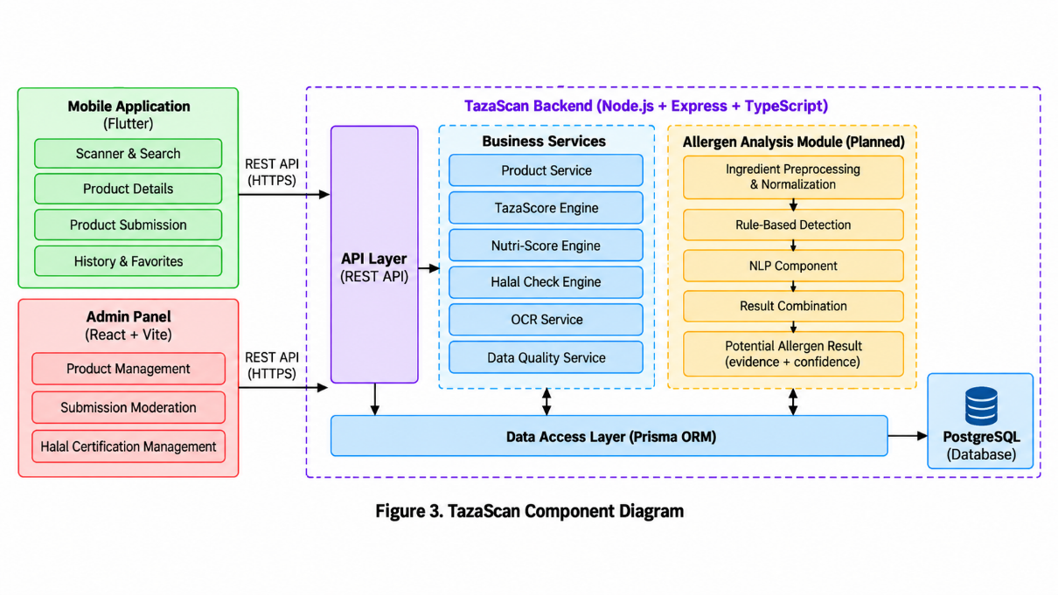

The proposed allergen analysis module is separated from the existing TazaScore, Nutri-Score, Halal Check, and OCR components. This allows the new functionality to be developed and evaluated independently while using the existing TazaScan product and ingredient data.

8. UX / Prototype
TazaScan already has a functional mobile prototype and a web administration interface. Therefore, this section is based primarily on the implemented user interface rather than conceptual mockups.
The main consumer flow starts with product identification. A user can scan a barcode, enter a barcode manually, search for a product by name, or use a package photo. After a product is found, the application opens the product details screen, where the user can view nutrition information, ingredients, TazaScore, Nutri-Score, Halal Check, and information about the reliability of the available product data.
If a product is not available in the database, the user can submit it for moderation together with product information and package images. The application also provides history and favorites for previously viewed products.
The planned allergen analysis functionality will be integrated into the existing product details flow. The user will be able to view detected potential allergens together with the ingredient or ingredient phrase that caused each result. The new functionality will extend the existing product analysis interface rather than introducing a separate application flow.

8.1 Product Search and Identification
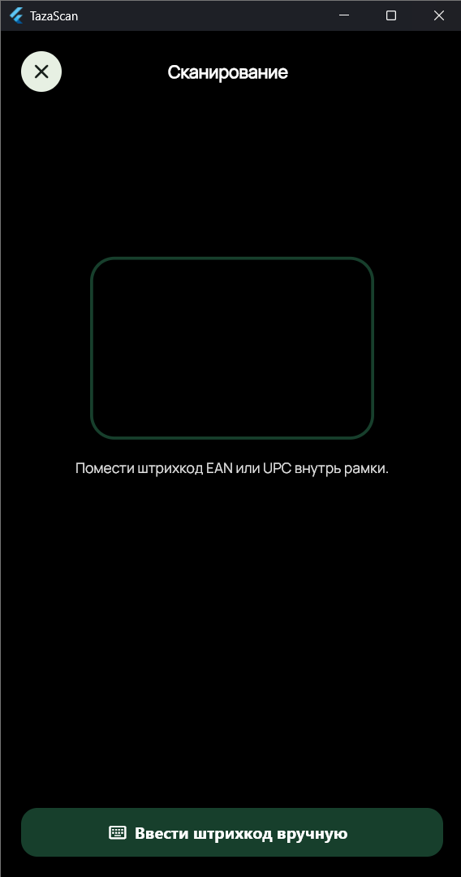

Figure 4. Product identification using barcode scanning

8.2 Product Details
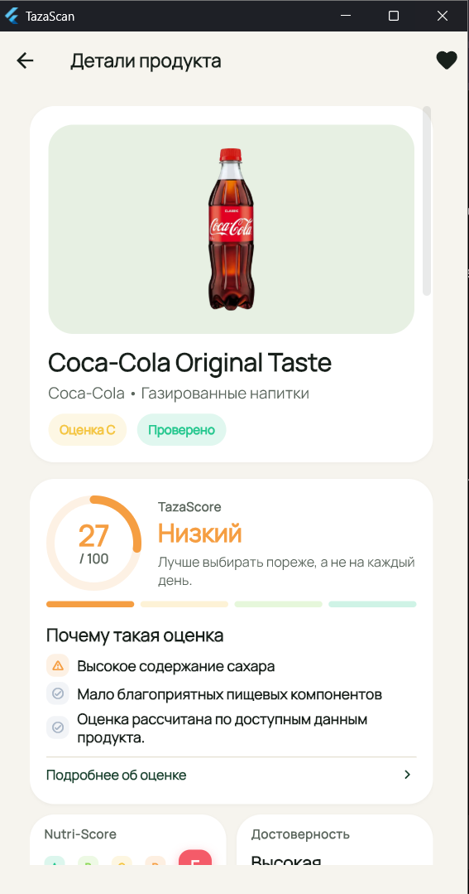
Figure 5. TazaScan product details screen

8.3 TazaScore Details
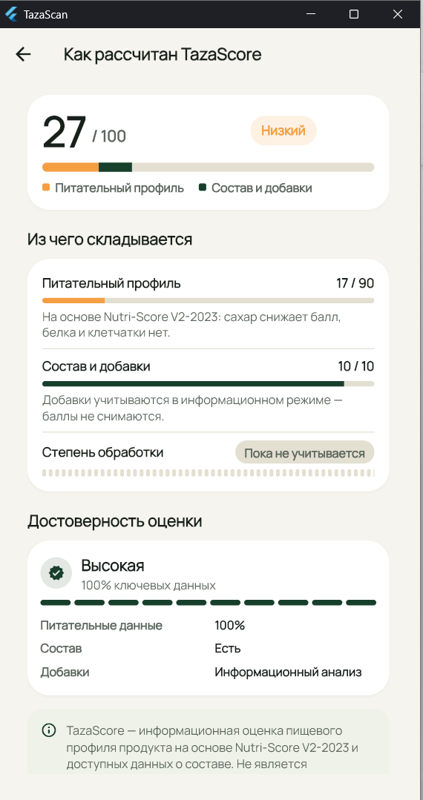
Figure 6. Detailed TazaScore explanation

8.4 Ingredient Information
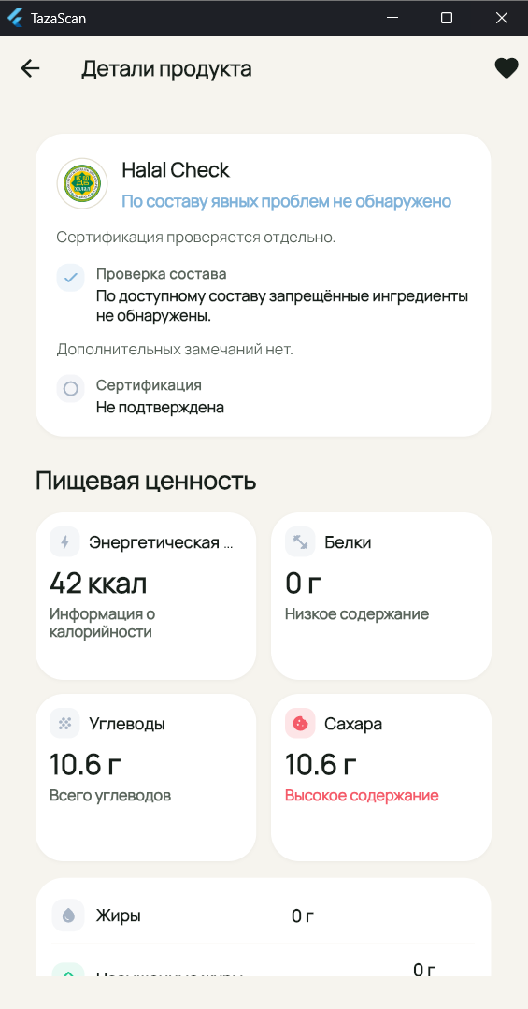
Figure 7. Ingredient information and Halal Check
8.5 Product Submission

Figure 8. Unknown product submission flow

Planned allergen analysis interface
A dedicated allergen result section will be added to the product details screen during the diploma implementation stage. The interface is planned to display the potential allergen, supporting ingredient evidence, and result status.

9. Verification and Evaluation Plan
The verification and evaluation will focus on both the technical integration of the allergen module and the quality of its detection results.
A labeled evaluation dataset will be prepared using product ingredient lists with known allergen information. The same allergen categories and preprocessing rules will be used for all evaluated approaches.
The main baseline will be a rule-based allergen detector that identifies allergens using predefined ingredient names, synonyms, and matching rules. The proposed hybrid approach will be evaluated under the same conditions and compared with this baseline.
Detection quality will be measured using Precision, Recall, and F1-score. These metrics will be used to determine how often the system correctly identifies allergens, how many relevant allergens it successfully detects, and the overall balance between missed and incorrect detections.
In addition to detection quality, functional testing will verify that the allergen module is correctly integrated into TazaScan and that the result shown to the user contains supporting ingredient evidence.
Evaluation Area | Verification Method | Expected Result
Allergen detection | Test on labeled ingredient dataset | Potential allergens are identified correctly
Precision | Compare predictions with known labels | Measure false-positive behavior
Recall | Compare predictions with known labels | Measure missed allergens
F1-score | Calculate from Precision and Recall | Compare overall performance
Baseline comparison | Rule-based vs Hybrid | Determine whether the hybrid approach improves detection
Evidence | Check detected allergen against triggering ingredient | Each detection includes supporting ingredient evidence
Missing ingredient data | Test products with incomplete/missing composition | System does not present an unsupported definite result
Backend integration | API/integration tests | Allergen result is returned correctly
Mobile integration | UI/functional tests | Result is shown in the existing product details flow
Regression testing | Run existing TazaScan tests | Existing functions continue to work

Measurement Conditions
All compared approaches will be evaluated using the same labeled test data, allergen categories, and evaluation procedure. Products with unavailable ingredient information will be treated separately from products for which no allergen is detected. If the NLP component requires model training or adaptation, the final test data will not be used during model development.

10. Project Management and Risks
TazaScan is an individual diploma project. The student is responsible for the mobile application, backend, database, integration of the allergen detection module, testing, evaluation, and project documentation.
GitHub is used as the main version control system. Development progress, source code, documentation, diagrams, and tests will be maintained in the same repository throughout the diploma project. YouTrack will be used to organize development tasks, priorities, deadlines, and acceptance criteria.
The project will be developed incrementally. The first stage focuses on project analysis, requirements, architecture, literature review, comparison of existing systems and technologies, and preparation of the evaluation plan. The next stages will cover the design and implementation of the allergen analysis module, its integration into TazaScan, preparation of the labeled evaluation dataset, experimental evaluation, testing, and final documentation.

Risk / Dependency | Possible Impact | Mitigation
Limited labeled allergen data | Difficult to evaluate the detector reliably | Prepare and verify a dedicated labeled evaluation dataset
Complex or ambiguous ingredient names | Potential allergens may be missed or incorrectly detected | Combine rule-based detection with NLP-based processing
Missing ingredient information | Reliable allergen analysis may not be possible | Return an insufficient-data/result-status message instead of a definite result
NLP component does not improve the baseline | Hybrid approach may not outperform rule-based detection | Evaluate both approaches using the same dataset and report the result honestly
Integration affects existing TazaScan functionality | Existing product analysis features may break | Use automated tests and regression testing during integration
Limited project time | Some secondary functionality may remain unfinished | Keep allergen detection and evaluation as the main diploma priority
Dependence on product data quality | Poor input data can reduce analysis quality | Track data completeness and clearly communicate limitations

Main Milestones
Milestone 1: Project analysis and pre-defense materials — proposal, requirements, literature review, comparisons, architecture, prototype, and evaluation plan.
Milestone 2: Allergen detection design and dataset preparation.
Milestone 3: Rule-based baseline and NLP/hybrid implementation.
Milestone 4: Integration with TazaScan mobile application and backend.
Milestone 5: Experimental evaluation, testing, and analysis of results.
Milestone 6: Final documentation, system refinement, and preparation for defense.

11. Supervisor Feedback
During the discussion of the diploma topic, the supervisor noted that the proposed project had similarities with an already approved 2026 topic related to AI-based food analysis and personalized nutrition recommendations.
The supervisor asked whether personalized nutrition recommendations would also be included in TazaScan. Based on this discussion, the project scope was clarified: personalized nutrition recommendations and meal planning are not part of the diploma project. The diploma work focuses specifically on potential allergen detection based on food ingredient analysis.
The supervisor also emphasized the need to make the distinctive feature and novelty of the project clear. TazaScan remains the existing application platform, while the allergen analysis module is defined as the main new contribution of the diploma project.

Supervisor Feedback | Action Taken
The topic may overlap with an approved project related to personalized nutrition recommendations. | Personalized nutrition recommendations were explicitly excluded from the project scope.
The difference between TazaScan and similar projects should be clear. | The diploma focus was narrowed to potential allergen detection based on ingredient analysis.
The project should have a clear distinctive feature and novelty. | The allergen analysis module was defined as the main new diploma contribution within the existing TazaScan platform.

Project Repository and Prototype Resources
Submitted GitHub Version:
https://github.com/AidosAidaruly/TazaScan/tree/prob-period-1
Existing Flutter Mobile Prototype (Source Code):
https://github.com/AidosAidaruly/TazaScan/tree/prob-period-1/apps/mobile
Architecture Diagrams — Editable Mermaid Sources:
System Context Diagram:
https://github.com/AidosAidaruly/TazaScan/blob/prob-period-1/docs/diploma/pre-defense-1/diagrams/system-context.mmd
Use Case Diagram:
https://github.com/AidosAidaruly/TazaScan/blob/prob-period-1/docs/diploma/pre-defense-1/diagrams/use-case.mmd
Component Diagram:
https://github.com/AidosAidaruly/TazaScan/blob/prob-period-1/docs/diploma/pre-defense-1/diagrams/component-diagram.mmd
Project Management Board:
https://tazascan.youtrack.cloud/agiles/204-1/current
The existing TazaScan Flutter application serves as the current functional MVP. The hybrid allergen detection module is planned for the next development stage and is not yet implemented.

References
[1] B. C. Holleman et al., “Poor understanding of allergen labelling by allergic and non-allergic consumers,” Clinical & Experimental Allergy, vol. 51, no. 10, pp. 1374–1382, 2021. doi: 10.1111/cea.13975. PubMed
[2] W. M. Blom et al., “Allergen labelling: Current practice and improvement from a communication perspective,” Clinical & Experimental Allergy, vol. 51, no. 4, pp. 574–584, 2021. doi: 10.1111/cea.13830. PubMed
[3] P. J. Turner et al., “Time to ACT-UP: Update on precautionary allergen labelling (PAL),” World Allergy Organization Journal, vol. 17, no. 10, 100972, 2024. doi: 10.1016/j.waojou.2024.100972. PubMed
[4] G. Popovski, B. Koroušić Seljak, and T. Eftimov, “FoodBase corpus: a new resource of annotated food entities,” Database, vol. 2019, baz121, 2019. doi: 10.1093/database/baz121. PubMed
[5] R. Stojanov, G. Popovski, G. Cenikj, B. Koroušić Seljak, and T. Eftimov, “A Fine-Tuned Bidirectional Encoder Representations From Transformers Model for Food Named-Entity Recognition: Algorithm Development and Validation,” Journal of Medical Internet Research, vol. 23, no. 8, e28229, 2021. doi: 10.2196/28229. jmir.org
[6] G. Hu, M. Ahmed, and M. R. L’Abbé, “Natural language processing and machine learning approaches for food categorization and nutrition quality prediction compared with traditional methods,” The American Journal of Clinical Nutrition, vol. 117, no. 3, pp. 553–563, 2023. doi: 10.1016/j.ajcnut.2022.11.022. ScienceDirect
[7] A. Roither, M. Kurz, and E. Sonnleitner, “The Chef’s Choice: System for Allergen and Style Classification in Recipes,” Applied Sciences, vol. 12, no. 5, 2590, 2022. doi: 10.3390/app12052590. MDPI
[8] G. A. Gadelha et al., “Processamento de Linguagem Natural na Identificação de Alérgenos em Rótulos Alimentares: Uma Aplicação no Contexto Brasileiro,” Journal of Health Informatics, vol. 16, Special Issue, 2024. doi: 10.59681/2175-4411.v16.iEspecial.2024.1325. OpenAlex
[9] E. Kına, “Real-time food allergen detection using OCR-enhanced machine learning techniques,” PeerJ Computer Science, vol. 11, e3338, 2025. doi: 10.7717/peerj-cs.3338. OpenAlex
[10] N. U. M. Badli, N. M. Sabri, and S. Abdul-Rahman, “Real-Time Allergen Detection in Packaged Foods Using OCR and NLP on Mobile Platform,” in 2026 International Conference on Cognitive Systems and Computer Interaction (ICoSCI), 2026. doi: 10.1109/ICoSCI66700.2026.11447524. DOI
[11] A. Susanto, O. J. Daud, and E. Irwansyah, “Allergen Detection in Food Labels Using Transformer-Based Named Entity Recognition,” in 2026 6th International Conference on Innovative Research in Applied Science, Engineering and Technology (IRASET), 2026. doi: 10.1109/IRASET68627.2026.11538466. EurekaMag
[12] Y. Feng et al., “Food additive lens: an on-device AI application for real-time science-based consumer education on food additives using retrieval-augmented generation,” Digital Discovery, vol. 5, pp. 1172–1190, 2026. doi: 10.1039/D5DD00444F. ScienceDirect
[13] G. Baryannis, L. Jia, and E. Papadakis, “FATO: The Food Allergen Traceability Ontology,” Semantic Web, vol. 17, no. 2, pp. 1–16, 2026. doi: 10.1177/22104968261435682. pure.hud.ac.uk
[14] Customs Union Commission, TR CU 022/2011: Food Products in Terms of Their Labelling, Decision No. 881, 9 December 2011

