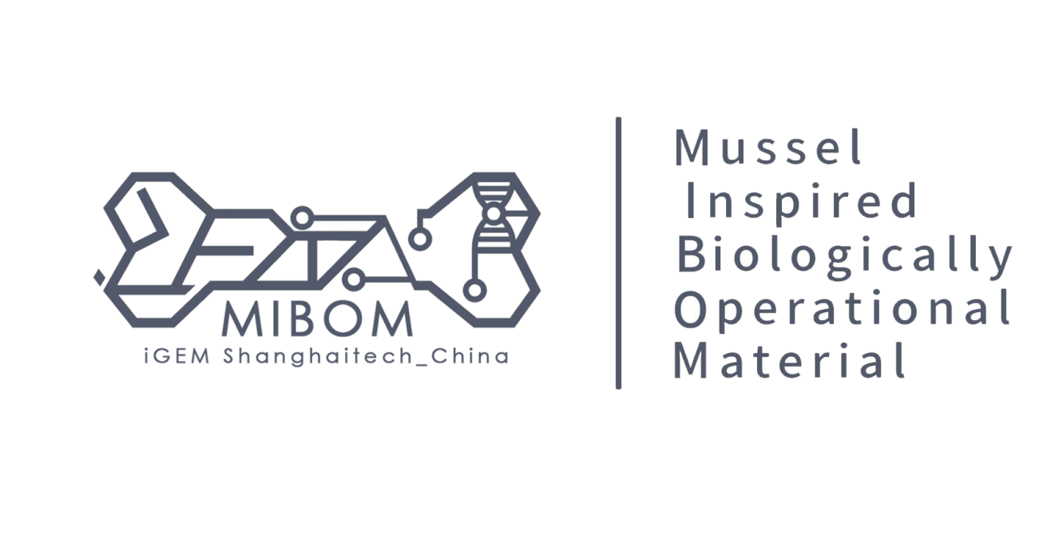

**Business Plan**

**MIBOM**

iGEM2021 ShanghaiTech_China

**Index**

1. Product Description 3

1.1 MIBOM functions： 3

1.2 MIBOM usage descriptions & application scenarios: 4

2. Market Assessment And Project Prospect 7

2.1 Market research 7

2.2 Market capacity 9

2.3 Market size & expectation market share 10

3. Advantages And Disadvantages Analysis And Solutions 15

3.1 SWOT Analysis 15

3.2 Risk Assessment 15

4. Financial Analysis And Marketing Strategy 17

4.1 Analysis of profitability: 17

4.2 Sales mode 19

4.3 Financing plan 20

Appendix: Members 21

## Product Description

MIBOM（Mussel Inspired Biocompatible Osteogenic Material）, is a new highly biocomatible bone glue material with mussel mucin as the core, which combined new material and cell engineering. Up to now, ShanghaiTech_China team has developed a relatively mature new generation of bone repair gels for the treatment of non-major stress bone fractures. The unique modular concept of ‘mussel mucin + hydrogel+cell engineering’ has offered high efficiency and low cost of R&D potential for development of a variety of products.

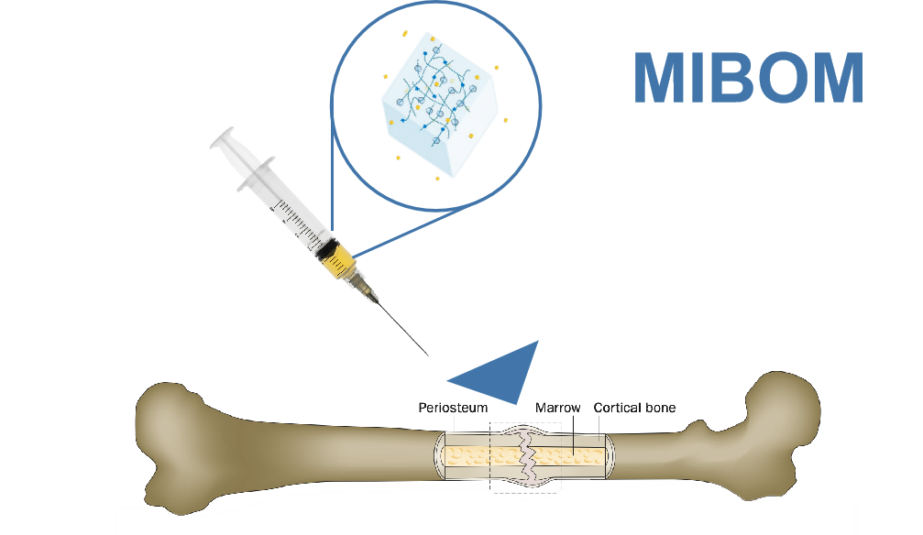

Figure 1. Product appearance

#### MIBOM functions：

**High strength viscosity**

High Strength Viscous MIBOM is a viscous colloid containing artificially modified mussel mucin to provide high strength viscosity for bone counterpoint repair.  This kind of viscosity can be used for fracture end bonding, fixation and treatment.

**Self-degradation and regulation**

Self-degradation and regulation MIBOM is a cell-material interaction system that can effectively sense the pressure caused by bone healing and regulate gel degradation according to the pressure caused by bone healing.  This enables MIBOM to have the ability of personalized repair for different patients, and adjust to different levels of bone healing to better alleviate the stress injury and muscle injury caused by steel plate.

**Promoting bone regeneration**

MIBOM adds a bone-healing drug molecule to accelerate bone repair while providing structural strength and triggering drug release.

**Operational flexibility**

Initially, MIBOM uses gel as the carrier of all systems and is injected into the bone. The semi-fluid and viscous characteristics of MIBOM will give doctors more room for the operation, which is conducive to personalized reduction operations for different patients with different trauma, so as to adjust the alignment of fracture repair.

**Expediting setting**

The gel carrier of MIBOM can be quickly cured after 2-8s UV irradiation, forming polymer network, improving the viscosity and bearing capacity of high strength structure.  The timely curing function improves the convenience of surgical operation, reduces the operation of plate fixation and reduces the difficulty of operation.

#### **MIBOM usage descriptions & application scenarios:**

**Use procedure description**

①.The MIBOM needs to be removed and thawed to a fluid 30 minutes before use.

②.After thawing and before use, it is necessary to carry out mild mixing to evenly distribute the ingredients in the gel and avoid excessive local concentration.

③.Reset the fractured end faces to ensure alignment. The end face should be properly cleaned to ensure no residual soft tissue.

④.Gently shake before opening, and pour into injection device after aseptic opening. Using the device injects MIBOM colloid along the fracture or fracture seams.

⑤.After the colloid is injected, the reduction is confirmed again. Then, the UV device should be turned on and the colloid part should be irradiated by UV for 2-8 seconds to fix the colloid and the fracture end.

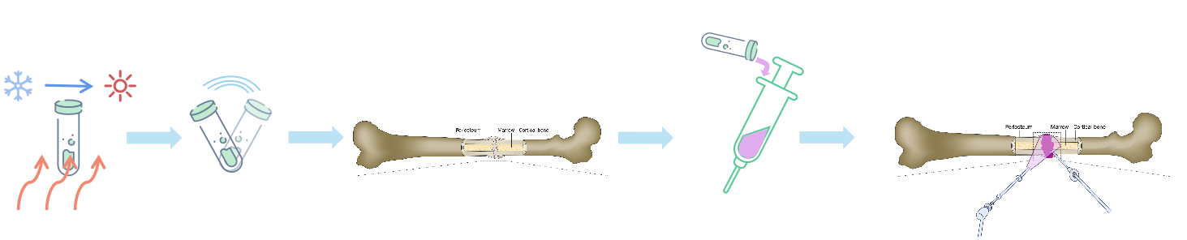

Figure 2. Use process description diagrams

**Application scenarios**

**·Non-stress fracture internal fixation materials**

Non-load-bearing fracture and comminuted fracture will be the main application scenarios of MIBOM.

The consumables, costs and time of the second operation have caused huge occupation and loss of patients and medical resources.  Patients need to bear the cost of titanium alloy plate consumables, the cost of removal and the impact of hospital stay on daily life.  Medical resources need to carry patients undergoing removal of internal fixation, so more medical resources are occupied.  On the other hand, the treatment of more serious comminuted fractures takes a long time because of its complex operation process, which increases the burden of doctors' energy and operation level.  Therefore, MIBOM was developed to be a new generation of fracture treatment options for non-load-bearing trauma and comminuted fractures.

MIBOM has the load-bearing strength required for non-load-bearing bones and can handle comminuted fractures with flexible handling capabilities.  Therefore, in comminuted fractures, cumbersome bone block treatment, bone nail repair will be replaced by MIBOM bone glue.  For conventional fractures, MIBOM can directly treat non-load-bearing fractures by cementing the fracture end with bone glue and reducing plate removal and injury to the bone.

**·Future application scenario -- trauma dressing**

Mussel mucin has a hydrophobic force, which can effectively form a nano-level protective film at the local microscopic level and effectively protect the wound surface or skin mucosa. The special structure of mussel mucin can also provide extended support for normal tissue cells around the wound, which is beneficial for cells to crawl and grow from the middle or from the bottom up, and promote wound healing. Therefore, mussel mucin can not only facilitate the exudation of wound and mucosal environment with fluid, but also provide a strong environment for wound healing.

Hydrogel modules, such as hyaluronic acid or hydrogel, help to block the outer structure and prevent microbes from entering, achieving antibacterial effect. At the same time, the gel can absorb exudate and toxic substances, providing an effective environment for wound healing. At present, there are many repair gels in circulation, which is one of the current treatment schemes for wound repair.

Therefore, using the MIBOM module, the gel can be loaded with mussel mucin, providing antibacterial, adhesion, absorption of exudate, and providing a wound healing environment, helping wound healing once. According to the module development, skin or cell growth factor can be added into the gel, and certain regulatory system can be added to achieve steady control.

The wound dressing has a variety of application directions, and corresponding products can be developed for different types of trauma. The use of flexible MIBOM modules will enable faster development and save r&d costs for concept exploration.

## Market Assessment And Project Prospect

#### **Market research**

At present, secondary operation is a difficult problem in fracture treatment.  On the other hand, the complex problems of bone damage, displacement and comminuted fracture caused by bone plate consumables have been causing trouble for patients and doctors in terms of health and treatment.  The goal of MIBOM is to optimize fracture treatment in detail and to innovate and improve treatment options.

**Problems with implant removal surgery**

According to the research results of ShanghaiTech_China team, the removal of implants will occupy a large number of medical costs and resources.  The team investigated the market situation of bone implants in China and the current actual situation. Also, ShanghaiTech_China team has interviewed the orthopedic trauma surgery team of Shanghai Ninth People's Hospital (North Hospital) to obtain the main plans and problems in the treatment of traumatic fractures.  According to the feedback, our team found that due to the safety issues such as stress shield injury, friction and wear, toxicity and other issues caused by orthopedic implant treatment, and the limited acceptance capacity of bone implant in domestic public psychology, most traumatic fracture surgeries in China are performed twice.

Depending on the field survey, taking Shanghai Ninth People's Hospital as an example, there were about 2,040 fracture operations annually, of which 29.25% were implant removal operations.

**·Huge medical expenses**

In China, the cost of a lower limb internal fixation removal is about 7000-8000 yuan, and the cost of upper limb internal fixation removal is about 6000-7000 yuan. According to statistics from the Health Bureau in 2017, there were 1,331 grade-A, three-level hospitals in China. According to the sampling statistics of five grade A hospitals (Zhongda Hospital affiliated to Southeast University, The First Affiliated Hospital of Shantou University, Nanjing Gulou Hospital, Shanghai Sixth People's Hospital and Beijing Third People's Hospital), each hospital had an average of 1730 orthopedic trauma surgeries in a year. According to preliminary modeling analysis, for 1331 grade A hospitals in China, secondary trauma surgeries will generate an average annual medical cost of 4.06 billion yuan. (1331(Grade A hospitals)*1730(orthopedic trauma)* 29.25%(ratio of secondary surgery)*6000(removal cost) = 4.06 billion RMB/year)

**·Occupation of medical resources**

Taking Shanghai Ninth People's Hospital as an example, the department of orthopedics has 200 beds, about 40% of which are orthopaedic trauma group.  In one trauma group, there were about 150 patients undergoing implant removal annually, and one bed was occupied for a second operation every 2.5 days, while implant removal patients occupied the bed for 3-4 days on average.  According to the data, a single orthopaedic trauma group admitted an average of 2-3 patients with implant removal per week, accounting for 32.82 % of the number of beds.  Therefore, it is estimated by modeling that Shanghai Ninth People's Hospital will undertake more than 1200 cases of implant removal surgery every year, and about 25 beds will be occupied by the second operation every week.  The national scale of orthopedic implant removal operations will affect the use of more than 33,275 beds per week.  (1331(Grade A hospitals) *25 (orthopedic secondary surgery beds/weekly/per hospital) = 33,275 beds)

**The damage from the alloy implants**

At present, most conventional fractures are fixed with titanium implants.  However, titanium alloy, stainless steel and other implants will produce gap corrosion, friction corrosion and fatigue corrosion fracture, and will cause prosthesis loosening due to friction and wear problems, and ultimately lead to implant failure, the main reason is stress shielding.  For titanium alloy bone plate and bone nail, the mismatch between heavy limbs and bone elastic wood will make the load cannot be well transferred from the implant to the adjacent bone tissue, resulting in stress shielding phenomenon, resulting in bone absorption around the heavy limbs, and ultimately causing implant loosening or fracture, resulting in implant failure.  There are also tumors associated with implant loosening, which are easy to form near the implant, indicating that allogenic reaction is the main mechanism of carcinogenesis.  Therefore, titanium alloy and other implants still have great defects in biocompatibility and other fields, requiring secondary surgical removal to eliminate their potential safety risks.

**Operational dilemmas in the treatment of comminuted fractures**

In china, it is estimated that in 2021, there will be 295526 traumatic fractures, of which 10.21% will be femoral fractures. 95% of femoral shaft fractures are comminuted. Therefore, there will be an average of at least 280,000 comminuted fractures per year in China.

According to our interviews with doctors in the hospital’s orthopedic trauma team, the surgical time for comminuted fractures is twice as long as that for conventional fractures, which is mainly because of the cumbersome fixation of bone fragments. In a grade-A hospital in china, about nine hours of surgery a week are taken up by complex bone repair. From the point of view of national health resources, about 7,986 operations a week will be taken up, which could cure an additional 7,986 people. Therefore, simplifying comminuted fractures will be a very necessary material development direction. On the other hand, comminuted sex fracture also brings about the circumstance such as bone is not connected extremely easily to happen.

#### **Market capacity**

On the base of the National Bureau of Statistics, the number and proportion of the population aged over 65 continued to increase in 2013, reaching 176 million at the end of 2019, accounting for 12.57% of the total population, up 2.90 percentage points from 2013.  Meanwhile, the average life expectancy of Chinese residents has increased from 74.83 years in 2010 to 77.3 years in 2020, according to the National Health Commission.

The incidence of orthopedic diseases is highly correlated with age. Taking osteoporosis as an example, the incidence of such diseases is significantly positively correlated with age, and the incidence is extremely high in women.  According to the epidemiological survey conducted by K M Jordan, C Cooper et al., the number of brittle bone fractures is 9 million every year, and in the United States,  Women aged 65 years and older accounted for 74%.[1] The burden of brittle fractures will increase as the population ages, with the annual incidence and cost of brittle fractures projected to increase by 50 % in the United States by 2025.  In 2018, the National Health Commission released the results of the epidemiological survey on osteoporosis in China for the first time, which showed that the prevalence of osteoporosis in people over 65 years old was as high as 32.0%, 10.7% in males and 51.6% in females.  According to the relevant orthopaedic epidemiological survey, the proportion of age group of orthopaedic diseases in China is also 44.1% over 60 years old.  With the increase of aging and average life expectancy, the incidence of fracture diseases will continue to grow, the development of the orthopaedic industry will be further concentrated, and the market demand for bone implants will gradually increase.

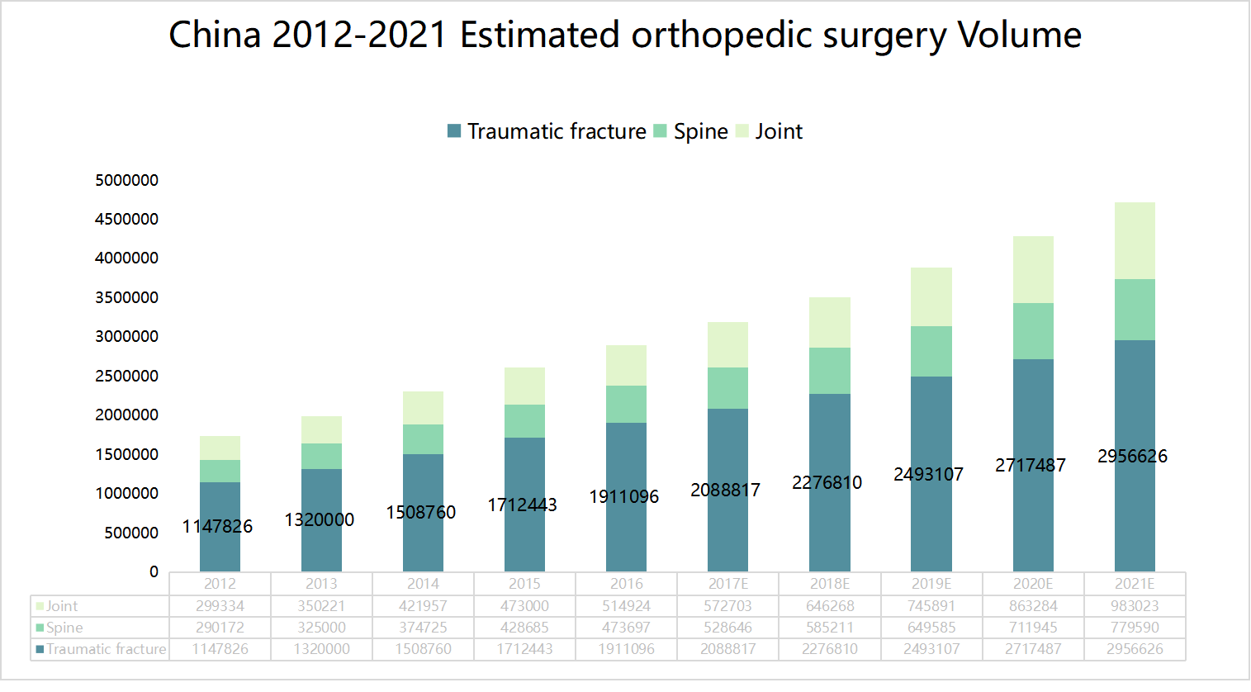

Figure 3. China 2012-2021E orthopedic surgery Volume

According to frost Sullivan database, the number of orthopedic surgeries in China increased from 1.7 million in 2012 to 2.9 million in 2016, with a compound growth rate of 13.8%, among which the number of traumatic orthopedic surgeries increased from 1.1 million in 2012 to 1.9 million.  However, most traumatic fracture operations require a second operation, so there is still a huge potential demand for "solving the second operation" in Orthopaedic surgery in China.  (Figure 3)

#### **Market size & expectation market share**

**Market Size**

Depending on Frost Sullivan database, the market size of Bone implants in China has also increased from 7.2 billion yuan in 2010 to 30.4 billion yuan in 2019, with a compound annual growth rate of 17.36%. It is expected to maintain a steady growth rate of about 15% from 2019 to 2023, and the market size will exceed 53 billion yuan in 2023.

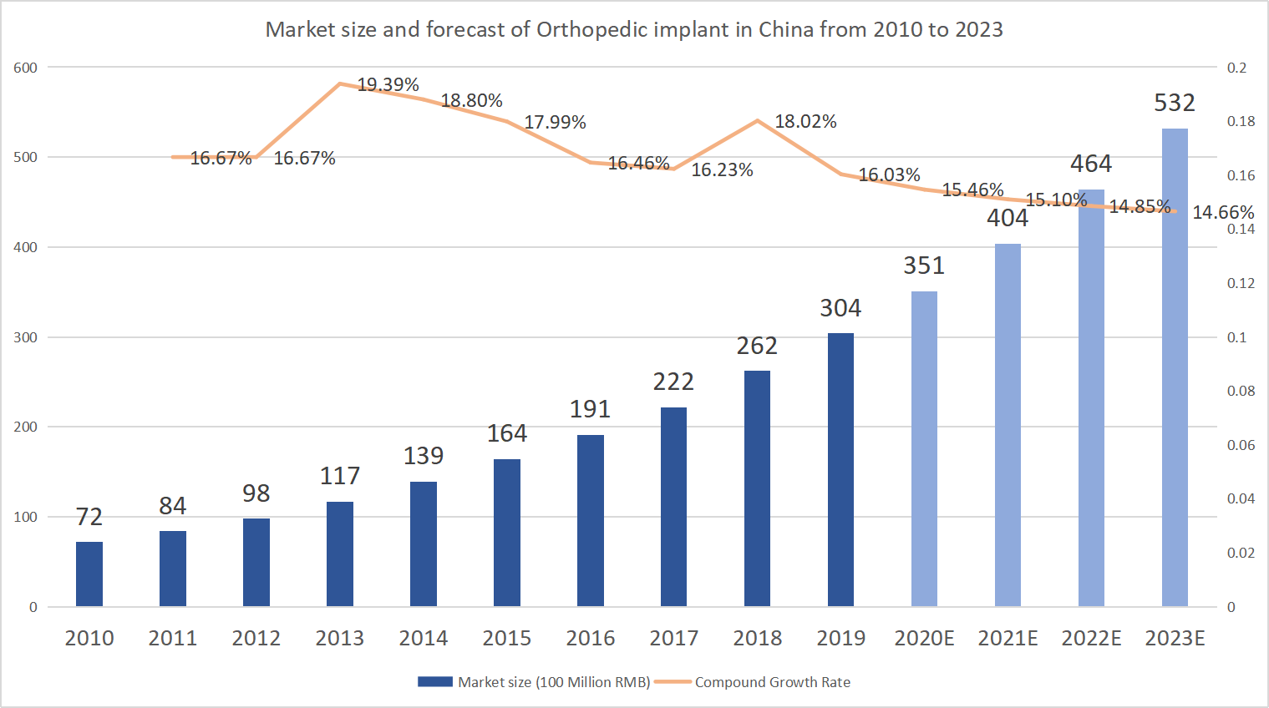

Figure 4. Market size and forecast of Orthopedic implant in China from 2010 to 2023

In the orthopedic market segment, according to IQVIA statistics, trauma products in China accounted for 24% of the market.  At present, as of 2013-2018, the sales revenue of trauma market has increased from 3.8 billion yuan to 7.7 billion yuan, and it is expected that the sales of trauma implantation market will reach 14.3 billion yuan in 2023, with a compound growth rate of 13.3% within five years.  It can be concluded that the trauma bone material market is mature and has sufficient market share, while the budding of new technology will have a huge space for development.

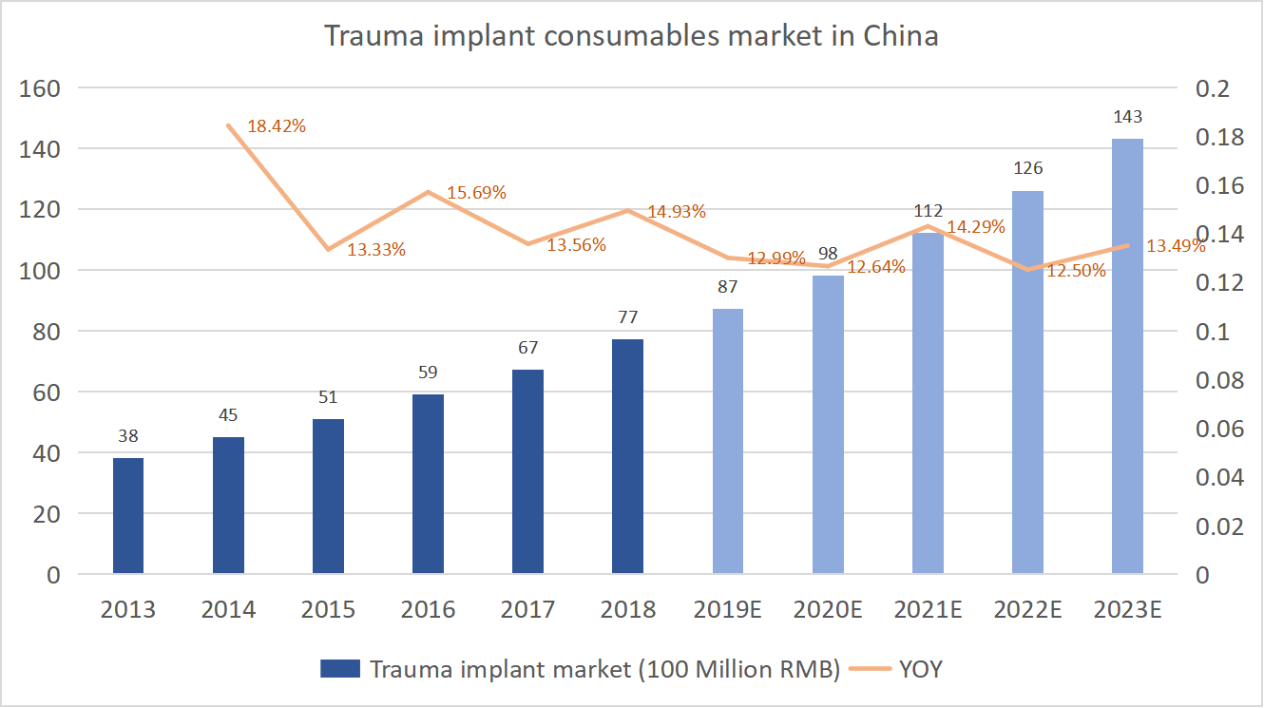

Figure 5. Trauma implant consumable market in China

**Analysis of competition**

Internal fixation of bone material properties of biodegradable is the orthopedic medical research and development of tuyere, and there is no completely absorbable internal fixation materials are widely used in the traumatic fracture, so most bone material equipment company will be main direction positioning on the biodegradable material, to fill the blank of the technology of the fractures of the clinical and break through the traditional treatment.

**·Chengdu Dikang Zhongke Biomedical Materials Co., LTD. (dikang Zhongke)**

**Main products:** absorbable fracture internal fixation screws, absorbable medical anti-adhesion film.

**Indications:** all kinds of non - bearing parts of fracture internal fixation, osteotomy, joint fusion

**Scientific research Foundation:** Scientific research achievement of "Ultra-high molecular weight poly-DL-lactic acid fracture internal fixation system", which was undertaken by Chengdu Institute of Organic Chemistry, Chinese Academy of Sciences.

**Basic Status:** Chengdu Dikang Zhongke Biomedical Materials Co., Ltd. successfully applied for the 2002 National Special appropriation of new materials for high-tech industrialization of 4 million yuan on the basis of "ultra-high molecular weight poly-DL-lactic acid and its fracture internal fixation system". The construction scale of the project is 200 kg of PLA per year, which can absorb 300,000 pieces of bone fixers, 1 million pieces of medical anti-adhesion film and 5 million sutures. The annual output value of the whole project reaches 1 billion yuan. At present, the company is the largest poly-DL-lactic acid production base in China.

**·Syntellix AG**

**Main products:** First generation magnesium alloy orthopedic trauma compression internal fixation screw MAGNEZIX MgYREZr

**Indications:** hand, foot small fracture, and fracture nonunion

**Scientific research Foundation:** Berlin University School of Medicine

**Basic Status:** In 2008, Syntellix AG was founded based on the scientific research and technology foundation of the Medical School of The University of Berlin.  In 2013, the MAGNEZIX MgYREZr (WE43) degradable magnesium alloy compression screw developed by Germany's Sytellix AG became the world's first Ce-certified orthopedic product for small and fragment fixation.  In December 2018, MAGNEZIX(WE43) degradable magnesium alloy compression screw was registered as an NMPA Innovative medical device in China. In 2019, MAGNEXZIX screw will begin a multi-center clinical trial in China.

**·Dongguan Eontec Co., Ltd.**

**Main products:** ‘99.99 % high purity magnesium’ orthopaedic internal fixation screws

**Indications:** femoral head necrosis bone flap transplantation operation fixation.

**Scientific research Foundation:**Professor Qin Ling, Faculty of Medicine, CuHK

**Basic Status:** In 2013, Eontec led the "China Medical Magnesium Alloy Innovation Alliance" and the biological magnesium alloy research team of Germany APP Implantate AG.  In 2014, Eontec applied for "degradable magnesium bone internal fixation screws" and passed the special approval application for innovative medical devices.  Since 2015, clinical trials of high-purity magnesium orthopedic screws have been carried out in Zhongshan Hospital affiliated to Dalian University, with more than 100 cases.

**·Competitive Frame**

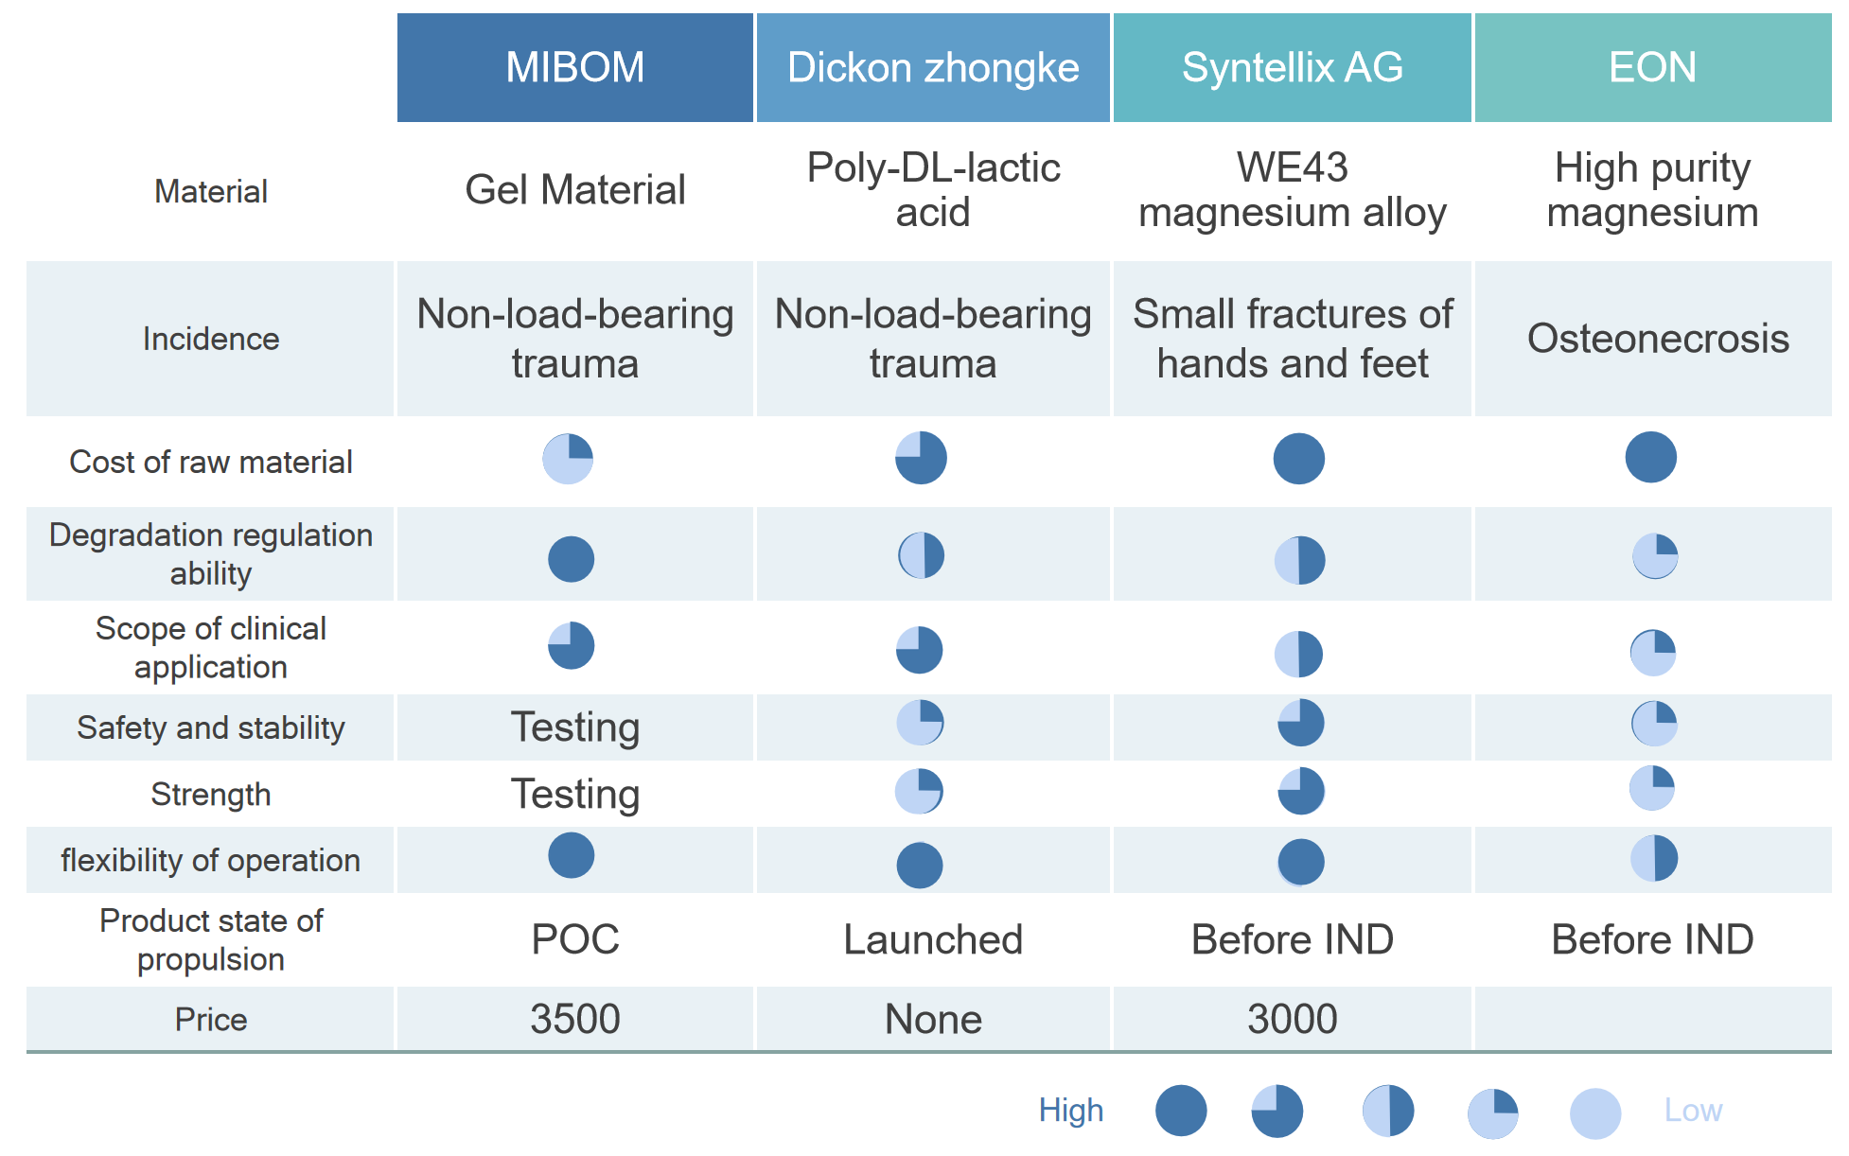

Figure 6. The competitive frame of degradable internal fixation material

By comparing the technical indicators, clinical application and price of the above enterprises, it can be found that currently, the degradable internal fixators are still in the embryonic stage of trauma bone materials, and most of them are in the process of technological transformation.  Most materials advocate the use of ultra-high molecular PLLA/PLGA or magnesium and magnesium alloys, which greatly improves the control of degradation ability and cannot bear excessive weight.  Therefore, MIBOM has great advantages in degradation regulation ability, clinical application range, operational flexibility and price setting.  Moreover, the internal fixators of ultra-high molecular materials are prone to damage and other problems. Therefore, although Dikang Zhongke is listed, it cannot completely solve all the needs of internal fixation.  However, most of the new degradable bone materials are based on the transformation of existing research and development technology, there is a big gap between the middle and the market, and the transfer cost is high.  MIBOM transcends the long process of technology transformation and is more sensitive to the market. Therefore, in the design process, MIBOM directly faces the market and continuously iterates, which can feed back the market demand more quickly, adjust timely and obtain effective product solutions.

**expectation market share**

In our product development plan, we plan to cover medical devices, medical cosmetology, postoperative rehabilitation and other industries.  Such products have a large and steady demand.

At present, MIBOM is a new biodegradable material, which will be developed in the orthopedic medical industry at the initial stage, and in the beauty and trauma treatment industry at the later stage. The product is in the embryonic stage of development in the above industries. During the implementation period, there are few competitors, and the profitability will be greatly enhanced.  According to the earnings forecast, if the market is implemented in 2023, the roe can reach 7%, and with the growth of the year, the ROE will reach 24% after 5 years in the market.

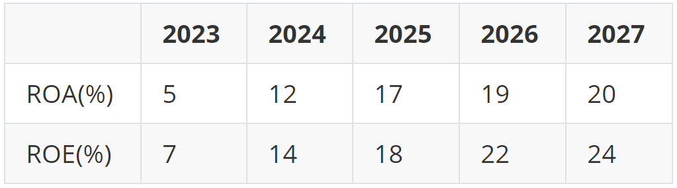

Table 1. Estimated yield of MIBOM project

## Advantages And Disadvantages Analysis And Solutions

**3.1 SWOT Analysis**

|  |  |  |
| --- | --- | --- |
|  | **Strength**   1. Efficient mussel mucin extraction solution. 2. Original modular design. 3. Raw materials have strict safety certification. 4. Rich sources of academic support and technical guidance. 5. Diverse multidisciplinary teams. | **Weakness**   1. The project system is still in the early stage of development and preparation. 2. Long fund recovery cycle, lack of cash flow, easy to cause economic risks of the team. |
| **Opportunity**   1. During the market bud period, competition category is few. 2. In China, medical device approval has a fast approval channel for innovative devices, which can optimize the time and cost of product approval. 3. MIBOM has more expandable areas because the modular concept. | **SO Strategy: Diversified layout**  MIBOM will accelerate the diversified product layout, further build a product layout across the medical, beauty, daily first aid and other fields, and give play to the mussel mucin as the core of our team's product body.  We will also develop mass market products to make up for cash flow shortfalls and meet the huge investment in initial research and development.  At the same time, MIBOM will give full play to the advantages of modular design ideas, accelerate the expansion of product lines, and lay the technology for product diversity.  Further improve the market share, brand. | **WO Strategy: Industrial chain cooperation**  MIBOM will integrate the industrial chain in the future and expand the cooperative relationship.  Upward, we integrate looking for OEM, looking for mature hydrogel synthesis companies.  By working with related synthetic biology companies, we hope to overcome the problem of high upfront costs inherent in startups.  At the same time, MIBOM's layout in the industrial chain is conducive to giving full play to the advantages of cooperation, further improving product quality and better occupying market share. |
| **Threats**   1. [research](D:/%E8%B5%84%E6%BA%90/Dict/8.9.9.0/resultui/html/index.html" \l "/javascript:;) [and](D:/%E8%B5%84%E6%BA%90/Dict/8.9.9.0/resultui/html/index.html" \l "/javascript:;) [development](D:/%E8%B5%84%E6%BA%90/Dict/8.9.9.0/resultui/html/index.html" \l "/javascript:;) [risk](D:/%E8%B5%84%E6%BA%90/Dict/8.9.9.0/resultui/html/index.html" \l "/javascript:;). 2. There are competitors in academic research. 3. Patients' acceptance of bone glue, a new medical product, is unpredictable. | **ST Strategy:**  **Accelerating the development of multi-line products**  MIBOM will take advantage of modular design to develop products for different application scenarios as soon as possible, such as trauma, beauty and other skin care products.  In the future, we will transform the overall product clients from hospitals to individual consumers, expand the market and make up for the turnover needs of cash flow. | **WT Strategy: Building Brand awareness**  After product industrialization, MIBOM will improve brand awareness as soon as possible.  As we target not only the high-end medical market, but also the popular market, the reputation and brand effect based on the high-end medical market will greatly increase our advantages in the market competition.  At the same time, our solutions based on personalized medicine help increase user engagement and stabilize relevant markets. |

Table 2. SWOT Analysis & Corresponding strategies

**3.2 Risk Assessment**

In order to deal with the risks caused by product development, production and use, we still developed a set of risk assessment forms.

|  |  |  |  |  |
| --- | --- | --- | --- | --- |
| **Sources of risk** | **Likelihood of occurence** | **Impact to  MIBOM** | **Description** | **Solutions** |
| Risk of experimentation | 3 | 5 | There is a risk of failure in the experiment, and MIBOM encountered difficulties in the verification of toxicity, residue or strength, which led to the failure of MIBOM in fracture treatment. | Conduct experimental plans through meetings with core members to minimize experimental risks. On the other hand, the simultaneous development of non-invasive products, reduce the requirements for product strength. |
| Human safety risks caused by implants | 1 | 5 | If the implant has adverse effects during the clinical trial, the clinical trial can easily be interrupted and the whole material cannot be registered for the market. | Rigorous in vivo material safety validation experiments should be established, and alternative treatment schemes and compensation mechanisms should be established for safety risks in clinical practice. |
| The emergence of competitors of the same type | 1 | 2 | The emergence of the same type of competition products or occupy the original market share of MIBOM, thereby compressing MIBOM itself. | Develop diversified products, consolidate the strength base of MIBOM team, increase team experience and scale economy. MIBOM will expand its profitability by expanding into different markets. |
| Risk of capital chain rupture | 3 | 5 | The fracture of the capital chain leads to the inability of all departments to advance the work, which easily increases the possibility of experiment failure. | By establishing a financial early warning system, MIBOM will improve the financial and operational management of the team when expanding the team, so as to reduce the possibility of capital chain fracture. The experimental department develops low-cost first-class medical device products, and establishes capital chain through registration and listing as soon as possible. |
| Change of policy | 2 | 2 | In China, medical apparatus and instruments policy has been changing, the most recent medical device policy change was mainly in 2019, so it is highly likely that new policies will be introduced before registration. | MIBOM plans to first protect the product by registering patents, and then establish a registration team to interpret policies and write registration materials. |

Table 3. Risk assessment & countermeasures

## Financial Analysis And Marketing Strategy

**4.1 Analysis of profitability:**

**Cost input**

Our product production is mainly divided into two parts, one is purification and modification of mussel mucin, the other is cell culture and preparation of hydrogel bone nails.

In general, the cost of raw materials for the two parts is very low. On average, the cost of materials for preparing 1ml hydrogel is about 5 yuan.  Another major cost of the product is hardware facilities. The purchase of high-speed centrifuges, ultra-clean tables, shakers and other equipment will be a considerable expenditure, and the estimated price will be about 1 million yuan.  Therefore, considering the cost of facilities, materials and labor, the cost of our product will be 20 yuan /ml.  The cost is much lower than the same type of products on the market.

**Product Pricing**

Given the low cost of the product, we can use pricing that is well below the industry average. At present, the price of a degradable bone nail in the market is about 3000-4000 RMB, while our product is estimated to be priced at 1000-1500 RMB. It is a product worthy of investment and development with high quality and low price and large profit space.

**Operation Capacity**

Our products cover medical devices, medical cosmetology, postoperative rehabilitation and other industries. These industries have a large and steady demand for products.

Every year, countless patients suffer from fractures, burns and other trauma, and our products such as bone repair gel and burn treatment gel will be favored by a large number of consumers because they can reduce the pain of patients in the treatment process and shorten the time of postoperative rehabilitation while being stable and efficient.

In recent years, people demand for beauty products show stable growth trend, the mussel mucin microscopic nanoscale protective film can be formed, the physical barrier, antioxidation, and at the same time, under the action of local anti-inflammatory have acne pitting scar, rapid repair wound skin, inhibit itching and melanin and multiple effect, Coupled with the fact that our mussel mucin extract is of low cost and high quality, our beauty products will quickly find a niche in the market.

To sum up, due to the extremely high market and the fact that as a new and pioneering product, there are almost no competitors in the industry at the initial stage of promotion, it is preliminarily predicted that the project will have strong profitability. After being in the market for a while and building your own brand, profitability will be more substantial.

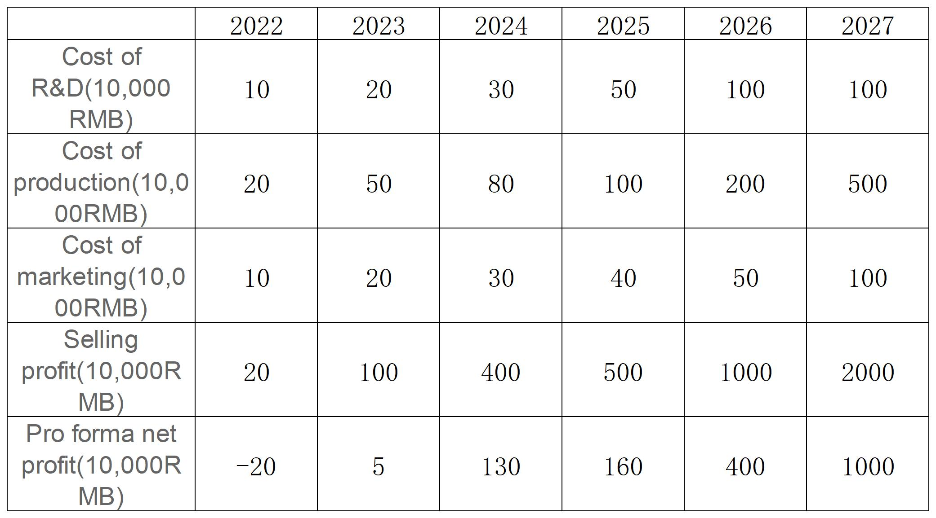

Table 5. Profitability of MIBOM

MIBOM project total asset turnover forecast for the next five years As a project involving the medical and beauty industry, the inventory turnover and total asset turnover of the project will be relatively high.  At the initial stage of project industrialization, there will be an overall upward trend, and then it will fluctuate around a stable value.  Is the second year of inventory turnover and total asset turnover compared to the first year because of the decrease in considering the product into the market, the improvement and adjustment and occupied a certain market share, will further expand production capacity, the two indicators fell, but the overall is still in a healthy positive level.  In general, MIBOM project is expected to have excellent operation capacity and strong asset liquidity, which can further provide a good short-term solvency for the project. To a certain extent, it allows us to bear some short-term debt to realize faster development of the project in the early stage.  At the same time, higher asset liquidity also corresponds to shorter receivable turnover days, which can reduce the risk of bad debts without restricting the growth of product sales.

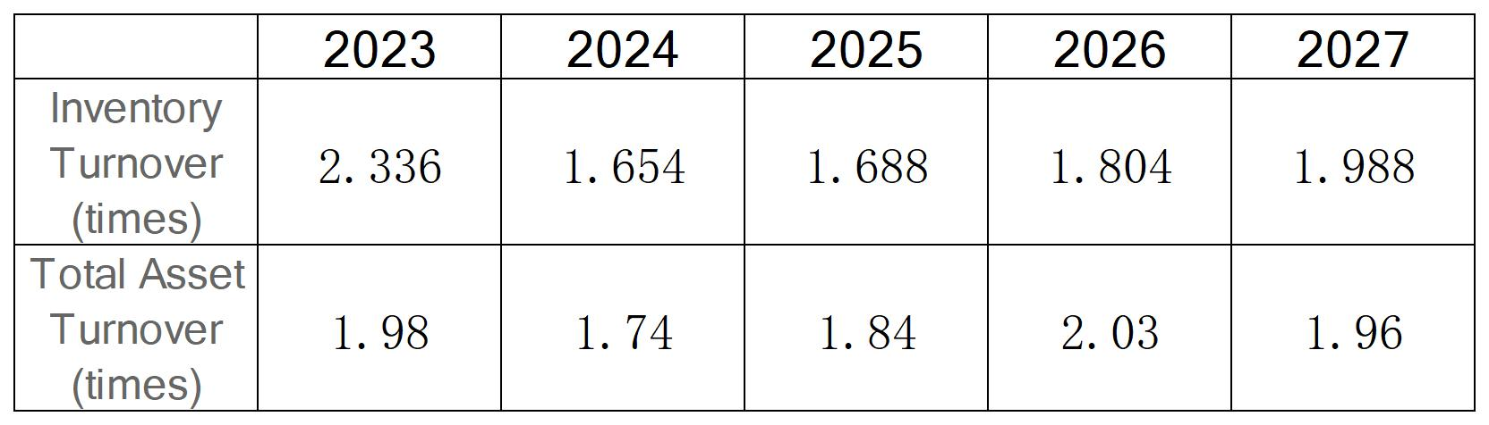

Table 6. MIBOM project total asset turnover forecast in the next five years

**Growth ability**

Given the innovation and efficiency of the product, as well as the large market demand, the MIBOM project will take a period of time to understand the market demand in detail and continue to improve the product.  At the same time, there is no strong competitor for the same type of products in the industry, so the project will not be suppressed by competitors.  In addition, as mussel mucin has a wide range of uses, the project team can further develop new products and further explore the market after stable production lines and sales channels have been established for existing products.  Overall, the MIBOM project has excellent growth potential.

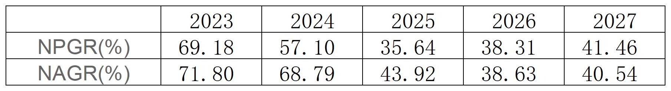

Table 7. Growth ability of MIBOM

**4.2 Sales mode**

MIBOM will enter the healthcare system by partnering with hospitals and other medical institutions.  Our initial plan is to reach clinical cooperation with ten hospitals, and build solid cooperative relations to pave the way for the subsequent commodity circulation.  MIBOM uses consulting sales to connect with hospital decision makers and train doctors.  MIBOM will enter into medical insurance, so we will reach agreements and cooperation with medical security institutions and insurance companies through consulting communication.

**4.3 Financing plan**

The first round of funding will be used to develop and manufacture bone repair hydrogels and further improve mussel mucin extraction technology.  The remaining funds will be used for market registration, market research and sales promotion.  The capital of each part of the preliminary idea is as follows: 60% for scientific research and development, 10% for market registration, 15% for market research and 15% for sales promotion.

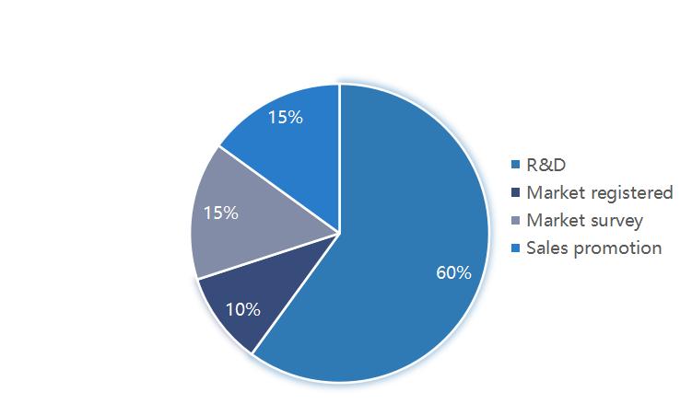

Figure 7. Financing plan

## **Appendix: Members**

**Rui Su:** General manager of MIBOM Project, Major in Biomedical Engineering, School of Life Sciences, ShanghaiTech University, minor in Innovation and Entrepreneurship, School of Entrepreneurship and Management, Leader of iGEM ShanghaiTech_China  Mainly responsible for MIBOM project design, material property measurement, biomaterial synthesis, cell experiment, etc., responsible for the overall cell experiment and material experiment design, overall control of project progress.

**Chenghao Zhu:** General director of molecular experiment of MIBOM Project, general director of laboratory finance, major in Biological Science of College of Life Science, ShanghaiTech University, mainly responsible for molecular experiment design of MIBOM project, all molecular cloning and construction, mussel mucin extraction and other important experiments.

**Shiyue Ding:** General manager of MIBOM Project Human Practice, General manager of Visual System, majoring in Biological Science, School of Life Science, ShanghaiTech University, mainly responsible for MIBOM project market research, entrepreneurial development, user demand and other related aspects.

**Huayu Wang:** Molecular experiment experimencer of MIBOM Project, majoring in Biological Science, College of Life Sciences, ShanghaiTech University. Participated in the preliminary project investigation, the construction of partial molecular cloning of MIBOM, and the extraction of mussel mucin, etc.

**Han Ding:** Molecular experiment experimentarian of MIBOM Project, majoring in Biological Science, College of Life Sciences, ShanghaiTech University, participated in the preliminary project investigation, the construction of part of molecular clones in MIBOM project, and the extraction of mussel mucin.  At the same time, I am the main director of Education in iGEM competition.

**Ziding Zhou:** Molecular experiment experimenator of MIBOM Project, majoring in Biological Science, College of Life Science, ShanghaiTech University. He participated in the molecular experiment teaching, preliminary project investigation, and experimental design of cell experiment of MIBOM project.

**Zixuan Li:** Molecular experiment experimencer of MIBOM Project, majoring in Biological Science, College of Life Science, ShanghaiTech University. She participated in the molecular experiment teaching, preliminary project investigation, and experimental design of cell experiment of MIBOM project.

**Ziao Ling:** The head of cell experiment of MIBOM project, majoring in Biomedical Engineering, College of Life Sciences, ShanghaiTech University. He participated in cell experiment teaching, project design and cell experiment design of MIBOM project. He completed cell phototoxicity test, Piezo1 function verification and other important experiments.

**Jieni Hu:** MIBOM cell experiment experimenator, majoring in Biomedical Engineering, College of Life Sciences, ShanghaiTech University, participated in Visual System art work, design work of MIBOM project, interaction between cells and hydrogel, Piezo1 function verification and other important experiments in cell experiment.

**Zhiwen Huang:** Experimental member of cell experiment of MIBOM project, majoring in Biological Science in College of Life Science, ShanghaiTech University, participated in Visual System art work, design work of MIBOM project, interaction between cells and hydrogel, Piezo1 function verification and other important experiments in cell experiment.  He also participated in the extraction and design of mussel mucin in molecular experiments.

**Zhuoya Li:** Molecular experiment experimenator of MIBOM Project, majoring in Biological Science, College of Life Science, ShanghaiTech University. She participated in Visual System art work, design of MIBOM project and some molecular experiment work.

**Ruixuan Ruixuan:** MIBOM project financial analyst, modeler, cell experiment experimencer, majored in physical Science, School of Material Science, ShanghaiTech University, participated in part of cell experiment, and also participated in part of mathematical modeling, responsible for the financial analysis of MIBOM project.

**Jing Sun:** Principal of MIBOM project modeling, cell experiment experimner, majoring in Biological Science, College of Life Sciences, ShanghaiTech University, mainly responsible for mathematical modeling of MIBOM project, theoretical simulation of drug release, gel degradation and other topics, and participated in some cell experiments.

**Yiyao Zhu:** Responsible person of MIBOM project hardware. Majoring in Electronic information Engineering, School of Information, ShanghaiTech University, he is mainly responsible for MIBOM project hardware adaptation and development.

**Zhiyi Wang:** Front-end development of MIBOM project, computer Science major, School of Information, ShanghaiTech University, mainly responsible for the presentation and development of web pages in Visual System.

**Kaijun Wang:** Molecular experimencer of MIBOM Project, majoring in Biological Science, College of Life Sciences, ShanghaiTech University. He mainly participated in relevant molecular experiments and participated in the design of some cell experiments.

**Handi Jia:** Molecular experimencer of MIBOM project, majoring in Biological Science, College of Life Sciences, ShanghaiTech University. Mainly involved in preliminary project investigation and part of molecular experiments, and responsible for making Promotion videos of MIBOM project.

**Shuyao Su:** Cell experimenter of MIBOM Project, majoring in Biological Science, College of Life Science, ShanghaiTech University, mainly involved in preliminary project investigation and part of cell experiments.

**Qi Xin:** Molecular experimencer of MIBOM Project, majoring in Biological Science, College of Life Sciences, ShanghaiTech University, mainly involved in preliminary project investigation and part of molecular experiments

1. Jordan KM, Cooper C. Epidemiology of osteoporosis. Best Pract Res Clin Rheumatol. 2002 Dec;16(5):795-806. doi: 10.1053/berh.2002.0264. PMID: 12473274.