================================================================================
QUERY: A person in a bright yellow raincoat.
================================================================================

[1] 7652c7a6757793e849c1c3ed52027706.jpg
Caption : A person wearing a dress, a coat, a sleeve, a sleeve, and lapel, on a casual afternoon outside....
Bi-Enc : 0.3820
Reranker : 0.9863

[2] dae5dfbd041819c8d8e507f5ccc5daf8.jpg
Caption : An outfit featuring a jacket, a sleeve, a sleeve, and pocket, relaxing in a sunny park....
Bi-Enc : 0.2751
Reranker : 0.9151

[3] 89c29ad72ff33092be3e9565250a1094.jpg
Caption : Wearing a jacket and sleeve — a great choice in a green outdoor setting....
Bi-Enc : 0.2589
Reranker : 0.8662

[4] 243b07abb1ffd79b7afe782b5d4b5fcc.jpg
Caption : A person wearing a dress, a coat, a sleeve, a neckline, a sleeve, and sleeve, at the beach....
Bi-Enc : 0.2937
Reranker : 0.0666

[5] e128aadc152564773ef0e6d8a02c2c6e.jpg
Caption : Wearing a jacket, a top, a sleeve, and sleeve — a great choice relaxing in a sunny park....
Bi-Enc : 0.2580
Reranker : 0.0372
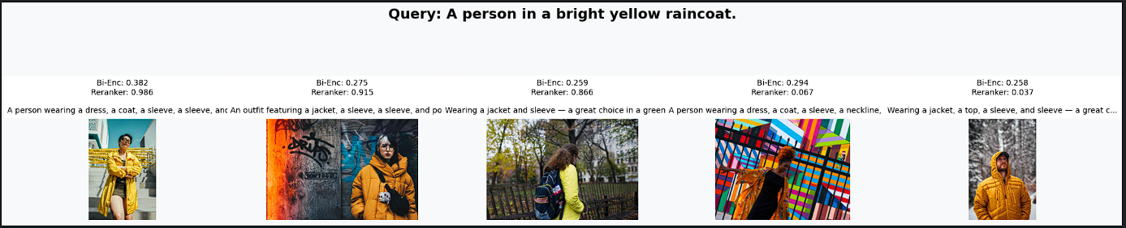

2026-07-17 19:55:27,434 | INFO | Parsed query 'Professional business attire inside a modern office.' → {'garment_filter': None, 'env_filter': 'office', 'vibe_filter': None}
2026-07-17 19:55:27,445 | INFO | Filtered retrieval returned 50 candidates

--- Query: Professional business attire inside a modern office. ---
2026-07-17 19:55:31,136 | INFO | ⏱️ Latency - Retrieval: 0.020s | Reranking: 3.690s

================================================================================
QUERY: Professional business attire inside a modern office.
================================================================================

[1] fda50824d4df0b09acbf8a1560c0ba77.jpg
Caption : Wearing a pants, a shirt, a jacket, a collar, a lapel, a sleeve, a sleeve, a pocket, and pocket — a great choice in a mo...
Bi-Enc : 0.4331
Reranker : 0.0275

[2] 42e993fe27bf6cd76d997ea2b61076c6.jpg
Caption : A person wearing a shirt, a jacket, a pocket, a pocket, a pocket, a lapel, a collar, a sleeve, a sleeve, a sleeve, and s...
Bi-Enc : 0.4051
Reranker : 0.0243

[3] 2bc07f96cc935adc5d0904935410d1da.jpg
Caption : An outfit featuring a jacket, a shirt, a pants, a lapel, a sleeve, a pocket, a sleeve, a collar, and pocket, heading int...
Bi-Enc : 0.3978
Reranker : 0.0177

[4] 01e013a29e7484d1fa4bbc3589e00036.jpg
Caption : An outfit featuring a dress and neckline, at a professional workspace....
Bi-Enc : 0.4864
Reranker : 0.0024

[5] dcb56d475a3f4fd6a506ce477d798ae2.jpg
Caption : Someone dressed in a jacket, a top, a skirt, a shoe, and shoe, at a professional workspace....
Bi-Enc : 0.3888
Reranker : 0.0019
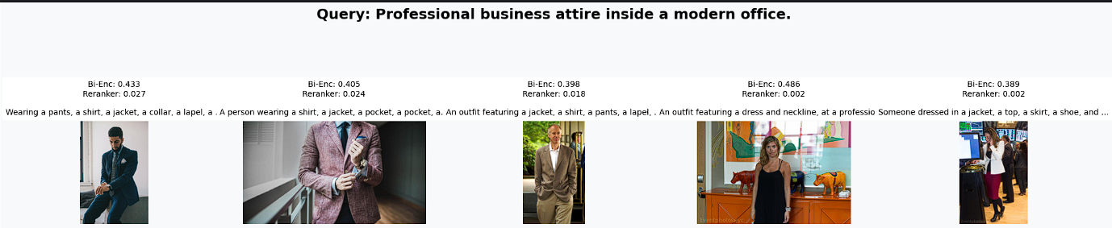
2026-07-17 19:55:32,413 | INFO | Parsed query 'Someone wearing a blue shirt sitting on a park bench.' → {'garment_filter': 'shirt', 'env_filter': 'park', 'vibe_filter': None}
2026-07-17 19:55:32,417 | INFO | Filtered retrieval returned < 10 results; retrying unfiltered
2026-07-17 19:55:32,423 | INFO | Unfiltered retrieval returned 50 candidates

--- Query: Someone wearing a blue shirt sitting on a park bench. ---
2026-07-17 19:55:36,222 | INFO | ⏱️ Latency - Retrieval: 0.019s | Reranking: 3.798s

================================================================================
QUERY: Someone wearing a blue shirt sitting on a park bench.
================================================================================

[1] d78a93afeb1284cc8631340acf133323.jpg
Caption : An outfit featuring a top, a pants, a shoe, a shoe, and neckline, strolling through an urban neighbourhood....
Bi-Enc : 0.3240
Reranker : 0.8241

[2] fc27ef2ee80f12b6e04dafc7d47c244d.jpg
Caption : A stylish look with a shoe, a shoe, a shirt, a pants, a jacket, a collar, a pocket, a sleeve, a sleeve, and collar, seen...
Bi-Enc : 0.3235
Reranker : 0.2678

[3] 670d771896aa91ecf42703b75831e3c7.jpg
Caption : A person wearing a top, a pants, and neckline, in a green outdoor setting....
Bi-Enc : 0.3368
Reranker : 0.0772

[4] ecb04b1ff1b1214bf40524c4f61b84e5.jpg
Caption : Someone dressed in a shirt, a pants, and sleeve, walking downtown....
Bi-Enc : 0.3498
Reranker : 0.0320

[5] 2662eec2d75f37aac689eaf3f5134728.jpg
Caption : Someone dressed in a pants, a shirt, a top, a neckline, a sleeve, a sleeve, a neckline, and neckline, in a cosy indoor s...
Bi-Enc : 0.3132
Reranker : 0.0269

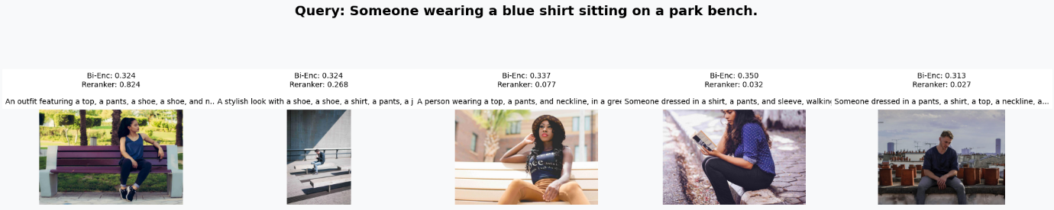
2026-07-17 19:55:37,348 | INFO | Parsed query 'Casual weekend outfit for a city walk.' → {'garment_filter': None, 'env_filter': 'street', 'vibe_filter': 'casual'}
2026-07-17 19:55:37,360 | INFO | Filtered retrieval returned 50 candidates

--- Query: Casual weekend outfit for a city walk. ---
2026-07-17 19:55:41,054 | INFO | ⏱️ Latency - Retrieval: 0.021s | Reranking: 3.693s

================================================================================
QUERY: Casual weekend outfit for a city walk.
================================================================================

[1] 0529a405d1682f448ffa91fd05cd4410.jpg
Caption : Wearing a top, a sleeve, a sleeve, and neckline — a great choice on a busy city street....
Bi-Enc : 0.4844
Reranker : 0.5129

[2] 664e267202cf50ea083a69e18144d79c.jpg
Caption : A stylish look with a pants, a top, a jacket, a shoe, a shoe, a pocket, a pocket, a sleeve, a sleeve, and lapel, seen wa...
Bi-Enc : 0.4620
Reranker : 0.4400

[3] 1761486c30e2428b3dfb983c630f018c.jpg
Caption : Wearing a top, a coat, a pocket, a sleeve, a lapel, and sleeve — a great choice on a city sidewalk....
Bi-Enc : 0.4601
Reranker : 0.3843

[4] 44ccbd47e14ce3bad917bebd19262eb7.jpg
Caption : A stylish look with a shirt, a pocket, a collar, and sleeve, seen on a busy city street....
Bi-Enc : 0.4635
Reranker : 0.3556

[5] 2c25bb9c7a3432ba09e77e1d408cd29b.jpg
Caption : Wearing a coat, a top, a pants, a shoe, a shoe, a sleeve, a sleeve, and neckline — a great choice walking downtown....
Bi-Enc : 0.4615
Reranker : 0.2110

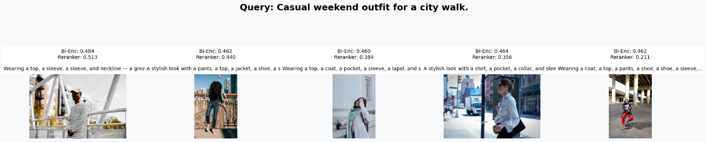
2026-07-17 19:55:42,194 | INFO | Parsed query 'A red tie and a white shirt in a formal setting.' → {'garment_filter': 'shirt', 'env_filter': 'event', 'vibe_filter': 'formal'}
2026-07-17 19:55:42,197 | INFO | Filtered retrieval returned < 10 results; retrying unfiltered
2026-07-17 19:55:42,203 | INFO | Unfiltered retrieval returned 50 candidates

--- Query: A red tie and a white shirt in a formal setting. ---
2026-07-17 19:55:45,948 | INFO | ⏱️ Latency - Retrieval: 0.017s | Reranking: 3.744s

================================================================================
QUERY: A red tie and a white shirt in a formal setting.
================================================================================

[1] ddcbcd05f8084df3eb80ed88ac040dbf.jpg
Caption : Wearing a jacket, a shirt, a collar, a sleeve, a sleeve, a pocket, a pocket, a pocket, a lapel, a sleeve, and sleeve — a...
Bi-Enc : 0.3185
Reranker : 0.0747

[2] 372862d6fc167cf3197ca12fab8c1e02.jpg
Caption : An outfit featuring a jacket, a shirt, a sleeve, a sleeve, a pocket, a lapel, a collar, a sleeve, and sleeve, on a busy ...
Bi-Enc : 0.3403
Reranker : 0.0403

[3] 2bc07f96cc935adc5d0904935410d1da.jpg
Caption : An outfit featuring a jacket, a shirt, a pants, a lapel, a sleeve, a pocket, a sleeve, a collar, and pocket, heading int...
Bi-Enc : 0.2876
Reranker : 0.0360

[4] 2d0584cb564b68f2b8661016e872463c.jpg
Caption : Wearing a shirt, a collar, a sleeve, and sleeve — a great choice at home on a relaxed day....
Bi-Enc : 0.2785
Reranker : 0.0334

[5] bfff250682154ef4651f5d74597f2936.jpg
Caption : Someone dressed in a shoe, a shoe, a pants, a jacket, a shirt, a sleeve, a sleeve, a lapel, a sleeve, a sleeve, and coll...
Bi-Enc : 0.2656
Reranker : 0.0060

